Construction Unloading Monitoring on Shenzhen Nanshan Science and Technology Innovation Center
Wei Lu¹, Yizhan He¹, Weihua Hu¹, Jun Teng¹, Chunfeng Ao², Zongcheng Huo², Zhongmin Mei³
¹ Department of Civil Engineering, Harbin Institute of Technology (Shenzhen), 518055, Shenzhen, China
² China Construction Steel Structure Engineering Co., Ltd, 518055, Shenzhen, China
³ Shenzhen Vanke City Construction Management Co., Ltd, 518000, Shenzhen, China

Email : lu.wei@hit.edu.cn, 19S054011@stu.hit.edu.cn, huweihua@hit.edu.cn, tengj@hit.edu.cn, 330924893@qq.com, 598807386@qq.com, meizm@vanke.com

ABSTRACT: Shenzhen Nanshan Science and Technology Innovation Center adopts the construction method of temporary bar to make the completed structure reach the designed configuration. The rigid unformed construction structure maintains its shape through the bar, unloads the bar step-by-step after the main structure is completed. But it also causes that structural deformation is difficult to predict and control. This paper carries out the construction simulation and monitoring of the large-span structure of Shenzhen Nanshan Science and Technology Innovation Center, through comparing the one time simulation results with the step-by-step construction simulation results, the change law of response of large-span structures in the process of step-by-step construction is studied, while the structural response changes and structural deformation before and after the removal of the bar through the analysis of monitoring data are determined.
KEY WORDS: Construction unloading; Structural Health Monitoring; Construction simulation; Deformation accumulation.

General guidelines
During the construction of a large-span structure, the unformed structure is usually unable to withstand the gravity of the structure itself, it needs temporary support to maintain ‘its configuration at this time [1]. The schematic diagram of the structure is shown in Figure 1. However, the temporary support needs to be dismantled before completion, the commonly used construction techniques such as unloading in the same proportion, unloading in sequence, unloading at the same time, etc. However, the unloading of temporary supports during construction will lead to changes in the structural degrees of freedom and redistribution of internal forces, resulting in changes in the overall stiffness of the structure and excessive structural deformation, which brings difficulty to structural construction controlling [2, 3]. Besides, the redistribution of internal forces will lead to the difference between the stress state of the components during construction and the designed stress state, thus it is necessary to effectively monitor the stress and deformation of components during the construction process to ensure that the completed state of the structure meets the design requirements [4, 5].

Engineering Introduction
Shenzhen Nanshan Science and Technology Innovation Center is designed with the concept of "urban ecological rainforest". There are seven towers ranging from 160 meters to 250 meters high as the "canopy". A huge platform about 400 meters long and about 110 meters wide surrounds the 7-11 floors of the tower. The middle of the layer constitutes the "umbrella layer" of the rainforest. The canopy layer combines a larger spatial scale with an efficient and flexible floor plan, and is well connected to the surrounding towers, as shown in Figures 2 and 3.
The 3 podium steel structures are located on the 7th to 11th floors. It is a 4-story building with a width of about 90m and a length of about 180m, surrounded by cantilevered structures. The steel structure of the podium is composed of connecting beams and truss structures, connecting the core tubes of the 3 buildings 1-7 units into a whole. The maximum span between the core tubes of the unit is 38m, and the maximum span of the outer overhang is 15m. The types of components are mainly box-shaped steel columns, H-shaped steel beams and box-shaped diagonal braces, and the span of the large-span truss is about 30m, as shown in Figure 4. The large platform steel truss has a large span, long cantilever length and high precision requirements. In order to ensure construction safety, the structural configuration is maintained by the bars during the construction phase, so that the structure will not undergo large vertical deformation during the construction phase.
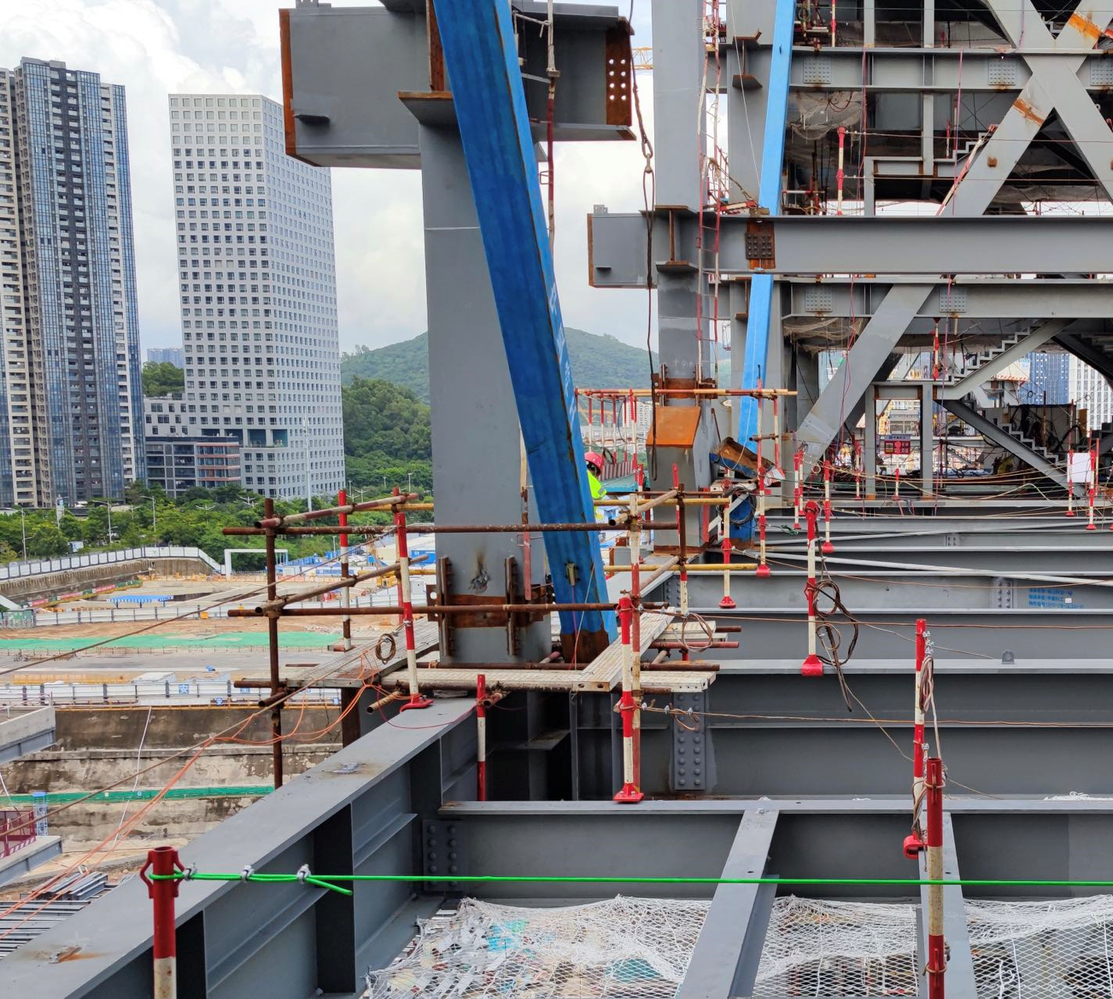
Figure 1. Schematic diagram of temporary bar


Figure 2.Architectural renderings
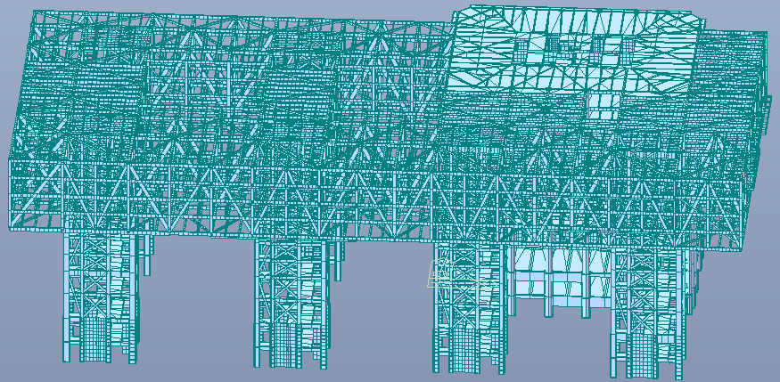
Figure 3.Construction Simulation Model
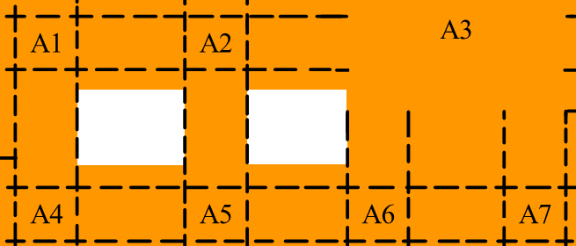
Figure 4. Layout of Shenzhen Nanshan Science and Technology Innovation Center
The construction method of the long-span truss between the A4 core tube and the A5 core tube is to first using the bars to maintain the configuration of the horizontal beams which have been installed, the upward structure is then constructed on the basis of the installed horizontal beams, as shown in Figures 5-7.
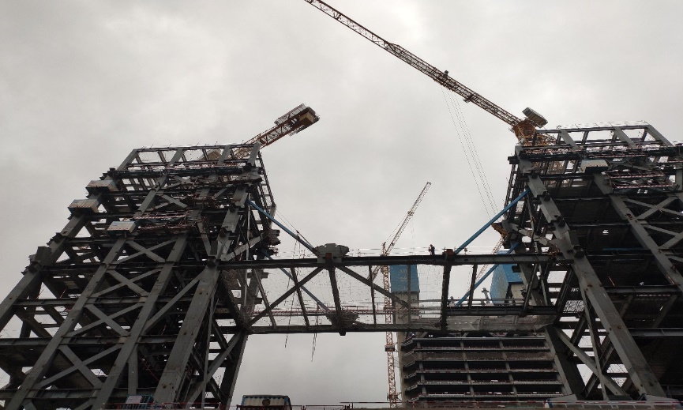
Figure 5.Temporary bars installation
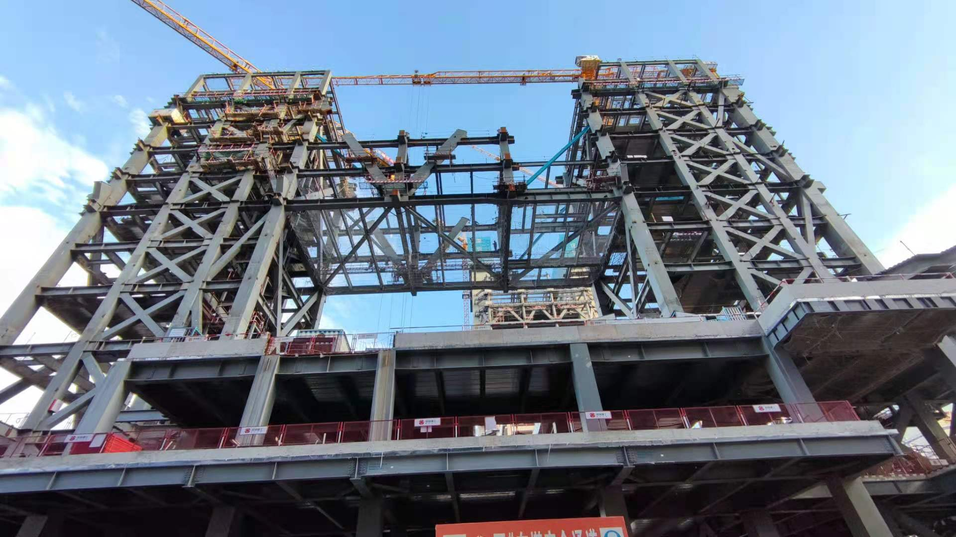
Figure 6. Components installation
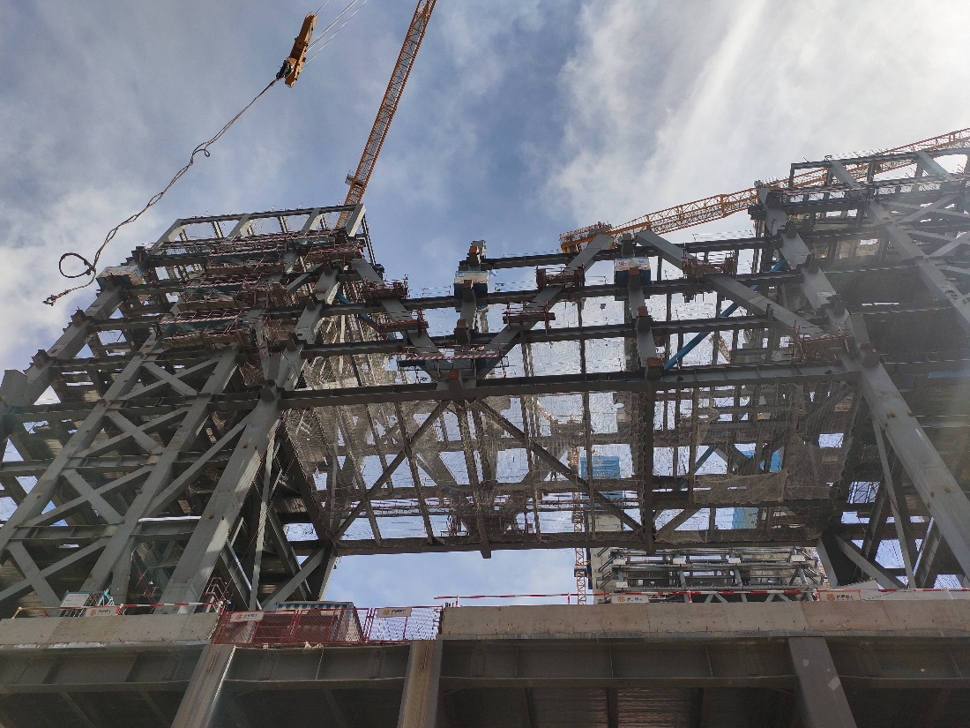
Figure 7. Main body completed

Construction simulation
During the construction of the main structure, the bars bear the main vertical load in the early stage and transfer the vertical load to the core tubes at both ends. The load mode is its own gravity. The stress and deformation results can be obtained by performing step-by-step construction simulation as shown in Figures 8-13.
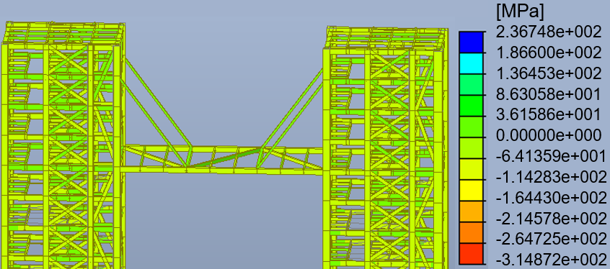
Figure 8. The stress map of temporary bars installation
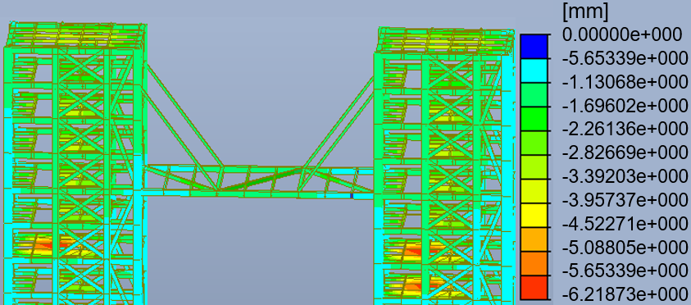
Figure 9. The deformation map of temporary bars installation
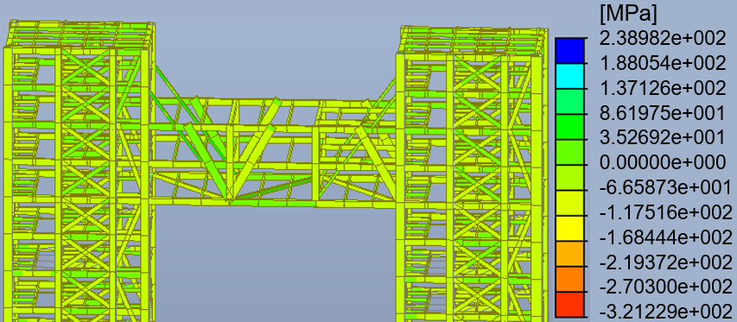
Figure 10. The stress map of components installation
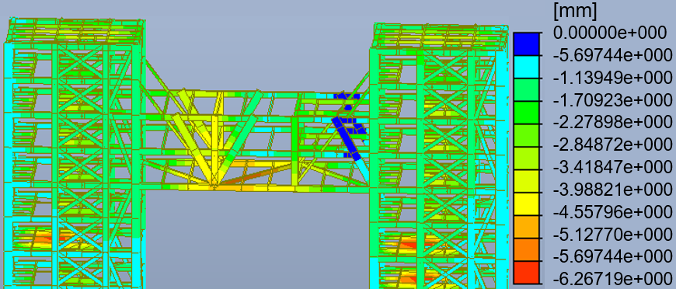
Figure 11. The deformation map of components installation
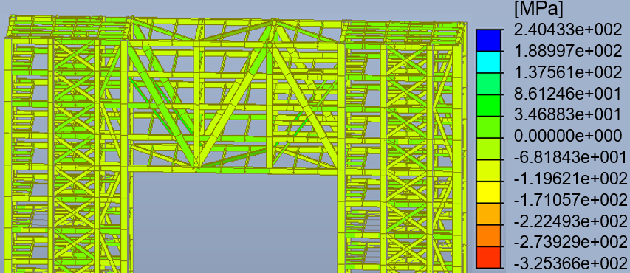
Figure 12. The stress map of main body completed
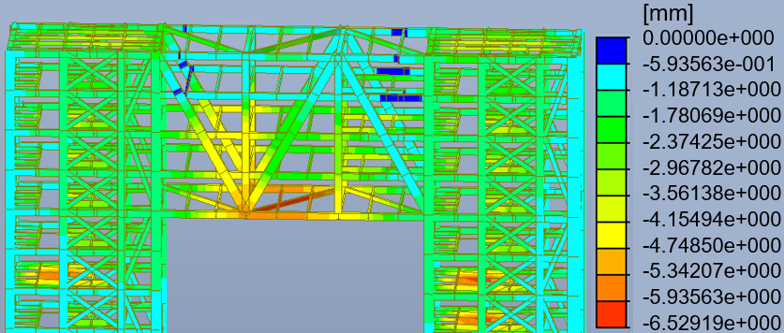
Figure 13. The deformation map of main body completed
In the above analysis, the step-by-step construction simulation results show that the maximum axial tensile force of the bars is 420.64kN, the minimum axial tensile force is 21.91kN, the maximum tensile stress is 31.9MPa, and the minimum tensile stress is 1.66MPa. The maximum vertical displacement of the bottom of the large-span truss is -6.30mm, which does not exceed the 30mm requirement for construction control. The components that are subjected to greater stress during the construction process include the bars, the horizontal beams at both ends of the core tube, and the diagonal braces which replace the bar after the bars are removed.

Construction monitoring plan and result analysiS

Construction monitoring
According to the construction simulation results, a total of 16 monitoring points of the bars and horizontal beams were selected for construction unloading monitoring. The stress sensors of the large-span trusses between the A4 core tube and the A5 core tube were installed on August 9, August 11, and August 16, 2021, respectively. On August 20, the sensor installation were completed and the collection boxes were energized. Then the collection boxes started to collect strain data. A total of 16 stress measurement points and 2 stress data collectors were arranged on the large-span trusses between the A4 core tube and the A5 core tube, each of stress data collectors is responsible for 8 sensors. The No. 3 collector is responsible for the sensors at the 4 beams and 4 bars on the 7th floor. The No. 4 collector is responsible for the sensors at the 6 diagonal braces on the 8th floor and the two beams on the 10th floor. The measuring point numbers are 3-1~3-8, 4-1~4-8. The deformation monitoring point is located in the middle of the bottom span of the large-span trusses between the A4 core tube and the A5 core tube. The layout of the measuring points is shown in Figures 14-16.
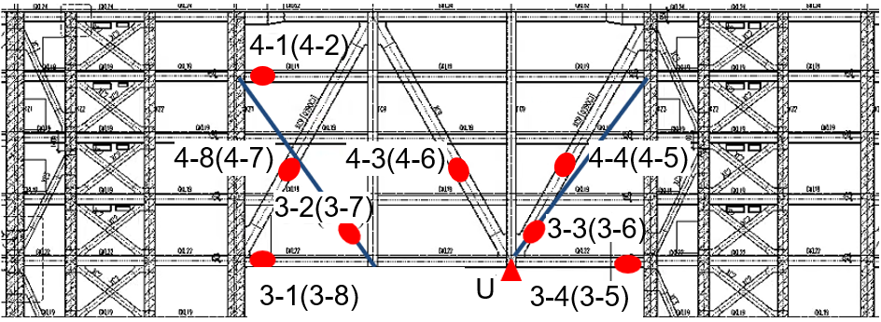
Figure 14. A4-A5 measuring point layout
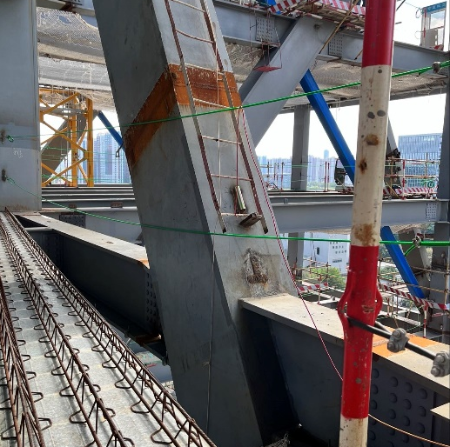
Figure 15.Stress measuring point installation
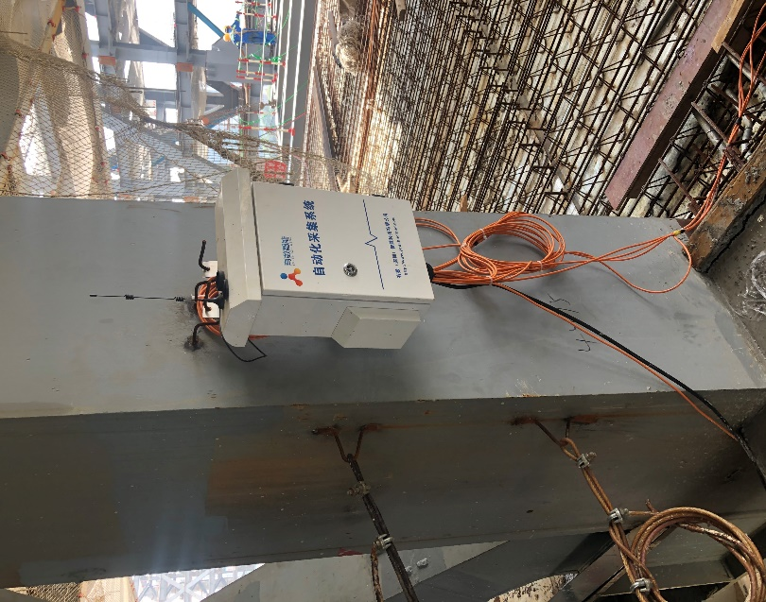
Figure 16.Collector installation
The monitoring system has been running since August 20, and the online real-time monitoring frequency is 1 time per hour, which is uploaded and recorded in real time by the data transmission equipment. The removal time of the bar sis from November 7th to November 8th, two bars are removed each day. At this time, the monitoring frequency is adjusted to 1 time per minute.
The structural deformation before and after unloading is simulated. Considering that there are some steel formwork for construction before unloading as part of the live load, the maximum deformation after unloading is -9.79mm. According to the requirements of construction control, it’s allowed to carry out bars unloading.

Analysis of stress monitoring results
The measurement point with the largest stress change between the A4 core tube and the A5 core tube from 14:00 to 16:00 on November 7, 2021 is the measurement point 3-3, which is the south side bar near the A5 core tube during the unloading process. When the stress of the bar changes from tensile stress to compressive stress, the change is 8.22MPa. Since 10:10~16:25 on November 8, 2021, the measurement point with the largest stress change is the measurement point 3-1, which is close to the south side of the A4 core tube. The tensile stress of the 7th-floor beams increases by 11.67MPa. The monitoring results of some import measurement points is shown in Figures 17-18.
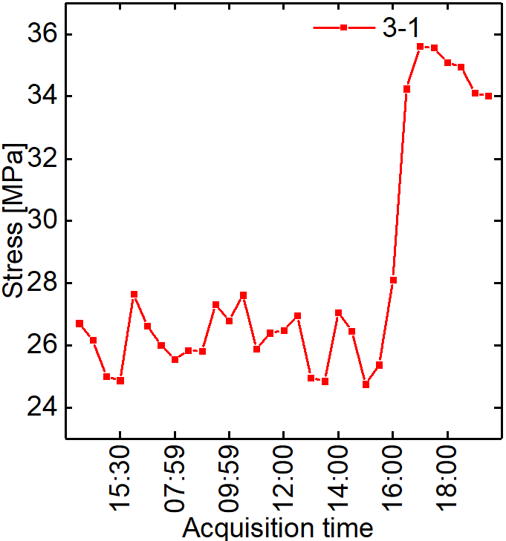
Figure 17. Stress curve of 3-1
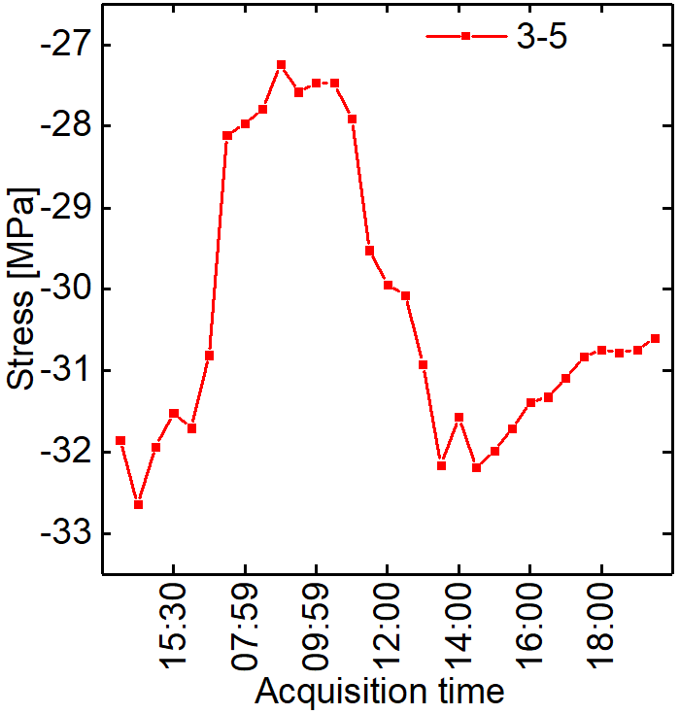
Figure 18. Stress curve of 3-5

Analysis of deformation monitoring results
The prism for deformation measurement was installed on August 16, 2021. On the afternoon of November 7, 2021, the connecting bars of A4 and A5 began to be unloaded, the two bars on the east side were removed on the 7th, and the two bars on the west side were removed on the 8th. The deformation observation position was on the fifth floor platform of A1 core tube. According to the on-site construction safety requirements, the displacement was measured five times at 14:20, 14:45, 15:11, 17:45, 18:00 on November 7, 2021, at 9:20 am on November 8, 2021, 9:00 am 43, 10:12, 10:29, 10:40, 10:52, 11:09, 11:12, 11:15, a total of nine measurements were reported and recorded on site. On November 7, 2021, before and after the unloading of the two bars on the east side of the long-span section of A4-A5, the vertical displacement of the monitoring point changed by 2mm. Before and after the unloading of the two bars on the west side of the long-span section of A4-A5, the vertical displacement of the monitoring point changed by 0mm. Before and after the removal of the four bars, the total deformation of the monitoring point is 2mm, as shown in Figure 19.
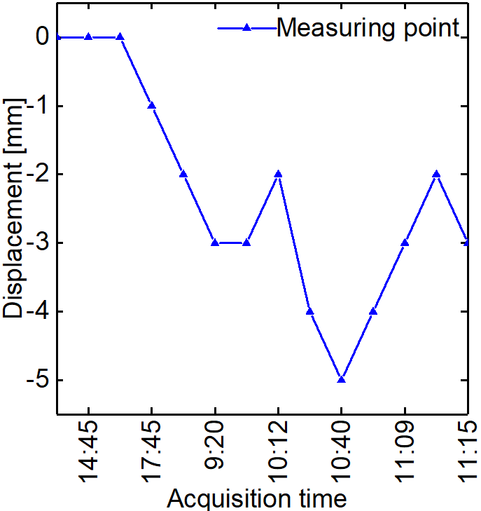
Figure 19.Deformation graph of measuring point
According to the previous simulation results, the structural configuration change before and after unloading of the boom is 2mm, and the measured result is 2mm. The actual monitoring results are consistent with the simulation results and meet the deformation limit of 30mm for construction control, displacement comparison is shown in Figure 20.
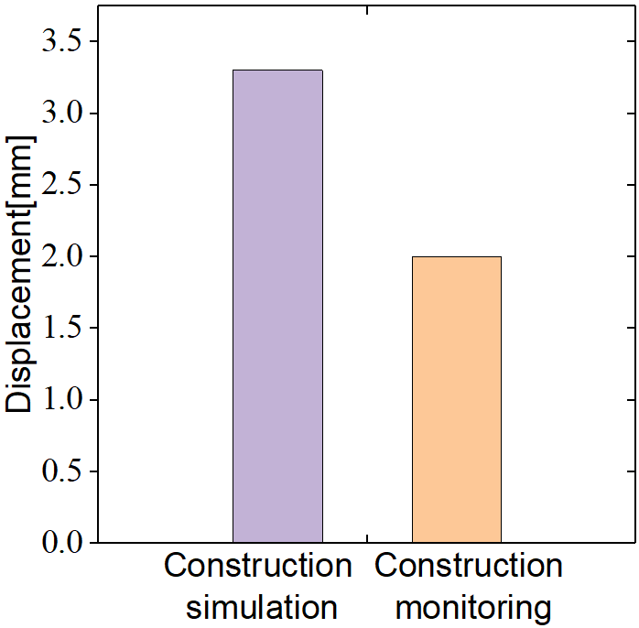
Figure 20. Displacement comparison

CONCLUSIONS
Based on the calculation of deformation and internal force accumulation during the construction phase of Shenzhen Nanshan Science and Technology Innovation Center, the determination of monitoring points, the construction simulation and analysis, the following conclusions and thinking are drawn.
(1) The accumulation of stress and deformation during the construction phase is caused by the failure to correct the deviation of the stress and deformation before the construction step. Real-time monitoring and feedback of the accumulation of stress and deformation should be carried out during the construction unloading phase.
(2) The construction support participates in the structural stress in the early stage of construction. With the construction process and the formation of the overall rigidity of the structure, the load borne by the supports gradually changes. The formulation of the unloading plan needs to consider the internal force distribution after the construction is formed.

Acknowledgements
This work was supported by the National Natural Science Foundation of China [grant numbers 52122804, 51978214, 51878226], the National Major Scientific Research Instrument Development Program of China [grant number 51827811], and the Fundamental Research Funds for the Central Universities [grant number HIT.BRET.202101].

References

- H.C. Li and C.W. Chang, X.R. Yang, Design of an Extra-Long Railway Overpass Bridges Construction Supporting Frame with Combat Readiness Equipments, Advanced Materials Research,2013,2331(671-674).
- J.X. Shi and Z.H. Ran, Construction simulation analysis of 120m continuous rigid frame bridge based on Midas Civil, IOP Conference Series: Earth and Environmental Science,2018,128(1).
- Z.H. Chen and Z.W. Zhao, H. Zhu, X.D. Wang, X.Y. Yan, The step-by-step model technology considering nonlinear effect used for construction simulation analysis, International Journal of Steel Structures,2015,15(2).
- K. Venkatachalam and H. Manoharan, J.S. Kumar, P. Reddy , R. Sugumaran, M. Raja, An effective construction monitoring system using sensor centered technologies[J]. International Journal of System Assurance Engineering and Management,2021.
- J.D. Lin and Y.B. Wei, M.W. Qiao, Construction monitoring on the unloading process of steel roof for Guilin Liangjiang International Airport Terminal T2, MATEC Web of Conferences,2020,319.

