An Integrated Approach for Pavement Networks Maintenance and Rehabilitation Planning
Ahmed_Mohammed¹, Ashutosh_Bagchi², Fuzhan_Nasiri³, Tarek_Zayed⁴
¹Ph.D Candidate, Building Civil and Environmental Engineering Department, Gina Cody School of Engineering and Computer Science, Concordia University, Montreal, Quebec, Canada, H3G 1M8
^{2,3}Professor, Building Civil and Environmental Engineering Department, Gina Cody School of Engineering and Computer Science, Concordia University, Montreal, Quebec, Canada, H3G 1M8
⁴Professor, Department of Building and Real Estate, The Hong Kong Polytechnic University, Hong Kong, China.

Email : ahmed.abdalmoujoud@yahoo.com, ashutosh.bagchi@concordia.ca

ABSTRACT: The growing decline in roads condition has recently grasped the attention of numerous researchers and practitioners regarding road resiliency during its life-cycle. Roads in Canada are classified as in good condition, while in the US, roads are classified as grade D, which refers to poor condition [1][2]. Nevertheless, the situation will deteriorate significantly with the current inadequate investment levels. Hence, this paper demonstrates an integrated approach to planning pavement networks maintenance and rehabilitation through a developed resilience-based asset management model. The resilience-based asset management model is carried out through the development of five components; 1) a central database of asset inventory that includes numerous data that would serve as input for the proposed model, 2) a pavement condition and level of service (LOS) assessment models that encompass the different effect of climatic conditions on the pavement surface, and structural conditions, and LOS, 3) regression modeling of the effect of Freeze-Thaw on pavement and application of flooding effect on both pavement surface and structural conditions, 4) financial and temporal models recovery/intervention actions are formulated through computational models that account for the intervention costs and time and link them to the later used optimization model, and 5) an optimization model to formulate the mathematical problem for the proposed resilience assessment approach and integrate the formerly-mentioned components. This model was applied to the suburb of Pierrefonds-Roxboro pavement network in Montreal. The proposed model serves as an initial step toward providing more resilient municipal infrastructures. The model emphasizes that recovery plans should follow proactive measures to adapt to sudden or unforeseen events.
KEYWORDS: Asset Management; Optimization; Pavement; Resilience.

INTRODUCTION
An infrastructure is exposed to various multi-level disruption events, from aging's effects to disasters, that impede its function and subsequently cause disruption in the interdependent infrastructure networks. Accordingly, maintaining the existing infrastructure networks is essential to meet the required Level of Service (LOS) and keep them operational in a satisfactory state [3]. Moreover, sustaining these assets is necessary for increasing their resistance to both extreme and regular events (i.e., aging effects) and their capability to recover their performance within the desired time frame and meet the required LOS. Unfortunately, infrastructure networks are aging, and insufficient investment is being made to salvage what is lost due to loading and severe environmental conditions.
There is a need to integrate resilience into the asset management concept in that context. This need arises from the growing burden on municipalities to maintain their assets in a satisfactory condition. Integrating the two concepts shall efficiently reduce maintenance costs and intervention plans to achieve the best budget allocation for infrastructure investments. Scholars also drew attention to the growing need to direct investments strategically to enhance a system's resilience in the face of the anticipated disruption. Such investment should involve a prioritization approach to satisfy limited budget and time constraints and achieve the overall effective resilience enhancement for the road network. Hence, it is essential to investigate the connection between resilience and other asset management concepts (i.e., Condition, reliability, and vulnerability). Resilience assessment models were limited in considering the effect of previous non-extreme disruption events on resilience. Previous models also, regarding pavement network, didn't introduce the impact of aging, deterioration, and extreme and non-extreme disruption events together to assess pavement resilience. Though there are multiple optimization models for selecting near-optimal intervention plans for pavement networks, limited research has been undertaken to develop optimization models that aim to maximize pavement resiliency within the existing budgetary constraints.

METHODOLOGY

Data Collection
Data was collected through the City of Montréal open-source database [4]. Data includes condition assessment results for designated road segments in the Montreal roads network. Both IRI and PCI values were assessed in three different years, 2010, 2015, and 2018. Pierrefonds Boulevard segments were the focus. Thirty-Nine corridors were established.

Pavement Condition and LOS modeling
The LOS was modeled based on the available IRI data, represents the existing deterioration for pavement corridors in the case study, and incorporates maintenance and rehabilitation actions' effect on IRI. The extracted formula is as follows.
${IRI}_{i}=0.011i^{2}-0.0434i+1.98$ (1)
${IRI}_{i}$ is the anticipated IRI at year i; i is the year counter (%).
Pavement Condition Index (PCI) was introduced in several studies to measure pavement condition representing pavement distresses. Accordingly, after a thorough review of the different models and based on the data available from the pavement network case study, Equation 2 was considered the best fit for this study to model PCI deterioration [5].
${PCI}_{i}=0.033i^{2}-2.688i+{PCI}_{in}$ (2)
${PCI}_{i}$ is the anticipated PCI at year i; i is the year counter (%).
${PCI}_{in}$ is the initial PCI (%).

Disruptive Events Modelling
Montreal lies in zero-to-20-year flood zones, which means there is a +5% likelihood of a yearly flooding event. The flooding effect on IRI is calculated using Equation 3 [6]. Based on the available flooding data about the 2017 flooding event that destructively hit several parts of Quebec and Ontario, several assumptions were made to simulate the flooding event in this case study.
$\%∆IRI=10.70-1.66NIRI+7.30NDepth-2.10NDuration+14.30Depth*IRI$ (3)
$\%∆IRI$ is the percentage change in IRI
$NIRI$ is the normalized IRI value before flooding
$NDepth$ is the normalized flooding depth
$NDuration$ is the normalized duration of the flood
Based on the flooding map presented in Figure 1, corridors from 19 to 24 and 27 to 29 shall undergo flooding adverse effects on their surface and structural condition. Yet, the previously mentioned sections are only affected by the 100-year flooding event and are not affected by the regular zero-to-20-year flood. Consequently, it is safe to assume that the flood will occur in 2017 to match the case study real scenario and reduce optimization model complexity. On the other hand, the deterioration in the structural condition for the fully submerged pavement section is assumed to be in the form of a reduction value of 50% from its structural condition before the flooding event.
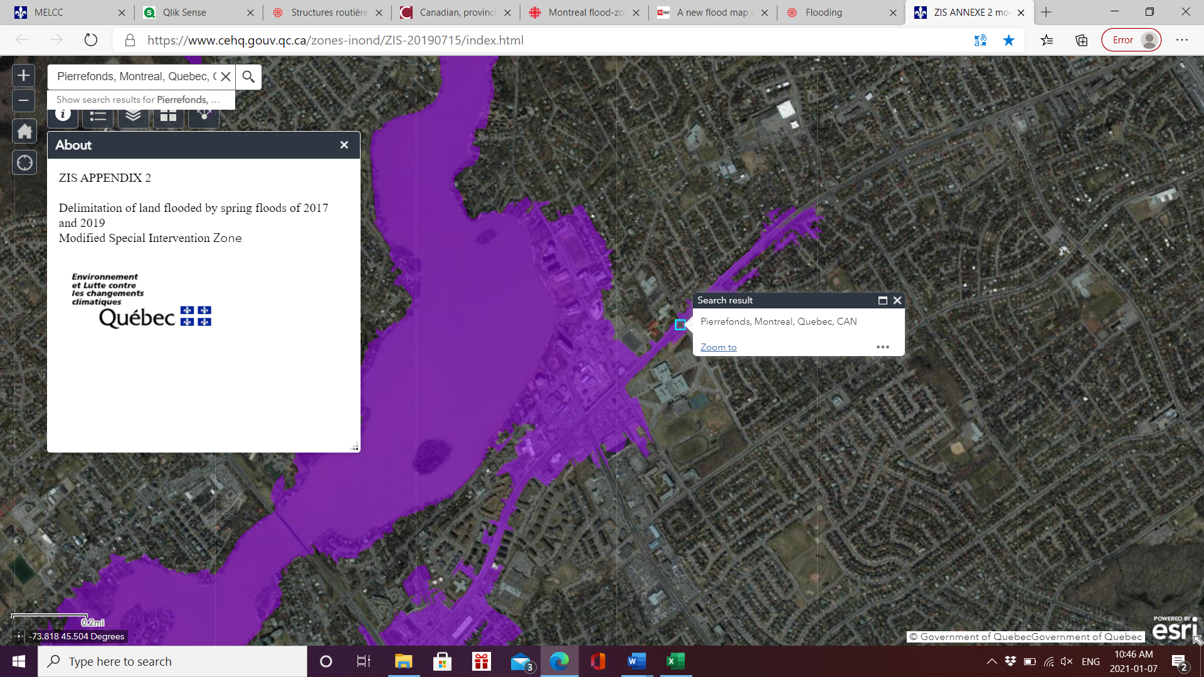
Figure 1. Pierrefonds Boulevard segments in the flooding zone [7].
The leading cause of road network deterioration in Canada is the climatic nature associated with severe weather conditions [8][9]. After a thorough literature investigation, it was found that any degradation in the mechanical properties of the pavement layers resulting from the Freeze-Thaw effect will directly cause additional distresses and accordingly drop the pavement condition [8][10]. Thus, it was assumed that the degradation in the resilience modulus due to the Freeze-Thaw displayed in Equation 4 shall similarly occur to the pavement surface and structural conditions.
${RM}_{x}={RM}_{o}+151.92 e^{-0.21X}-151.92$ (4)
${RM}_{X}$ is pavement resilience modulus after X Freeze-Thaw cycles
${RM}_{o}$ is the initial pavement resilience modulus
X is the annual number of Freeze-Thaw cycles

Intervention Strategies Modelling
Figure 2 summarizes the proposed M&R actions and their applicability ranges.
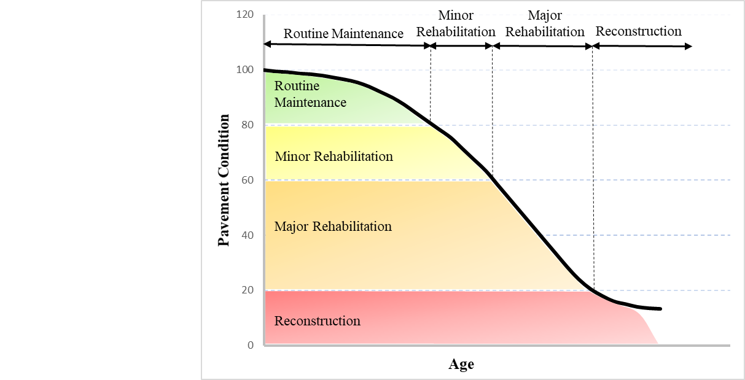
Figure 2. Intervention actions applicability range versus each intervention category
The mathematical formulation of the impact of the maintenance actions (decision variables) is displayed through Equations 5 to 7.
${PCI}_{ik}=\left[\begin{matrix}Do Nothing & 0.033i^{2}-2.688i+{PCI}_{in} \\ Minor Rehab. & \left(1.125\right){PCI}_{x-1} \\ Major Rehab. & (0.90){PCI}_{in} \\ Reconstrcution & {PCI}_{in}\end{matrix}\right]$ (5)
${NCI}_{i}= \sum_{i=1}^{n}{\left[W_{k}*{PCI}_{ik}\right]}$ (6)
$NCI$ =$\overline{{NCI}_{i}}$ (7)
${PCI}_{ik}$ is the pavement condition index at year i for corridor k,
${PCI}_{in}$ is the initial pavement condition,
${NCI}_{i}$ is pavement network average condition at year i,
$NCI$ is pavement network average condition.

Core Optimization Model Development
EvolverTM Version 8.1 was utilized with an advanced ExcelTM spreadsheet modeling to develop the optimization model. Decision variables were functioning on two levels. The first level was formulated using binary coding rules, where "0" represents the "Do Nothing" option and "1" represents the existence of an intervention/recovery action. A second level was formulated to select the appropriate intervention action based on the condition and LOS application ranges. Nine constraints are set to ensure that the chosen intervention scenarios are valid. Similar to the first level of decision variables, the constraints are modeled through binary coding rules, where "0" represents meeting the constraint, and "1" represents failing to meet the constraint. The constraints are summarized as follows; (1) annual recovery cost should not exceed the available annual budget, (2) annual recovery time should not exceed the total number of annual available resources, represented by working hours, (3) PCI of any section at any point of time throughout the planning horizon should meet the minimal condition threshold 20%, (4) the average network PCI at any year throughout the planning horizon should meet the minimal condition threshold 60%, (5) IRI of any section at any point of time throughout the planning horizon should meet the LOS threshold 5.2mm/m, (6) the average network at any year IRI throughout the planning horizon should meet the LOS threshold 2.7mm/m, and (7) number of annual interventions should not exceed 20% of the total number of sections in the network to avoid extreme service disruption (8) number of successive routine maintenance activities (Do Nothing) per corridor should not exceed five throughout the planning horizon (9) number of reconstruction activities should not exceed two per corridor throughout the planning horizon.. For the City of Montreal decision-makers management level, the prime target is to reduce costs and maintain an acceptable LOS for end users. Thus, it is crucial to utilize the proposed optimization model where the objective function targets minimizing the network LCC as follows:
Minimize overall average network LCC subject to the constraints mentioned above.
$$\sum_{i=1}^{T}{\left[\sum_{k=1}^{s}{\left[{RC}_{ik}\right]}*{\left(1+in\right)}^{I}\right]}$$
${RC}_{ik}=\left[X_{ik}* {RUC}_{x}* L_{k}\right]$ (8)
${RC}_{ik}$ is the rehabilitation/Recover cost of corridor k at year i,
$X_{ik}$ is a binary decision variable with "0" representing the "Do nothing" option and "1" representing the "Rehabilitation/Recovery" action,
${RUC}_{x}$ is the recovery unit cost of decision variable X,
$L_{k}$ is corridor length,
$I$ is the cash flow time.

Results and discussion
To demonstrate model analysis and results, corridors 18 and 20 conditions are represented in Figures 3 and 4. The major difference between both corridors is that; Corridor 20 lies in the flooding zone and is affected by the 2017 flood in that area. A noticeable decrease in condition and LOS occurred that year, followed by delayed intervention. Though this optimization scenario offers a considerable reduction in M&R interventions number and costs, the end-users will encounter reduced conditions and LOS by the end of the planning horizon. This may hinder the network users on that corridor.

Figure 3. Optimized condition for corridor 18

Figure 4. Optimized condition for corridor 20
The resulting optimized M&R plan timetable of the proposed model is demonstrated in Figure 5. Major intervention actions took place early in the network life cycle to offset the poor conditions and LOS existing in the pavement network at the start of the analysis. In addition, the model condition and LOS constraints also pushed the model in that direction to keep the overall pavement condition and LOS within acceptable limits later throughout the planning horizon, thus imposing early major intervention actions to maintain network resiliency based on resilience definition with respect to asset management.
It is worth mentioning that the NPV costs/m to maintain the pavement corridors in this case study (~$2.28/m) is significantly less than the NPV cost to maintain roads in the City of Montreal, which is $17.8/m. These results do not contradict each other. Through looking at the City of Montreal dataset, the pavement condition deterioration throughout the eight years of data age was severe, indicating poor intervention actions planning and an insignificant M&R investment in the pavement network under study.

Figure 5. Optimized intervention plan layout
The results also demonstrated a maintained pavement condition and LOS within the acceptable thresholds. In addition, the 2017 floods randomly hit several network corridors, yet the model mitigated any sudden and significant deterioration for both: condition and LOS. As a result, the overall weighted average surface condition, structural condition, and LOS fell within the acceptable limits reaching 75.33%, 487.24 KPa (78%), and 2.60 mm/m.

Conclusions
This updated model application on the selected case study demonstrates proof of concept and establishes model testing based on the original model proposed by Mohammed et al. 2021 [11]. Resilience indicators models were updated to include the two types of pavement condition, surface and structural. In addition, climatic data and flooding were included while building the primary model. The LCC-based optimization provides a more realistic conclusion that coincides with municipalities' priorities when planning pavement network M&R.
It was concluded that integrating resiliency and asset management concepts when planning an infrastructure M&R would significantly affect budget allocation in the infrastructure network and mitigate the sudden loss of LOS through its life-cycle.

References
- FCM (Federation of Canadian Municipalities). (2016). "The Canadian Infrastructure Report Card." 〈http://www.canada infrastructure.ca/en/〉 (May 12, 2016).
- ASCE (American Society of Civil Engineers). (2017). "ASCE Infrastructure Report Card." American Society of Civil Engineering. 〈https://www.infrastructurereportcard.org/〉 (May 24, 2017).
- Turnquist, M., and Vugrin, E. (2013). "Design for resilience in infrastructure distribution networks." Environment Systems & Decisions, 33(1), 104-120.
- Road Network Pavement Condition Indicators - Dataset - Data Québec (donneesquebec.ca) (Access on May 2021)
- Hamdi, A. S., Alyami, Z., Zhou, T., and Tighe, S. (2012). Improving Ontario pavement management through long term monitoring. In Proceedings of the 91st Transportation Research Board Annual Meeting (pp. 1-16). University of the Sunshine Coast, Queensland.
- Shamsabadi, S. S., Tari, Y. S. H., Birken, R., & Wang, M. (2014, July). Deterioration forecasting in flexible pavements due to floods and snow storms. In EWSHM-7th European Workshop on Structural Health Monitoring.
- https://www.cehq.gouv.qc.ca/zones-inond/ZIS-20190719/index.html (Access on June 2021)
- Doré, G., Drouin, P., Pierre, P., and Desrochers, P. (2005). Estimation of the relationships of road deterioration to traffic and weather in Canada. Transport Canada, Final Report.
- Jacobi, R. (2012). Le rapport des villes à leur fleuve: le cas de Québec et du Saint-Laurent (Doctoral dissertation, Université de Neuchâtel).
- Ma, B., Si, W., Zhu, D., and Wang, H. (2014). "Applying method of moments to model the reliability of deteriorating performance to asphalt pavement under freeze-thaw cycles in cold regions." J.Mater.Civ.Eng., 27(1), 04014103.
- Mohammed, A., Abu-Samra, S., Zayed, T., Bagchi, A., and Nasiri, F. (2021). Resilience-based optimization model for maintenance and rehabilitation of pavement networks in a freeze–thaw environment. Canadian Journal of Civil Engineering, 48(4), 399-410.

