Application of structural health monitoring techniques for tracing fire-induced spalling in concrete structures
Srishti Banerji¹, Augusto Gil², Venkatesh Kodur²
¹Department of Civil and Environmental Engineering, Utah State University, Logan, Utah, United States
²Department of Civil and Environmental Engineering, Michigan State University, East Lansing, Michigan, United States
Email : srishti.banerji@usu.edu, masierog@msu.edu, kodur@egr.msu.edu

ABSTRACT: Fire-induced spalling is a major concern in newer concretes with higher strengths and this is detrimental to the performance of concrete structures. One of the primary reasons for the occurrence of fire-induced spalling in concrete is the build-up of high pore pressure and associated stresses. The development of pore pressure in heated concrete is dependent on several factors including heating rate, concrete type, specimen conditions, as well as sensitivity of instrumentation used for measurements. Currently, there is no standardized guidance for measuring pore pressure variations in concrete at elevated temperatures. In addition, there is lack of instrumentation to measure pore pressure at elevated temperatures. To overcome these gaps, the presented study undertook the design and fabrication of sensors for measuring the variation of pore pressure at elevated temperatures. Using the developed sensors, an experimental study was undertaken to measure the pore pressure in heated concrete specimens. Results from the tests are utilized to show the comparative pore pressure generated in normal strength concrete (NSC) and ultra-high performance concrete (UHPC) specimens.
KEY WORDS: Fire-induced spalling; Pore pressure; Concrete structures; Fire resistance; Ultra-high performance concrete.

INTRODUCTION
Civil infrastructure can be subjected to numerous hazards and severe loading conditions during its lifetime. Through structural health monitoring (SHM) techniques, the performance and condition of the structures can be monitored. SHM involves deploying sensors at critical locations in a structure, collecting data from these sensors, and assessing the structural condition through analysis of the collected information.
Fire is one of the most severe hazards that can damage structures during their service life. Reinforced concrete (RC) structures generally exhibit excellent fire resistance and this can be attributed to the low thermal conductivity and high thermal capacity of concrete, as well as to the slower degradation of the mechanical properties of concrete with temperature [1]. Over the years, research and development in the field of concrete technology have led to the development of advanced concrete types, such as high-strength concrete (HSC) and ultra-high performance concrete (UHPC), with superior strength and durability properties [2]. However, the performance of these advanced concretes under fire conditions as compared to conventional normal strength concrete (NSC), is lower due to faster degradation of its mechanical properties and higher susceptibility to fire-induced spalling [3].
Fire-induced spalling is the break-up of concrete layers from a concrete member under severe fire exposure. Studies in the literature have reported that fire-induced spalling is stochastic in nature due to its interdependency on several factors such as concrete permeability, concrete strength, structural configuration, specimen shape, heating rate, test conditions, etc. [4]. One of the widely accepted mechanisms of fire-induced spalling is the build-up of pore pressure due to the moisture present in concrete getting converted to steam with increase in temperatures, as in the case of fire [5, 6]. When vapor (steam) cannot escape from concrete due to low permeability of concrete, pore pressure builds up and tensile stresses are generated in concrete. When these tensile stresses exceed the degrading tensile strength, chucks of concrete spall-off from the specimen. Previous studies have indicated that the addition of steel or polypropylene (PP) fibers to the concrete mix can be an effective strategy to mitigate fire-induced spalling [7]. The increased tensile strength facilitated by the presence of steel fibers, or enhanced permeability resulting from the melting of PP fibers at around 160°C during a fire event is effective in minimizing fire-induced spalling in RC members [8]. As compared to traditional NSC, HSC and UHPC have lower permeability, which hinders the movement of moisture and escape of pore pressure, making them more prone to spalling. Figure 1 illustrates the spalling patterns in NSC and UHPC beams after fire tests in a furnace [9]. It can be seen that while the NSC beam experienced minimal spalling, the UHPC beam suffered much higher levels of spalling.

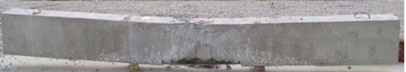
(a) NSC beam after fire exposure
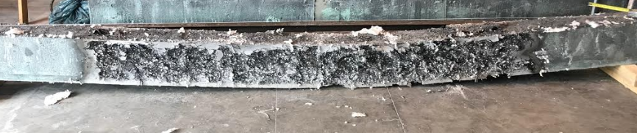
(b) UHPC beam after fire exposure
Figure 1. RC beams after exposure to fire in a furnace
Spalling reduces the sectional area of structural members, thereby increasing heat penetration to inner concrete layers and steel reinforcement. Higher heat ingress increases the rate of reduction in strength and stiffness of RC members, resulting in early failure under fire exposure. This scenario can be life-threatening to firefighters and occupants inside a building. Therefore, it is important to monitor spalling during a fire situation for preventing such accidents and fatalities. Build-up of pore pressure is a driving factor for spalling, however, it is very complex to measure pore pressure during fire tests due to a lack of measuring techniques and temperature resistant sensors that can withstand high temperatures and precisely measure pore pressure [10]. Till date, only few studies in the published literature have measured pore pressure and all of these studies were at a laboratory scale following different measurement techniques [11, 12]. The pore pressure measurements reported in the literature have significant variation due to the differences in test methods. The previous studies mainly used different types of pressure measuring heads, such as sintered metal spheres or bare steel tubes, and different mediums to transfer pore pressure from the head to the pressure transducer, such as air, silicone oil or hydraulic jack oil [13]. Therefore, further research is needed to develop methods for monitoring pore pressure and fire-induced spalling during fire events. This paper presents an SHM based approach to monitor pore pressure development in heated concrete and characterize the effect of influencing factors on pore pressure evolution. The outcomes of this study will aid in developing methods for predicting and monitoring fire-induced spalling in RC structures under fire.

EXPERIMENTAL PROGRAM
To measure temperature-induced pore pressure in heated concrete specimens, a unique experimental set-up is designed and this set-up is utilized to demonstrate the pore pressure measurements. The development of test procedure with some initial results are discussed herein.

Test specimens
Three batches of concrete, namely, NSC, UHPC-ST (UHPC reinforced with steel fibers), and UHPC-ST-PP (UHPC reinforced with both steel and polypropylene fibers) were used for fabricating the pore pressure test specimens and the details of mix proportions are presented in Table 1. All the batches comprised carbonate (calcareous) coarse aggregates. In comparison to the NSC mix, a lower amount of coarse aggregates was used in UHPC mixes for optimization of density and strength [2, 9]. To achieve the desired strength and workability properties, high volumes of fine mineral admixtures such as silica fume and chemical admixtures were added to UHPC batch mixes. For both the UHPC mixes, 1.5% by volume fraction of steel fibers were added. The steel fibers were of straight type (without hooks) with 0.2 mm diameter and 13 mm length. In addition, polypropylene fibers (0.11% by volume) having a length of 13 mm and a melting point of 160°C were added to the UHPC-ST-PP batch mix. For undertaking the pore pressure measurements, concrete cubes with 100 mm side and cylinders with 75 mm diameter and 150 mm height were cast. In addition to pore pressure test specimens, additional cylinders were cast for measuring compressive and tensile strength of concrete. The batch mix properties, together with the measured compressive and splitting tensile strength of the concretes at 28 days and 90 days, are listed in Table 1.

Instrumentation
As a part of this study, sensors or probes for pore pressure measurement were designed and fabricated. The pore pressure sensor comprised of sintered-metal heads of 5 mm in length, fitted on capillary steel pipes of 2 mm diameter as shown in Figure 2. Aggregate-shaped heads and narrow steel pipes were utilized, in order to minimize alteration of the concrete matrix. The sintered metal heads were fabricated and provided by Dr. Felicetti, Politecnico di Milano, Italy [11]. The pore pressure sensors were placed in the center of the molds before casting the concrete test specimens as shown in Figure 3. Thermocouples were installed inside the furnace for continuously recording temperatures during the tests.
Table 1. Concrete batch mix proportions
Component | NSC  (kg/m³) | UHPC-ST  (kg/m³) | UHPC-ST+PP  (kg/m³)
Cement | 312 | 510 | 510
Coarse aggregate | 970 | 517 | 517
Fine aggregate | 838 | 1027 | 1027
Water | 140 | 121 | 121
Water reducer | 6.1 | 48 | 48
Silica fume | - | 224 | 224
Steel fibers | - | 127 | 127
Polypropylene fibers | - | - | 1.6
Comp. strength-28th day | 39 | 145 | 160
Comp.strength-90th day | 42 | 167 | 173
Split tensile strength-28th day | 3 | 15 | 14
Split tensile strength-90th day | 3 | 16.5 | 15

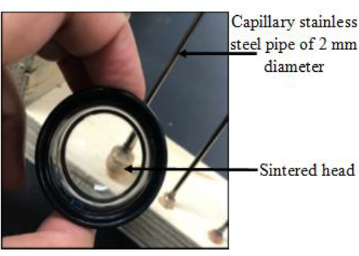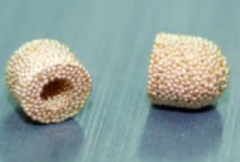
Figure 2. Probe for measuring pore pressure in concrete
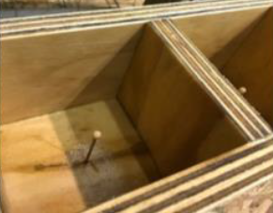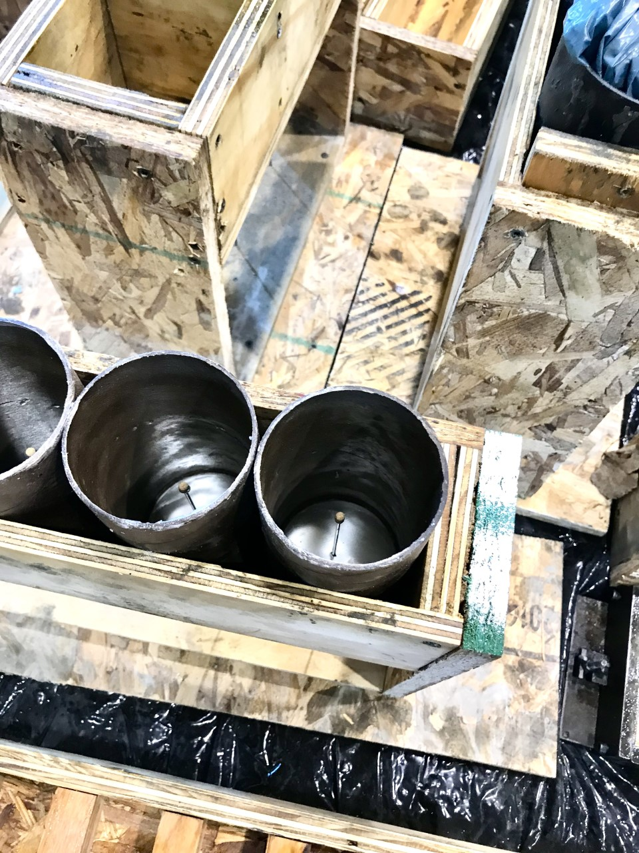
(a) Cubic mold (b) Cylindrical mold
Figure 3. Molds with pore pressure sensor before casting

Test set-up and procedure
For the pore pressure tests, the embedded steel pipes in the casted concrete specimens were filled with heat-resistant silicone oil. Thereafter, the probes were tightly connected to a pressure transducer which was attached to the data acquisition system for measuring pore pressure. The portion of the steel pipe outside the specimen was insulated to prevent exposure to elevated temperatures during the test. The final test set-up is illustrated in Figure 4, comprising the instrumented specimen and thermocouple positioned in the furnace and connected to the data acquisition system.
Using the above set-up, a set of tests is carried out to illustrate its applicability. The test matrix for the results presented in this paper is tabulated in Table 2. Cubic specimens were heated from the top and bottom whereas the sides were insulated with ceramic fiber insulation which generated a mono-directional heating flux, as shown in Figure 5. Cylindrical specimens were heated from all sides and were not provided with any insulation. The specimens were heated at three different heating rates of 1℃/min, 5℃/min, and 10℃/min until the furnace temperature reached 600℃. After reaching this temperature, the furnace temperature was kept constant until the end of the test. The test was considered to be complete when the measured pore pressure decreased back to a low level (below 0.05MPa).
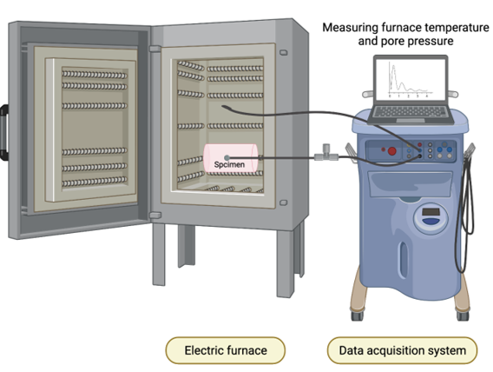
Figure 4. Test set-up for monitoring pore pressure during heating and cooling processes
Table 2. Test matrix for pore pressure tests
Concrete | Geometry | Heating rate (°C/min) | Insulation | Samples
NSC | Cubic | 10.0 | Yes | 3
NSC | Cylindrical | 5.0 | No | 1
NSC | Cylindrical | 10.0 | No | 1
UHPC-ST | Cylindrical | 1.0 | No | 1
UHPC-ST | Cylindrical | 5.0 | No | 1
UHPC-ST | Cylindrical | 10.0 | No | 1
UHPC-ST-PP | Cylindrical | 1.0 | No | 1
UHPC-ST-PP | Cylindrical | 5.0 | No | 1
UHPC-ST-PP | Cylindrical | 10.0 | No | 1
ST-steel fibers; PP-polypropylene fibers
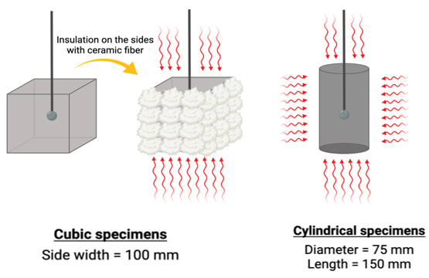
Figure 5. Schematic of cubic and cylindrical test specimens

PRELIMINARY RESULTS
To ensure the accuracy and reliability of the measurements, the first set of pore pressure tests in this study were adapted from tests in the literature [11, 12], wherein insulated cubic NSC specimens were subjected to mono-directional heating at a rate of 10℃/min. This set of tests was repeated three times and the measured pore pressure with fire exposure time is plotted in Figure 6. The pore pressure build-up in these tests followed a similar bell-shaped curve, with peaks of pressure varying from 0.4 to 0.6 MPa, which is within the range of reported experiments in the literature [11, 12]. This repeatability demonstrated that the pore pressure readings were reliable.
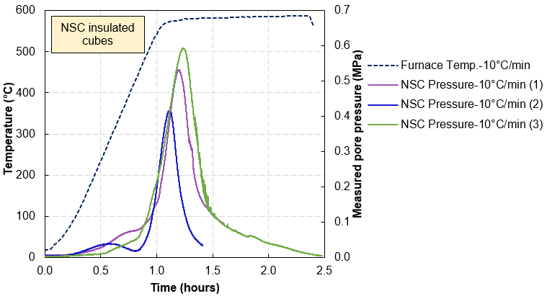
Figure 6. Measured pore pressure in NSC cubes repeat tests
For interpreting further test results, it is critical to understand the bell-shaped pattern of pore pressure development, wherein pore pressure rises with heating time, reaches a peak value, and then decreases. When a concrete member is heated, the moisture in concrete evaporates and a part of this moisture migrates into the cooler interior regions. This migrated water vapor condenses, resulting in the formation of a saturated layer at a certain distance away from the heated dry concrete surface as illustrated in Figure 7. In concretes with a lower permeability, this saturated layer forms closer to the heated surface since water vapor cannot migrate inwards easily. The saturated layer restricts further moisture movement and raises pore pressure in concrete. With an increase in heating time, the temperatures in inner regions increase further leading to the drying of concrete and a drop in pore pressure after reaching the peak. In addition to concrete drying, a decline in pore pressure can be associated with a release in pore pressure due to an increase in permeability from cracking and spalling of concrete. At the locations where pore pressure is accumulated, tensile stresses are generated in the member. When the stress from temperature-induced pore pressure exceeds the tensile strength of concrete (which is decreasing with temperature), spalling occurs in the concrete member as shown in Figure 7.
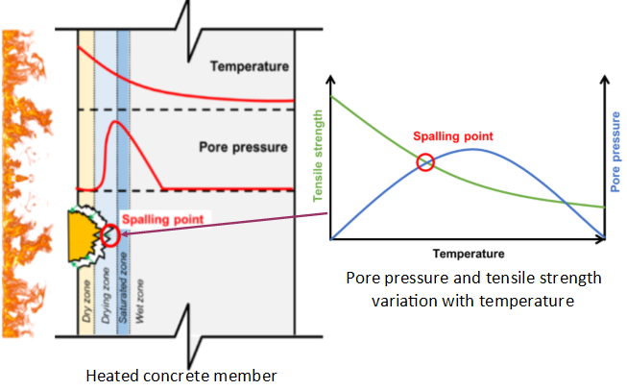
Figure 7. Schematic of pore pressure build-up and fire-induced spalling in concrete
The second set of tests was designed to investigate the effect of varying heating rates in uninsulated NSC cylinders heated at 10℃/min and 5℃/min, as plotted in Figure 8. The processes of moisture evaporation, migration, condensation, pore pressure build-up, and dehydration took place at a faster pace in the NSC cylinder heated at a higher heating rate of 10℃/min as compared to the other NSC cylinder heated at a lower rate of 5℃/min. The pore pressure reached the peak value after 1-hr (60 min) in the NSC cylinder heated at 10℃/min, whereas the peak pore pressure occurred after around 1.5-hr (90 min) in the NSC cylinder heated at 5℃/min. Similar peak pressure values of around 0.8 MPa were recorded under both the heating rates.
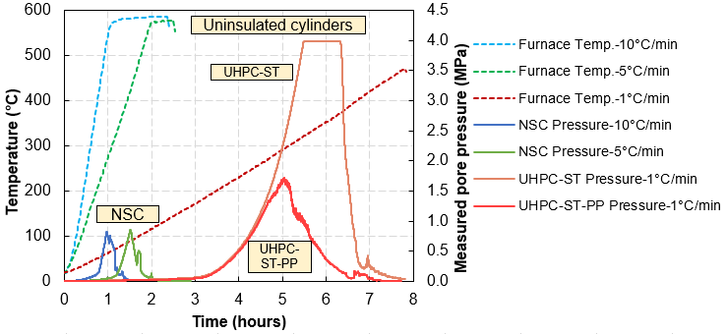
Figure 8. Measured pore pressure in uninsulated NSC and UHPC cylinders
In the third set of tests, the effect of varying concrete types (strength and permeability) on pore pressure was evaluated by testing uninsulated cylinders made using NSC, UHPC-ST, and UHPC-ST-PP. Under similar heating rates, UHPC cylinders experienced explosive spalling and the pore pressure measurements could not be recorded. To mitigate spalling and be able to record pore pressure, the UHPC cylinders were heated at a low heating rate of 1℃/min. As shown in Figure 8, the peak pore pressure in NSC, UHPC-ST, and UHPC-ST-PP specimens were measured as 0.8 MPa, 4 MPa, and 1.6 MPa respectively. A flat reading of 4 MPa peak pressure was recorded for UHPC-ST due to limitations associated with the range of pressure transducer and signal conditioner. The peaks in pore pressure curves of NSC cylinders occur earlier than that in UHPC cylinders. This is because NSC cylinders were heated at a higher rate than UHPC cylinders, resulting in faster moisture migration. As compared to NSC specimens, higher pore pressure was measured in UHPC specimens due to the denser microstructure and lower permeability of UHPC, which inhibited the release of vapor pressure. The peak pore pressure in UHPC-ST-PP cylinder (1.6 MPa) was much lower than that in UHPC-ST cylinder (4 MPa), which can be attributed to the enhanced permeability and partial dissipation of pore pressure in UHPC-ST-PP through the burning of PP fibers.

APPLICABILITY OF RESULTS
Currently, fire-induced spalling is monitored after a fire event mainly to gauge the residual structural capacity through visual records and geometrical measurements. Although efforts have been put to measure temperatures, vibrations, and strains in some structures during a fire, pore pressure and fire-induced spalling are currently not monitored [14]. Pore pressure sensors installed in structural members can be activated during a fire event and the recorded pore pressure can be analyzed to compute fire-induced spalling using a connected computer system. The calculated extent of spalling can be used to evaluate the real-time capacity of a structural member and help predict a structurally unsafe situation during fire. Techniques for pore pressure measurements is under development at laboratory scale. Further studies are needed to develop techniques for monitoring pore pressure in field applications. In addition, further research for quantification of parameters that influence pore pressure measurements is required to develop test methods for tracing fire-induced spalling.

CONCLUSIONS AND ONGOING RESEARCH
This paper presents the preliminary results of an ongoing experimental study to measure pore pressure in concrete, which is a critical parameter for gauging fire-induced spalling in concrete structures. The pore pressure test apparatus, specially designed and fabricated at MSU, is capable of measuring the development of pore pressure in concrete specimens during heating, as encountered in a fire situation. Preliminary results captured higher pore pressure in UHPC specimens as compared to NSC specimens. Lower pressure was measured in UHPC specimens with PP fibers as compared to UHPC specimens without PP fibers. As compared to NSC, real time measurement of pore pressure and prediction of spalling in UHPC is challenging due to its high susceptibility to spalling. Additional tests investigating critical parameters are currently underway for developing methods to trace pore pressure build-up and predict spalling in concrete structures.

ACKNOWLEDGMENTS
The authors wish to acknowledge the support of Michigan State University and would also like to thank Dr. Roberto Felicetti, Politecnico di Milano, Italy for providing the sensor probes and for his guidance on the design of the pore pressure sensors.

References
1. Kodur V (2014) Properties of concrete at elevated temperatures. Int Sch Res Not 2014:. https://doi.org/10.1155/2014/468510
2. Banerji S, Kodur V, Solhmirzaei R (2020) Experimental behavior of ultra high performance fiber reinforced concrete beams under fire conditions. Eng Struct 208:110316
3. Banerji S, Kodur V (2021) Effect of Temperature on Mechanical Properties of Ultra-High Performance Concrete. Fire Mater
4. Kodur VKR, Phan L (2007) Critical factors governing the fire performance of high strength concrete systems. Fire Saf J 42:482–488. https://doi.org/10.1016/j.firesaf.2006.10.006
5. Kodur V, Banerji S (2021) Modeling the fire-induced spalling in concrete structures incorporating hydro-thermo-mechanical stresses. Cem Concr Compos 117:103902
6. Bazant ZP (1997) Analysis of Pore Pressure, Thermal Stress and Fracture in Rapidly Heated Concrete. In: Intern. Workshop on Fire Performance of High-Strength Concrete. Appendix B: Workshop Papers. B10, NIST Special Publication 919, Gaithersburg, MD, pp 155–164
7. Khaliq W, Kodur V (2018) Effectiveness of Polypropylene and Steel Fibers in Enhancing Fire Resistance of High-Strength Concrete Columns. J Struct Eng 144:04017224
8. Khaliq W, Kodur VKR (2011) Effect of High Temperature on Tensile Strength of Different Types of High-Strength Concrete. ACI Mater J 108:394–402
9. Kodur V, Banerji S (2020) Comparative fire behavior of reinforced concrete beams made of different concrete strengths. In: 11th International Conference on Structures in Fire (SiF2020). Brisbane, Australia, pp 254–261
10. Kodur VK, Banerji S, Solhmirzaei R (2020) Test methods for characterizing concrete properties at elevated temperature. Fire Mater 44:381–395
11. Felicetti R, Lo Monte F, Pimienta P (2017) A new test method to study the influence of pore pressure on fracture behaviour of concrete during heating. Cem Concr Res 94:13–23
12. Li Y, Yang E-H, Zhou A, Liu T (2021) Pore pressure build-up and explosive spalling in concrete at elevated temperature: A review. Constr Build Mater 284:122818
13. Li Y, Zhang D, Tan KH (2020) On measuring techniques of pore pressure in concrete at elevated temperature. Cem Concr Compos 114:103737. https://doi.org/10.1016/j.cemconcomp.2020.103737
14. Kim M, Hwang I, Seong M, Choi J, Kim M, Lee H-D, Shin K-J, Son H, Sohn H, Choi J, Jeong HE, Kwak MK (2020) Multifunctional Smart Ball Sensor for Wireless Structural Health Monitoring in a Fire Situation. Sensors 20:4328

