Improved Crack Localization in Concrete Structures using Acoustic Emission Data
Mohamed Barbosh¹, Ayan Sadhu², Bing Q. Li³
¹PhD Student, Department of Civil and Environmental Engineering, Western University, London, ON, Canada, N6A 3K7
²Associate Professor, Department of Civil and Environmental Engineering, Western University, London, ON, Canada, N6A 3K7
³Assistant Professor, Department of Civil and Environmental Engineering, Western University, London, ON, Canada, N6A 3K7
Email: mbarbosh@uwo.ca, asadhu@uwo.ca, bing.li@uwo.ca

ABSTRACT: Acoustic Emission (AE) is considered one of the popular non-destructive testing techniques (NDT) that has been widely used to identify the location of damage in different systems. In this paper, improved crack localization method based on a combination of empirical mode decomposition (EMD) and the difference between the time of arrivals (TOA_{s}) model using AE sensors without considering AE parameters. First, EMD is used to eliminate the presence of noise in the recorded AE waveforms and extract the key AE components, followed by determining the difference between the TOA of AE components to localize the crack in concrete elements. Experimental studies are undertaken to validate the performance of the proposed method using concrete beams. Finally, the results of the proposed method are compared with the traditional method that uses raw AE waveforms. The results obtained from the proposed method show high accuracy for identifying the location of a crack in a concrete beam over the traditional method, which makes it a robust cracks localization tool.
KEYWORDS: SHM; NDT; crack localization; AE; EMD; TOA.

Introduction
Many structural elements suffer from internal damage due to unexpected conditions such as overloading, fatigue, and corrosion. Structural health monitoring (SHM) is an essential tool that can assess the service life and ensure the safety of these structural elements to avoid any catastrophic failure (Kralovec and Schagerl 2020). SHM applies different sensing approaches to monitor various systems, identify any abnormal behavior and provide the infrastructure owners opportunities for timely maintenance (Singh and Sadhu 2020). Lately, Acoustic Emission (AE) has been considered one of the proper non-destructive testing techniques (NDTs) that can be applied to detect and localize the crack in structural elements. AE can be defined as a transient elastic wave generated due to rapid material deformation resulting from the initiation and propagation of a micro-crack (Sarfarazi 1992). AE parameters such as counts, duration, energy, signal strength, amplitude, and rise time can be evaluated to predict the abnormal behavior of the monitored element. These parameters are sensitive to environmental conditions and background noise in the measured data, which may lead to misleading information about the existing condition of the monitored element. In this study, an improved crack localization method based on AE sensing is proposed using EMD and the time of arrival (TOA) model.
AE-based crack detection and localization techniques have been used in different concrete elements (Aggelis et al. 2010, Benavent-Climent et al. 2011, Worley et al. 2019, Quy and Kim (2021). Al-Jumaili et al. 2016 proposed an AE-based method using the delta T mapping technique to identify the location of AE sources in composite elements. The results showed the high efficiency and performance of the proposed method over the other techniques as a damage localization tool. He et al. (2018) developed a new technique based on AE data to detect and localize AE sources in plate elements. The results obtained from an experimental test on steel plate showed that the developed technique was able to localize multiple AE sources. In another study, Lin et al. (2020) employed the AE technique to detect and identify the location of AE events in prefabricated utility tunnels during the sealing test. Mirgal and Banerjee (2020) applied an online monitoring technique for localizing damage-induced acoustic emission sources in concrete elements. AE data was collected from concrete slab utilized to detect and localize the AE sources resulting from Pencil lead break calibration tests. The results proved the capability of the applied technique as a damage localization technique.
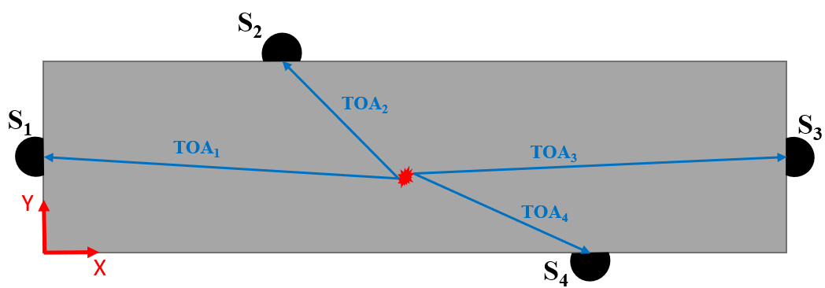
Barbosh et al. (2021) proposed a new damage localization method based on AE data collected from structural elements. The proposed method combined EMD and Shannon Entropy in AE waveforms to detect and identify the approximate location of minor damage. The performance of the proposed method was validated using AE data collected from experimental and full-scale studies. In another study, Cheng et al. (2021) proposed an AE-based technique using artificial neural networks to detect and identify the location of AE sources in an I-shaped steel girder. The numerical and experimental results obtained from the proposed technique showed higher accuracy for AE source localization than the traditional TOA method. Ebrahimkhanlou et al. (2019) proposed a deep learning-based approach to localize and characterize AE sources in metal plates. The results obtained from the experimental test showed the high accuracy of the proposed method to localize the zonal coordinate-based AE source localization. However, most previous studies have used either the raw AE waveforms, traditional AE parameters, or feature extraction method to localize the damage, which can be time-consuming due to the enormous data and may provide inaccurate localization due to the effect of noise in the measured AE data. The process of localization involves inverting for the best-fit source location and origin time that minimizes the difference between the observed and predicted TOAs given a reasonable velocity model. Fig. 1 represents the process of localizing the micro-crack, where each sensor detects the AE waveform at TOA_{i}. In this study, The EMD-based time-frequency method is applied to eliminate the noise and extract the key AE components (IMFs) that belong to the crack. Then, the difference between the time of arrivals (TOAs) of extracted IMFs of instrumented sensors is determined to localize the AE events due to crack initiation and propagation. It is found that the IMF-based TOA method results in improved accuracy of the crack location as compared to raw data.

Figure 1: Schematic of crack event location reflection. Sensor locations are indicated in black, the event location in red, the travel path in green, and the related time of arrivals TOA_{i}.

Proposed AE-based Crack Localization Method
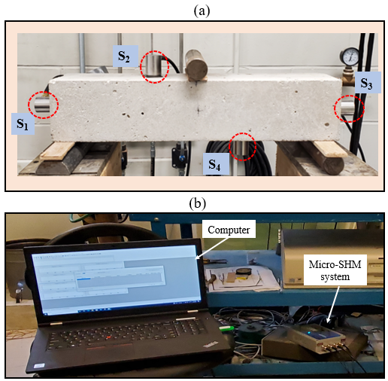
The proposed method combines the EMD method and TOAs model to identify the location of AE events in concrete material due to crack. EMD is a time-frequency technique that can decompose nonlinear and non-stationary signals into a group of mono-component signals known as intrinsic mode functions (IMFs). Each mono-component signal must meet two criteria to be considered as IMF (Huang et al. 2002): (i) the number of extremums and the number of zero-crossings should be the same or differ at most by one in the entire data set, and (ii) the mean of the envelope defined by local maxima and minima is zero at any point. More details, such as the systematic steps of EMD and its performance can be found elsewhere (Barbosh et al. 2020). Suppose x (t) is the AE waveform to be decomposed by EMD, following the systematic steps of EMD in (Barbosh et al. 2020) the AE waveform can be expressed as shown in Eq. 1:

$x\left(t\right)=\sum_{j=1}^{n}{{IMF}_{j}(t)+s_{n}(t)}$ (1)

Where ${IMF}_{j}\left(t\right)$(j =1, 2, ……, $n$) represents the IMFs of the recorded AE waveform $x\left(t\right)$ and $s_{n}(t)$ is a residue of $x(t)$. Once the IMFs of raw AE waveforms are extracted, the location of the crack can be predicted by determining the difference between TOAs of these IMFs using an optimized velocity model developed by Li et al. 2019. The location of AE events due to crack initiation and propagation is identified using the minimization of residuals that can be expressed mathematically as searching for the position in space that minimizes a residual function, as shown in Eq. 2 (Shearer. 2009):

$R= \sum_{i=1}^{m}{| {TOA}_{ji}-\frac{\sqrt{(x_{a}-x_{i})^{2}+(y_{a}-y_{i})^{2}}}{v}}|$ (2)

Where TOA_{ji} is the time of arrival of j-th (j = 1, 2,….., n) IMF of sensor i, m is the number of sensors, x_{a} and y_{a} are the assumed coordinates of the source, x_{i} and y_{i} are the coordinates of the sensor, and v is the wave velocity. The assumed coordinate (x_{a} and y_{a}) that provides the lowest residual $(R)$ is considered the best fit for the crack location.

Experimental Study
In this section, the performance of the proposed method as a crack localization tool is validated using AE data collected from concrete beams.

The test setup and AE system
In this study, two concrete beams (B₁ and B₂) are poured where the concrete mixture contains Portland cement, fine aggregate, and coarse aggregate. The size of both beams is 355 mm in length and 78 mm in width and thickness. Each beam is subject to a three-point flexural loading test using a MTS loading machine to generate indirect tensile cracks. Four AE sensors (S₁, S₂, S₃, and S₄) are placed on the beam to monitor and collect the AE waveforms during the test, as shown in Fig. 2 (a). The crack location and propagation are monitored visually, where it is observed that the crack initiates at almost the center bottom of the beam and then propagates to the top. A Micro-SHM acquisition system containing four input channels is used to collect the AE data from the concrete beams, as shown in Fig. 2 (b). The Micro-SHM is connected to four sensors placed on the beam from one end and connected to the computer from the other end to transfer the measured AE data from sensors. AEwin software is used to monitor AE activities during the test and collect the AE waveforms from the concrete beams. The AE system is set to 5 Msamples/s sampling rate that can capture the high-frequency AE waveforms that belongs to the micro-cracks in concrete material. A 40 dB threshold is used, where the system recorded waveforms upon registering any amplitude higher than 40 dB. The file lengths are set to 5k samples in order to minimize downtime between acquisition files during periods of high AE activity (Li et al. 2015).

Figure 2: (a) Experimental setup and (b) AE monitoring system.

Results
The EMD method is applied to the measured waveforms to extract the mono-component signals (e.g., IMFs). Fig. 3 shows the time-history response of the first two IMFs of typical AE waveform obtained from EMD using S₁ and S₃ (first column) and S₂ and S₄ (second column) placed on B₁. It can be observed that the time-history of IMF-1 and IMF-2 obtained from S₁ and S₃ has a similar amplitude value, as shown in Fig. 3 (a and c). Moreover, the same observation can be seen for the time-history of IMF-1 and IMF-2 obtained from S₂ and S₄, as shown in Fig. 3 (b & d). Therefore, using the amplitude of the time-history of IMFs to indicate the location of the crack might provide misleading information about the crack location, which motivates us to apply the proposed method to localize the crack in concrete beams.
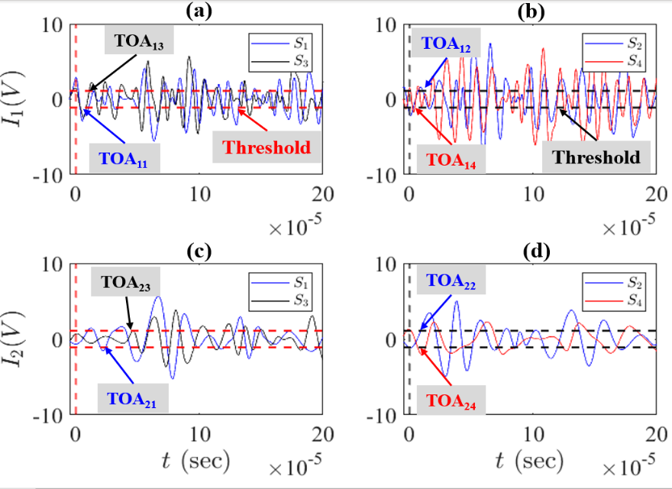

Figure 3: Time history of the first two IMFs extracted from EMD using sensors S₁, S_{2,} S_{3,} and S₄ placed on B₁.

The location of AE events due to the crack in B₁ is predicted using a constant velocity model of 4630 m/s. Fig. 4 (a) shows the location of the actual crack on beam B₁ at the end of the test, where it can be seen that the crack is located at the center of the beam, which is 180 mm from the edge. Fig. 4 (b) represents the location of AE events due to the crack initiation and propagation extracted from the proposed method where the difference of TOA of IMFs obtained from EMD are considered. It can be observed that the location of AE events matches with the visually observed crack path, where the AE events spread from the center bottom to the top of the beam. Fig. 4 (c) represents the location of AE events due to the crack initiation and propagation extracted using the difference between TOAs of measured AE waveforms. It can be noted that the location of AE events is not matching the crack path observed visually. Therefore, the results show that the proposed method can identify the location of the crack with high accuracy than using the raw AE data.
Fig. 4 (d) displays the box plot of crack location for the proposed method and raw AE data. It can be observed that the crack is localized using the proposed method with less variance in the X direction compared with the one from the traditional method that utilizes TOA_{s} of raw AE data. Also, the median value of the proposed method indicates the location of the crack with less error compared to the median value of raw data. In order to ensure the consistency of the results, the same experiment is undertaken on beam B₂, where the location of the crack is identified using the proposed method and the traditional method. Fig. 5 (a) shows the location of the actual crack after B₂ is damaged, where it is visually noticed that the crack initiates in the bottom center of the beam at a distance of 170 mm from the edge and then propagates to the top during the test. Fig. 5 (b) represents the box plot of crack location for the proposed method and traditional method, where it can be observed that the crack is localized using the proposed method with less variance in the X direction compared with the one from the traditional method that utilizes TOA_{s} of raw AE data. Therefore, the same trend for crack localization in both B₁ and B₂ has occurred. Based on the consistent results obtained from B₁ and B₂, it can be concluded that the proposed method has the capability to localize the crack in concrete elements with high accuracy compared with the traditional method considering the raw AE data. Thus, the proposed method can be a suitable candidate as a crack localization tool for structural elements.
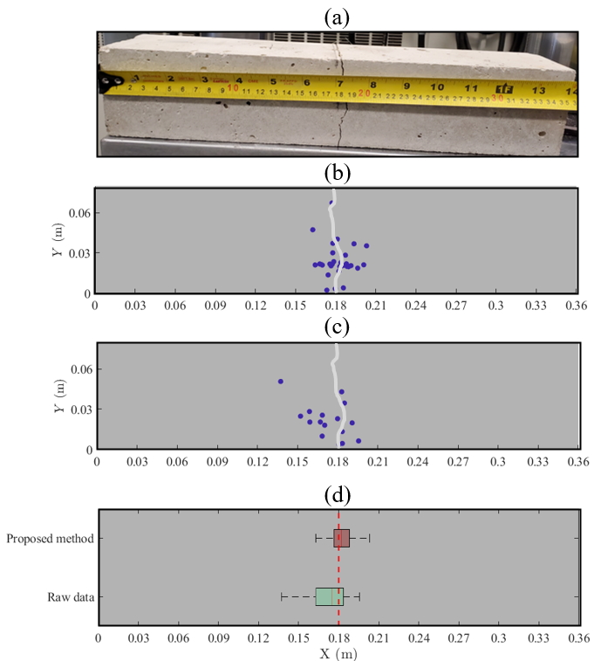

Figure 4: (a) Location of actual crack, location of AE events extracted using (b) the proposed method, (c) raw AE waveforms, and (d) box plot of crack location obtained from the proposed method and raw AE data for beam B₁.

Figure 5: (a) Location of the actual crack and (b) box plot of the location of crack extracted using the proposed method and raw AE data for beam B₂.

Conclusion
In this paper, an improved AE technique has been developed to monitor and evaluate the health condition of various structural elements. In this study, the EMD method combined with a model based on TOA_{s} has been proposed to localize the crack in concrete beams using recorded AE waveforms. The proposed method shows improved performance and accuracy in localizing the crack in concrete beams. An experimental study is undertaken using two concrete beams to show the performance of the proposed method as a crack localization tool. The results suggest that the proposed method can identify the location of the crack using AE data collected from concrete elements. The performance of the proposed method is compared with the traditional method, where the proposed method shows high efficiency and accuracy, making it a suitable candidate as a damage localization approach in civil structures.

ACKNOWLEDGMENTS
The authors would like to thank the University of Tripoli for funding the research through the Libyan Ministry of Education. This research is also funded through the corresponding author’s NSERC Discover grant.

References
- Kralovec, C., and Schagerl, M. (2020). “Review of structural health monitoring methods regarding a multi-sensor approach for damage assessment of metal and composite structures.”, Sensors, 20(3), 826.
- Singh P and Sadhu A. (2020). “System identification enhanced visualization tool for infrastructure monitoring and maintenance Front.”, Built Environ. 6 1–13.
- Sarfarazi, M.P. (1992), “Acoustic emissions and damage constitutive characteristics of paper.”, Institute of paper science and technology, Project 3571.
- Aggelis, D. G., Shiotani, T., and Terazawa, M. (2010). “Assessment of construction joint effect in full-scale concrete beams by acoustic emission activity.”, Journal of Engineering Mechanics, 136(7), 906-912.
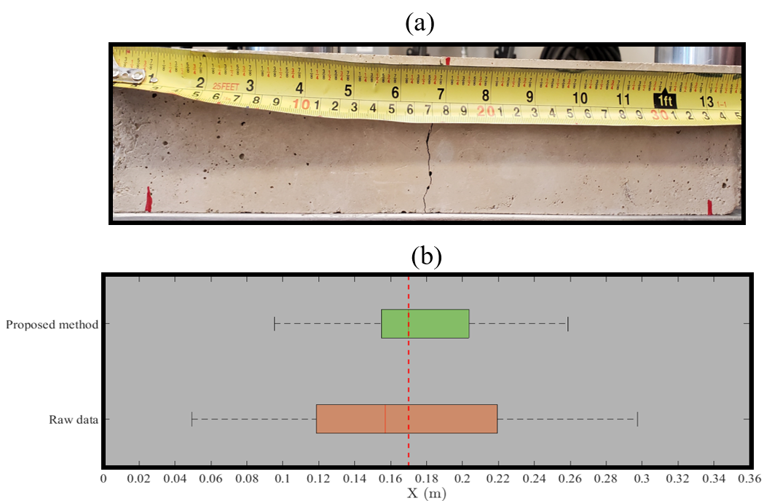
- Benavent-Climent, A., Gallego, A., and Vico, J. M. (2011). “An acoustic emission energy index for damage evaluation of reinforced concrete slabs under seismic loads.”, Structural Health Monitoring: An International Journal, 11(1), 69-81.
- Worley, R., Dewoolkar, M. M., Xia, T., Farrell, R., Orfeo, D., Burns, D., and Huston, D. R. (2019). “Acoustic emission sensing for crack monitoring in prefabricated and Prestressed reinforced concrete bridge girders.”, Journal of Bridge Engineering, 24(4), 04019018.
- Quy, T. B., and Kim, J. (2021). “Crack detection and localization in a fluid pipeline based on acoustic emission signals.”, Mechanical Systems and Signal Processing, 150, 107254.
- Al-Jumaili, S. K., Pearson, M. R., Holford, K. M., Eaton, M. J., and Pullin, R. (2016). “Acoustic emission source location in complex structures using full automatic delta T mapping technique.”, Mechanical Systems and Signal Processing, 72-73, 513-524.
- He, T., Xie, Y., Shan, Y., and Liu, X. (2018). “Localizing two acoustic emission sources simultaneously using beamforming and singular value decomposition.”, Ultrasonics, 85, 3-22.
- Lin, Z., Deng, J., Ma, H., Ni, P., and Guo, C. (2020). “Time series analysis of acoustic emissions in prefabricated utility tunnel during the sealing test.”, International Journal of Geosynthetics and Ground Engineering, 6(4).
- Mirgal, P., Pal, J., and Banerjee, S. (2020). Online acoustic emission source localization in concrete structures using iterative and evolutionary algorithms. Ultrasonics, 108, 106211.
- Cheng, L., Xin, H., Groves, R. M., and Veljkovic, M. (2021). “Acoustic emission source location using lamb wave propagation simulation and artificial neural network for I-shaped steel girder.”, Construction and Building Materials, 273, 121706.
- Ebrahimkhanlou, A., Dubuc, B., and Salamone, S. (2019). A generalizable deep learning framework for localizing and characterizing acoustic emission sources in riveted metallic panels. Mechanical Systems and Signal Processing, 130, 248-272.
- Barbosh, M., Sadhu, A., and Sankar, G. (2021). “Time–frequency decomposition-assisted improved localization of proximity of damage using acoustic sensors.”, Smart Materials and Structures, 30(2), 025021.
- Huang, N. E., Shen, Z., Long, S. R., Wu, M. C., Shih, H. H., Zheng, Q., and Liu, H. H. (2002). “The empirical mode decomposition and Hilbert spectrum for nonlinear and non-stationary time series analysis.”, Proceedings of the Royal Society A, 454, 903–995.
- Barbosh, M., Singh, P., and Sadhu, A. (2020). “Empirical mode decomposition and its variants: A review with applications in structural health monitoring.”, Smart Materials and Structures. 29(9), 093001.
- BQ Li., Z., Moradian, B. Goncalves da Silva, JT Germaine. (2015) “Observations of acoustic emissions in a hydraulically loaded granite specimen.”, 49th US Rock Mechanics/Geomechanics Symposium, San Francisco, USA.
- BQ Li., Gonçalves da Silva, B., and Einstein, H. (2019). “Laboratory hydraulic fracturing of granite: Acoustic emission observations and interpretation.”, Engineering Fracture Mechanics, 209, 200-220.
- Shearer, P. M. (2009). Introduction to Seismology. Cambridge University Press.

