Hybrid seismic control methodology for smart highway bridge structures using evolutionary algorithms and replicator dynamic

Zahrasadat Momeni¹, Ashutosh Bagchi²
¹Building Civil and Environmental Engineering Department, Gina Cody School of Engineering and Computer Science, Concordia University, Montreal, Quebec, Canada, H3G 1M8
²Building Civil and Environmental Engineering Department, Gina Cody School of Engineering and Computer Science, Concordia University, Montreal, Quebec, Canada, H3G 1M8
Email : zahra.momeni24@yahoo.com, ashutosh.bagchi@concordia.ca

ABSTRACT: Control algorithms are crucial for protection of civil engineering structures that are subjected to significant levels of the seismic or wind-induced vibration. Intelligent adaptive control algorithms as data-driven methods have been developed in recent years as feasible alternatives to model-based control algorithms. Recently, evolutionary game theory-based and artificial intelligence-based models are gaining interest in the field of complex civil infrastructure control. In this paper, the modified version of the non-dominated sorting genetic algorithm or NSGA-II utilized and enhanced for obtaining the replicator dynamic parameters that represents the functions of an actuator or damper. The efficiency of such algorithms depends upon the accuracy of following three important parameters: total population of the potential solutions, growth rate, and the fitness function. The present algorithm based on NSGA-II has been used to obtain Pareto optimal values for replicator dynamic parameters, including total population of the potential solutions, growth rate, and the fitness function for each semi-active Magnetorheological (MR) damper considered here vibration control. Previously, the replicator dynamic controller was designed based on assigning the one value for the growth rate. However, the performance of the replicator dynamic controller improved in this study by determining the growth rate for each actuator.

KEY WORDS: Structural Control, Replicator Dynamic, Multi-Objective Optimization.

Introduction

Challenged with the inadequacies of standard codes and Passive Vibration Control (PVC) systems for adjusting dynamic structural properties such as mass and stiffness, smart structures were developed. Since 1980, Active Vibration Control (AVC) and Semi-active Vibration Control (SVC) systems have grown into intelligent structures that can adapt dynamically to their environment through the use of sensors, actuators, signal processors, and power sources. AVC and SVC are intelligently controlled systems that use actuators to gradually adjust stiffness and damping [1].
The control algorithm is at the heart of VCS. This helps to create more dependable and safe constructions. Combinations of adaptive and intelligent control schemes (AIC) have gained increased attention in recent years due to their unique capabilities, which include the ability to handle nonlinear complex systems, high adaptivity, and robustness to errors and uncertainties, as well as their superior effectiveness in controlling civil structures when compared to Model-Based Control methods [1].
Machine Learning (ML), Evolutionary Game Theory (EGT), Reasoning systems, and Adaptive Filters (AFs)-based control are all AIC techniques. Replicator Dynamics (RD) controllers belong to EGT. It can be used to construct engineering-related resource allocation problem-solving models. In a normal resource allocation problem, a finite resource (in this case, the voltage resource) must be given to a large number of customers in order to accomplish a goal. Each consumer is assigned a fitness function that quantifies their capacity to receive voltage. After comparing the fitness values of various consumers, those with a better fitness are given a higher voltage [2]. The replication dynamic controller's effectiveness is contingent upon determining the ideal values for important replicator dynamic parameters, including the total population, P, the growth rate, and the value of the fictional floor fitness function, fn+1. To obtain the optimal settings for replicator dynamics parameters, Replicator Dynamics controllers were combined with a multi-objective optimization technique. Here, a modified version of the non-dominated sorting genetic algorithm or NSGA-II [5] has been used for obtaining the optimal values of the replicator dynamic parameters. Here, the controller's performance was enhanced by utilizing the decentralized multi-agent replicator controller idea and determining the appropriate replicator dynamic settings for each control device.
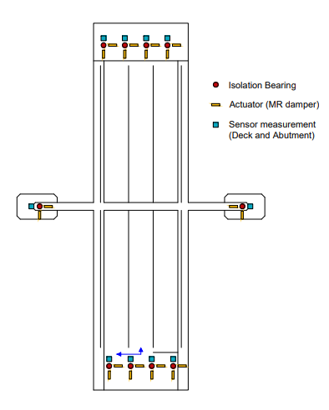
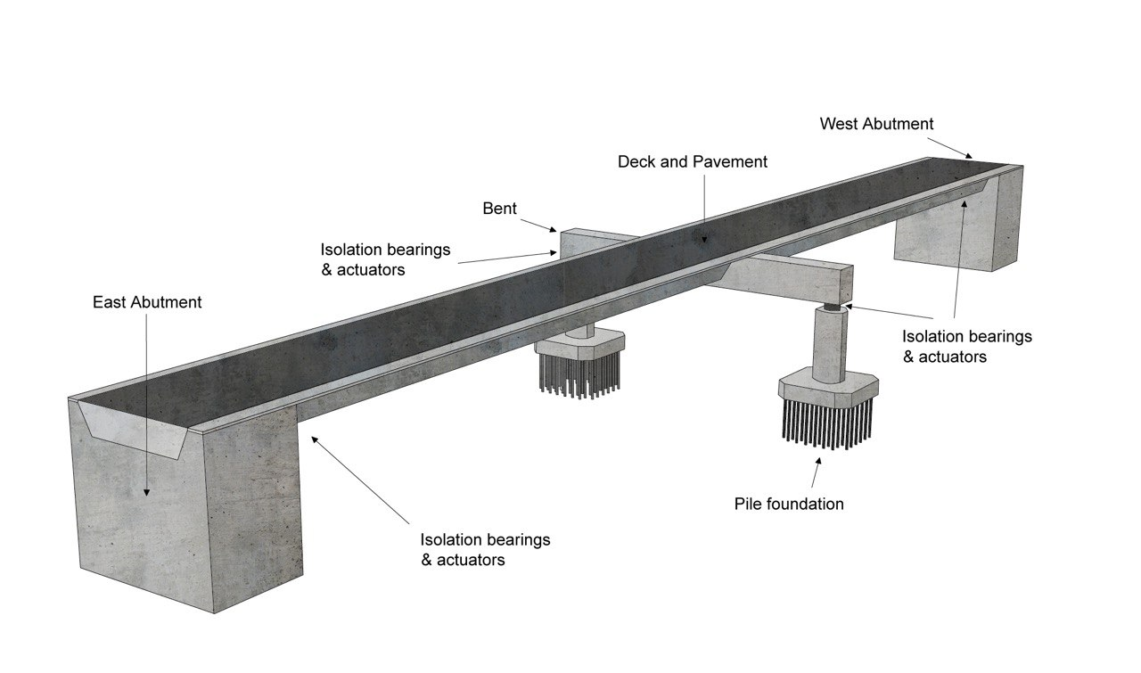
Determining the most appropriate values of the parameters of the replicator dynamics is multi-objective Pareto-based optimization problem (MOPs). In many-objectives problem, there are several objectives which are generally conflicting, result in preventing a simultaneous optimization of each main objective. A multi-objective optimization problem considers multiple conflicting objectives concurrently. In most cases, there is no single optimal solution in this scenario, but rather a range of options with varying trade-offs, referred to as Pareto optimal or non-dominated solutions. Despite the fact that there are several Pareto optimal options, just one of these answers is frequently chosen. Thus, unlike single-objective optimization, multi-objective optimization comprises at least two key tasks: an optimization task for discovering Pareto optimal solutions (through the use of a computer-based procedure) and a decision-making activity for selecting the single most preferred alternative [3]. Several researchers independently advocated in the 1960s that optimization should be based on natural evolutionary principles, particularly Darwin's notion of survival of the fittest. The employment of a population of solutions is one element that separates these so-called evolutionary algorithms (EAs). This is especially advantageous for multi-objective optimization, as it allows for the simultaneous search for numerous Pareto optimal solutions, offering a set of possibilities for decision-making. One of the early examples of EAs was the non-dominated sorting genetic algorithm (NSGA) published in [4]. NSGA-II is a modified form of NSGA that was employed in this investigation. Deb [5] provided a detailed description of the NSGA-II algorithm. The proposed control technique is combined with a multi-objective optimization algorithm, NSGA-II, in this study to provide Pareto optimal values for the replicator dynamic parameters, including total population, the fitness function and growth rates for each MR damper. Unlike previous studies, that used one specific growth rate value for all control devices, here, the author improved the performance of the controller by determining the growth rate value for each damping device.
Figure 2. Control system components, isolation bearing and sensor locations [8]
Figure 1. 3D representation of the highway bridge [2]

Smart Highway Bridge
In [6] and [7] a highway benchmark control problem was constructed using a model of a 91/5 overpassing highway bridge subjected to historical seismic loading. The bridge is a two-span pre-stressed concrete box-girder structure located in southern California. The outrigger is angled toward the center span. To decrease vibration, it features ten MR fluid dampers at each end abutment. This bridge is located close to the fault. Transverse and longitudinal periods of less than 0.4 s for the considered highway bridge, indicating the need for further damping [8]. The global stiffness and mass matrices were calculated in MATLAB by adding the stiffness and mass matrices of the original elastic element from Abaqus.

Problem Formulation

The equations of motion for a superstructure subjected to seismic loads with both a base isolation system and an active/semi-active control system are as [2]:

$M\ddot{u}\left(t\right)+ C\dot{u}\left(t\right)+ Ku\left(t\right)= -Mϑ\ddot{{ u}_{g}} \left(t\right)+ Rr\left(t\right)+ Ww\left(t\right)$(1)

Equation (1) can be represented in the state space model as shown in Equation (2) [2]:

$\dot{x}\left(t\right) = Ax\left(t\right)+ B_{r} z_{r} \left(t\right)+B_{w} z_{w}\left(t\right)+ E\ddot{{ u}_{g}} \left(t\right)$ (2)

The output vector, 𝐲, is obtained through Eq. (3).

𝐲 (𝑡) = 𝐓 $x\left(t\right)$+ 𝐃 Z+ 𝐋g $\ddot{{ u}_{g}}$ (𝑡) (3)

More details about parameters in the equations can be found in [9][10][2].

Replicator Dynamics

In this study, replicator dynamics controls the structural responses of an isolated highway bridge. The bridge's control devices (MR dampers) do this by distributing available voltage to the dampers. V(t) denotes the population vector at time, t [2] [9]:
${V(t)=V}_{t}\left(t\right)…V_{n}\left(t\right)$(4)

The link between the resources fitness function and the weighted average of all resources fitness functions, $φ(t)$ defines the voltage distribution among MR dampers [11] [12].

$φ(t)=\frac{1}{V}\sum_{i=1}^{n+1}{V_{i} (t)}f_{i} \left(t\right)$(5)

Calculate the variation of the command voltage (V(t)) of the current driver for each MR damper using the duplication formula [9]:
${\dot{V}}_{i}\left(t\right){=βV}_{i}\left(t\right)\left(f_{i}\left(t\right)-φ\left(t\right)\right)$ (6)
The rate in which the resources are distributed among participants (control devices) is defined as the growth rate, β.
The fitness function should be defined using the sensor measurements of the control devices. More details of replicator controller can be found in [13][9].

Optimal Replicator Dynamic Using NSGA-II

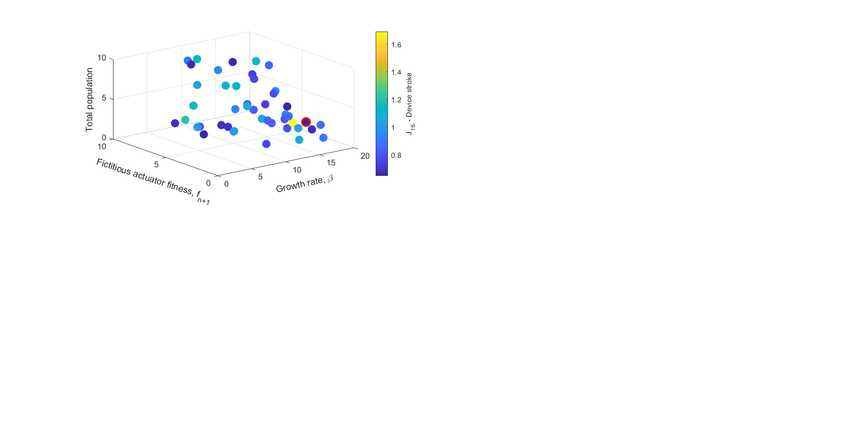
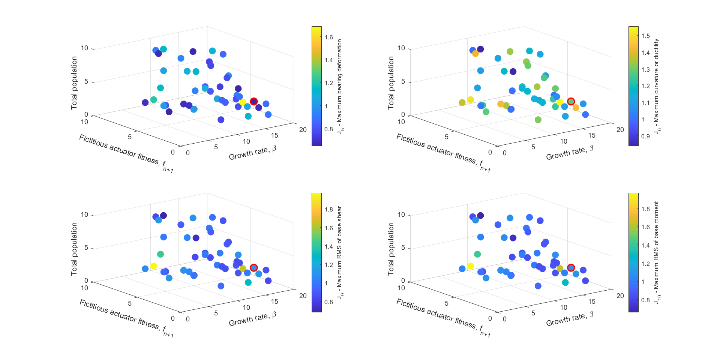
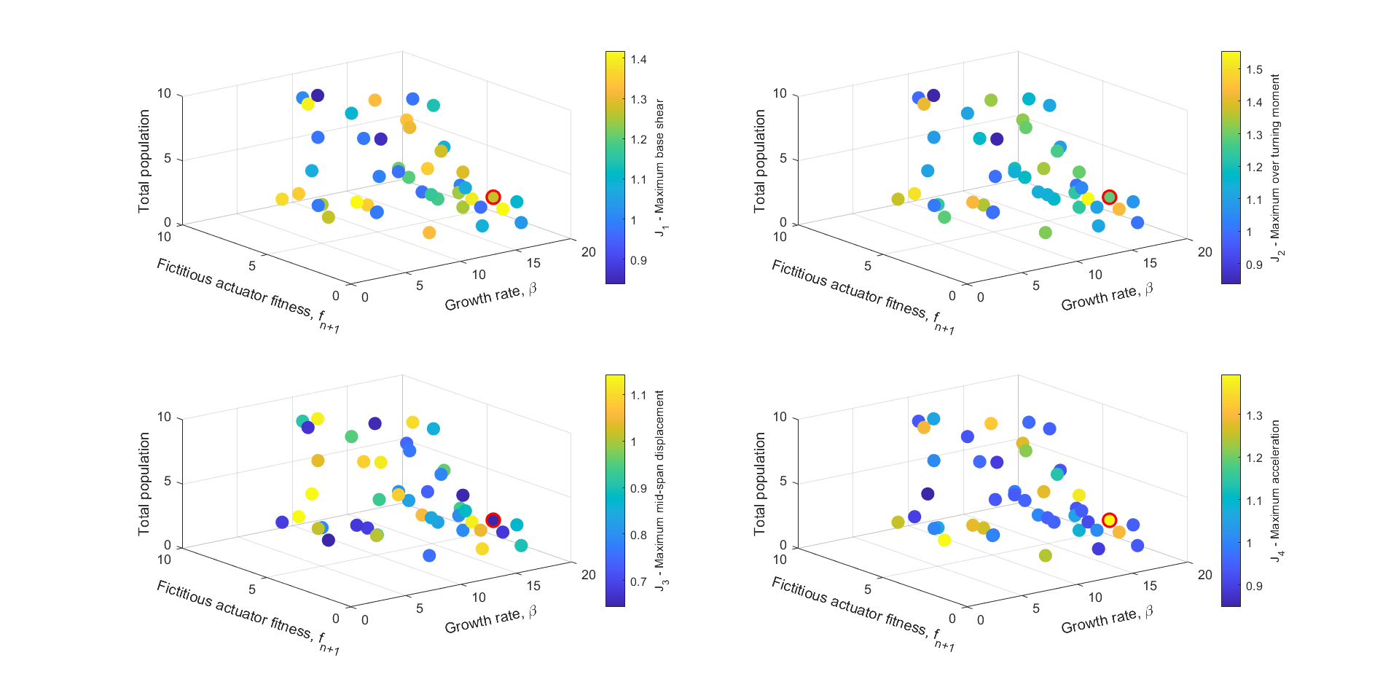
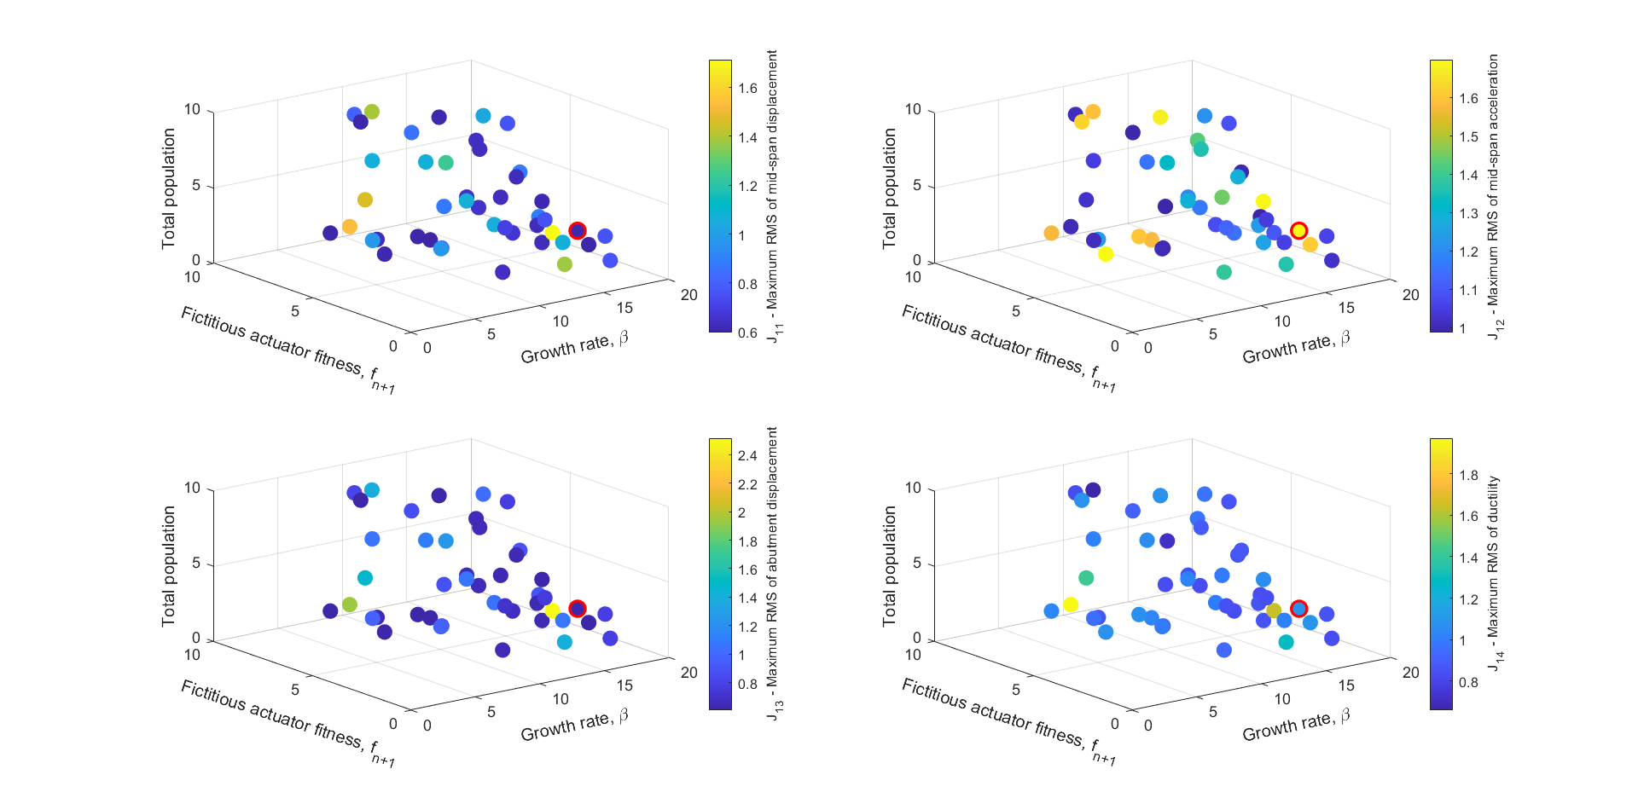
In this multi-objective optimization problem, the replicator dynamic parameters are design variables for the goal or fitness functions that affect how the control decision is made to meet the objectives. At each time step during the earthquake excitation, iterative optimization is utilized to establish the ideal values for the replicator dynamic parameters. To begin, the initial settings of NSGA-II, which comprise the solution population size, maximum number of iterations, crossover and mutation probability selection, are configured to construct a random parent population, or total chromosomes of size N. The optimization problem generates chromosomes that are defined by 12 parameters: total resources, P, growth rate for each MR damper, and a fictitious function, f_{(n+1)}. In the previous attempts by researchers, all actuators were given the same growth value. This procedure has been developed further in the current study, so that each control device has its own growth rate, which is determined using a multi-objective optimization technique. The optimization problem in the present study contains thirteen distinct goal functions: including maximum base shear (J1), overturning moment (J2), mid-span displacement (J3), acceleration (J4), maximum bearing deformation (J5), maximum ductility (J6), maximum RMS of base shear (J9), maximum RMS of base moment (J10), maximum RMS of mid-span displacement (J11), maximum RMS of mid-span acceleration (J12), maximum RMS of abutment displacement (J13), maximum RMS of ductility (J14) and (J16) maximum stroke of control device, that are determined by optimal values of replicator dynamic parameters corresponding to NSGA-II solutions. More details of objective/goal functions were described in [9].
Figure 3. Performance criteria based on all Pareto solutions obtained by NSGA II

Evaluation

The benchmark problem is evaluated by subjecting the structure to major historical earthquakes. Details of the earthquake are shown in Table 1.

Table 1: Properties of selected earthquake records[8]

Recording Station | Earthquake | Magnitude  (Mw)
North Palm Springs | 1986 N. Palm Springs | 6.0
TCU084 | 1999 Chichi | 7.6
El Centro | 1940 Imperial Valley | 7.0
Rinaldi | 1994 Northridge | 6.7
Bolu | 1999 Duzce,Turkey | 7.1
Nishi-Akashi | 1995 Kobe | 6.9

Results and Discussion

Using a replicator dynamic controller and the NSGA-II algorithm, the dynamic response of bridge structures subjected to seismic loading was estimated while optimizing the force allocation in the control device. The optimal Pareto front of replicator dynamic parameters was determined using the multi-objective NSGA-II algorithm. The performance criteria based on all Pareto solutions obtained by NSGA II in the study are summarized in Figure 3. Tables 2 and 3 reveal maximum and lower bounds for replication dynamic parameters, as well as values for NSGA-II parameters. In this way, the process becomes more sustainable, requiring less resources to reach the same level of performance.

Table 2: Upper and lower bounds for replicator dynamic variables
P | Fn+1 | Betai | Vi | Variable/parameter
[5,200] | [0,10] | [0.001,20] | [$-$10,10] | Range

Table 3: NSGA-II parameters
Maximum Iteration | Mutation Percentage | Crossover Percentage | Population size | Parameter
100 | 0.4 | 0.7 | 50 | VALUE

For the north palm spring earthquake, the optimization model returns the Pareto optimal set of replicator dynamic parameters is shown in Table 4.

 | Performance | Benchmark |  |  | Soto and Adeli[13] | Considering equal beta | Proposed Model
 | criteria | Passive | LQG | Lyapanov | Soto and Adeli[13] | Considering equal beta | Proposed Model
 |  | Passive | Active | Semi-Active | Soto and Adeli[13] | Considering equal beta | Proposed Model
North Palm Spring | J1 | 1.057606202 | 0.937154735 | 0.919494158 | 0.78 | 0.804350559*** | 0.804350559***
North Palm Spring | J2 | 1.095858845 | 0.918512617 | 1.034929869 | 0.82 | 0.908223969*** | 0.893167643***
North Palm Spring | J3 | 0.867934706 | 1.010173646 | 0.556613594 | 0.8 | 0.756894231*** | 0.654856008***
North Palm Spring | J4 | 1.174329596 | 1.12560996 | 1.56643623 | 1.15 | 0.989729464**** | 0.979729464****
North Palm Spring | J5 | 0.884392008 | 1.007216871 | 0.563624684 | 0.76 | 0.703708739*** | 0.703698739***
North Palm Spring | J6 | 1.095858845 | 0.918512617 | 1.034929869 | 0.82 | 0.908223969*** | 0.873167643***
North Palm Spring | J9 | 1.185867268 | 0.968569456 | 0.669697967 | 0.96 | 0.755265975*** | 0.750287004***
North Palm Spring | J10 | 1.205091332 | 0.96669717 | 0.659772373 | 0.96 | 0.760054566*** | 0.754792013***
North Palm Spring | J11 | 1.015192128 | 0.940677911 | 0.430431634 | 0.96 | 0.361484191**** | 0.360732190****
North Palm Spring | J12 | 0.912725511 | 0.907865059 | 1.594134401 | 1.01 | 0.980439738** | 0.980439737**
North Palm Spring | J13 | 1.025032368 | 0.941155875 | 0.417733692 | 0.91 | 0.337328965**** | 0.317125964****
North Palm Spring | J14 | 1.205091332 | 0.96669717 | 0.659772373 | 0.96 | 0.760054566*** | 0.754792013***
North Palm Spring | J16 | 0.884392008 | 1.007216871 | 0.563624684 | 0.76 | 0.703708739*** | 0.703697739***
Table 4: Comparison between the results of the proposed method with competing models in each earthquake (the number of better answers of the proposed model than the competing models is marked with *.)

Conclusion

The goal of this research is to find the best replicator dynamic parameter values without undertaking sensitivity analysis. Choosing the best settings for the replicator dynamics parameters improves the performance of the vibration reduction control system. This study is unique in that it evaluates all performance criteria simultaneously while the model is running to identify the Pareto optimal values for the replicator dynamic parameters and specifically growth rate parameters for each MR dampers. Furthermore, by calculating the appropriate growth rate for each MR dampers, the present study advances the concept of semi-active replicator control.

References

[1] M. U. Saeed, Z. Sun, and S. Elias, “Research developments in adaptive intelligent vibration control of smart civil structures,” J. Low Freq. Noise Vib. Act. Control, vol. 0, no. 0, pp. 1–38, 2021, doi: 10.1177/14613484211032758.
[2] S. Javadinasab Hormozabad and M. Gutierrez Soto, “Load balancing and neural dynamic model to optimize replicator dynamics controllers for vibration reduction of highway bridge structures,” Eng. Appl. Artif. Intell., vol. 99, no. November 2020, p. 104138, 2021, doi: 10.1016/j.engappai.2020.104138.
[3] Y. Cui, Z. Geng, Q. Zhu, and Y. Han, “Review: Multi-objective optimization methods and application in energy saving,” Energy, vol. 125, pp. 681–704, 2017, doi: 10.1016/j.energy.2017.02.174.

[4] N. and K. D. Srinivas, “Muiltiobjective optimization using nondominated sorting in genetic algorithms.,” Evol. Comput. , vol. 2, no. 3, pp. 221–248, Sep. 1994.
[5] K. Deb, A. Pratap, S. Agarwal, and T. Meyarivan, “A fast and elitist multiobjective genetic algorithm: NSGA-II,” IEEE Trans. Evol. Comput., vol. 6, no. 2, pp. 182–197, 2002, doi: 10.1109/4235.996017.
[6] A. Agrawal, P. Tan, S. Nagarajaiah, and J. Zhang, “Benchmark structural control problem for a seismically excited highway bridge-part I: Phase I problem definition,” Struct. Control Heal. Monit., vol. 16, no. 5, 2009, doi: 10.1002/stc.301.
[7] S. Nagarajaiah, S. Narasimhan, A. Agrawal, and P. Tan, “Benchmark structural control problem for a seismically excited highway bridge-part III: Phase II sample controller for the fully base-isolated case,” Struct. Control Heal. Monit., vol. 16, no. 5, 2009, doi: 10.1002/stc.293.
[8] M. Gutierrez Soto, “Bio-inspired hybrid vibration control methodology for intelligent isolated bridge structures,” 2018, doi: 10.1117/12.2300393.
[9] M. Gutierrez Soto and H. Adeli, “Semi-active vibration control of smart isolated highway bridge structures using replicator dynamics,” Eng. Struct., vol. 186, 2019, doi: 10.1016/j.engstruct.2019.02.031.
[10] M. Gutierrez Soto, “Multi-Agent Replicator Control Methodologies For Sustainable Vibration Control Of Smart Building And Bridge Structures,” 2017.
[11] G. Soto and H. Adeli, “Multi-agent replicator controller for sustainable vibration control of smart structures mariantonieta,” J. Vibroengineering, vol. 19, no. 6, 2017, doi: 10.21595/jve.2017.18924.
[12] M. Gutierrez Soto and H. Adeli, “Recent advances in control algorithms for smart structures and machines,” Expert Systems, vol. 34, no. 2. 2017, doi: 10.1111/exsy.12205.
[13] G. Soto and H. Adeli, “Multi-agent replicator controller for sustainable vibration control of smart structures mariantonieta,” J. Vibroengineering, vol. 19, no. 6, pp. 4300–4322, 2017, doi: 10.21595/jve.2017.18924.

