As it is well known, every bridge undergoes a progressive deterioration of its structural conditions due to the presence of ordinary service loads and environmental conditions. Consequently, it is essential to rely on efficient Structural Health Monitoring (SHM) techniques that could be applied throughout the entire infrastructure network. For this purpose, in this study, an innovative Vehicle-Bridge Interaction (VBI) based approach is investigated as a diffused and low-cost monitoring system for the identification of the dynamic characteristics of bridges, and pertinent modal shapes. Notably, compared to traditional SHM methods that usually require expensive setup and time-consuming procedures, the proposed VBI-based procedure shows the advantage of efficiency and economy. Specifically, a very simple and low-cost setup comprising a scaled-up electric vehicle as mobile platform and few piezoelectric accelerometers has been used. In this regard, an experimental campaign has been carried out on different bridges in the city of Palermo (Italy) testing the proposed VBI-based procedure. With the aim of validating this procedure, the results of the tests have been compared with those obtained from traditional Operational Modal Analysis (OMA) methods and classic VBI ones. Furthermore, in order to maximize cost-benefits ratios, the proposed VBI-based approach has been considered for the first time by employing Micro Electro-Mechanical Systems (MEMS) accelerometers available in common smartphone as cheaper and more diffuse sensors than piezoelectric ones in a crowdsensing perspective.
An indirect bridge monitoring method based on Vehicle-Bridge Interaction using a low-cost scaled-up electric vehicle
Dario Fiandaca¹, Alberto Di Matteo¹, Antonina Pirrotta¹
¹Department of Engineering, University of Palermo, Viale delle Scienze, 90128 Palermo, Italy
email: dario.fiandaca@unipa.it, alberto.dimatteo@unipa.it, antonina.pirrotta@unipa.it
KEY WORDS: Vehicle-Bridge Interaction; Structural Health Monitoring; Scanning; Indirect measurement; Modal parameters; Vehicle; Experimental test.

INTRODUCTION
In the field of Structural Health Monitoring SHM [1], Operational Modal Analysis (OMA) [2], is among the most widely used class of procedures to obtain structural modal parameters, including frequencies, modal shapes, and damping ratios, employing data collected when the structures are under their operating conditions [3]. Specifically, OMA methods allow the identification of structural dynamic parameters using sensors placed directly on site and usually connected with long cables to an acquisition system. Although these procedures have gained increasing interest among researchers and engineers, the required setup may be really expensive also necessitating access to the power grid, difficult to achieve in operating conditions.
To overcome these issues, indirect measurement of the dynamic parameters of bridges by using moving vehicle responses has been proposed [4] as a promising alternative to the traditional SHM procedures. These methods have been lately renamed as Vehicle Scanning Methods (VSM) or Vehicle Bridge Interaction (VBI) procedure, since the dynamic parameters of the bridge are obtained analyzing in frequency domain the measured vehicular vibration response. The validity of this approach has been investigated for the first time by Yang et Al. [5]. Since then, some experimental verifications, using different kind of test-vehicles, have been carried out [6] and many research efforts have been focused on the identification of bridge modal parameters, such as modal frequencies [7], mode shapes [8], damping ratios [9]. However, as shown in all the previous studies, two main issues may affect the accuracy of this approach. Specifically, pavement roughness can be detrimental to the scanning quality, by adding random and uncontrollable high-frequency excitations to the vehicle response [10]. Further, an additional issue is related to the frequency of the test vehicle. In this regard, the visibility of some bridge frequencies in the Power Spectral Density (PSD) function could be compromised due to the magnitude of the PSD in correspondence of the frequency of the vehicle itself. To tackle these issues, Yang et al. [11] recently proposed to adopt a hybrid method in which the vehicle is used in static mode, acquiring the vertical acceleration in different points of the structure with the aim of obtaining the modal parameters of the bridge. However, it is worth noting that in [11] an expensive setup, including a vehicle with a truck, has been used; furthermore, the considerable mass of the vehicle-tractor system, due to the interaction between vehicle and bridge, influences the final results.
On this base, in this paper a new VBI-based method has been investigated using a low-cost scaled-up electric vehicle. Specifically, the vertical accelerations of this “mobile platform” have been acquired by parking it alternately in various measuring points on the structure. It should be noted that this approach is in contrast with the classic VBI methods which require many acquisitions of the vehicle vertical acceleration during the passage on the structure.
However, the use of a scaled-up vehicle leads to several advantages including the adoption of a very cost-effective mobile platform in comparison with a real vehicle and the possibility to monitor also pedestrian bridges where vehicular transit is not allowed. In addition, since this vehicle is characterized by low weight, its influence on the dynamic behavior of the bridge is negligible. Notably, the adopted scaled-up electric vehicle has been instrumented with a piezoelectric accelerometer as well as a MEMS one, by exploiting the use of a common smartphone, to provide a comparison between the different sensors.

RESULTs AND DISCUSSION
With the aim of validating the reliability of the proposed approach in comparison with traditional OMA methods and classic VBI ones, an experimental campaign on different bridges in the city of Palermo (Italy) has been carried out.
For these tests, a customized scaled-up electric vehicle (Figure 1a) and only two high-sensitivity piezoelectric accelerometers have been used. In particular, the first sensor has been positioned directly on the structure (Figure 1b) and the second one has been installed on the test vehicle as in Figure 1a. In addition to the accelerations measured by the piezoelectric accelerometer, vehicle vertical accelerations have been acquired simultaneously through a MEMS-type accelerometer available on a common smartphone (iPhone 11 Pro) placed on the vehicle (see Figure 1a). It should be noted that all the piezoelectric accelerometers have been connected to a PC through a signal conditioner and signals have been recorded using a self-developed acquisition software in LabView environment.
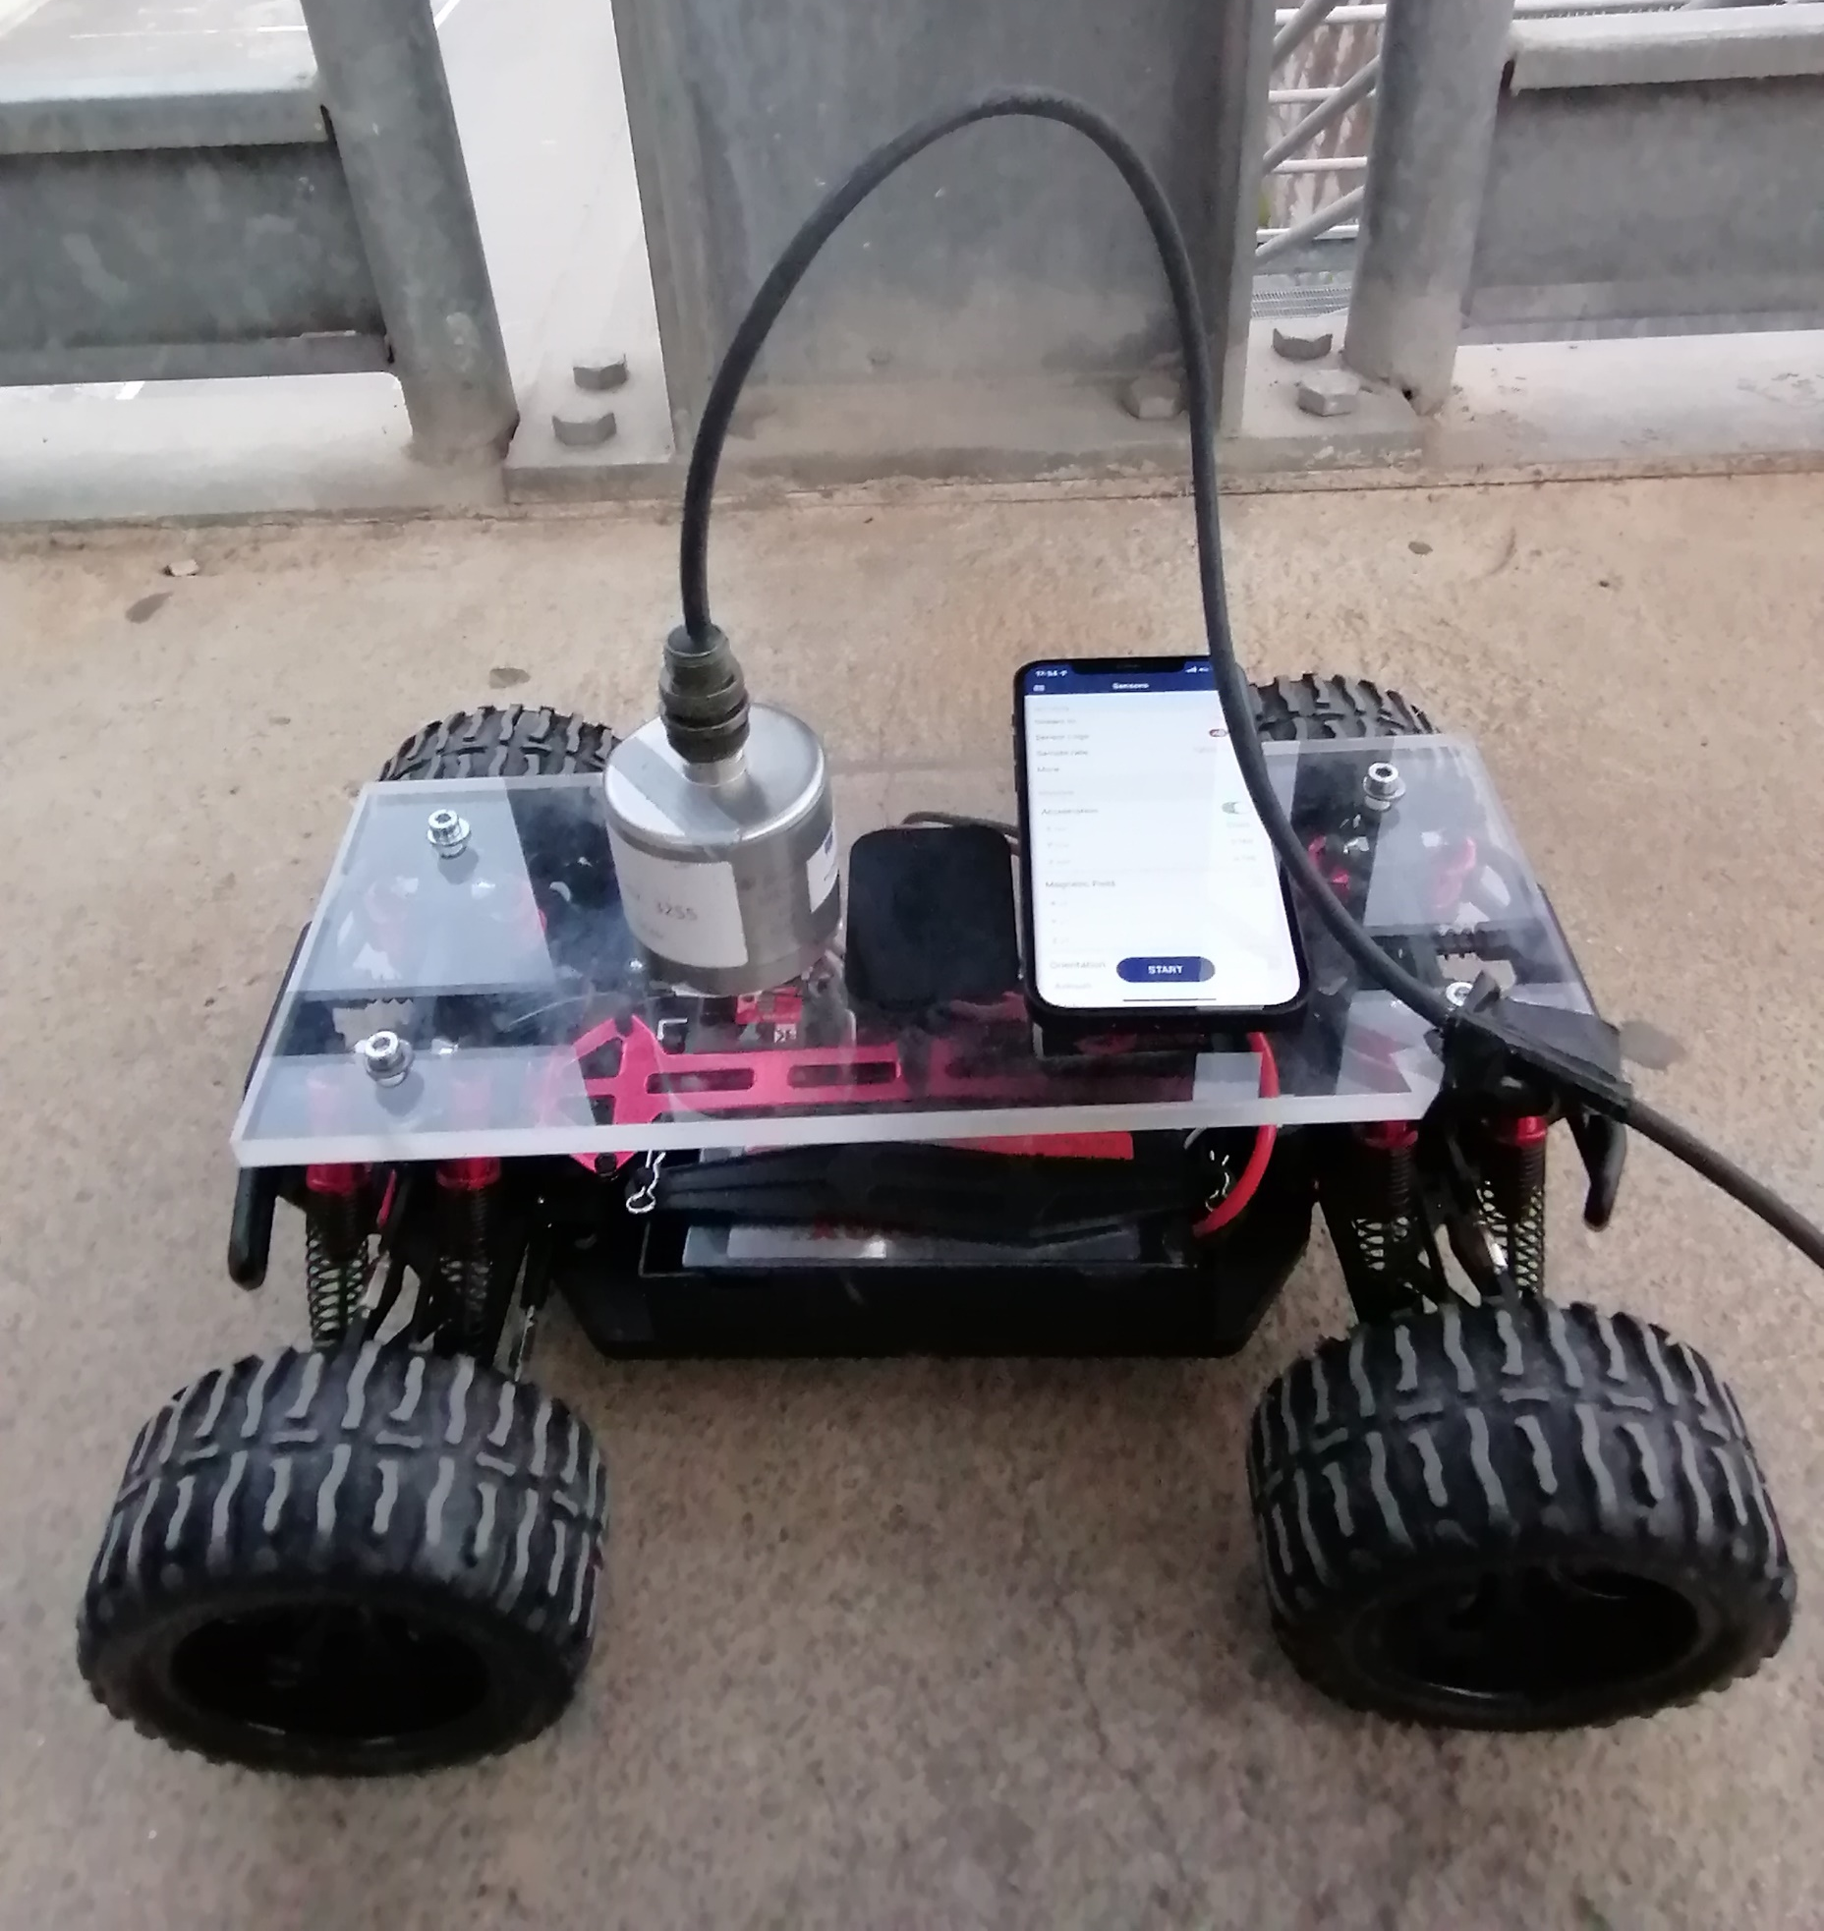 | 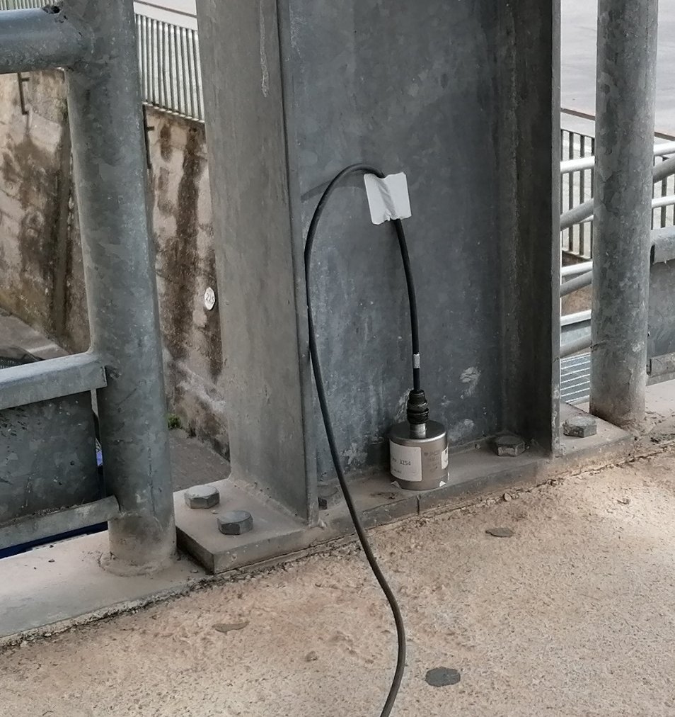
(a) | (b)
Figure 1. Test setup: (a) scaled-up electric vehicle instrumented with two accelerometers, (b) piezoelectric accelerometer placed on the structure.
The monitoring technique consists of simultaneous acquisitions from the accelerometer positioned into a point referred to as “reference point” of the structure (point A in Figure 2) and from the sensors installed on the vehicle that is alternately placed for 180 seconds in six different measuring points on the structure (points 1-6 in Figure 2).
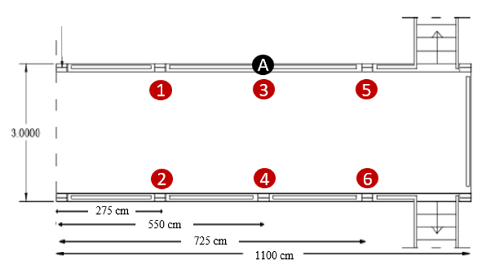
Figure 2. Arrangement of measuring points for the vehicle (Points 1-6) and reference point on the bridge surface (point A).
Once the accelerations have been acquired, they have been filtered and analyzed in the frequency domain determining the PSD functions according to the Welch method [12]. In addition, mode shapes have been obtained evaluating the modal amplitude ratio of the cross-power spectrum and the auto-power spectrum between the measuring points and reference point following the approach in [13]. Results show a satisfactory agreement in terms of identified frequencies and modal shapes between the innovative approach and traditional methods based on sensors placed directly on the structure. Furthermore, results obtained by applying the proposed approach show a far greater accuracy in terms of identification of structural dynamic parameters than those achieved by classical VBI method. It is worth noting that, the innovative approach employs few sensors (just two) to monitor different kind of bridges, while traditional OMA ones would require a much higher number of sensors to be effective. Consequently, the aforementioned approach leads to a significant reduction of the cost related to the setup and of the time required to perform the tests while keeping the same accuracy. Finally, the comparison between piezoelectric accelerometers and MEMS ones demonstrates that these can be employed even in VBI-based procedure as high-performing and cost-effective sensors. In conclusion, this study shows that the innovative VBI-based approach can effectively be regarded as a reliable tool to be employed for the structural dynamic parameters identification in low-cost SHM procedures.

aCKNOWLEDGMENT
Authors gratefully acknowledge the financial support of the project PO FESR 2014-2020 Crowdsense.

References
- S. Alsamahi, D. Llort, A. Pirrotta, A. Di Matteo, R. Inguanta and A. Mulone, Structural health monitoring, damages identification and durability assessment of constructions by sensors and smartphone-based technique, 18th IRF World Meeting & Exhibition, Dubai, 2021.
- G. Cottone, A. Pirrotta and S. Salamone, Incipient damage identification through characteristics of the analytical signal response, Structural Control and Health Monitoring, vol. 15, n. 8, pp.1122-1142, 2008.
- R. Brincker, L. Zhang, and P. Andersen, An Overview of Operational Modal Analysis: Major Development and Issues, Proceedings of the 1st International Operational Modal Analysis Conference, IOMAC , 2005.
- H. Shokravi, H. Shokravi, N. Bakhary, M. Heidarrezaei, S.S.R. Koloor and M. Petru, Vehicle-assisted techniques for health monitoring of bridges, Sensors, vol. 20, p. 3460, 2020.
- Y.-B. Yang, C. Lin and J. Yau, Extracting bridge frequencies from the dynamic response of a passing vehicle, Journal of Sound and Vibration, n. 272, pp. 471-493, 2004.
- Y.-B. Yang, W.-F. Chen, H.-W. Yu and C. Chan, Experimental study of a hand-drawn cart for measuring the bridge frequencies, Engineering Structures, vol. 57, pp. 222-231, 2013.
- A. Di Matteo, D. Fiandaca, A. Pirrotta, Smartphone-based bridge monitoring through vehicle-bridge interaction: analysis and experimental assessment, Journal of Civil Structural Health Monitoring, Springer, 2021. [Under review]
- C. Tan, H. Zhao, E.J. OBrien, N. Uddin, P. C. Fitzgerald, P. J. McGetrick and C. Kim, Extracting mode shapes from drive-by measurements to detect global and local damage in bridges, Structure and infrastructure engineering, Vol. 17, 1582-1596, 2021.
- A.Gonzalez, E.J.Obrien and P J. McGetrick, Identification of damping in a bridge using a moving instrumented vehicle, Journal of Sound and Vibration, vol. 331, pp. 4115-4130, 2012.
- Y.B. Yang, Y.C. Li and K.C. Chang, Using two connected vehicles to measure the frequencies of bridges with rough surface: A theoretical study, Acta Mechanica, Vol. 223, pp. 1851-1861, 2012.
- Y.B. Yang, Z. Li, Z.L. Wang, K. Shi, H. Xu, F.Q. Qiu and J.F. Zhu, A novel frequency-free movable test vehicle for retrieving modal parameters of bridges: Theory and experiment, Mechanical Systems and Signal Processing, Vol. 170, 2022.
- P. Welch, The use of fast fourier transform for the estimation of power spectra: a method based on time averaging over short, modified periodograms, IEEE Trans. Audio Electroacoust, 1967.
- A.E. Hami, B. Radi, Introduction to Structural Dynamics, Cambridge University Press, 2006.

