Application of Clustering Techniques in Acoustic Emission Monitoring of Reinforced Concrete Structures: A Preliminary Study
Paresh Mirgal¹, Harsh Mahajan², Sauvik Banerjee³
^{1,2} PhD Research Scholar, Department of Civil Engineering, Indian Institute of Technology, Bombay, Powai, Mumbai,400076, India.
³ Professor, Department of Civil Engineering, Indian Institute of Technology, Bombay, Powai, Mumbai,400076, India
Email : parsh49@gmail.com, mahajanharsh1909@gmail.com, sauvik@civil.iitb.ac.in

The Acoustic Emission (AE) technique has gained popularity over the last two decades as a monitoring methodology and assessment tool for evaluating the safety and reliability of reinforced concrete structures, historic structures, and masonry buildings. However, widespread acceptance of analytical strategies for the management and interpretation of AE data is still limited. Recently, unsupervised machine learning methods such as clustering technique and discriminant analysis have been used to classify AE patterns and to determine the mode of damage. The purpose of the proposed work is to develop and compare various clustering methodologies for determining the processes of cracking in the concrete structure. As analytical tools, unsupervised approaches such as k - mean, fuzzy c-mean and DB-SCAN were used. The principal component analysis (PCA) method was also explored for dimensional reduction. Certain features of AE waves such as peak amplitude, peak frequency, centroid frequency, RA value, and AE hits were used. The findings imply that frequency may be used to deduce the processes behind the AE sources. The analytic approach was shown to be successful and may be utilised to classify future AE data. This study provides direction for utilization of unsupervised ML techniques for real-time analysis of acoustic emission testing leading to more robust and efficient testing technique.
KEY WORDS: Reinforced concrete beam, AE data clustering, principal component analysis (PCA).
- INTRODUCTION:
In the last two decades, the Acoustic Emission (AE) technique has grown in popularity as a monitoring method and evaluation tool for evaluating the safety and dependability of reinforced concrete structures, historic structures, and masonry buildings. However, analytical methodologies for the administration and interpretation of AE data are still not widely accepted. When the nature of the damage process is known in advance, supervised pattern recognition techniques such as the K-nearest neighbours method (K-NN method) are used [1,2]. On other hand, unsupervised pattern recognition refers to the whole approach comprising procedures for descriptors selection, cluster analysis, and cluster validity when there is no information on attended clusters. The k-means algorithm is a prominent clustering strategy [4-6]. Principal component analysis (PCA), a traditional method of multivariate statistics, might alternatively be utilised to obtain the dimension reduction of big data sets [4]. PCA is a mathematical process that turns a set of potentially linked variables into a smaller set of uncorrelated variables known as principal components. The first principal component accounts for as much of the data's variability as possible, and each subsequent component accounts for the remaining variability.
Numerous recognised statistical approaches (Z, RA, b, and Ib values) may be utilised to analyse AE data in order to determine the damage state of a building subjected to a specific loading situation. Recently, machine learning algorithms and artificial neural networks (ANN) have been used to decrease data redundancy and improve the feature set of AE signals. Generally, cluster analysis can be used to separate a collection of data into various groups based on their underlying pattern in parameters. This analytical approach was used in this article to evaluate the acoustic emission data collected during 3-point bending tests on concrete beams under cycling and constant load conditions, as well as rising loads. Three clustering algorithms were utilised with same set of features: K-mean clustering, fuzzy c-means and DB-SCAN. PCA was also utilised prior to applying mentioned algorithms for dimension reduction. By employing the methodologies, it was feasible to assess the degree of the damage and to track its progress during the test.

- EXPERIMENTAL SET UP:
The experimental setup consisted of a universal testing machine (UTM) and AE monitoring system. The beam samples were subjected to displacement-controlled loading up to the failure load with a loading rate equivalent to a mid-span deflection of 0.001 mm/seconds. The M30 grade concrete beam specimen was prepared with a mix proportion according to guidelines from IS 10262:2019 [7]. The 445 kg/m³ of cement, 1061 kg/m³ of aggregates and 751 kg/m³ of sand are mixed with 197 kg/m³ of water for the concrete mix used for the beam sample. The Water-cement ratio was considered as 0.44. The two numbers of steel reinforcements with diameter 12 mm and 10 mm are provided with stirrups placed at 120 mm c/c. Three beams samples of size 150 mm x 150 mm x 700 mm were prepared following RILEM TC 212-ACD recommendations [8]. A notch of width, approximately 10 mm, was created at the bottom of the beam mid-span for stable and controlled crack growth.

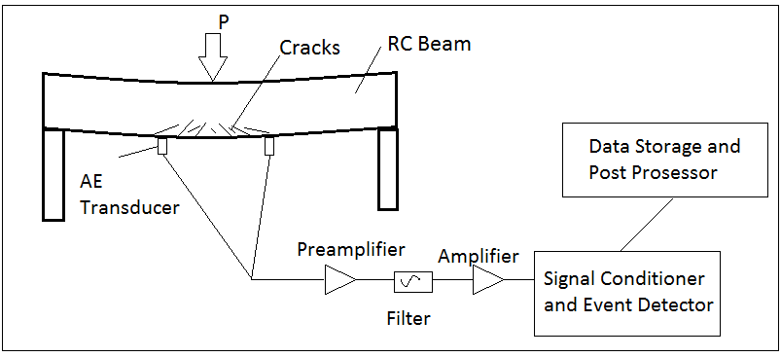 | 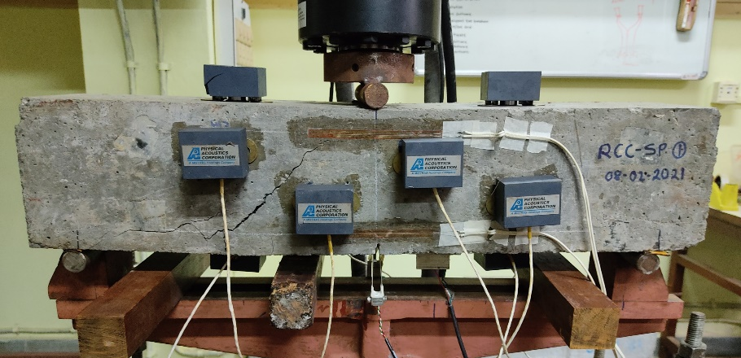
(a) | (b)
Figure 1. (a) Schematic representation of AE system; (b) RC beam specimen after failure
The AE signals emitted during the experiment was captured with the help of eight AE sensors (type R6D with the resonant frequency of 60 kHz). The sensors in the present experiment are located in such a way that they would capture the complete fracture process during the loading. Four sensors are placed along the front face of the specimen, and two sensors are placed at 100 mm distance at the top as well at the bottom, as shown in Figure 1 (a).

- AE DATA CLUSTERING:
When significant datasets of AE signals are obtained, recording all raw AE signals (i.e. voltage vs time history for each sensor)
becomes prohibitively expensive from a hardware perspective. More often than not, signals are reduced to a collection of patterns
that describe the signal. We classified these patterns into three categories: the amplitude, counts, duration, rise-time, and energy
patterns that the acquisition system calculates from the raw AE wave input. The second group includes statistical patterns derived
on the population of AE hits, such as the historical index and severity, as well as the RA value and average frequency. The last
category contained factors such as time, sensor identification, and external variables such as loading state. On the basis of a 12-
variable dataset, a multi-step technique is provided here for identifying homogenous clusters of AE signals associated with certain
damage circumstances (e.g. tensile or shear cracks, micro or macro cracking). At the time of data collection, the data were filtered
in hardware using a 40dB high pass filter to remove low amplitude noise.

- RESULT AND DISCUSSION:
  - Parametric analysis of AE data:
The temporal variation in AE parameters like counts and energy are studied as these parameters are affecting directly the final outcome of the AE experiments. The graphical presentation in Figure 2 (a) showing the increase in the activities near the peak loading suggesting the critical failure. The parametric analysis of the AE data recorded from the experiment suggesting the low frequency events during the final failure indicating the shear crack. The same can be observed in Figure 2 (b).

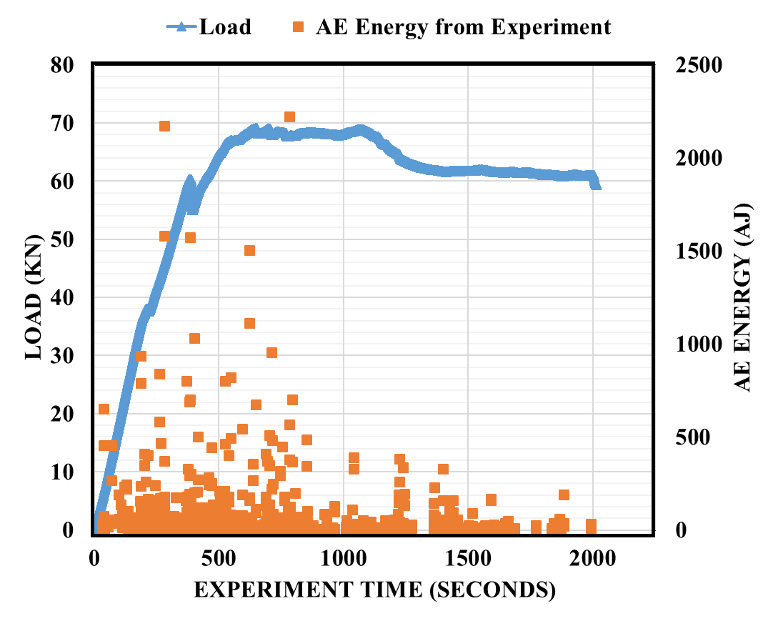 | 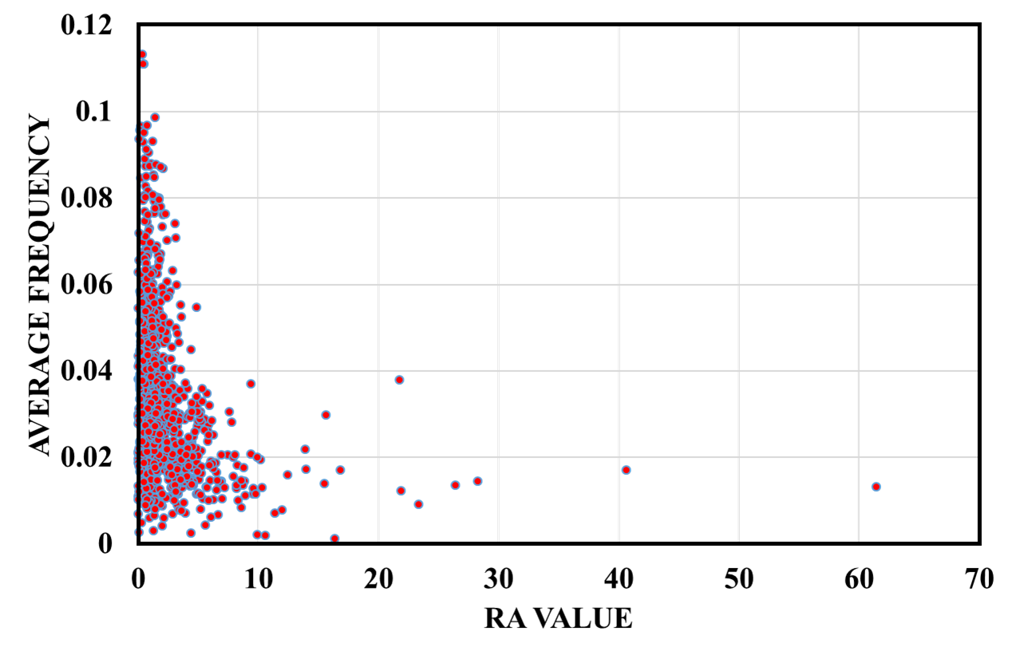
(a) | (b)
Figure 2. (a) Variation of AE energy with load along the experiment; (b) Parametric analysis of the experiment

  - AE clustering
Due to noise sources, acoustic emission testing generated a good amount of data. It is essential to distinguish true signals from other data sources. Three clustering techniques were utilised: k-means, Fuzzy C-means, and DB-SCAN. These wave-based characteristics have time-domain, frequency-domain, and parametric characteristics. Principal component analysis (PCA) was also utilised to minimise dimensions, hence enhancing performance and efficiency, because these attributes were linked.
The best number of clusters is determined by doing clustering with varying numbers of clusters and assessing quality criteria. The silhouette score is a commonly used cluster quality metric; a higher score suggests a superior solution. To compute the silhouette score for each observation/data point, it is necessary to determine the distances between each cluster's observations. Figure 3 demonstrates that five clusters are optimum and that PCA paired with k-means produces the highest silhouette score among all techniques.
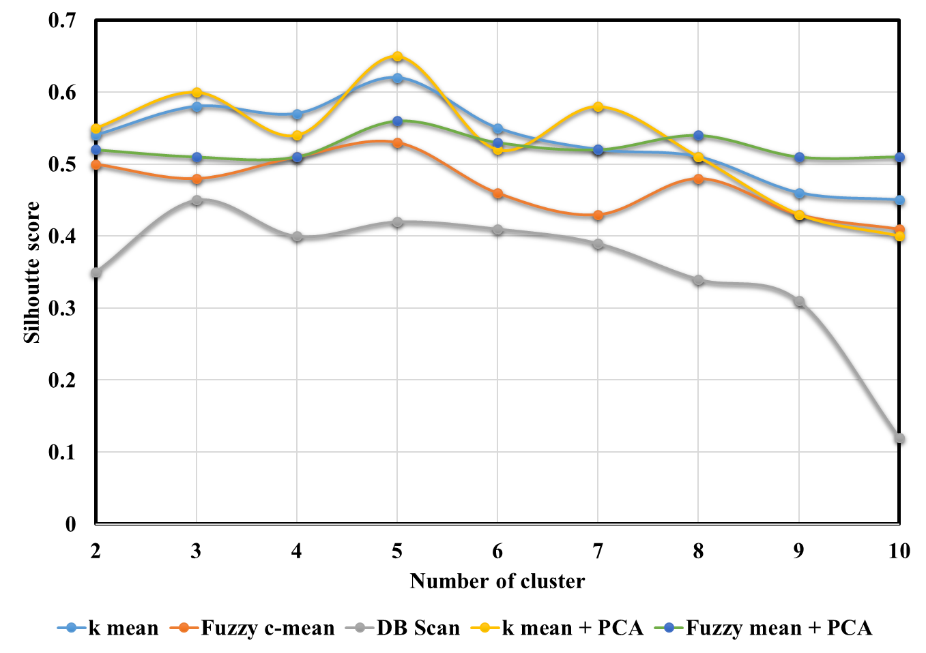
Figure 3. Comparison of Silhouette score of each clustering technique and number of cluster

Figure 4a illustrates the clusters in terms of energy and rise time. It is evident that cluster 0 and cluster 3 are both noisy datasets that may not include any meaningful AE signals due to their extremely weak energy components. Now, the signals belonging to clusters 1, 2 and 4 are extracted from the dataset and their occurrence times during the experiment are shown. Peak energy signals can be recorded on all channels, showing energy release under peak load. (Refer figure 4(b)).

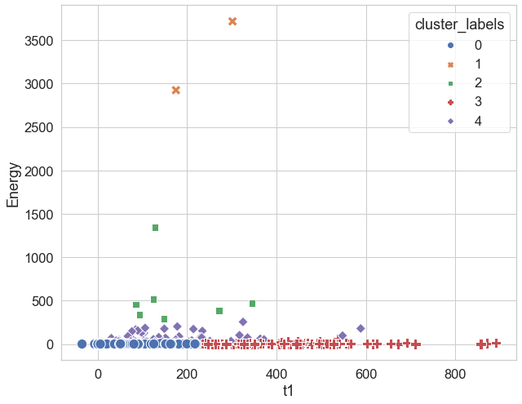 | 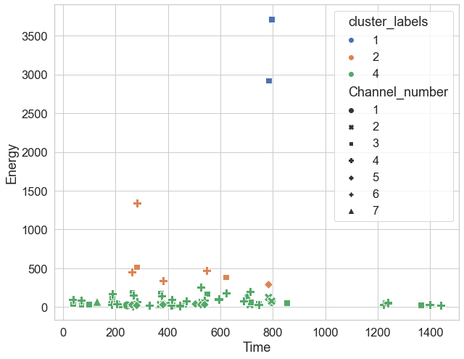
(a) | (b)
Figure 4. Result from clustering (a) Cluster labels with respect to energy and rise time (b) Experiment time vs energy for selected clusters

  - AE waveforms selection
The signal having highest energy from figure 4(b) has been selected and wave analysis is presented. The parametric analysis and AE data clustering were used for the selection of good AE signals. The good AE signals are the one which can justify the AE event with the parameters associated with the same. This can be done by frequency analysis (wavelet transform) of the AE signals. As observed in the Figure 2 (b), the initial events associated with the tensile cracks are having high frequency, whereas events due to shear cracks are having low frequency.
The sample waveform of AE response received at the bottom sensor shown in Figure 5. The waveform is corresponding to the tensile cracks generated at the bottom in the initial phase of the experiment. The FFT and wavelet transforms of the signal showing the higher frequency indicating the tensile crack.
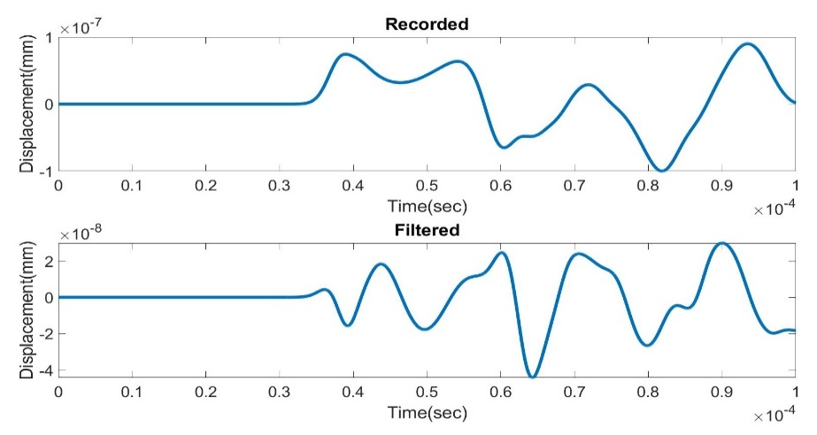 | 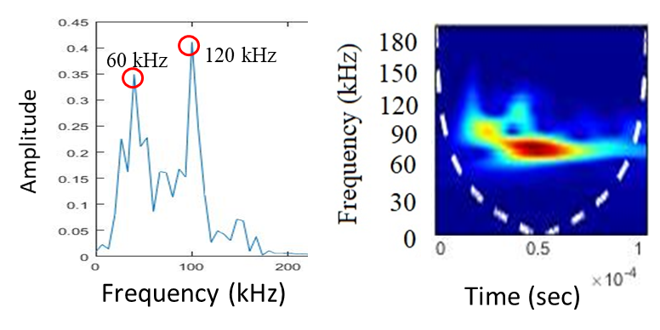
(a) | (b)
Figure 5. Frequency analysis of the selected AE waveform received at bottom sensor

- SUMMARY
The Acoustic Emission approach is receiving increasing recognition in the field of assessing the structural health of reinforced
concrete structures. However, noise reduction and suppression continue to be a challenge in AE data processing. Clustering
techniques have been offered in this study as a means of resolving this issue. Indeed, clustering can aid in the identification of underlying correlations between sets of data, such as fracture development mechanisms or noisy perturbations. It may serve as a
fundamental tool not only for classifying existing classes, but also for discovering new relevant classes.
Several techniques for automatically clustering and separating AE events based on several characteristics were used in this
work. The noise was isolated from the important events and then eliminated using a variety of different techniques such as PCA
and the k-means approach. Numerous validation strategies have also been devised for the examination of AE expression data. To enhance prediction of the number of relevant clusters, procedures for normalisation and validity aggregation have been presented.
Using acoustic emission for non-destructive testing of concrete structure reveals significant information of structure present condition as well as its serviceability in future. However, the process of acoustic emission, due to presence of various sources of noise and wide band of sensor, generates huge amount of data. AE data usually contains distinguishable groups based on their underlying patterns. To understand the damage process in concrete and to form a robust algorithm for damage detection, an algorithm based on unsupervised ML algorithm was developed based on features of AE waveform. This algorithm resulted in few separate clusters with distinctive properties. Thus, for further analysis, dataset can be filtered based on clusters.
REFERENCES

- Parhizkar, Tarannom. (2021). Evaluation and improvement of energy consumption prediction models using principal component analysis based feature reduction, Journal of Cleaner Production, 279.
https://doi.org/10.1016/j.jclepro.2020.123866
- Soucy, Pascal & Mineau, Guy. (2001). A simple KNN algorithm for text categorization. 647 - 648. 10.1109/ICDM.2001.989592
- Jiang, Qiuhong & Liu, Zhi-Chao & Liu, Weiwei & Li, Tao & Cong, Weilong & Zhang, Hongchao & Shi, Junli. (2018). A principal component analysis based three-dimensional sustainability assessment model to evaluate corporate sustainable performance. Journal of Cleaner Production. 187. 10.1016/j.jclepro.2018.03.255.
- Harsh Mahajan, Sauvik Banerjee (2022). A machine learning framework for guided wave-based damage detection of rail head using surface-bonded piezo-electric wafer transducers. Machine Learning with Applications. Volume 7,100216, ISSN 2666-8270,
https://doi.org/10.1016/j.mlwa.2021.100216.
- Pashmforoush F, Khamedi R, Fotouhi M (2014). Damage Classification of Sandwich Composites Using Acoustic Emission Technique and k-means Genetic Algorithm. Journal of Nondestructive Evaluation; 33:481–492. https://doi.org/10.1007/s10921-014-0243-y.
- Farhidzadeh A, Dehghan-Niri E, Salamone S. Gaussian Mixture Modeling of Acoustic Emissions for Structural Health Monitoring of Reinforced Concrete Structures. Proceedings of SPIE - The International Society for Optical Engineering. 2013.
- IS (Indian Standard) 10262:2019. Concrete mix proportioning – guidelines. Second revision.
- RILEM (Réunion Internationale des Laboratoires et Experts des Matériaux, systèmes de construction et ouvrages [International Union of Laboratories and Experts in Construction Materials, Systems and Structures]. [In French]). 2010. Acoustic emission and related NDE techniques for crack detection and damage evaluation in concrete, TC212-ACD,Material Structure 43:1177–81

