ABSTRACT: In order to study the ground surface vibration characteristics of road tunnels and the law of vibration propagation, the ground surface vibration of the adit for vehicle passing in a real road tunnel and the vibration of the road shoulder surface near the tunnel exit are measured. The acceleration time history of tunnel longitudinal, tunnel transversal and vertical direction under different working conditions are collected, and the frequency spectrum is also analyzed. By analyzing the acceleration peak value, frequency spectrum analysis and vibration acceleration level analysis of the component with larger absolute value in the acceleration, the influence of the vehicle traffic in the road tunnel on the ground surface vibration characteristics is studied. The experimental results show that: the maximum vibration acceleration energy of the western boundary of the adit for vehicle passing tunnel is greater than that of its eastern boundary and center; the vibration frequency range of the boundary of the adit for vehicle passing is wider than that of its center; the main vibration frequency ranges of the center and boundary of the adit for vehicle passing are 65-160Hz, 45-172Hz, respectively; The peak value of the acceleration vibration level near the tunnel exit is about 97dB, which is the largest among the center of the adit for vehicle passing in the tunnel, the boundary of the adit for vehicle passing in the tunnel and the road shoulder near the tunnel exit. The conclusions of this paper can be used as a reference for relevant departments to research such vibrations and take vibration reduction and isolation measures.
Ground Surface Vibration Characteristics Caused by
Vehicle Traffic in Road Tunnels

Wei Lu ¹, Wanpeng Zhang¹, Weihua Hu¹, Jun Teng¹, Dehui Tang¹
¹Department of Civil Engineering, Harbin Institute of Technology (Shenzhen), 518055, Shenzhen, China
Email : lu.wei@hit.edu.cn, zhangwanpeng@stu.hit.edu.cn, tengj@hit.edu.cn, huweihua@hit.edu.cn, tangdehui@stu.hit.edu.cn

KEY WORDS: Road tunnel; Adit for vehicle passing; Vibration acceleration energy; Spectrum analysis; Vibration attenuation; Acceleration vibration level.

INTRODUCTION
With the rapid development of the transportation [1], the scale of the city continues to expand, highways, expressways, subways, light rails, etc. come into being and developed continuously, gradually forming a spatial system underground, ground and air.
The emergence of these modes of transportation not only brings great convenience to people's travel, but also generates vibration and noise correspondingly, which affects people's lives and even has a great impact on underground structures. Internationally, traffic vibration pollution is also listed as one of the "seven major public hazards" [2].
Many scholars have done a lot of theoretical and experimental research on this [3-4]. Hajek et al. [5] mentioned that the traffic dynamic load caused by random ground surface irregularity is about 15% larger than the static load, and the dynamic load caused by specific ground surface unevenness is 50%~80% larger than the static load. Vogiatzis et al. [6] carried out vibration evaluation for the Athens subway section through a large number of vibration measurements and data analysis. Crispino et al. [7] conducted field measurements on buildings adjacent to traffic arteries in Naples, Italy. The results showed that the peak speed exceeds the somatosensory limit, and the building vibration even exceeds the minimum damage limit in extreme cases. Turumen-Rise et al. [8] and Klaeboe et al. [9] conducted field tests on buildings adjacent to traffic arteries in a large number of areas in Norway, and the results show that the impact of traffic vibration significantly affects adjacent buildings safety and the comfort of people in the building. Jia et al. [10] measured the ground vibration caused by driving heavy-duty trucks and analyzed the vibration attenuation from the acceleration peak value, frequency spectrum and vibration level. Zhao et al. [1] proposed the calculation formula for the acceleration of the foundation of the structure caused by the passing of the vehicle and the calculation method of the ground vibration attenuation caused by the vehicle and verified it with the actual measurement. Lou et al. [11] measured the vibration of a certain tunnel section and the nearby surface respectively and found that the main frequency and attenuation law of vibration of highway traffic and tunnel traffic are different. Qin et al. [2] measured the site vibration caused by urban ground traffic and found the attenuation law of the vibration caused by the bus with distance.
However, the above studies have not carried out in-depth research on the ground surface vibration characteristics of road tunnels. Based on this, this paper takes the ground surface vibration caused by vehicles passing through road tunnels in urban traffic as the analysis object and analyzes the maximum vibration acceleration and vibration frequency range by measuring the ground surface acceleration response of road tunnel to clarify the vibration characteristics of road tunnels.

Field measurement

Brief introduction of the actual measurement site
The measurement site is located in a real road tunnel where vehicles normally pass. The road tunnel is a two-way three-lane tunnel and in the middle of the tunnel there is an adit for vehicle passing. The adit for vehicle passing is an access for rescue or personnel in an emergency [12], which should be connected vertically with the main caves in order to facilitate the two-way access of rescue vehicles. The speed limit of small vehicles in the tunnel is 60km/h, and the speed limit of large vehicles such as trucks is 40km/h.

Layout of measuring point
A total of 11 measuring points are arranged on the site, including 3 measuring points in the adit for vehicle passing, 4 measuring points on the shoulder near the adit for vehicle passing, and 4 measuring points near the tunnel exit.
The central measuring point H0 of the adit for vehicle passing is placed on the middle ground of it, the boundary measuring point H1 of the adit for vehicle passing is placed on the western boundary of the adit, and the boundary measuring point H2 is placed on the eastern boundary of the adit. Both the distance between measuring points H0 and H1, and the distance between H0 and H2 are about 13m.
The road shoulder measuring points J1 and J2 are respectively placed at about 15m and 30m on the western side of the adit from H1, and the road shoulder measuring points J3 and J4 are respectively placed at about 15m and 30m on the eastern side of the adit from H2. The schematic diagram of the layout of measuring points of the adit for vehicle passing and the road shoulder is shown in Figure 1. Tunnel exit measuring points C1, C2, C3, and C4 are respectively placed at about 2m, 18m, 36m, and 48m from the tunnel exit in the westbound section of the tunnel, which is shown in Figure 2.
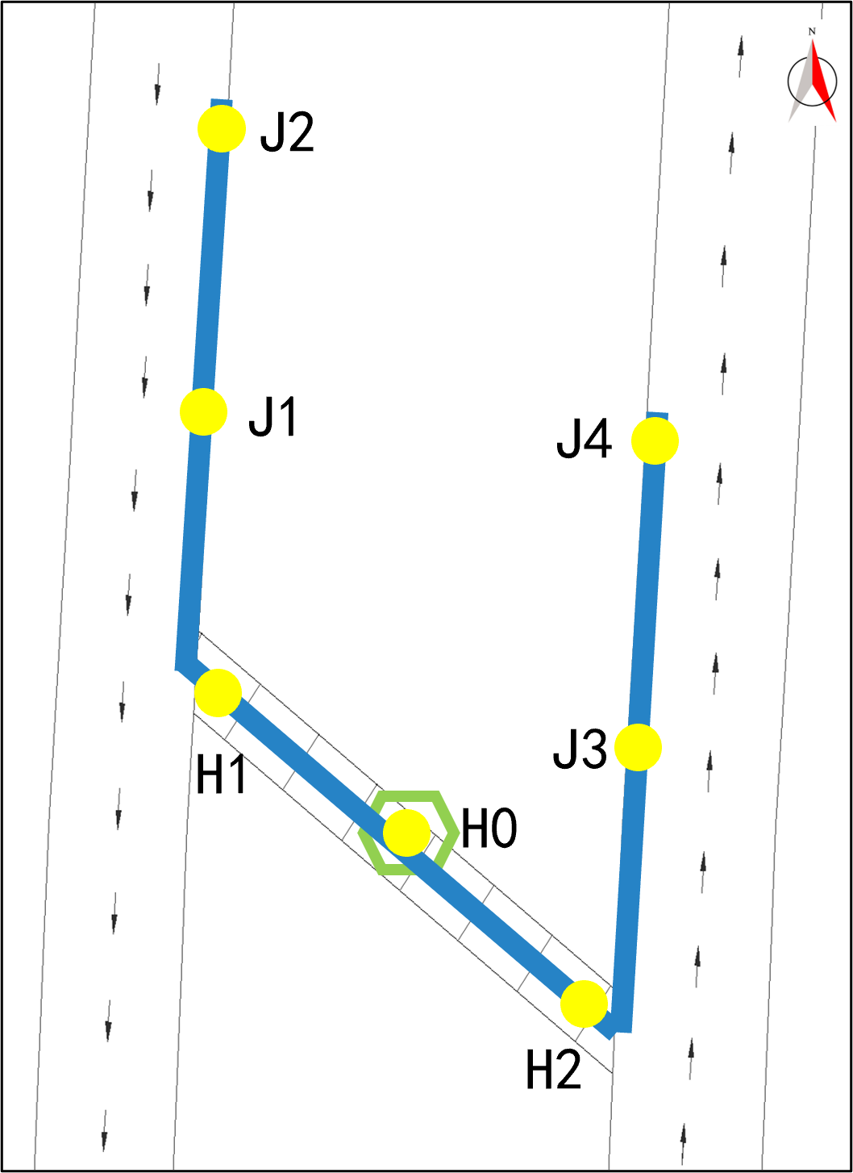
Figure 1. Measuring point near adit for vehicle passing
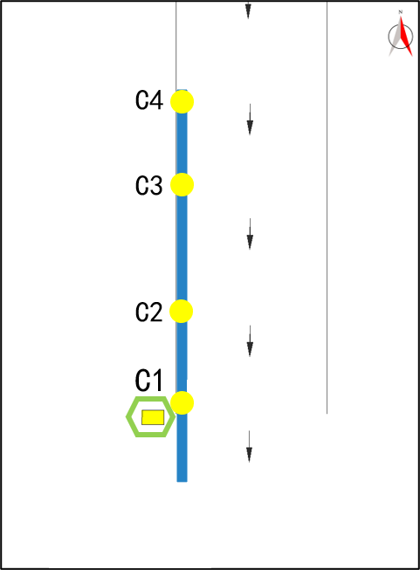
Figure 2. Measuring point of tunnel exit shoulder

Measurement equipment
The equipment used in this field measurement includes the following:
- 991B and 941B acceleration sensor
- data gathering equipment from NI
- mobile power
- collection computer.
The sampling frequency is set as 500Hz, the acceleration sensors are adjusted to the acceleration gear, and the measurement starts after confirming that the acquisition equipment can work normally. During the measurement, many records are made consisting of the acquisition channel corresponding to the measuring point, the distance between the measuring points, the start time and the end time of the measurement, and so on. The reflective triangles for vehicles are also placed in front of the measuring point to prevent the tunnel staff or other personnel from interfering with the recording. The sensors located in the tunnel are shown in Figures 3 and 4.
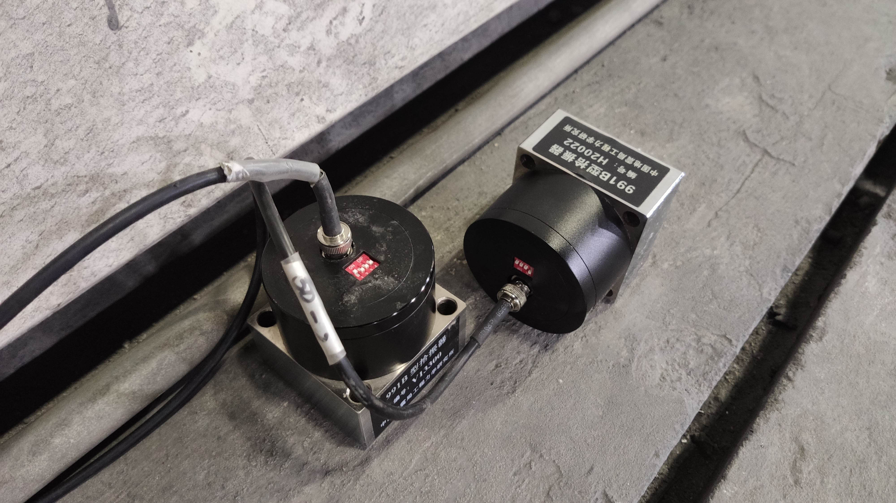
Figure 3. 991B acceleration sensor.
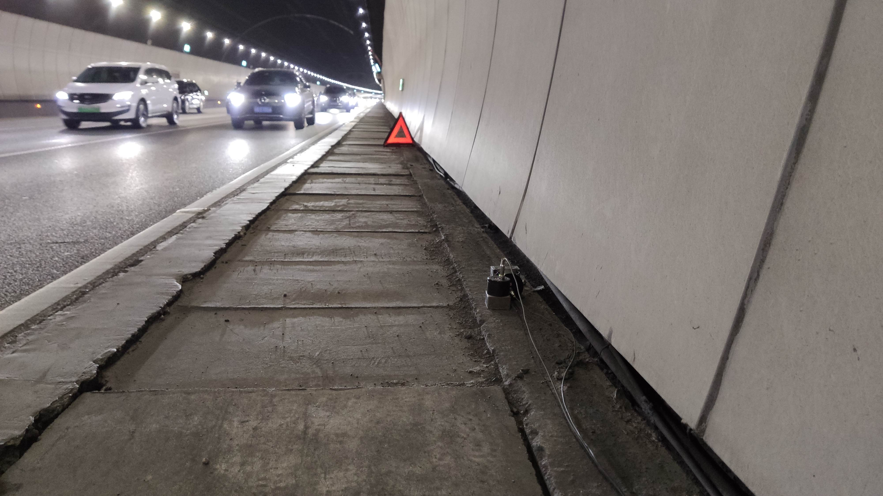
Figure 4. Road shoulder measuring point near adit.

Measurement condition settings
The measurement starts at 02:00 on December 30, 2021， recording the vibration acceleration of each measuring point， exporting a set of data every 10 minutes and saving data in the collection computer. A total of 206 sets of vibration acceleration are gathered. Due to the limited length of the article, only part of the data is shown in this paper. The list of measurement location conditions is as follows:
Table 1. Measurement location table.
Measurement location | 02:00-14:00 | 14:00-02:00 | 06:00-15:00
Location 1 | Inside adit Near adit
Location 2 |  | Inside adit Near adit
Location 4 |  |  | Inside adit Tunnel exit

Field measurement
Through time history analysis, frequency domain analysis and acceleration vibration level analysis, the law of road tunnel ground surface vibration caused by vehicles passing through is studied from various angles. According to the monitoring statistical data of the real road tunnel and its traffic flow during the measurement period, the vibration acceleration data collected during the peak period of the westbound section from 07:00 to 09:00 are determined and analyzed.

Time History Analysis
According to the measurement results, the 10-min acceleration time-history curves of the center of the adit for vehicle passing and the road shoulder measuring points near the boundary of the adit under peak conditions are shown in Figures 5-7.
Figure 5. Vertical direction acceleration of H0.
Figure 6. Vertical direction acceleration of H1.
Figure 7. Vertical direction acceleration of H2.
It can be seen from Figures 5-7 that the maximum vibration acceleration energy at the center of the adit is 0.011281 (m/s²), the maximum vibration acceleration energy at the boundary of the adit is 0.045232 (m/s²), and the maximum vibration acceleration energy on the western boundary of the adit is greater than both the eastern boundary and the center of the adit.

Frequency Domain Analysis
The vibration spectrum of a certain period of acceleration time history of each measuring point during the peak period can be obtained by power spectrum analysis (PSD). In the analysis process, the outliers are filtered out by filtering. Then the frequency diagram of the center of the adit for vehicle passing, the road shoulder near the boundary of the adit, and the road shoulder near the tunnel exit under the final peak condition is shown in Figures 8-10.
As can be seen from Figure 8-10, the main frequencies of the center of the adit for vehicle passing are 65Hz, 85Hz, and 160Hz, the main frequencies of the western side of the adit for vehicle passing are 45, 55, and 62Hz, and the main frequencies of the eastern side of the adit for vehicle passing are 70, 130, and 172Hz; the dominant frequency on the eastern side of the adit for vehicle passing is higher than that on the western side, and the frequency range of the boundary of the adit is wider than that of the center.
Figure 8. Vibration frequency and energy of H0.
Figure 9. Vibration frequency and energy of H1.
Figure 10. Vibration frequency and energy of H2.

Vibration level analysis
Vibration acceleration level is often used as a numerical index to characterize vibration intensity. The vibration acceleration in numerical calculation is converted into vibration acceleration level to analyze the propagation law of ground vibration caused by traffic of the road tunnel. Reference [13] gives the calculation formula of vibration acceleration level as follows:
VAL = 20log (a_{rms}/ a₀) (1)
Where: VAL is the vibration acceleration level, dB; a₀ is the reference acceleration, 10⁻⁶m/s²; a_{rms} is the effective value of the vibration acceleration, m/s².
It can be seen from Figures 11-12 that the peak acceleration vibration level of the road shoulder near the tunnel exit is about 97dB. As the distance from the tunnel exit increases from 2m to 36m, the peak acceleration vibration level of the road shoulder shows a trend of attenuation.
Figure 11. Tunnel longitudinal direction of C1.
Figure 12. Tunnel longitudinal direction of C3.

conclusions
The vibration response of the ground surface around a road tunnel is relatively complex, and more field measurements are still needed to master its propagation law at present. In this paper, through the field measurement of the ground surface vibration of the real vehicle-passing road tunnel, the acceleration time histories in the tunnel longitudinal, tunnel transversal and vertical directions of the tunnel under different working conditions are collected, and the following conclusions are drawn after acceleration peak value analysis, frequency spectrum analysis and vibration acceleration level analysis, which can be a reference for relevant departments to research and control vibration:
(1) The maximum vibration acceleration energy of the boundary of the adit for vehicle passing is 0.045232 (m/s²), which is greater than the maximum vibration acceleration energy of 0.011281 (m/s²) at the center of the adit. The maximum vibration acceleration energy of the western boundary of the adit is larger than that of the eastern boundary and the center of the adit. Therefore, in the actual measurement of the road tunnel, the arrangement of the measuring points on the western side of the adit can be appropriately increased.
(2) The main frequency range of the center of the adit for vehicle passing of the tunnel is 65-160Hz, the main frequency range of the adit boundary is 45-172Hz, so the frequency range of the adit boundary is wider. Therefore, in the future field measurement, the sampling frequency of the measuring points near the boundary of the adit and the tunnel exit can be appropriately increased.
(3) The peak value of the acceleration vibration level near the tunnel exit is about 97dB, and it shows a decreasing trend with the increase of the distance from the tunnel exit.
(4) It is necessary to reduce the impact caused by the vibration induced by the traffic of the road tunnel by adopting speed and traffic restrictions during peak hours.

ACKNOWLEDGMENTS
This work was supported by the National Natural Science Foundation of China [grant numbers 52122804, 51978214, 51878226], Shenzhen Knowledge Innovation Program (KCXFZ202002011010039), and the Fundamental Research Funds for the Central Universities [grant number HIT.BRET.202101].

References
- R. Zhao, Y.G. Zhang, Calculation method of vehicle-induced ground vibration attenuation, Vibration, Measurement and Diagnosis, 35, 02, 295-301+399, 2015.
- L. Qin, G. Zong, Measured analysis of site vibration caused by ground traffic load, Highway, 05, 194-198, 2013.
- H. Verbraken, G. Lombaert, G. Degrande, Verification of an empirical prediction method for railway induced vibrations by means of numerical simulations, Journal of Sound and vibration, 330, 08, 1692-1703, 2011.
- H. Hao, T.C. Ang, J. Shen, Building vibration to traffic-induced ground motion, Building and Environment, 36, 03, 321-336, 2001.
- J.J. Hajek, C.T. Blaney, D.K. Hein, Mitigation of highway traffic-induced vibration, 2006 Annual Conference of the Transportation Association of Canada, 01-13, 2006.
- K. Vogiatzis, Protection of cultural heritage from underground metro vibration and ground-borne noise in Athens Centre: The case of the Kerameikos Archacological Museum and Gazi Cultural Centre, International Journal of A coustics & Vibrations, 12, 02, 39-72, 2012.
- M. Crispino, M. D’apuzzo, Measurement and prediction of traffic-induced vibration in a heritage building, Journal of Sound and Vibration, 246, 02, 319-335, 2001.
- I.H. Turumen-Rise, A. Brekke, L. Harvik, et al., Vibration in dwellings from road and rail traffic Part Ⅰ: A new Norwegian measurement standard and classification system, Applied Acoustics, 64, 01, 71-87, 2003.
- R. Klæboe, I.H. Turumen-Rise, L. Harvik, et al., Vibration in dwellings from road and rail traffic Part Il: Exposure-effect relationships based on ordinal logit and logistic regression models, Applied Acoustics, 64, 01,89-109, 2003.
- B.Y. Jia, M.L. Lou, G. Zong, et al., Field measurements for ground vibration induced by vehicle, Vibration and Shock, 32, 04, 10-14, 2013.
- M.L. Lou, G.B. Tan, In situ experimental and attenuation analysis of environmental vibration by tunnel and road, Chinese Quarterly of Mechanics, 34, 04, 663-672, 2013.
- Ministry of Transport of the People's Republic of China, Guidelines for Design of Highway Tunnel, JTG/T D70-2010, Beijing, China Communications Press, 2010.
- Ministry of Housing and Urban-Rural Development of the People's Republic of China, Allowable Vibration Standards for Construction Engineering, GB 50868—2013, Beijing, China Planning Press, 2013.

