Optical-band satellite remote sensing of river turbulent and flow features to assist in structural health monitoring of bridge stability
Helen Stewart¹, Richard Simpson¹, Anthony Peach², David Millar¹, Daniel Cusson³, Steven Anderson⁴
¹ Fugro USA Marine, Houston, Texas, USA
²Fugro Canada Corp., St. John’s, Newfoundland, Canada
³ National Research Council Canada, Ottawa, Ontario, Canada
⁴ Areté Associates, Longmont, Colorado, USA
Email : hstewart@fugro.com, rsimpson@fugro.com, anthony.peach@fugro.com, dmillar@fugro.com,
daniel.cusson@nrc-cnrc.gc.ca, spanderson@arete.com

ABSTRACT

With the advent of very high resolution multi-spectral commercial satellite imagery, it is possible to observe fine-scale surface turbulent and flow features around built structures and naturally occurring features. High-resolution stereo satellite images are separated in time and may be fed into Particle Image Velocimetry algorithms to determine current speed and direction over the area surrounding a structure. River currents and turbulent features are dynamically linked to the river morphology. Detecting changes in the flow features can be an indirect indicator morphological change occurring around the structure or if the main river channel is shifting, bringing spatial context into time-series observations from instruments mounted to structures.

A pilot study of flow features around bridges in the La Prairie Basin of the Saint Lawrence River, near Montréal, Canada, was conducted to gain a deeper understanding of how observing these features may be used for structural health monitoring. Sixteen mono satellite images and one Airbus Pleiades Tri-Stereo image acquired March 2019 – September 2021 were obtained for the study. The Airbus Pleiades Tri-Stereo image was tested using Areté Particle Image Velocimetry software to obtain remotely sensed river current and speed vectors. These current vectors were consistent with available in-situ data and information on published nautical charts. The mono image set, including the central scene of the Tri-Stereo image, were qualitatively inspected to determine presence, persistence, and morphology of turbulent and flow features and how they varied over time. Changes in turbulent feature morphology associated with construction activity and with nearshore accretion were observed in two bridges in the La Prairie Basin: the Samuel de Champlain Bridge and the Nun’s Island Bypass Bridge.
KEY WORDS: SHMII-11, Remote Sensing; Multi-Spectral Imagery; Particle Image Velocimetry; Turbulence; Sediment Transport; Structural Health; Infrastructure Monitoring

Introduction
Novel research on observing the presence and morphology of turbulent water column structures in optical-band satellite imagery was first presented in 2020 as a means for hydrographic surveyors to detect submerged and awash dangers to navigation in shallow waterways or to identify variation in surface currents for survey planning purposes¹.

These turbulent features, including vortex streets, vortex dipoles, and turbulent jets, are commonly observed to form near built structures in rivers and near-coastal bays and estuaries. The relationship between turbulent and flow features and water bottom sediment motion is robust enough that flow features on the water’s surface can be used to detect evidence of erosion, scouring, or accretion even when the water is not optically clear. The researchers proposed a pilot study to observe flow features around bridges and structures in the La Prairie Basin of the Saint Lawrence River near Montréal, Québec, Canada to determine if observed river flow features correlated to changes in bathymetry or above-waterline changes in bridge structures. In addition, stereo imagery was acquired and processed using Particle Image Velocimetry (PIV) software as a proof-of-concept to determine if PIV results could be obtained using optical-band satellite imagery.

METHODS

Study Area Background and Survey Control
The study comprised a 25 km² Area of Interest (AOI) in the La Prairie Basin and surrounding urban areas near the city of Montréal, Québec, Canada. Figure 1 shows the study area in plan view. Eight major bridges are present in the AOI, including the newly constructed Samuel de Champlain and Nun’s Island Bridges and the temporary Nun’s Island Bypass Bridge, as well as infrastructure associated with the Port of Montreal, the Saint Lawrence Seaway, and the Estacade, a structure designed for ice control on the river.

The AOI included land areas so that images could be georeferenced to existing photogrammetric ground control points. Ground Control Points were chosen by comparing high-resolution imagery in Google Earth with benchmark datasheets obtained from the Réseau Géodésique du Québec. Nine monuments were confirmed to exist and were used for ground control. These points are shown in Figure 1.

Water depths are relative to Low Water Datum (LWD) as defined at Jetée No.1 of the Port of Montréal. Depths are positive above LWD and negative below LWD.

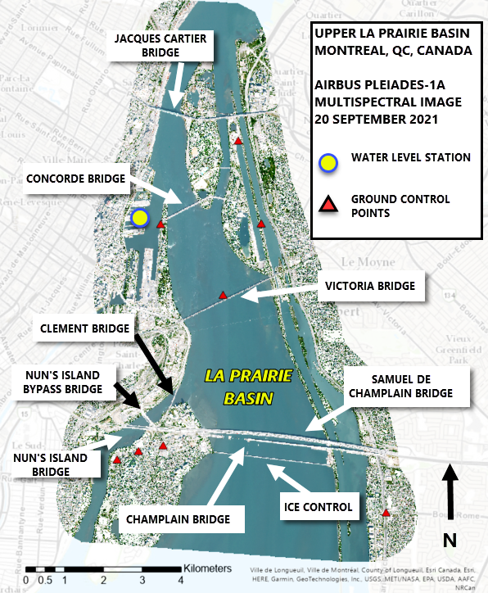
Figure 1. La Prairie Basin Area of Interest

Satellite Image Selection
Eighteen individual high-resolution panchromatic-band (PAN) images from either Airbus Pleiades or Maxar Worldview satellites corrected to top-of-atmosphere reflectance forming sixteen total mono image scenes were acquired in the Area of Interest. These images were acquired over the period of March 2019 to September 2021. Image selection criteria was minimal cloud cover, no aerosol interference (e.g., pollution), and no low fog. The image set included at least one image from every calendar month except December and January (no cloud-free images were available). Three images included ice cover on the water’s surface. One image, acquired 20 September 2021, had very clear water in the river and the water level was only 20 cm above Low Water Datum; this image was used for multispectral analysis. All images were georeferenced to the WGS84 datum using the previously described ground control points, projected into planar coordinates in the MTM-8 projection, and orthorectified using the High-Resolution Canadian Digital Elevation Model (HR-CDEM) of 2013.

One Airbus Pleiades Tri-Stereo image dated 3 April 2021 was acquired for processing with Arete PIV software. The images in the Tri-Stereo set were acquired in sequence with 17.5 s elapsed time between the first and second images and 20.6 s between second and third images. PAN images from the Tri-Stereo set were georeferenced into WGS84 geographic coordinates using the photogrammetric control points as described above and converted into NITF format for processing.

RESULTS

Particle Image Velocimetry Image Processing
The georeferenced Airbus Pleiades Tri-Stereo set of 3 April 2021 converted into NITF format were loaded into software developed by Areté Associates of Colorado for Particle Image Velocimetry processing².

Surface current extraction in the project area was achievable at different sampling densities. The time separation between image subsequent image acquisitions and expected range of current velocities determine the spatial resolution for this type of algorithm. The time separation for the subsequent Pleiades Tri-Stereo images are 17.5 s and 20.6 s and maximum current speed in the project area is approximately 3 ms⁻¹ near the Port of Montréal, giving a whole-AOI native spatial resolution of current sampling (X/Y/Velocity) of 115 m and subsampled (X/Y/Velocity) spatial resolution of about 100 m. Closer to the Samuel de Champlain Bridge, typical current speeds are between 0.5 – 1.5 ms⁻¹ and native resolution between 20 – 30 m and subsampled resolutions of 15 m were achieved.

River current speed and direction obtained from the PIV algorithm were consistent with historical data available for the region. The area of fastest-flowing currents overlapped with data from published Canadian Hydrographic Service nautical charts³, pre-construction environmental studies⁴, and GIS data about the Samuel de Champlain Bridge provided by Fugro geotechnical engineers who worked in design phases of the bridge.

A stick plot of current speed and direction sampling points in the full AOI (115 m sample spacing) is shown in Figure 2.

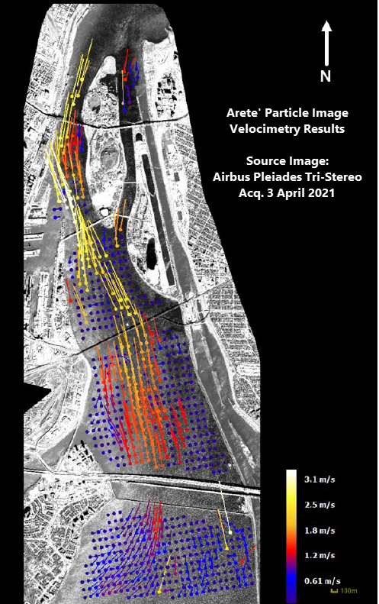
Figure 2. Particle Image Velocimetry Results

Mono Image Stack Analysis
Observations of flow features at the Samuel de Champlain Bridge are limited to areas over open water of the Greater La Prairie Basin, bounded by the Saint Lawrence Seaway Levee. Areas east of the levee were not considered as current speeds in the Saint Lawrence Seaway channel are controlled by canal lock activity and not natural river flow.

PAN-band images in the Mono image set were analyzed by inspection in ArcGIS Pro software. Images were assessed to determine presence, morphology, persistence, and direction of travel of vortices and turbulent features shed downstream of piers of the Samuel de Champlain Bridge, the Nun’s Island Bridge, and the Nun’s Island Bypass Bridge.

For the waters in the immediate vicinity of the Samuel de Champlain Bridge, there was a strong correlation between persistence of vortices shed downstream and the deepest part of the main river channel. Figure 3 shows water-surface turbulent features (blue/yellow palette) overlaid on multibeam sonar data from the pre-construction environmental survey. In the deepest part of the river channel, individual vortices (small yellow arrows) remained coherent at distances up to about 800 m from the downstream edge of the bridge pier (white arrow). East of Pier W-14 (white circle), river depth decreases from -6 m LWD to -2 m LWD, and turbulent features do not persist more than about 200 m downstream.

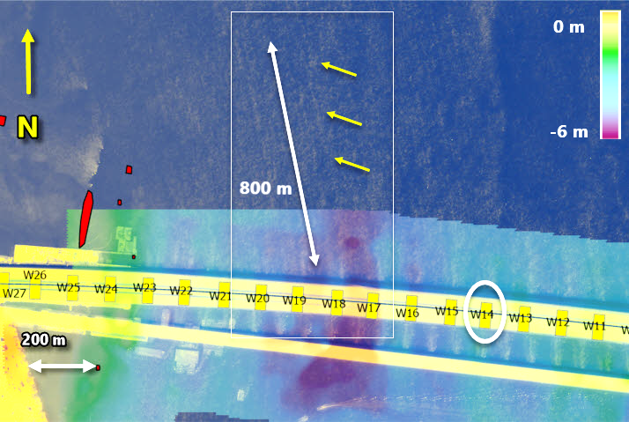
Figure 3. Turbulent flow persistence vs. depth

Surface flow features indicate a change in river current flow direction occurring at or near Pier W-23 of the Samuel de Champlain Bridge. Shed vortices propagate downstream in the direction of the prevailing currents. In imagery from July 2020 to July 2021, a 45° westward change in river current angle of attack from upstream to downstream of Pier W-23 was observed, with the inflection point occurring almost directly underneath the pier itself. Qualitative results from image inspection were compared to quantitative results from the Areté PIV software, and the results correlated well.

Mono images from March 2019 – June 2020 showed a gravel pad in the vicinity of where the current flow deviation was first observed. The image from 18 July 2020, the first image in
which the flow deviation was observed, contains a surface hose which was interpreted to be dredging equipment. The flow direction change was thus interpreted to be caused by of incomplete subsurface removal of the gravel pad, which was later confirmed by the bridge authority (personal communication, May 2022). To the west of the area of flow deviation, there is some evidence of sediment deposition west of Pier W-24: land-fast ice where it was not previously observed and changes in sediment colour in the multispectral image acquired on 20 September 2021.

Figures 4(a) – 4(d) show the current deviation over time. The change in current angle of attack is indicated by red arrows. In Figure 4(a), the dredging hose is shown in a cyan circle. The acronyms “PL” and “WV” in the image titles refer to Airbus Pleiades and Maxar Worldview images, respectively.

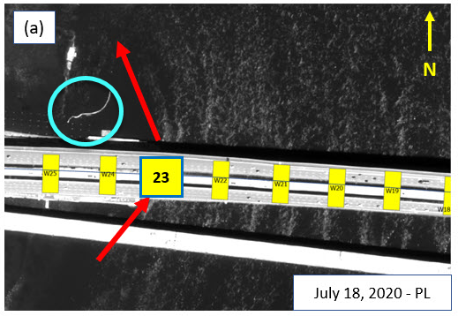
Figure 4(a). Flow deviation & dredging apparatus

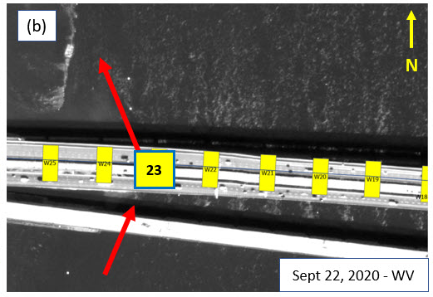
Figure 4(b). Flow deviation persists after 3 months

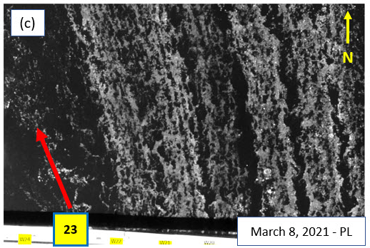
Figure 4(c). Flow deviation visible in broken ice

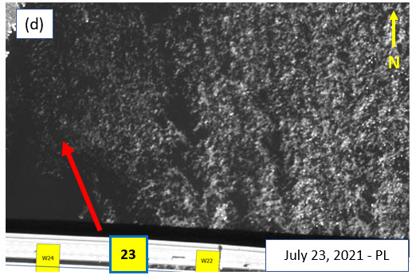
Figure 4(d). Flow deviation is persistent after a year

DISCUSSION

The key finding of research conducted by the first author for hydrographic surveying and safety of navigation is that data in the water column has value. Satellite-derived bathymetry for nautical chart purposes typically limits the analysis of multi-spectral satellite images to only those with optically clear water and the ability to see the water bottom. By adding analysis of turbulence patterns, turbidity patterns, and breaking waves and white water in multi-spectral imagery, hydrographic surveyors gain an additional tool in their toolbox.

This study extended these investigations of turbulent flow features to waterways around built structures. While we were unable to compute satellite-derived bathymetry due to the complex hydrodynamics of the La Prairie Basin, and thus could not make direct observations of potential scouring around bridge piers in the study area, the presence and distribution of turbulent river flow features correlated well with existing information on river bathymetry, current speeds, and known seasonal variation in flow. We were able to observe changes in river current speed and direction, distribution of land-fast ice, and sediment colour near the new Samuel de Champlain Bridge correlated with a change in current flow caused by a change in river morphology (construction of the gravel pad).

Numerous types of geodata can be obtained by analyzing multi-spectral satellite image sets near built structures, ranging from turbulent features on the surface to spatial information on currents to sediment colour to presence and distribution of ice. We call this the Environmental Envelope. In structural health monitoring, combining Environmental Envelope data around a structure with in-situ operational technical data helps asset owners better understand any anomalies in the in-situ data and in some cases (such as the gravel pad example) identify the likely cause. With the large footprint and rapid update capability of satellite remote sensing, it is possible to simultaneously monitor the Environmental Envelope of several assets on a given river reach with the same dataset.

The number of commercial satellites continues to increase, which is driving down the cost and increasing availability of imagery. It may soon be cost effective to repeatedly task satellites to routinely monitor for environmental changes around structures and possibly determine the real-world cause of those changes without an inspection. Where inspections are required, whether they are routine or if operational technical data indicates an anomaly, Environmental Envelope data helps asset owners plan smarter instructions, such as designating priorities, or safer inspections, such as assessing waterways for new hazards after flood events before in-situ inspection crews arrive on scene.

CONCLUSIONS
This collaborative pilot project explored the feasibility of analyzing multi-spectral satellite remote sensing data for the purpose of structural health monitoring. We demonstrated that mapping turbulent flow features observed in the multi-spectral satellite image set is suitable as an indirect indicator of water bottom morphology and that quantitative data on river current speed and direction can be obtained from Airbus Pleiades Tri-Stereo multispectral satellite imagery using a Particle Image Velocimetry algorithm.

Future studies on using multi-spectral satellite remote sensing of the surfaces of waterways will offer more insight into how this technology can be used for structural health monitoring and conditional asset maintenance.

acknowledgments
The authors would like to acknowledge the financial support of Infrastructure Canada through the National Research Council Initiative on Climate Resilient Built Environment and of contributions from Fugro USA and Fugro Canada.

References
- Stewart, van de Poll, and Brumley (2020). Satellite water column data for hydrography. International Hydrographic Review No. 23, May 2020.
- Dugan, John P., and Cindy C. Piotrowski (2012). Measuring currents in a coastal inlet by advection of turbulent eddies in airborne optical imagery. Journal of Geophysical Research: Oceans 117.C3.
- Canadian Hydrographic Service Chart V-1429-CA579227 “Canal de la Rive Sud” Ed. 1.013, 24 March 2010. Department of Fisheries and Oceans Canada, Québec City.
- Dessau-CIMA+ (2013). A New Bridge for the St. Lawrence Environmental Assessment – Summary Report – Project and Environmental Description. Dessau-CIMA+ Report 068-P-0000810-0-00-110-01-EN-R-0001-00

