ABSTRACT: There is considerable interest in network-wide structural health monitoring of bridges. Spaceborne InSAR technology appears to be uniquely positioned for this task. Its primary advantage is fast and efficient wireless data collection over large geographic areas. However, as opposed to many ground monitoring applications, there are some specific factors to consider in order to obtain actionable results when scaling up spaceborne remote sensing from a single bridge to a complex network of hundreds of bridges. Of prime importance is the ability to deliver timely deformation data at user-specified locations on the structure. Additional research may be needed to accomplish this task.

Feasibility of network-wide bridge monitoring from space
Edward Hoppe¹
¹Virginia Transportation Research Council
530 Edgemont Road
Charlottesville, Virginia, 22903, USA
Email : edward.hoppe@vdot.virginia.gov
KEY WORDS: SHM; InSAR; Satellite; Bridge monitoring.

INTRODUCTION
The problem of ageing transportation infrastructure, compounded by extreme weather events, underscores the need for structural health monitoring (SHM). Effective monitoring of the structural condition of existing infrastructure is critical to public safety. To achieve this goal, SHM augments conventional visual inspections with various sensor technologies. One of the available approaches is spaceborne remote sensing. This technology is fairly mature and has recently undergone numerous advances with respect to the processing algorithms. Using a satellite as a sensing platform is conceptually attractive because it allows monitoring of wide geographic areas at any location on the Earth’s surface.

Theory of operation
The idea of implementing spaceborne remote sensing to the monitoring of transportation infrastructure centers on the use of synthetic aperture radar (SAR). SAR operates by transmitting radar pulses along the path of a rapidly moving platform and subsequently combining (synthesizing) the return echoes to reconstruct the surface of interest. This approach effectively simulates the use of a large physical antenna, allowing extremely high resolution imaging in the cross range direction [1].
The application of satellite radar remote sensing to infrastructure monitoring involves a numerical signal processing technique commonly known as Interferometric Synthetic Aperture Radar (InSAR). Of prime interest is the precise determination of the phase component of the return radar signal. The difference in the phase angle computed from the successive revisit scans over the same location is translated into the actual surface displacement along the satellite line of sight (LOS), as shown in Figure 1. Accuracy on the order of a small fraction of the signal wavelength can be achieved.

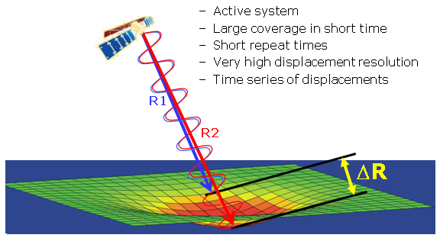
Figure 1. Principle of InSAR differential measurement.
The propagation and the backscatter characteristics of the radar signal depend on its frequency. Typically the objective is to minimize signal attenuation. Table 1 lists common frequencies and the corresponding wavelengths for radar signals.
Table 1. Radar frequencies and applications.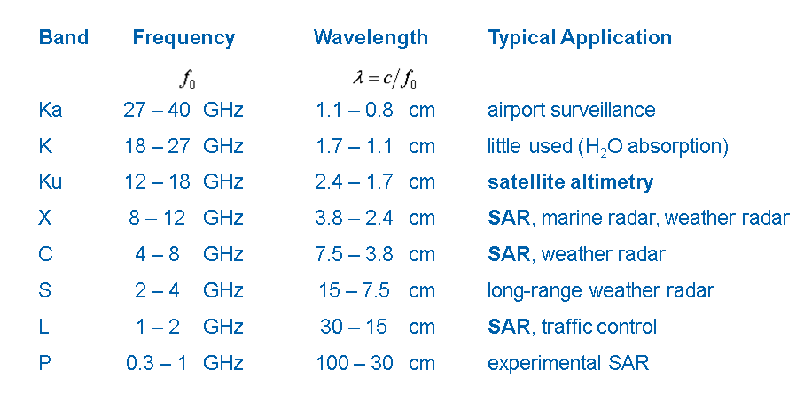
Typically only C, X, and L radar bands are used for civilian applications. Higher frequencies offer greater measurement accuracy but usually at a cost of reduced spatial coverage.
Signal backscatter depends greatly on the monitored surface characteristics, primarily roughness. However, roughness is a relative quantity, strongly dependent on the radar signal frequency. The scatterers detected by the InSAR technique are typically classified as permanent (PS), temporary (TS), and distributed (DS). Distributed scatterers are indicative of some irregular area, and permanent scatters provide coherent data at specific locations over the entire monitoring period. Satellite-based interferometric techniques have already been proven very effective in detecting minute displacements of the Earth’s surface over a wide range of applications [2, 3, 4, 5].

CASE STUDIES
Figure 2 shows the results of SqueeSAR algorithm X-band data processing over parts of Washington, D.C. Consistent with the commonly adopted convention, “hot” colors indicate areas of significant movement. The red band of PS points corresponds to the extent of subsidence caused by groundwater extraction associated with a tunnel construction. The south portion of the image shows bridges near Anacostia. It can be seen that the PS point density at these bridges is relatively low and random. These remote sensing data were acquired by the COSMO-SkyMed satellite in Stripmap mode (3x3m).
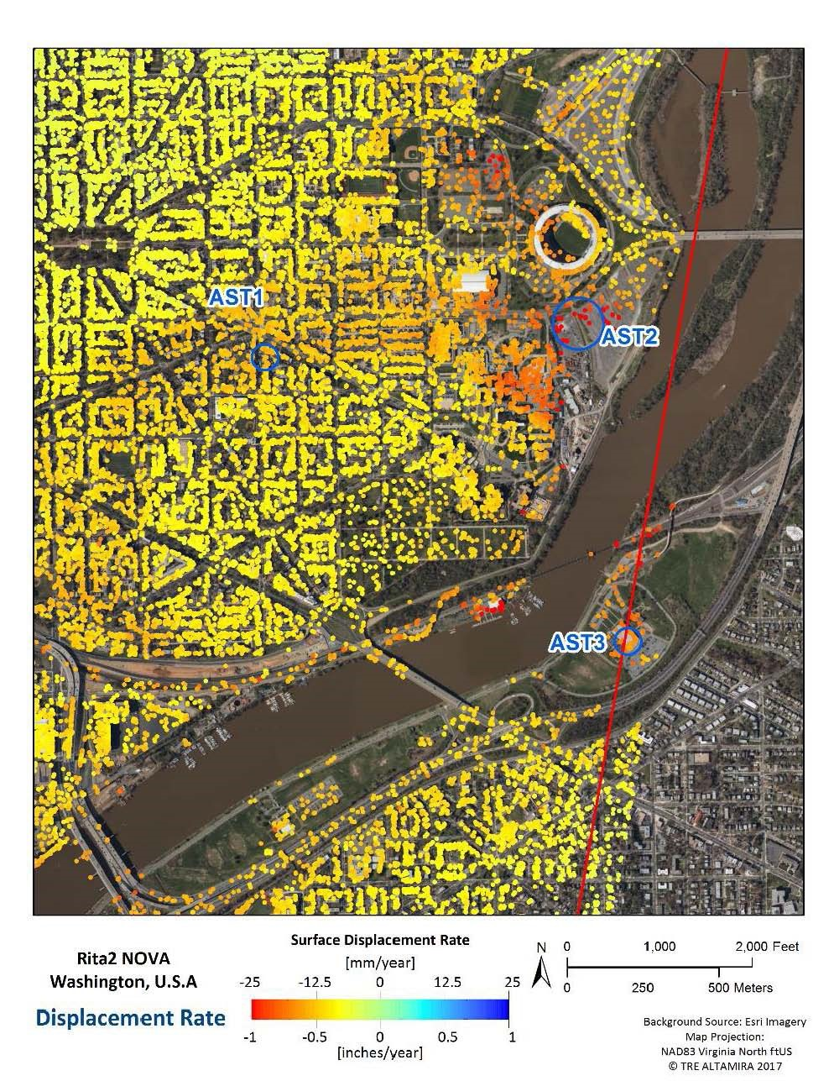
Figure 2. Distribution of X-band scatterers over Washington, D.C.

Figure 3 shows the results of X-band processing on the Woodrow Wilson Bridge over the Potomac River near Alexandria, Virginia. The bridge has a traffic volume of approximately 200,000 vehicles per day. As a consequence, it may not be realistic to expect identifiable PS points along the traffic lanes. Most of the identifiable scatterers are associated with secondary features on the bridge, parapets, lamp posts, and overhead traffic signs. These are not necessarily locations indicative of the bridge structural health. Data were acquired by the COSMO-SkyMed satellite in Stripmap mode (3x3m) and subsequently processed using the SqueeSAR algorithm.

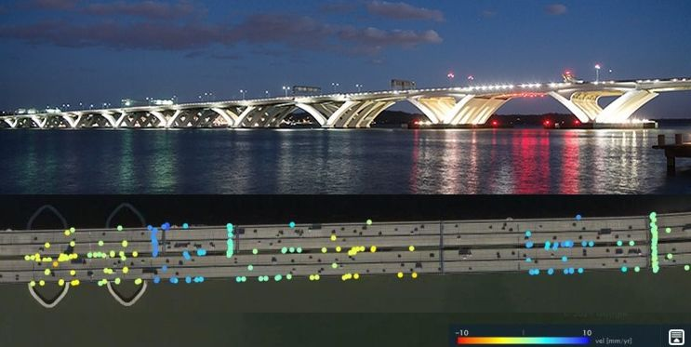

Figure 3. Distribution of X-band permanent scatterers across the Woodrow Wilson Bridge.

Figure 4 shows two bridges linking the town of West Point, Virginia. Relatively high spatial density was achieved through the use of the Staring Spotlight mode of data acquisition with the TerraSAR-X satellite, in contrast to the traditional Stripmap imaging mode used in the previous case studies. More than 1 million distinctive scatterers were identified [6]. Staring Spotlight offers significantly higher scatterer density as compared with the Stripmad mode.
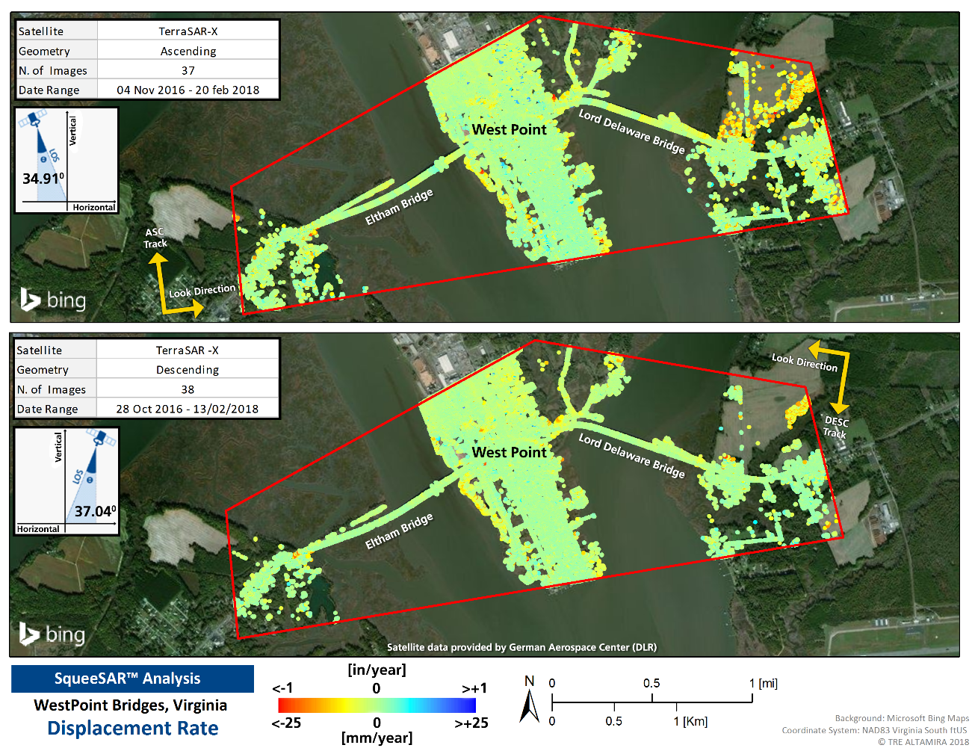
Figure 4. Distribution of permanent scatterers over West Point.

DISCUSSION
Spaceborne InSAR technology lends itself exceptionally well to monitoring wide swaths of land. It became a tool of choice for detecting abnormal ground deformations and unstable slopes. In most cases, point density and spatial distribution are sufficient to characterize the location of interest. Successful applications at the regional level prompted new research aimed at monitoring specific infrastructure assets. A recent study by Macchiarulo et al. [7] offers a potential implementation path to the network-level bridge monitoring.
It is evident that the challenge of monitoring bridges from space is significant, albeit not insurmountable. Spaceborne monitoring of hundreds of bridges across a widely dispersed transportation network adds another level of complexity. The entire premise behind implementing InSAR technology for bridge monitoring is that movement is a proxy for potential distress. It further assumes that capturing this movement will provide an early warning signal to bridge owners.
One of the problems with the idea of focusing on bridge displacement is that virtually all bridges move all the time, mainly in response to ambient air temperature variations and other factors such as wind loading. For example, Figure 5 shows an envelope of thermally induced superstructure lateral displacements on the bridge in West Point, Virginia. These displacements represent the time history of a longitudinal cross section of scatterers located along the northern parapet. The displacement pattern is characteristic of fixed and expansion bearing locations.

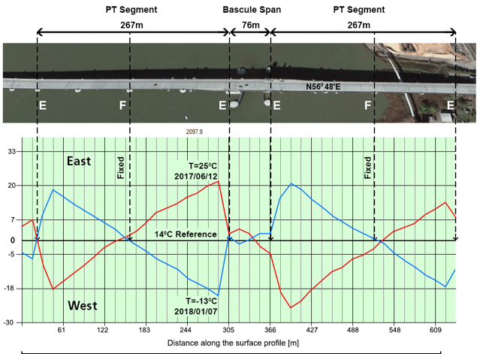

Figure 5. Envelope of the long-term east-west horizontal component thermal displacements of the Eltham Bridge superstructure. Results are based on the longitudinal cross-section of PS points along the parapet.

It is important to recognize that millimeter-range displacements can be resolved quite accurately. In this respect, InSAR offers approximately an order of magnitude advantage over the currently used LiDAR sensors. However, it must also be recognized that depending on the specific location on a bridge, the onset of distress-related movement may be effectively masked by “normal” displacements. Thus, it is important to identify properly the locations of PS points to assess the significance of their time-displacement history.
In a typical InSAR application, the locations of permanent scatterers are not known a priori. They are determined during the subsequent data processing stage, following a protracted period of repetitive data acquisition. The actual locations of PS points depend on the local scattering properties of the structure. This “opportunistic” nature of InSAR can be advantageous in ground monitoring applications, but it presents a serious challenge when applied to bridges. Since the actual locations of radar scatterers are not known a priori, there is a need for extensive redundancy, as only a fraction of these measurement points may end up being useful to bridge engineers. Ultimately, it comes down to the ability to monitor effectively certain specific locations on a bridge. These locations may vary across the entire bridge network.
One of the common concerns for many bridge owners is the issue of foundation scour. Ostensibly it should be relatively straightforward to detect using InSAR since the substructure support locations at piers and abutments are permanently fixed and not subject to thermally induced movements. The main challenge, in addition to monitoring the “right” locations, is to reduce the unavoidable time delay between data collection and processing of results to capture the onset of scour-induced settlement. With reference to Figure 5, if the objective is to monitor some specific element on the superstructure, then the early warning signal must be separated from the ordinary background movement. A case study of spaceborne monitoring to predict the onset of bridge foundation scour was reported by Selvakumaran et al. [8].
The range of remote sensing options available to address these identified issues is currently rather limited. Typical Stripmap imaging offers wide and continuous spatial coverage but frequently less than adequate point density. Spotlight imaging offers excellent localized spatial resolution at a cost of limited area coverage. It may be very appropriate for monitoring certain signature structures, but it is currently impractical to implement network-wide in a cost-effective manner.
One potential avenue of further research is the development of radar reflectors optimized for bridge applications. These may include active and passive units. It may be infinitely more practical to focus on the development of passive reflectors, as active transponders inevitably require periodic maintenance. Although the use of corner reflectors is well documented for ground surface monitoring [9, 10, 11], the principal constraint with the bridge application is the physical size. Cusson and Greene Gondi [12] reported on the successful implementation of trihedral passive corner reflectors on the Confederation Bridge in Canada.
A potential research goal may be to optimize the footprint and the cost of a reflector while providing an adequate radar cross section (RCS) signature for reliable detection. Each unit would provide a user-specified point for precise periodic and post extreme event monitoring of LOS displacement using a variety of radar satellites and orbits. Post extreme event assessment (earthquakes, floods, etc.) will require rapid data processing to allow follow-up inspections of potentially compromised structures.
Some preliminary experiments with the use of Lunenburg lens reflectors on a bridge in Virginia, as shown in Figure 6, indicate that the minimum equivalent RCS should be approximately 10 square meters. Dheenathayalan et al. [13] advanced the concept of a small (sub-meter) and inexpensive box-like reflector that could be used for monitoring structures. Necsoiu et al. [14] proposed the use of a flat, two-dimensional Van Atta array reflector as a more efficient replacement for the traditional corner reflector. Further research in this field is needed to advance current practice.

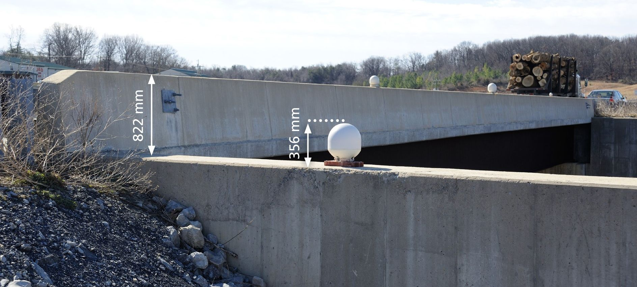

Figure 6. Lunenburg lens reflectors on a bridge in Virginia.

CONCLUSIONS
- There have been numerous attempts to harness satellite remote sensing technology to bridge monitoring. Despite its very attractive features, notably no need for active sensors, there are some significant technical obstacles to overcome before a reliable system can be implemented network-wide.
- Typically there is a trade-off between spatial coverage and scatterer density when spaceborne InSAR is employed, posing a significant challenge to network-wide implementation.
- Bridge engineers need detailed results from certain user-specified locations on a structure. Simply monitoring a cluster of random natural scatterers on a bridge may provide a false sense of security.
- Artificial targets in the form of man-made reflectors may provide the means to address the challenge of SHM of bridges across the entire network using the Stripmap mode of data acquisition.
- Staring Spotlight mode of acquisition offers very detailed coverage of specific bridges but does not readily lend itself to network-wide coverage with the current technology.
- Timely processing of spaceborne remote sensing data is essential to provide actionable information on bridge structural condition, especially when dealing with the post extreme event assessment.

ACKNOWLEDGMENTS
The author wishes to acknowledge technical support provided by the bridge engineers of the Virginia Department of Transportation (VDOT). TerraSAR-X satellite radar data used in this study were provided by the German Aerospace Center (DLR). SqueeSAR data processing was performed by TRE Altamira Inc. of Vancouver, BC, Canada. Linda Evans of VDOT provided assistance with the editorial process.

References
- Berens, P. Introduction to synthetic aperture radar (SAR). In Advanced Radar and Data Processing, 3.1-3.14. Accessed June 29, 2022. https://www.sto.nato.int/publications/STO%20Educational%20Notes/RTO-EN-SET-086bis/EN-SET-086bis-03.pdf.
- Ferretti, A., A. Fumagalli, F. Novali, C. Prati, F. Rocca, and A. Rucci. A new algorithm for processing interferometric data-stacks: Squee-SAR. IEEE Trans. Geosci. Remote Sens. 49 (9): 3460–3470, 2011.
- Ferretti, A., G. Savio, R. Barzaghi, A. Borghi, S. Musazzi, F. Novali, C. Prati, and F. Rocca. Submillimeter accuracy of InSAR time series: Experimental validation. IEEE Trans. Geosci. Remote Sens. 45 (5): 1142–1153, 2007.
- Ferretti, A., C. Prati, and F. Rocca. Permanent scatterers in SAR interferometry. IEEE Trans. Geosci. Remote Sens. 39 (1): 8–20, 2001.
- Cusson, D., Rossi, C., and Ozkan, I. Early warning system for the detection of unexpected bridge displacements from radar satellite data. Journal of Civil Structural Health Monitoring (11), 189-204, 2021.
- Hoppe, E., Novali, F., Rucci, A., Fumagalli, A., Del Conte, S., Falorni, G., and Toro, N. Deformation Monitoring of Post-Tensioned Bridges Using High-Resolution Satellite Remote Sensing. ASCE Journal of Bridge Engineering 24(12), 2019.
- Macchiarulo, V, Milillo, P., Blenkinsopp, C., and Giardina, G. Monitoring deformations of infrastructure networks: A fully automated GIS integration and analysis of InSAR time-series. Structural Health Monitoring 21(4), 1849-1878, 2022.
- Selvakumaran, S, Plank, S., Geiß, C., Rossi, C., and Middleton, C. Remote monitoring to predict bridge scour failure using Interferometric Synthetic Aperture Radar (InSAR) stacking techniques. International Journal of Applied Earth Observation and Geoinformation (73), 463-470, 2018
- Qin, Y., D. Perissin, and L. Lei. The design and experiments on corner reflectors for urban ground deformation monitoring in Hong Kong. Int. J. Antennas Propag. 2013.
- Crosetto, M., J. A. Gili, O. Monserrat, M. Cuevas-González, J. Corominas, and D. Serral. Interferometric SAR monitoring of the Vallcebre landslide (Spain) using corner reflectors. Nat. Hazards Earth Syst. Sci.13 (4): 923–933, 2017.
- Bovenga, F., G. Pasquariello, R. Pellicani, A. Refice, and G. Spilotro. Landslide monitoring for risk mitigation by using corner reflector and satellite SAR interferometry: The large landslide of Carlantino (Italy). CATENA151 (Apr): 49–62, 2017.
- Cusson, D., and Greene Gondi, F. Assessment of Trihedral Corner reflectors to improve satellite-based monitoring of bridges. SHMII-10 Conference, June 30 to July 2, 2021 – Porto, Portugal.
- Dheenathayalan, P., Cuenca, M., Hoogeboom, P., and Hanssen, R. Small Reflectors for Ground Motion Monitoring With InSAR. IEEE Transactions on Geoscience and Remote Sensing 55(12), 6703-6712, 2017.
- Necsoiu; M., Martinez; E. and Moore D. Satellite radar interferometry using micro-retroreflective arrays. Proc. SPIE 11003, Radar Sensor Technology XXIII, 1100311, 2019.

