ABSTRACT: Predictive models are a critical component of data interpretation in the context of Structural Health Monitoring. In this document, we present the Bayesian TAGI-LSTM method for time series which accounts for both epistemic and aleatory uncertainties. This method allows to learn the network parameters analytically and provide uncertainties for the predictions. Our experiments on the ICOLD-BW2022 benchmark show that the method proposed has a good predictive capacity and the ability to scale.

Bayesian Long-Short Term Memory Neural Network for Dam Behavior Prediction
Van-Dai Vuong, James-A. Goulet
Department of Civil, Geologic and Mining Engineering,
Polytechnique Montreal, Montreal, Quebec, Canada
Email : van-dai.vuong@polymtl.ca, james.goulet@polymtl.ca

KEY WORDS: Structural Health Monitoring; Bayesian Neural Network; Long-short Term Memory

Introduction
Predicting the responses under loading and environment condition is a critical part of a dam’s Structural Health Monitoring (SHM) system. The most popular methods used among dam engineers to predict dam behaviour are numerical models based on the finite element method (FEM), the hydrostatic-season-time method (HST), and the multivariate linear regression method (MLR) [5]. All of them have their own limitations. Numerical models governed by physical laws require a knowledge of the different structural properties such as the stress-strain relation of the dam and foundation which is typically not available, leading to poor predictive performances. Moreover, a single numerical model is typically not enough to predict all quantities of interest; multiple models need to be built to predict different quantities such as displacements, and crack openings. Original HST models do not take into account the temperature effects as well as the delayed effects of the temperature and the reservoir water- level. Although modifications to the original HST method have been done to consider these effects [5], the manual process to choose which moving average window of the explanatory variables should be used is tedious. MLR goes through the same procedure in order to select predictor variables for the model. Even if these variables are chosen appropriately, when the dependency between the target variable and the explanatory variable is non-linear, it is necessary to define a non-linear transformation function for each variable. The abovementioned manual procedure is both time consuming and requires expert knowledge which prevents the methods from being scaled when analyzing a large number of time series from different sensors of different types.
The long-short term memory neural network (LSTM) [3] specializes in modelling time series. This method has been widely used in many fields including SHM. The key limitation of LSTM is that it is a deterministic model which only provides deterministic predictions, and fails to take into consideration the epistemic uncertainty associated with the model’s parameters. Bayesian LSTM can address these limitation; in this document, we present the Bayesian TAGI-LSTM method which is based on the existing LSTM architecture and the tractable approximate Gaussian inference method (TAGI) [2]. This method allows to learn the network parameters analytically using Bayes’ theorem, and take into account both the epistemic and aleatory uncertainties in order to provide uncertainties associated with the predictions.

Long-short term memory neural network
The LSTM cell consists of four gates and two types of memory: short and long-term. The input variables go through these gates, and relevant dependency information are automatically selected and stored in the two memories. The cell states encodes the long-term memory, whereas the hidden states store the short-term one. Thanks to these features, LSTM does not require a specific setup for defining the dependencies between the explanatory variables and the target which is difficult when using HST and MLR methods. The parameters of a LSTM network are typically deterministic, and are learnt using the gradient backpropagation. This method has the drawbacks of not considering the uncertainties for the model parameters, and shows instability when learning using a batch size of one which is required for an online learning setup.

TAGI-LSTM
We apply the TAGI method to the existing LSTM architecture in order to build a Bayesian LSTM network, TAGI-LSTM. This method uses the same equations as the deterministic LSTM method trained by backpropagation, but it considers all parameters and variables in the equation as Gaussian random variables. These parameters’ uncertainties and the input variables’ uncertainties are propagated up to the LSTM’s output so that the parameters $θ$ are updated using Bayes’ theorem as
$$p\left(θ | D\right)= \frac{p\left(D\right)|θ)p(θ)}{p(D)},$$
where $p\left(θ | D\right)$is the posterior, $p\left(D\right)|θ)$ is the likelihood, and $p(θ)$ is the prior. The posterior distribution in Equation 1 is approximated analytically using the TAGI method [2]. The aleatory uncertainties are taken into account by adding an error hidden variable v to the LSTM’s output $z^{\left(O\right)}$following
$$y=z^{(O)}+v, v: V\sim N(0,∑_{V})$$
This error term considers the precision of the measuring device as well as the model aleatory prediction errors. As a result, TAGI-LSTM can provide the uncertainties associated with the predictions.

Advantages of using Lstm in Shm
LSTM has the ability to figure out automatically the dependency structure between the target and the inputs so that we can simply provide LSTM with normalized input data without having to do feature engineering. This is unlike HST and MLR models for which the inputs need to be transformed in order to take into account this dependency.
When predicting dam responses such as displacements and crack openings, such variables typically have a delayed effect with other environmental variables such as water temperature and reservoir level. However, these delayed effects are not constant over time. HST models take this into account by not only using these environmental variables alone but also different windows of their moving average [5]. The process to find which window is most appropriate is time consuming. LSTM deals with this effect by simply including a sequence of environmental variables, and a sequence of past observations as inputs so that
$$h_{t}=g\left(h_{t},y_{t-L:t-1},x_{t-M+1:t}\right),$$
where $g(.)$ is the function modelled by the LSTM layer, h are the hidden states, $y$ is the target, $x$ are explanatory variables, $L$ is the look-back period to take into account the effect of historical observations, $M$is the look-back period for the covariates to consider the possible delayed effect on the target variable. Moreover, the cell states and the hidden states which act as long and short-term memories also contribute to solve the delayed effect.
The current practice for anomaly detection in SHM relies on threshold-based approaches where observations outside thresholds are considered as abnormal. The uncertainties associated with the predictions provided by a TAGI-LSTM network can inform the users about how uncertain the predictions are, but should not be used directly as thresholds to detect anomaly and trigger alarms. This is because the threshold-based approaches typically result in a high false alarm rate. Instead, these uncertainties should be used as inputs to other methods such as the Switching Kalman Filter [4] in order to detect anomalies with a high accurate rate.

Results
We apply the TAGI-LSTM method to predict the pendulum datasets CB2 and CB3 of the ICOLD-BW2022 benchmark which are a dam’s radial displacements. The two explanatory variables used are the reservoir water-level [m] and the temperature TB [$℃$]. Figures 1 and 2 compare the observations with the model predictions in the validation set for the two datasets CB2 and CB3. The result shows that the method has a good predictive capacity.

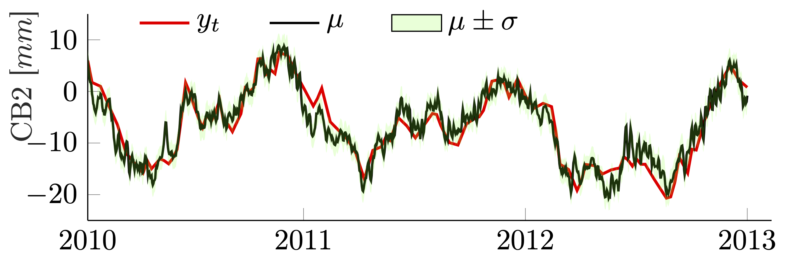
Figure 1. Predicted CB2 displacements by TAGI-LSTM.
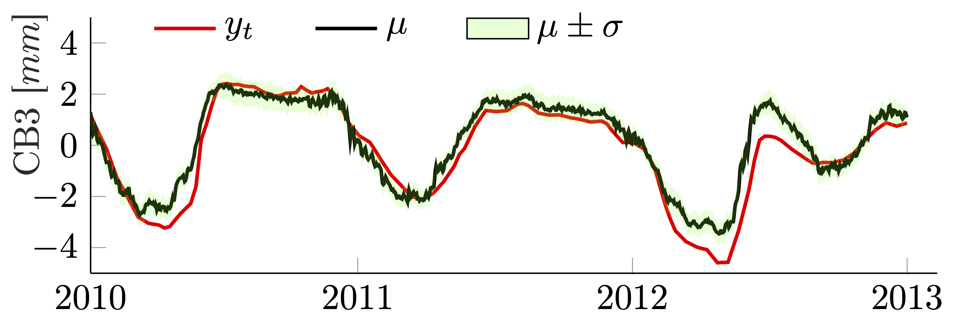
Figure 2. Predicted CB3 displacements by TAGI-LSTM.

Conclusion
We proposed the Bayesian TAGI-LSTM method that combines the TAGI framework with the existing LSTM architecture. We demonstrated that the network parameters can be learnt analytically based on Bayesian inference.

ACKNOWLEDGMENTS
This project is funded by Natural Sciences and Engineering Research Council of Canada (NSERC) and Hydro Québec (HQ).

References
- Gal, Y. and Ghahramani, Z. (2016). “A theoretically grounded application of dropout in recurrent neural networks.” Proceedings of the 30th International Conference on Neural Information Processing Systems, 1027–1035.
- Goulet, J.-A., Nguyen, L. H., and Amiri, S. (2021). “Tractable approximate gaussian inference for Bayesian neural networks.” Journal of Machine Learning Research, 22, 1–23.
- Hochreiter, S. and Schmidhuber, J. (1997). “Long short-term memory.” Neural computation, 9, 1735–80.
- Nguyen, L. H. and Goulet, J.-A. (2018). “Anomaly detection with the switching Kalman filter for structural health monitoring.” Structural Control and Health Monitoring, 25(4).
- Salazar, F., Morán, R., Toledo, M., and Oñate, E. (2015). “Data-based models for the prediction of dam behaviour: A review and some methodological considerations.” Archives of Computational Methods in Engineering.

