ABSTRACT: Hammer testing has been proven to contain the information about structural defects from previous research. As a non-destructive testing (NDT) method, one of the biggest challenges in hammering-based testing is to detect the internal defects and the compound defects with various defects. In order to solve this problem, this paper puts forward the importance and feasibility of using variable frequency impact hammer and acoustic data to identify the composite defects in concrete structures. First, we establish a fundamental frequency-based autocorrelation method to identify the internal defect of concrete. Second, by the different short-time energies obtained by the defects at different hammering frequencies, we used to distinguish the compound defects in concrete structures based on transforming different hammering frequencies. At last, the feasibility of this method is verified by experiments.

Development of acoustic-based variable frequency hammering defect detection system for concrete structures
Xi Huang¹, Huang Huang¹, Zhishen Wu¹
¹ Department of Urban & Civil Engineering, Ibaraki University, 4-12-1 Nakanarusawa-cho, Hitachi 316-8511, Japan
Email : 22nd302r@vc.ibaraki.ac.jp, hhly9527@gmail.com, zhishen.wu.prof@vc.ibaraki.ac.jp

KEY WORDS: Hammering test; Non-destructive testing; Acoustic Data.

Introduction
Concrete is very common in modern society, especially in social infrastructure such as tunnels. In some cases, aging and damage may result in its structural failure [1,2]. In recent years, research on automatic detection of aging infrastructures structures has developed vigorously. In addition to non-destructive testing [3,4.5], new technologies such as sensors and robots are used to promote information sophistication, labor savings, and cost reduction [6,7]. On the other hand, the main method of detecting concrete structures is to manually judge the sound of hammering test and visually inspect it. However, with the current shortage of specialists, it is becoming increasingly difficult to prevent accidents involving collapses of tunnels and bridges and falling of exterior walls by non-scientific methods that rely solely on human senses.
Up to now, a great amount of research has been done on hammering test. Its wide applications include the diagnosis of concrete structures [8], such as the diagnosis system of spalling tiles on the facades of high-rise buildings [9], and the construction of cavity and crack detection algorithms [10].
However, the hammering test system currently used only imitates the hammering method of human beings, and detects specific defects by hammering at a single frequency. In this study, we focus on being able to detect internal and surface defects, and distinguish the compound defects composed of these two types of defects. Coin tapping test is the simplest form of pulse echo method [11]. This is one of the oldest nondestructive testing methods and is often used for crack and damage detection. In Cowley's research [12], a high frequency coin striking test with a lighter coin striking structure was studied. Test results showed that, compared with conventional coins, high frequency coin tapping can observe deeper cracks and pores. Therefore, we introduced the concept of variable frequency into hammering test, and change the hammering frequency to detect defects in the structure.
In this work, we want to put forward a variable frequency hammering detection system. In order to detect internal defects in concrete and distinguish complex compound defects. It is composed of two detection methods: First method is the acoustic identification of structural defects based on fundamental frequency; Another method is to identify the complex defects in the structure by changing the hammering frequency. Finally, we tested each of these two technologies, and successfully identified internal defects with a depth of 40 mm from the concrete surface. In the test in the bridge, the compound defects were successfully identified and distinguished.

Variable frequency hammering detection system

An acoustics-based method for detecting internal defect
This paper proposes a novel solution to defect analysis, which extracts the fundamental frequency of the audio signal as a feature and then applies the Dynamic Time Warping (DTW) algorithm to locate the internal defect in a series of data by comparing the similarity of two hammering points.
Fundamental Frequency
Herein, the spectrum/time pitch detection algorithm is adopted in the PDA based on a combination of time domain processing where an autocorrelation function such as normalized cross correlation is applied, and the pitch is identified by means of frequency domain processing where spectral information is used [13]. Then, among the candidates estimated from the two domains, a final pitch track can be computed through dynamic programming. The advantage of these approaches is that the tracking error in one domain can be reduced by the process in the other domain.
The feature extraction performed through fundamental frequency mainly involves five steps, including pre-emphasis (Pre-Emphasis, Framing, windowing), short-time average energy and autocorrelation, as shown in Figure 1. The variation of autocorrelation analysis can be expressed as Eq (1).
$R_{i}\left(k\right)=\sum_{m=1}^{N-m}{x_{i}\left(m\right)x_{i}\left(m+k\right)}$(1)
Where $x_{i}\left(m\right)$represents the sample of signal of the $ⅈ$-th frame for the signal sequence of length $N$, and $x_{i}\left(m+k\right)$ refers to the sample time-shifted $k$ seconds.
Dynamic Time Warping
As a much more robust distance measure for time series, dynamic time warping (DTW) enables the matching of similar shapes even though they are out of phase in the time axis [14]. For instance, the similarities in walking could be detected using DTW, even if an individual was walking faster than the other, or if acceleration and deceleration occurred during an observation. Due to this flexibility, DTW has been extensively applied to the temporal sequences of video, audio, and graphics data. In fact, DTW is applicable to analyze any data that can be converted into a linear sequence.

variable frequency hammering for detection of compound defect
In order to identify the compound defects, a detection method is proposed in this paper that is based on variable frequency hammering. Firstly, it is confirmed that the short-time energy collected at the healthy point is significantly different from the short-time energy collected at the damage point, as shown in Figure 2(a)(b). Besides, it is capable to distinguish healthy point from defective point with short-time energy. Then, it is confirmed that the same defect, with varying frequencies of hammering, obtained different amounts of short-time energy, and the damage was identified through different hammering frequencies, as shown in Fig 2(b)(c).
Short-Time Energy
The short time energy refers to the energy of short speech segment [15]. Short time energy is treated as a simple and effective classifying parameter for both voiced and unvoiced segments [16]. Energy is also used to detect the end points of utterance [17]. For a short-time signal, a n-th frame window is applied to this signal:
$$x_{n}\left(m\right)=x\left(m\right)w\left(n-m\right)$$
$n-N+L≤m≤n$(2)
n=0,1T,2T, …, N represents the window length and T refers to the frame shift.
The short-time energy of above signal can be determined by the following equation:
$E_{n}=\sum_{m=n-N+1}^{n}{{[x\left(m\right)w\left(n-m\right)]}^{2}}$(3)
Where w(n-m) represents the window, n indicates the sample that the analysis window is centered around, and N denotes the window length.
Figure 1 illustrates the flowchart of variable frequency hammering for the detection of compound defect.

EXPERIMENTS

Detection of internal defects
To simulate the internal defects of concrete, a 6cm foam was pre-buried in a concrete specimen with a total length of 40cm, as shown in Figure 3 and Figure 4. The foam was positioned at 20-26 cm. The concrete specimen (40 cm long, 10 cm high, and 10 cm wide) was divided into two parts as shown in Figure 5. Besides, hammering points were taken at an interval of 2 cm

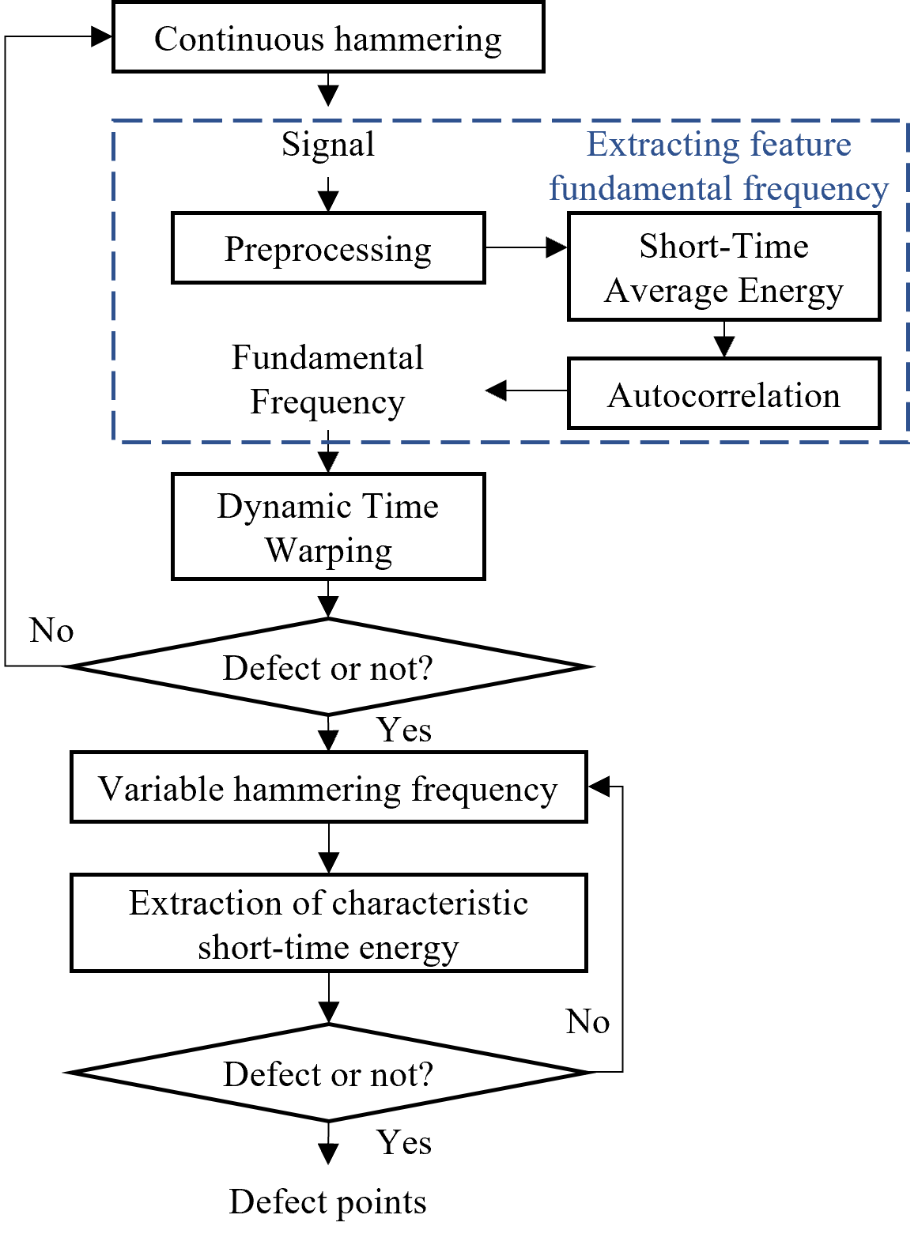
Figure 1. The flowchart of variable frequency hammering detection system

(a) Short-time energy of a healthy point at hammering frequency = 5hz
(b) Short-time energy of a defected point at hammering frequency = 5hz
(c) Short-time energy of a defected point at hammering frequency = 10hz
Figure 2. The short-time energy of healthy and defected points at different hammering frequencies

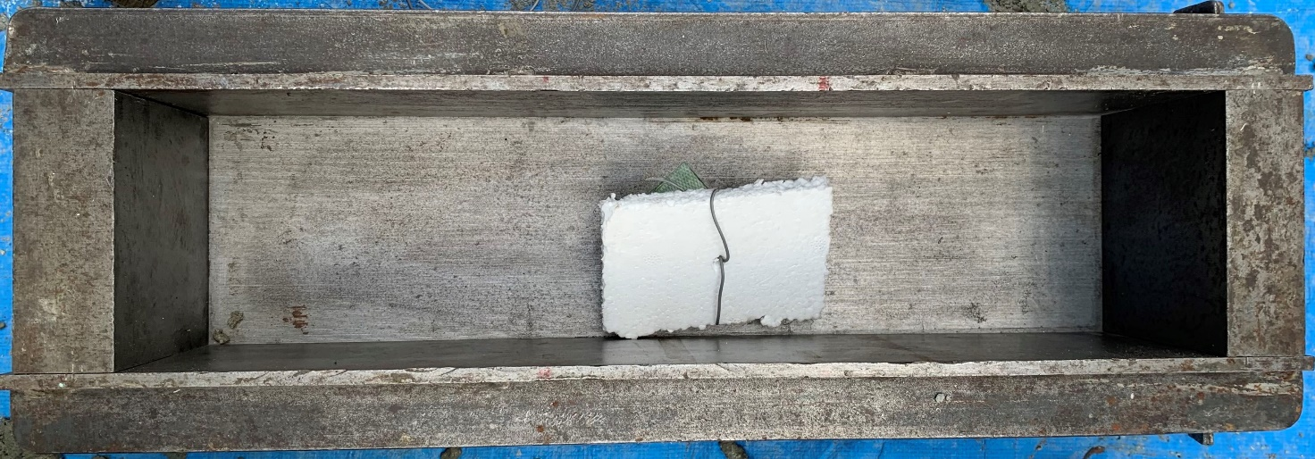

Figure 3. The concrete specimen with internal defect(foam)

from left to right, for a total of 19 strike points, and the acoustic sound data of hammering were recorded at a 192 kHz sampling frequency at each point.

Detection of compound defects
As shown in Figure 6, this experiment of detecting compound defects was conducted in the interior of the bridge.
During this experiment, a horizontally oriented strike path was set up with five test points, each of which was spaced 30 cm apart, as shown in Figure 7. In the horizontal direction, two adjacent defects, including a surface defect (a crack with a width of more than 2 mm and a length of 120 cm) near the third point (P3) and an internal defect (a spalling of about 25 cm × 25 cm) at the second point (P2), were treated as compound defects. While the first point, the fourth point, and the fifth point were treated as healthy points. This experiment was performed using the frequency hammering inspection method.

results and discussion

Detection Result of internal defects experiment
As shown in Figure 8, the fundamental frequency-based acoustic detection method was applied to compare the similarity of fundamental frequencies between two test points frame by frame through the DTW algorithm. The first point was taken as the reference point, which is considered as an invariant. By comparison, all of the other points were treated as variables. With the similarity of each point to the reference point recorded, the distance/score curve was obtained. As for the images, the score curve drops sharply at around 20-26 cm. The position of curve change is consistent with the actual position of damage. Therefore, this method can be used to detect the internal damage caused to the concrete.

Detection result of compound defects experiment
Figures 9 shows the change in short-time energy as the distance to the reference point varies.
The results are shown in Figure 9(a). When the hammering frequency reached 5 Hz, the short-time energy obtained from the collected sound data showed a significant change at the surface defect (60 cm from the reference point), but it is not the case at the internal defect (30 cm from the reference point). As shown in Figure 9(b), when the hammering frequency rose to 10 Hz, the short-time energy obtained from the collected sound data varied significantly at the internal defects, but it is not the case at the surface defects (60 cm from the reference point).
Hammering the same test points, the two hammering frequencies highlighted two different defects, with internal defects showing a greater sensitivity to the hammering frequency of 5 Hz. Moreover, the surface defects were more sensitive to the hammering frequency of 10 Hz.

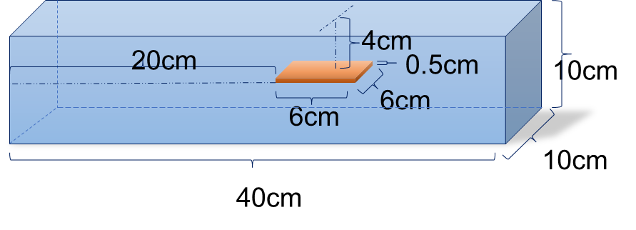

Figure 4. Schematic diagram of the concrete specimen

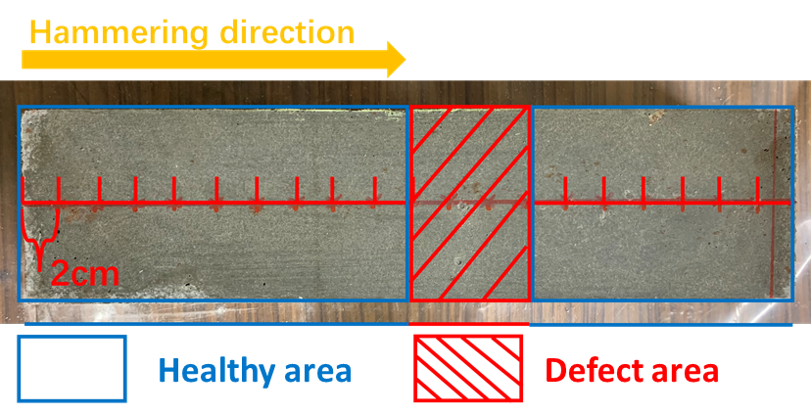
Figure 5. The defect area of concrete specimen

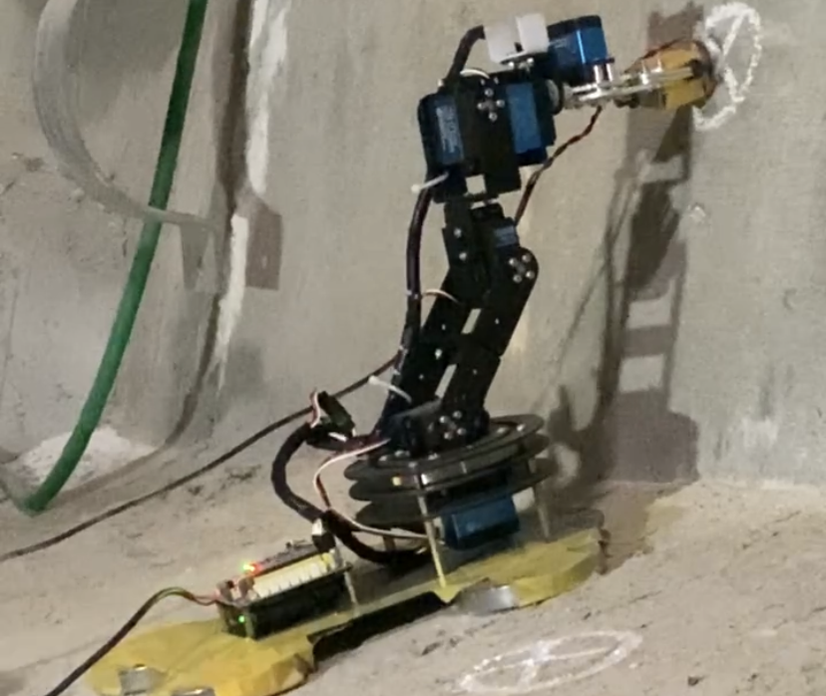
Figure 6. The variable frequency hammer used to inspect the concrete inside the bridge.

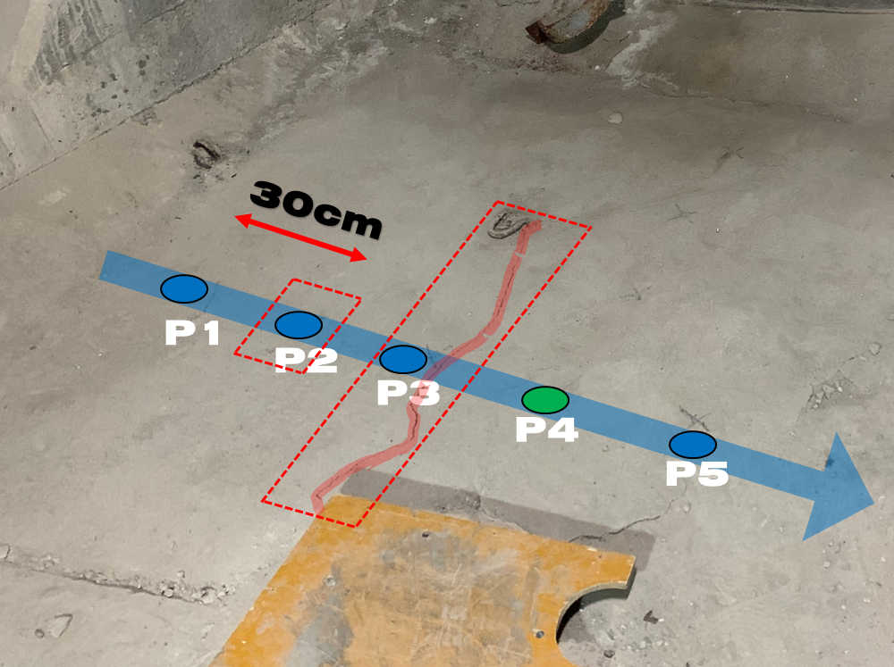
Figure 7. Schematic diagram of the hammering points

Figure 8. The relationship between scoring from the similarity of two hammering points and the distance to the reference point

Surface defect
(a) 5Hz

Internal defect
(b) 10Hz

Figure 9. The relationship between short-time energy and the distance to the reference point at different hammering frequencies

conclusion
This paper introduces a variable frequency hammering inspection system that is able to identify the defects in concrete. Firstly, the system detects the internal defects of concrete based on the fundamental frequency autocorrelation method. Then, acoustic data obtained from different hammering frequencies are used to distinguish the composite defects in concrete structures composed of surface and interior. Finally, the effectiveness of the frequency conversion hammering detection method is verified through experiments.

References
- Wu, Z.S., Sustainability enhancement of infrastructures with smart and resilient materials. In Sustainable Development for The Americas: Science, Health, and Engineering Policy and Diplomacy. W. Colglazier Eds., 1st ed., pp. 98-136, CRC Press. 2021.
- Mori, Y., & Ellingwood, B. R. (1993). Reliability-based service-life assessment of aging concrete structures. Journal of Structural Engineering, 119(5), 1600-1621.Bureau International des Poids et Mesures, The international system of units (SI), BIPM, Paris, France, eighth edition, 2006.
- Annan, A. P. "Ground-penetrating radar." Near-surface geophysics. Society of Exploration Geophysicists, 2005. 357-438.
- Kandhall, Prithvi S., and Rajib B. Mallick. Evaluation of asphalt pavement analyzer for hma design. No. Report No: NCAT Report no. 99-4. National Center for Asphalt Technology, 1999.
- Watanabe, Atsushi, et al. "Robot-assisted acoustic inspection of infrastructures-cooperative hammer sounding inspection." 2015 IEEE/RSJ International Conference on Intelligent Robots and Systems (IROS). IEEE, 2015.
- Feng, Jinglun, et al. "Automatic Impact-sounding Acoustic Inspection of Concrete Structure." arXiv preprint arXiv:2110.13125 (2021).
- J. Y. L. Kasahara, H. Fujii, A. Yamashita and H. Asama, "Fuzzy Clustering of Spatially Relevant Acoustic Data for Defect Detection," in IEEE Robotics and Automation Letters, vol. 3, no. 3, pp. 2616-2623, July 2018, doi: 10.1109/LRA.2018.2820178.
- Ye, Jiaxing, et al. "Statistical impact-echo analysis based on grassmann manifold learning: Its preliminary results for concrete condition assessment." EWSHM-7th European workshop on structural health monitoring. 2014.
- F. Inoue, S. Doi, T. Ishizaki, Y. Ikeda and Y. Ohta, "Study on automated inspection robot and quantitative detection of outer tile wall exfoliation by wavelet analysis," ICCAS 2010, 2010, pp. 994-999, doi: 10.1109/ICCAS.2010.5669653.
- Igual, J., Salazar, A., Safont, G., & Vergara, L. (2015). Semi-supervised Bayesian classification of materials with impact-echo signals. Sensors (Basel, Switzerland), 15(5), 11528–11550. https://doi.org/10.3390/s150511528
- McCann, D. M., and M. C. Forde. "Review of NDT methods in the assessment of concrete and masonry structures." Ndt & E International 34.2 (2001): 71-84.
- Cawley, Peter. "A high frequency coin-tap method of non-destructive testing." Mechanical Systems and Signal Processing 5.1 (1991): 1-11.
- Müller, Meinard. "Dynamic time warping." Information retrieval for music and motion (2007): 69-84.
- Tan, Li, and Montri Karnjanadecha. "Pitch detection algorithm: autocorrelation method and AMDF." Proceedings of the 3rd international symposium on communications and information technology. Vol. 2. 2003.
- X. Yang, B. Tan, J. Ding, J. Zhang and J. Gong, "Comparative Study on Voice Activity Detection Algorithm," 2010 International Conference on Electrical and Control Engineering, 2010, pp. 599-602, doi: 10.1109/iCECE.2010.153.
- Dong Enqing, Liu Guizhong, Zhou Yatong and Cai Yu, "Voice activity detection based on short-time energy and noise spectrum adaptation," 6th International Conference on Signal Processing, 2002., 2002, pp. 464-467 vol.1, doi: 10.1109/ICOSP.2002.1181092.
- Yiu-Kei Lau and Chok-Ki Chan, "Speech recognition based on zero crossing rate and energy," in IEEE Transactions on Acoustics, Speech, and Signal Processing, vol. 33, no. 1, pp. 320-323, February 1985, doi: 10.1109/TASSP.1985.1164503.

