Finite Element Model of Bibi-Khanum Based on Laser Scanning and its Calibration to Data from Real-Time Strong Motion Monitoring Instrumentation Array
Shakhzod Takhirov¹, Davron Matrasulov², Ilyas Aripov², Sultan Kudratov³, and Shukhrat Shamansurov⁴
¹Department of Civil and Environmental Engineering, University of California, Berkeley, 337 Davis Hall, Berkeley, Berkeley, California 94720, USA
²Turin Polytechnic University in Tashkent, 100095, Tashkent, Uzbekistan
³Department of Computer Science, Tashkent University of Information Technologies, Tashkent, Uzbekistan s.kudratov@gmail.com.
⁴Sigma Innovative Tech, Tashkent, Uzbekistan
Email : takhirov@berkeley.edu, dmatrasulov@gmail.com, ilyasaripov55@gmail.com, s.kudratov@gmail.com, shukhratshamansurov@gmail.com.

ABSTRACT: Bibi-Khanum ensemble is one of the famous touristic destinations in Samarkand (Uzbekistan). It was constructed in the fourteenth century. The structures inside of the ensemble were recently restored and reinforced. In 2019, the research team conducted a laser scanning project to capture the current geometry of the monuments with a high accuracy. A terrestrial laser scanner was used for that. The remaining anomalies of the monuments were analyzed earlier by the team. This paper is focused on generating a finite element (FE) model based on the laser scans. The FE model of the main building of the mosque is correlated to the actual responses of the building under ambient vibrations from the permanently installed instrumentation array. The finite element model is updated to make sure that linear performance of the model matches that of the actual mosque. This fully calibrated model was used to compare the performance of the model to that of the building during recent moderate earthquakes originated in Uzbekistan and neighboring countries. More results of this study will be presented in the extended version of the paper.
.
KEY WORDS: Finite-Element Modeling; Structural Health Monitoring; Real-Time Strong Motion Monitoring Instrumentation Array; Seismic Performance Prediction.

Introduction
An extensive laser scanning project was conducted in July 2019 to capture as-found geometry of the Bibi-Khanum ensemble in Samarkand (Uzbekistan). A resultant point cloud of the ensemble was combined of points clouds collected from seven scanner positions. Visual observations and the collected point clouds indicated that the ensemble had undergone a recent reinforcement and some of the work was ongoing. To capture the current geometry of the monument, a terrestrial scanner was deployed. A terrestrial laser scanner from Leica Geosystems, Scan Station C10 [1], was utilized for the project. Anomalies of the main mosque (shown in a magenta box in Figure 1) were studied earlier [2].

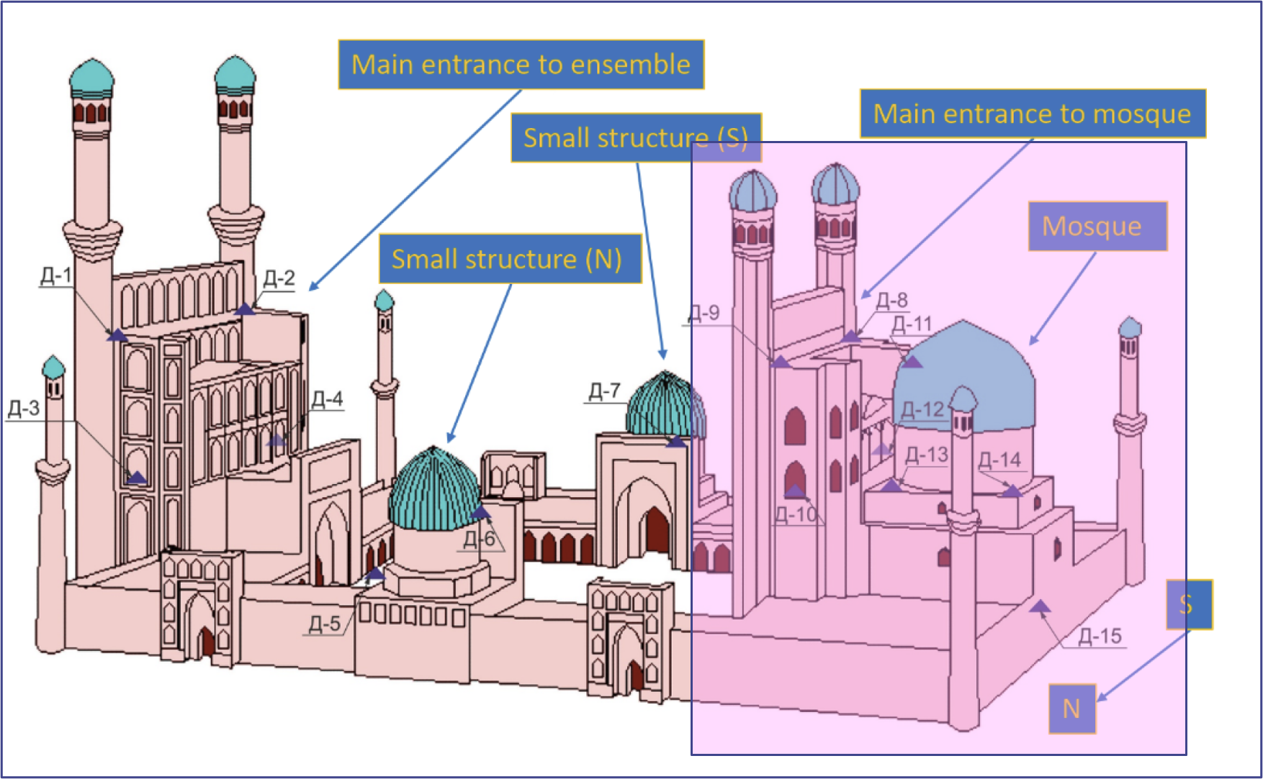
Figure 1. Bibi-Khanum ensemble [2].

This paper is aimed at finite element modelling of the mosque and investigating its performance under static and dynamic loads.

Finite Element Modeling Based on Laser Scans

As-found geometry of the main mosque
A point cloud of the outer surface of the main mosque is presented in Figure 2.
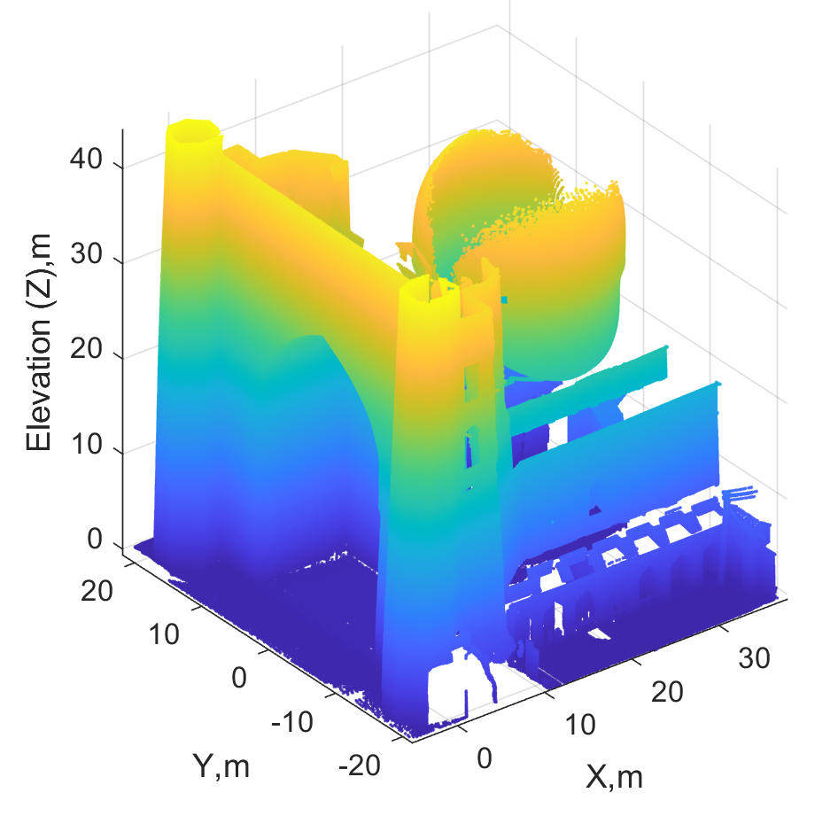
Figure 2. Outer surface of the main mosque.
A respective point cloud of the interior surface of the main mosque is presented in Figure 3.
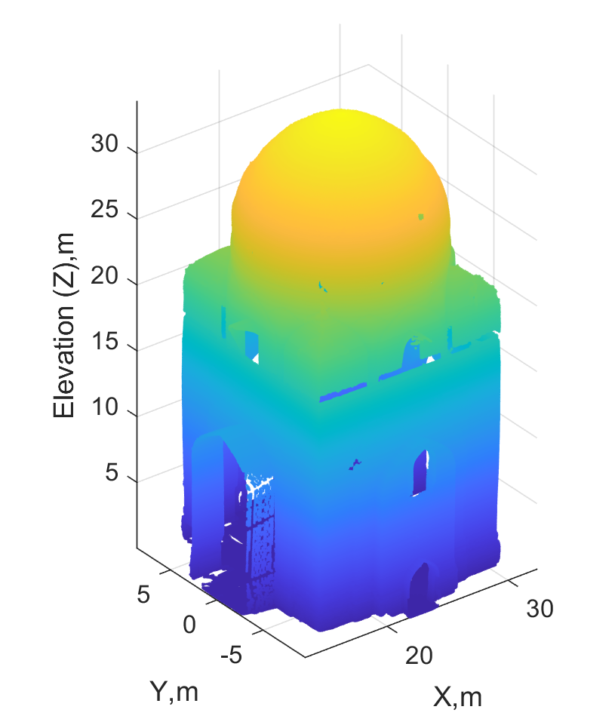
Figure 3. Inner surface of the mosque.

As-found geometry of the globes
A minaret design is typically based on having two globes with an open space between the globes. The inner globe has smaller diameter, whereas the outer globe has greater diameter. The air in the open space between the globes is circulated through multiple openings that serves as a thermal insulation in cold winter times and in hot summer times. Only visible surfaces of both globes were captured by a laser scanner. In the case of the outer globe, its outer surface was captured and in the case of the inner globe only its interior surface was captured. Thin horizontal slices of the corresponding point clouds were best fit to circles at different elevations. A typical result of best fitting procedure for the outer globe is presented in Figure 4.

Figure 4. Outer globe’s cross sections best fit to circles
A result of best fitting to the horizontal slices of the inner globe is presented in Figure 5.
It is worth noting that the origin of the coordinate system of the minaret’s point cloud was selected in such a way that it stays at the centers of these circles. The centers’ locations in respect to the selected coordinate system are presented in Figure 6.
Figure 5. Inner globe’s cross sections best fit to circles.
Two conclusions were made from Figure 6. First, the centers’ locations do not deviate from the selected origin by more than 0.15m for the exception of one outlier. Second, the axis of the outer globe has a trend in the centers’ Y coordinates that serves as evidence of its inclination in Y-Z plane shown by cyan dashed line). Other data have more random distribution without a trend.
Figure 6. Center locations in respect to the selected origin.
A cross section of the globes are presented in Figure 7. It is obtained in the following way. The horizontal axis represents radii of the best fit circles (both positive and negative values are shown here to complete a section with its mirror half). The vertical axis correspond to elevation and the dashed line is a portion of the outer globe which was not captured by the laser scanner and as such, it is extrapolated from the points below that elevation.
Figure 7. Center locations in respect to the selected origin.

Modelling of the globes
Based on ancient drawing [3], a wall thickness of each globe was estimated to be close to 1m. Solid elements were used to model the globes in the SAP2000 environment [4]. A resultant finite element model of the globes is presented in Figure 8.
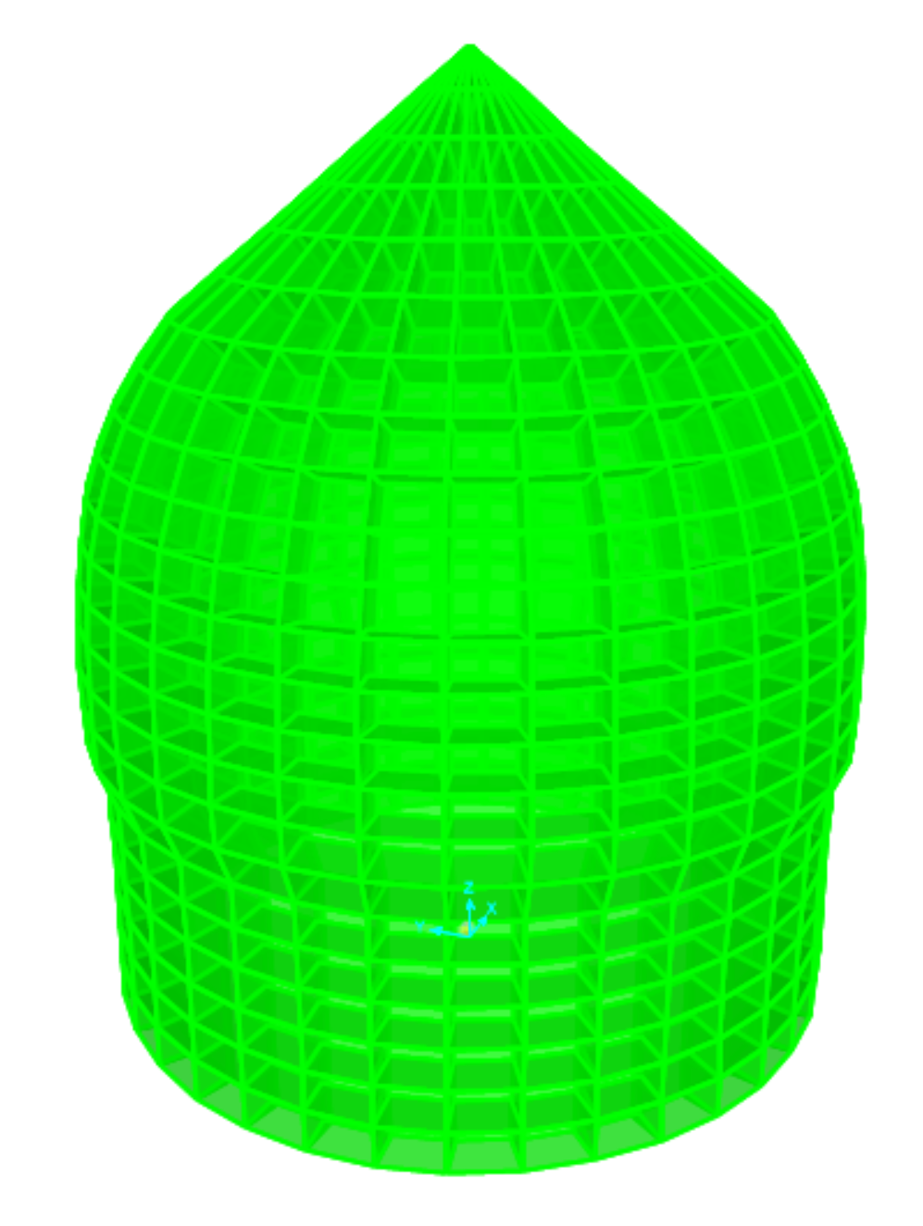
Figure 8. Finite element model of the globes.

Finite Element Modeling of Building under Globes

As-found geometry of the main mosque
A point cloud of one of the interior walls is presented in Figure 9 [2].
A solid element model was generated in the SAP2000 environment. A view of the same wall is presented in Figure 10.
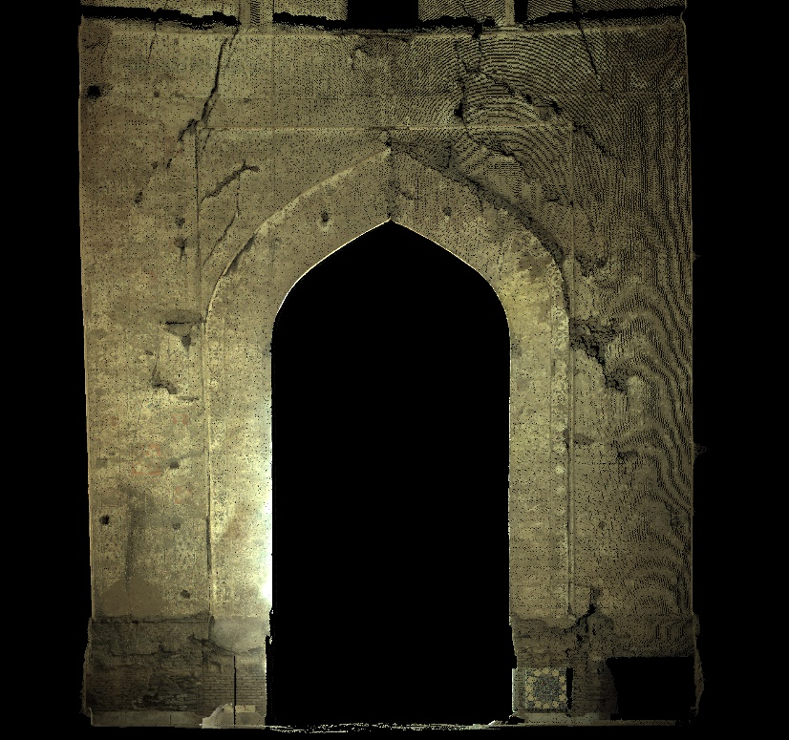
Figure 9. Point cloud of north wall (typical).

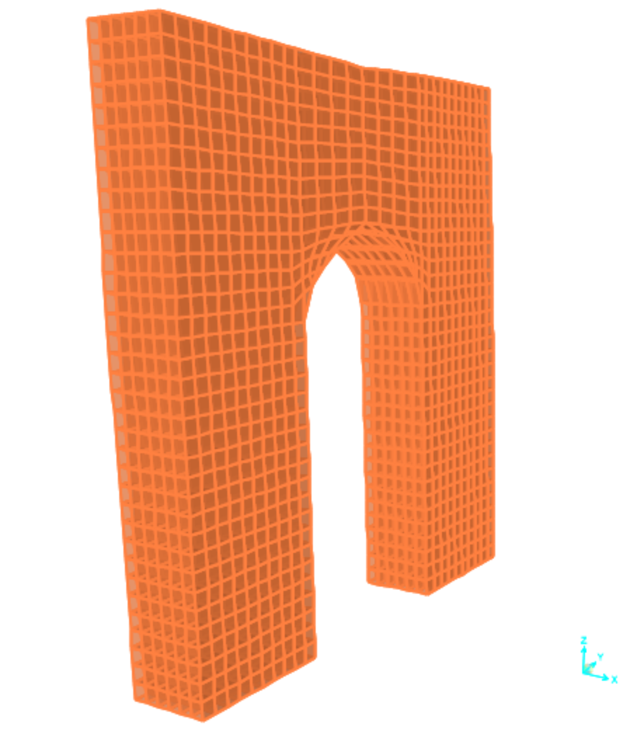
Figure 10. Finite element model of the wall.

Real-Time StrOng Motion Monitoring System

Location of accelerometers
Since 2019, an extensive array of instrumentation had been permanently installed throughout the assemble as shown in Figure 1. Mode detailed view focused on the main mosque instrumentation is presented in Figure 11.

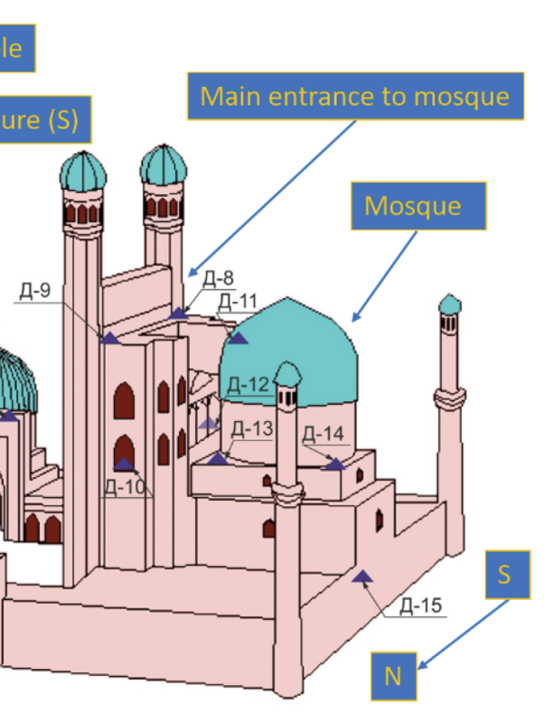
Figure 11. Senor locations on the main mosque.

Conclusions
The finite element model of the main building of the mosque is correlated to the actual response of the building under ambient vibrations. The finite element model is updated to make sure that both performances match each other at this low level of excitation. Consequently, this fully calibrated model was used to compare the performance of the model to that of the building during recent moderate earthquakes originated in Uzbekistan and neighboring countries. The results of this study will be presented in the extended version of the paper.

ACKNOWLEDGMENTS
This work is partially supported by the Ambassador’s Fund for Cultural Preservation of the Embassy of USA in Tashkent (Ref. Nr. S-UZ800-17-GR-0043). The expenses associated with renting a terrestrial laser scanner was covered by the Turin Polytechnic University in Tashkent (Uzbekistan) and is greatly appreciated. The deployment of the laser scanner and the data reduction of the point clouds was provided by Sensor Fusion and Monitoring Technologies, LLC (USA), and is greatly appreciated. Special thanks are due to Holly Halligan of UC Berkeley for editing the paper. The paper’s registration fee required for the participation in this conference was covered by Sigma Innovative Tech (Tashkent, Uzbekistan), which is greatly appreciated.

References
- Leica Geosystems AG (2011). Leica ScanStation C10. http://w3.leica-geosystems.com/downloads123/hds/hds/ScanStation%20C10/brochures-datasheet/Leica_ScanStation_C10_DS_us.pdf.
- Shakhzod M. Takhirov, Ilyas Aripov and Davron Matrasulov (2020). Real-time Structural Monitoring of Bibi-Khanum in Samarkand (Uzbekistan) Combined with Subsequent Laser Scans. 12th International Conference on Structural Analysis of Historical Constructions (SAHC 2020), Barcelona, Spain, September 29-30, and October 1, 2021.
- Shostak, L. A. (between 1865 and 1872). Turkestanskīi l'bom, chast' arkheologicheskaia ..., 1871-1872, part 1, vol. 1, pl. 70.
- Computers and Structures, Inc. (CSI). (2014). SAP2000 Ultimate Version 16.1.1. Structural Analysis Program.

