Numerical Modeling of Thermo-Hydro-Mechanical processes of a Highway Embankment in North Canada.
${Zubair Akhter}^{1}$, ${Biao Li}^{2}$, ${Ali Nazemi}^{2}$
Building Civil and Environmental Engineering Department, Gina Cody School of Engineering and Computer Science, Concordia University, Montreal, Quebec, Canada, H3G 1M8

Email : zubair.akhter@concordia.ca, biao.li@concordia.ca, ali.nazemi@concordia.ca

ABSTRACT: Degradation of permafrost is the major cause of strength reduction in frozen soil, which plays the vital role in damage of transportation infrastructures. This study uses numerical methodology to analyze the mechanism of deformation in a highway embankment section along an existing highway embankment in Manitoba, Canada. Specifically, extreme cyclic climate temperature variations may cause considerable embankment settlement. There are very limited available data in the literature with a focus on thermal-hydro-mechanical responses of permafrost. In this paper, a fully coupled thermal-hydro-mechanical analysis is performed based on the finite element framework to investigate the geo-risk of ground subsidence due to the degradation of permafrost. The temperature-dependent mechanical parameters of frozen clay soil examined in the simulation are taken from literature. The linear Drucker–Prager model is used for analyzing plastic zones of highway embankment during the thawing of permafrost. Significant subsidence is expected during a long-term degrading of permafrost.

KEY WORDS: Frozen soil, cyclic climate temperature variation, Temperature-dependent mechanical parameters

Introduction

Permafrost areas occupy 24% of the land in northern hemisphere (Nelson, 2003) and around 40% to 50% of Canada’s total land surface of 10 million square kilometers (Brown, 1960). Railroads, highways, pipelines and airport runways have been, and continue to be, constructed in this large area of permafrost land.
These infrastructure systems rely on the underlying permafrost for their foundation support. Frozen soils are less compressible than unfrozen soils (Girgis et al., 2020). The pore ice in a frozen soil acts like cement that binds the solid soil particles together and therefore, if remain frozen, frozen soils have much higher shear strength compared to unfrozen soil. Warming temperatures can reduce the ability of frozen soils to support a load. This thawing can induce serious damages to the overlying infrastructures. Thawing can be the consequence of the climate warming, human activities, or a combination of both factors. Clearing land of shaded trees, any excavation in the permafrost region and the added heat from a house are examples of human activities that can cause permafrost to melt.
When a road embankment is constructed, it alters the natural ground surface in two ways: the topography of the terrain (acts as a snow fence which can accumulate snow on the embankment shoulders and toes) and the surface material (new material of the embankment has different surface albedo, heat capacity, and thermal conductivity).
It is important to note that problems related to frozen soil are inherently complex. This is mainly because of drop and rise in temperature of soils, which are multiphase materials consisting of ice, water, soil grains and air (Fig-1).

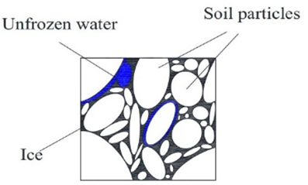
Fig. 1. Schematic section of the frozen soil (Wang et al., 2019).
The permafrost layer consists of unconsolidated sediments, and the contact between the permafrost layer and the bedrock is minimal. Any construction on this sediment creates large settlement due to the consolidation behavior (Delage et al., 2000).
Therefore, a comprehensive and reliable numerical model to simulate a frozen soil problem requires an in-depth knowledge of the process and advanced numerical modeling platforms.
The studied site is a low road embankment on PR391, about 18 km north-west of Thompson, Manitoba. It is in a region of discontinuous permafrost area (Fig-2). The section is symmetric along centerline line of embankment. In the section the silty clay is overlaid by clayey silt and gravel embankment (Fig-3).

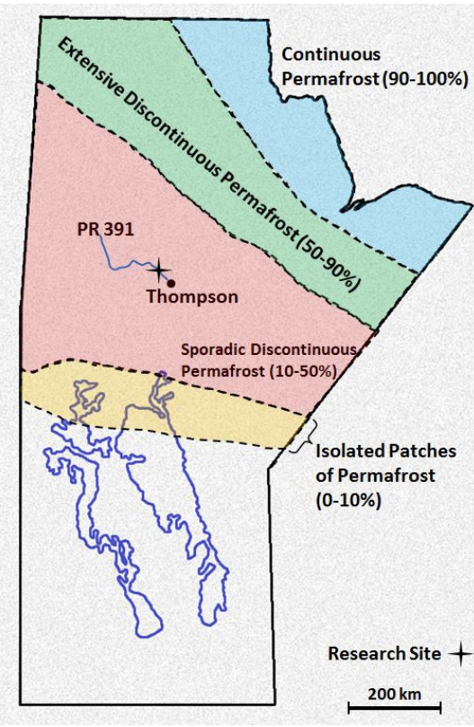

Fig-2, Permafrost types and distribution in Manitoba and the location of the research site.
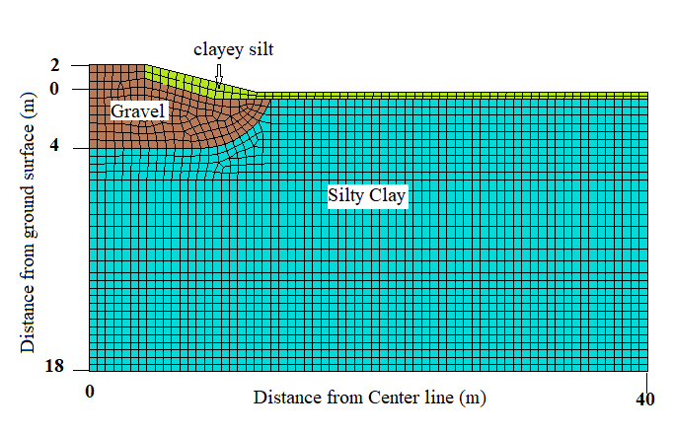
Fig-3, Geometry of the studied section.

Numerical Modeling

The section was treated as an elasto-plastic material and modeled by a Linear Drucker-Prager (D-P) model with strain hardening (Abaqus, 2016). Parameters of the D-P model can be derived from the previously described triaxial test data.
The linear Drucker-Prager yield function is given by:
$F=t-ptanβ-d=0$ (1)
Where

$t=\frac{1}{2}q[1+\frac{1}{k}-(1-\frac{1}{k}){(\frac{r}{q})}^{3}$ (2)

where $p$ is the mean effective stress, and $q$ is the Mises shear stress; $k$ is the ratio of the yield stress in triaxial tension to the yield stress in triaxial compression; $β$ and $d$ are the friction angle and cohesion in $p-q$ space, respectively.

The Mechanical properties of Silty clay (Ruiqiang et al., 2020) and clayey silt (Akhtar and Li, 2020) for range of temperature values can be expressed as respectively,

$E=\left\{\begin{aligned}20+11.3{\left(T_{0}-T\right)}^{0.6} T≤T_{0} \\ 20 T>T_{0}\end{aligned}\right.$ (3)

$C= \left\{\begin{aligned}20+6{(T_{0}-T)}^{1.24} T≤T_{0} \\ 20 T>T_{0}\end{aligned}\right.$ (4)

Where E is Young’s Modulus an C is the cohesion.
Similarly for Clayey Silt,

$E=2.676{(-T)}^{1.324}$ (5)

$C=2C_{0}\frac{Cosϕ}{1-Sinϕ}$ (6)

$C_{0=}0.125{(T)}^{1.065}$ (7)
Where, $C_{0}$is uniaxial compression strength.

The surface temperature for 2 years is collected from Environment Canada and applied on surface in boundary conditions (Fig-4)

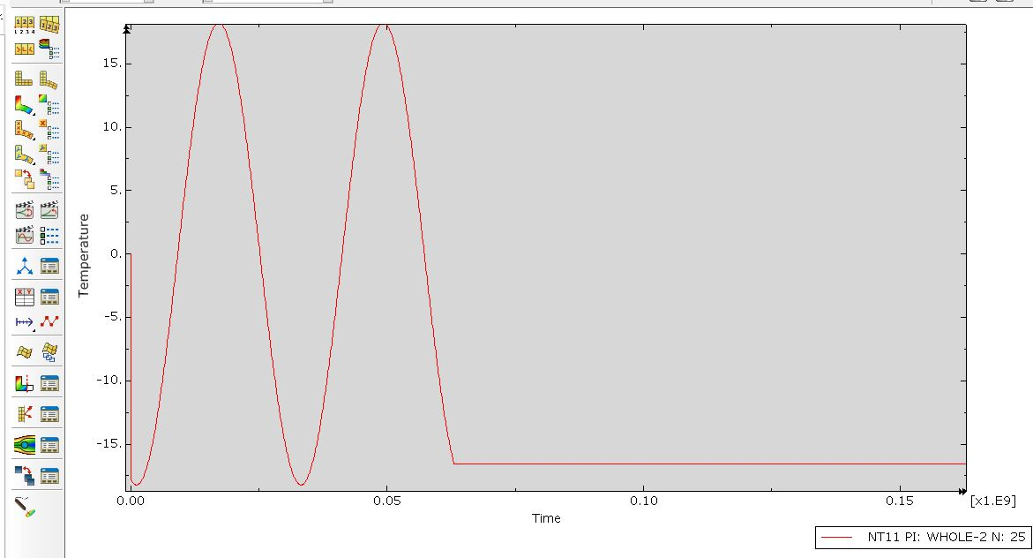
Fig-4, Environmental temperature variation.

Results
The simulations of two periodic years of temperature for Highway embankment section at Manitoba were conducted and the results are shown in Fig-5, Fig-6, and Fig-7, respectively. From the presented results, it is clear that the frost bulb is available in silty clay portion of Embankment which is degrading and extending with periodic surface temperature (Fig-5). Simulated plastic strain is shown in Fig-6. For understanding the stresses in soil, Linear Drucker-Prager Model is used as shown in Fig-7 for three monitored points. There are two yield curves for silty clay soil (one for unfrozen, and the other one for frozen condition). The soil does not display yielding in the frozen condition. By contrast, when the temperature increases, the degrading of strength leads to some plastic yielding displayed by the simulated stress paths shown in Fig-7.

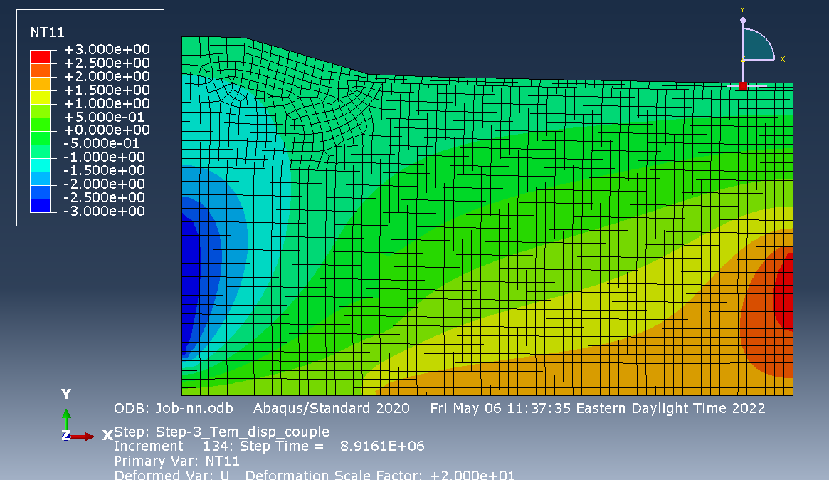
Frost Bulb

Fig-5, Location of Frost Bulb (Units = °C)

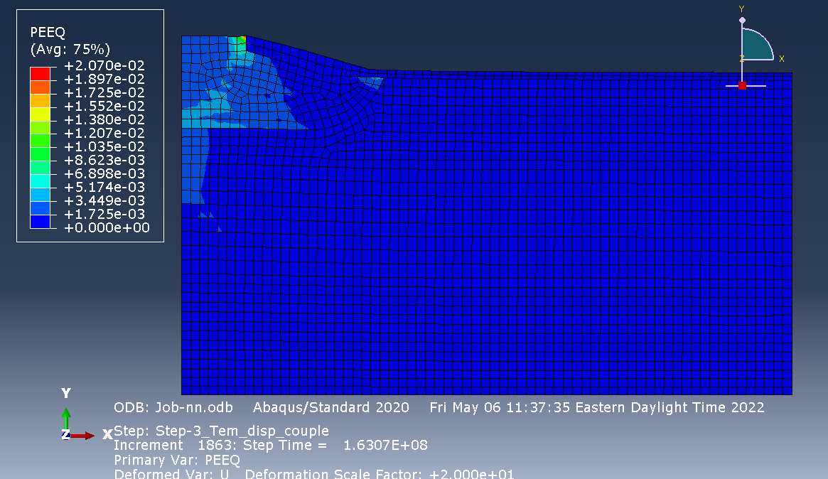
Point 3

Point 2
Point 1

Fig-6, Simulated Plastic strain in the Embankment section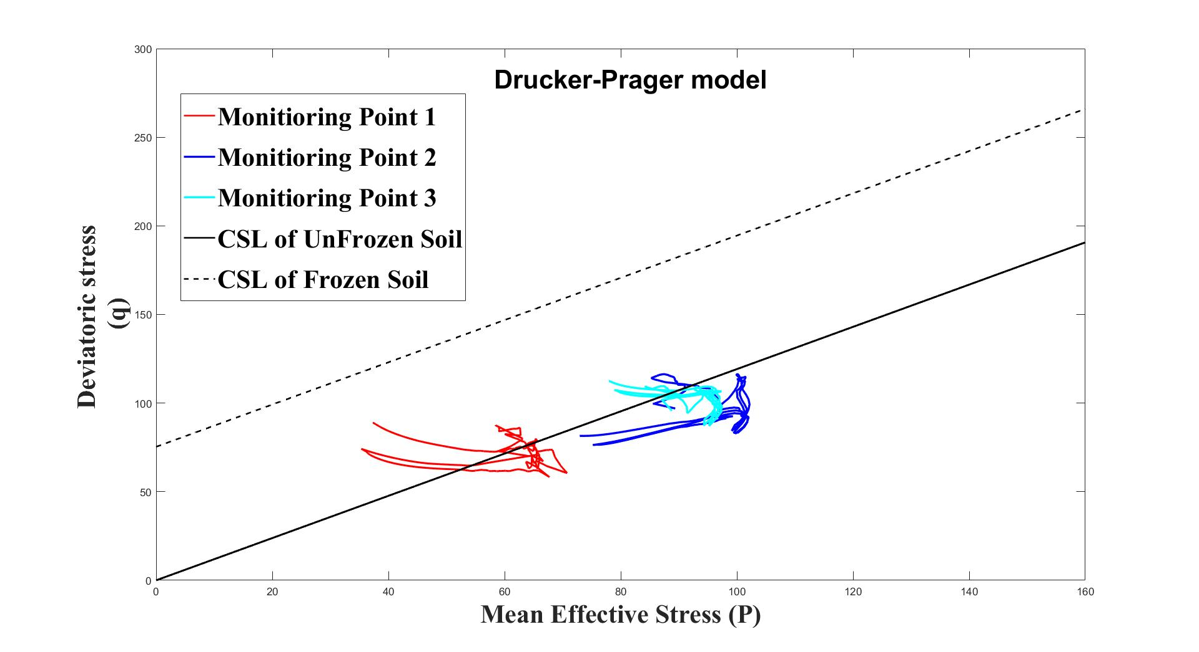

Fig-7, Stress path of simulated Drucker-Prager Model

References
- Girgis, N., Li, B., Akhtar, S., and Courcelles, B, (2020). Numerical Analysis of Experimental study of rate-dependent uniaxial compressive behaviors of two artificial frozen sandy clay soils. Cold Regions Science and Technology, 180. https://doi.org/10.1016/j.coldregions.2020.103166.
- Gholamzadehabolfazl, A, (2015). A Numerical Study of a Highway Embankment on Degrading Permafrost, University of Manitoba.
- Akhtar, S., Li, B. (2020). Numerical Analysis of Pipeline Uplift Resistance in Frozen Clay Soil Considering Hybrid Tensile-Shear Yield Behaviors. Int. J. of Geosynth. and Ground Eng. 6, 47. https://doi.org/10.1007/s40891-020-00228-9
- Ruiqiang, B., Yuanming, L., Wansheng, P., and Mingyi, Z, (2020). Investigation on frost heave of saturated–unsaturated soils, Acta Geotechnica. https://doi.org/10.1007/s11440-020-00952-6
- Delage, P., Sultan, N., & Cui, Y. J. (2000). On the thermal consolidation of Boom clay. Canadian Geotechnical Journal, 37(2), 343–354.
- Nelson, F. E., Brigham, L.W.,Hinkel, K.M., Smith, O., Parker, W., Tucker, W., Romanovsky, V. E., Vinson, T., Shiklomanov, N.I. (2003). Climate Change , Permafrost , and Impacts on Civil Infrastructure. U.S. Arctic Research Commission: Permafrsot Task Force Report
- Brown, R.J.E. (1960). The distribution of permafrost and its relation to air temperature in Canada and the U.S.S.R. Arctic, 13(3), 163-177.

