ABSTRACT: Transportation infrastructure ages faster under harsher weather conditions that may arise due to climate change and increasing use. Conventional condition assessment generally relies mainly on visual inspection with years between inspections and cannot detect subtle ongoing changes in performance. In this context, Transport Canada, Infrastructure Canada, and the National Research Council of Canada have been collaborating for many years in adapting, further developing, and validating space-based earth observation technology for bridge displacement monitoring. The partners are looking to go a step further to extend the scope of application to new types of transportation infrastructure such as marine ports, airports, and railways of national importance. This paper outlines a case study comparing sets of settlement measurements taken over the North runway of the Vancouver International Airport obtained from satellite monitoring techniques and conventional surveying methods conducted by the airport authority.

Satellite Monitoring of Transportation Infrastructure – A Case study at the Vancouver International Airport
Istemi F. Ozkan¹, Daniel Cusson¹, Juan Hiedra Cobo¹
¹National Research Council Canada, Construction Research Centre, Ottawa, Ontario, Canada, K1A 0R6
Email : istemi.ozkan@nrc-cnrc.gc.ca, daniel.cusson@nrc-cnrc.gc.ca, juan.hiedracobo@nrc-cnrc.gc.ca
KEYWORDS: Satellite-based displacement monitoring, InSAR analysis, airport runway settlement, case study

Background
As numerous studies show ([1] and [2]), linear transportation infrastructure ages faster under harsher weather conditions due to climate change and increasing use (e.g., traffic loads). Conventional condition assessment generally relies on visual inspection with years between inspections. For this reason,the conventional condition assessment cannot detect subtle ongoing changes in performance due to structural deterioration that could otherwise alert engineers to initiate early countermeasures and avoid possible service disruption and structural failure [3]. In this respect, public infrastructure owners have been looking for innovative solutions that would help them maintain high levels of user safety, avoid prolonged disruption of service as well as extend service life, which may help reduce the life-cycle cost of their infrastructure.
To protect federal assets and investments of national significance from severe service disruptions, transportation infrastructure owners and operators require transportation infrastructure that is safe, economically and operationally efficient, and resilient to the impacts of climate change. In this context, Transport Canada, Infrastructure Canada, and the National Research Council of Canada (NRC) have been collaborating for many years in adapting, further developing, and validating space-based earth observation technology for bridge displacement monitoring. The partners are looking to go a step further to extend the scope of application to new types of transportation infrastructure such as marine ports, airports, and railways of national importance. This paper outlines a case study on the comparison of settlement datasets for Vancouver International Airport’s North runway obtained from satellite monitoring techniques and conventional surveying methods implemented by the airport authority.

Interpretation of Satellite displAcement measurements

Satellite viewing geometry
Most radar satellites follow near-polar orbits and thus travel on a north-south orbit (and vice-versa). Since they are imaging the Earth sideways, the radar line-of-sight (LOS) has an east-west direction at some incidence angle from the vertical.
For instance, radar images can be taken when the satellite is flying from South to North (ascending orbit pass) with the LOS oriented towards the East (Figure 1a), or when the satellite is flying from North to South (descending orbit pass) with the LOS oriented towards the West (Figure 1b). In Figure 1, by convention, negative values (red) indicate movement away from the satellite while positive values (blue) indicate movement towards it.
As a result, the same displacement vector can produce different satellite readings when viewed from different pass directions and incidence angles, as illustrated in Figure 1. For example, a downward movement going to the east (D_{real}, depicted by the grey arrow) can be measured as a negative movement (going away from the satellite) in ascending mode (D_{asc}) or a positive movement (going towards the satellite) in descending mode (D_{desc}).
It is therefore warned that an oversimplified interpretation of this movement (with no additional means of validation) could be interpreted as a downward vertical movement if measured from an ascending satellite pass or as an upward vertical movement if measured from a descending satellite pass.

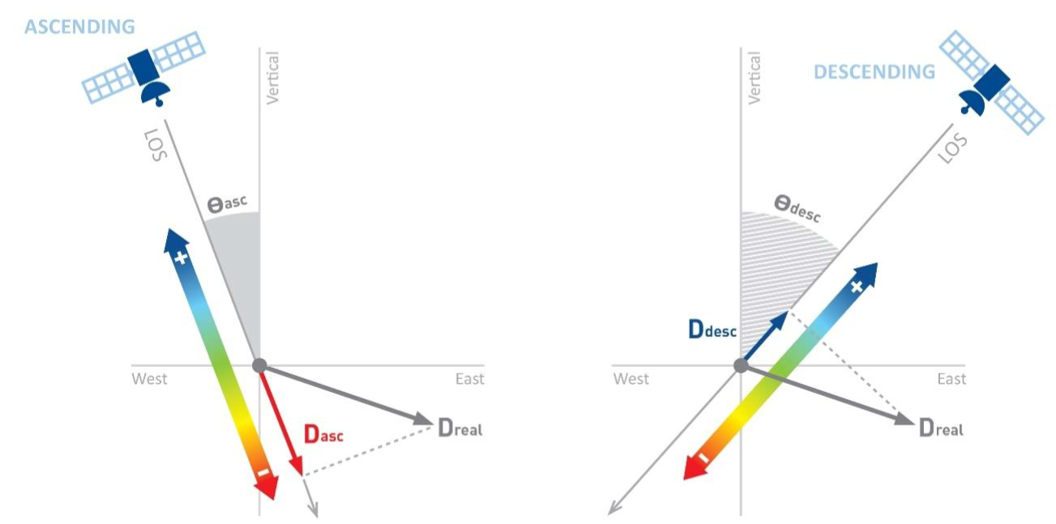
Figure 1. Projection of real movement onto the LOS for ascending and descending passes [4].

Furthermore, it is possible that a given LOS measurement, D_{desc}, from a descending pass (for example) could be the result of different real displacements for the case illustrated in Figure 2.
If one knows what to expect as a displacement (e.g., from predictive modelling or in-situ measurements), then it can be converted to LOS from trigonometry and compared directly for validation. But the reverse is not straightforward, i.e., converting LOS to a real displacement if we only have one ascending or one descending set of satellite displacement data and no alternative verification method.

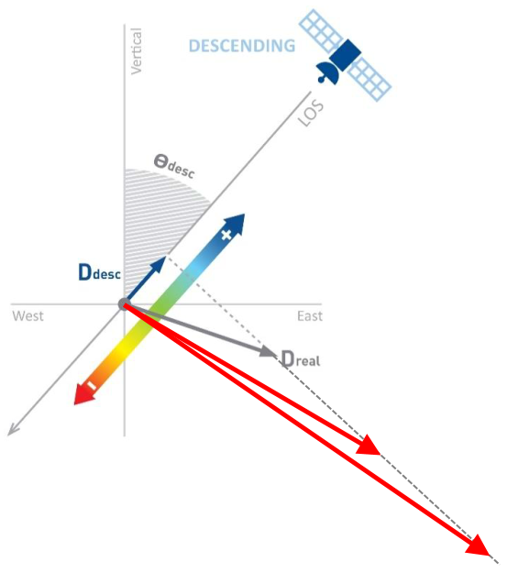
Figure 2. Projection of different values of real movement onto the line of sight for a descending pass
(modified from [4])

Prediction of general displacement
Suppose the motion can be predicted from numerical methods or trends based on in-situ sensor measurements. In that case, comparing these predictions with satellite measurements for validation purposes is relatively more trivial since converting model predictions of vertical and horizontal components into LOS is straightforward.
For example, Figure 3 illustrates four simple cases that depend on the direction of the satellite pass (descending or ascending) and the component of movement being considered (upward or eastward). If one assumes that a movement towards the satellite is positive, then an upward movement will be measured as a positive LOS regardless of pass direction (Figure 3a and Figure 3b), while an eastward (horizontal) movement will be measured as a positive LOS for the descending pass (Figure 3c), and a negative LOS for the ascending pass (Figure 3d).
Given the above observations, the LOS movement in the up-east plane can be calculated as follows:

D_{LOS} = D_{V} cos α + D_{L} sin α (for desc. passes) | (1)
D_{LOS} = D_{V} cos α − D_{L} sin α (for asc. passes) | (2)

where D_{LOS} is the calculated line-of-sight displacement; D_{V} is the predicted vertical component of displacement; D_{L} is the predicted longitudinal component of displacement; and α is the incidence angle of the satellite line-of-sight.
Equations (1) and (2) are valid for structures aligned perpendicular to the satellite track projected on the ground. The next step is to consider the angle difference between the satellite track heading and the structure orientation. As a result, the LOS displacement can be calculated as [5, 6]:

D_{LOS} = D_{V} cosα – D_{L} sinα sinβ (for all passes) | (3)

where β is the angle measured clockwise from the satellite track heading to the asset’s longitudinal axis. If the horizontal movement, D_{L,} is assumed to be negligible, vertical movement, D_{V,} may be calculated as:

D_{V} = D_{LOS} / cos α (if D_{L} ⁓ 0) | (4)

SAT  E  V  α  - Descending pass and vertical movement – Upward movement : positive LOS | SAT  E  V  α  - Descending pass and horizontal movement – Eastward movement: positive LOS
SAT  E  V  α  - Ascending pass and vertical movement – Upward movement: positive LOS | SAT  E  V  α  - Ascending pass and horizontal movement – Eastward movement: negative LOS

Figure 3. Viewing geometry for either descending pass or ascending pass of satellite, where vertical or horizontal movement is projected onto the satellite LOS

CAse study on vancouver international airport

Monitored site and satellite information
Figure 4 presents a view of the monitored Vancouver International Airport. The SAR data used for monitoring the airport was acquired from the German TerraSAR-X (TSX) satellite in ascending orbit (i.e., satellite ﬂying north, looking east). A total of 66 images were acquired in Stripmap mode using an incidence angle of 30.5° from vertical, with a 3 m pixel resolution, a footprint of 60 km x 33 km, and a minimum revisit time of 11 days.

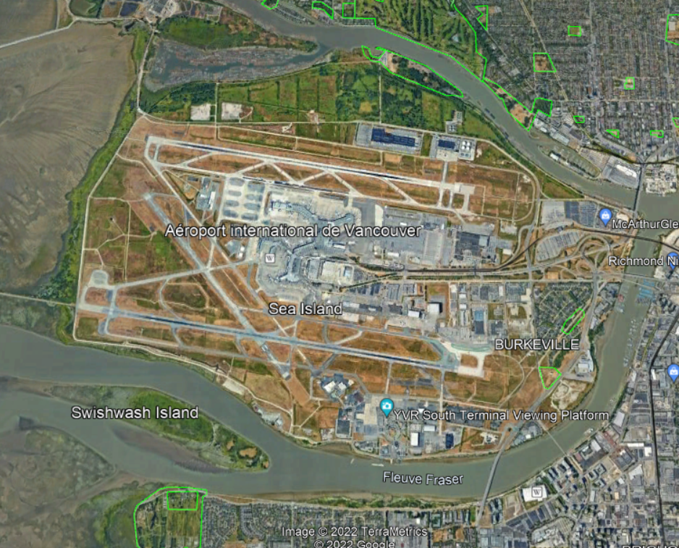
North runway
South runway
Figure 4. Satellite view of Vancouver International Airport (North up)

Figure 5 demonstrates the satellite-measured displacement data obtained from Interferometric Synthetic Aperture Radar (InSAR) analysis conducted by 3v Geomatics [7]. Since the field surveying datasets were made available for comparison purposes, the focus of the study was on the north runway identified with a red rectangle. Significantly fewer InSAR data points were observed on the north runway compared to the south runway. One reason may be due to the different surface textures of the runways. According to the Vancouver Airport Authority, the older south runway, which was originally made of concrete, has been overlaid with asphalt toppings over the years, whereas the newer north runway is made of bare concrete with a smooth surface. It appears that the rougher asphalt surface of the south runway might have allowed for more radar returns to the satellite.

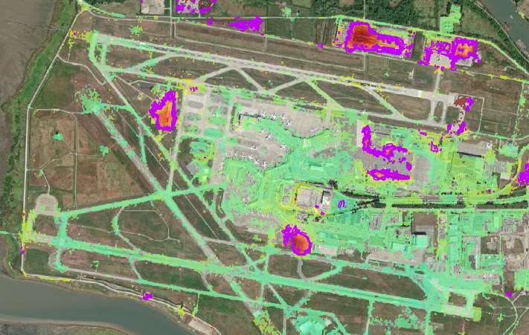
Figure 5. Satellite measurements of the InSAR-derived displacement over the Vancouver International Airport

Surveying-based vertical movement along north runway
A set of field survey data outlining the measured elevations and their relative changes (settlement or heaving) were obtained from the Vancouver Airport Authority. One of the datasets included surveying the north runway along its entire length. Figure 6 illustrates the surveying stations along the runway, starting with Station 5+040 (40 m from the West end of the runway) up to Station 8+018 (3 km East of the first station), with intermediate stations spaced at every 100 m approximately. There are three surveying points at each station: one along the centerline of the runway, one at the north edge, and one at the south edge.

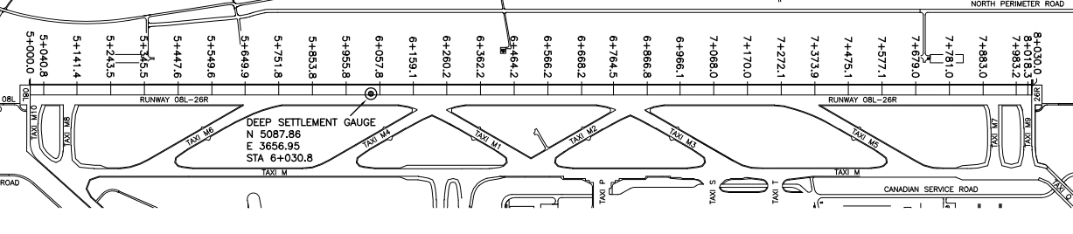
Figure 6. Surveying stations along the North runway

The surveying started as early as August 3, 1995, at some stations; however, all stations were fully surveyed starting on August 14, 1996. Figure 7 illustrates the surveying dates (blue dots) and the satellite image acquisition dates (red dots), which were focused from 21-June-2019 to 8-July-2021.

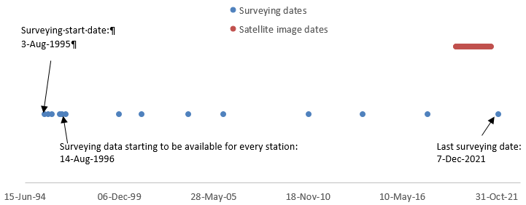
Figure 7. Surveying vs. satellite image acquisition dates

Figure 8 depicts the changes in the elevation profile over time (from thinner to thicker curves). As illustrated, settlement as large as 436 mm occurring over a period of 25 years is observed at Station 7+272 (or 2.232 km from the West end of the runway). The settlement rate is observed to be non-uniform along the runway. For example, at Station 6+260, a much lower settlement of 68 mm is observed after 25 years of surveying. The overall settlement of the runway also seems to increase steadily over time.

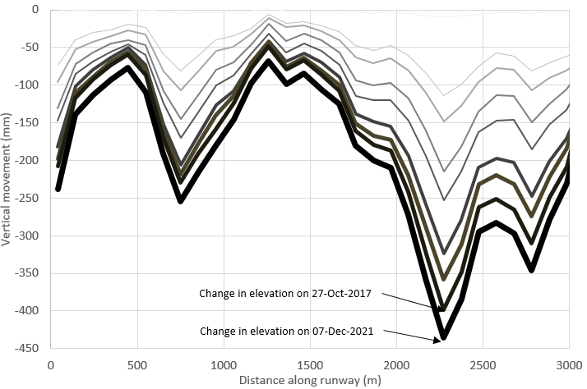
Figure 8. Changes in elevation profile along the north runway over time (from surveying data)

Further data processing with linear interpolation is needed to make a suitable comparison between field survey results and the satellite measurements. For instance, the last two elevation profiles in Figure 8 are used to calculate the profiles that would correspond to the first and last acquisition dates of satellite imagery, being 21-June-2019 and 8-July-2021 (Figure 7). The change in the elevation profile between these two dates is thus calculated along the runway, resulting in the green curve in Figure 9. This is the curve that will be compared to the satellite measurements in the next section.

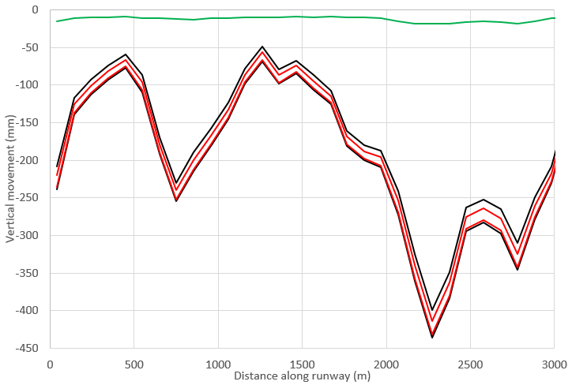
Figure 9. Changes in elevation profile along the north runway (Black curves: profiles from last two field surveys; Red curve: linearly interpolated profiles corresponding to the first and last dates of satellite image acquisitions; Green curve: difference between the two red curves)

Satellite-based vertical movement along north runway
Figure 10 illustrates changes in elevation profile along the north runway centreline between 21-June-2019 and 8-July-2021, as measured by the satellite and calculated based on Equation (4) with the assumption that the horizontal movement is negligible. It is warned, however, that neglecting the horizontal component may induce errors in the estimation of the vertical component of movement from the LOS measurement [8].

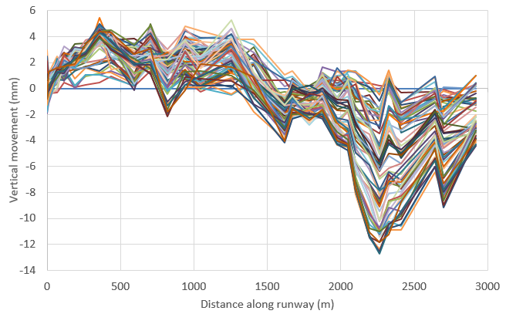
Figure 10. Changes in elevation profile along the north runway over time (from satellite data)

Figure 11 compares the satellite-based cumulative vertical movement on 8-July-2021 (solid black curve) with the field surveying movement data spatially and temporally adjusted to that date (solid green curve in Figure 9). Estimated error bands for the satellite data are also provided by dashed black curves computed as +/- 4 mm estimated from [7] (+/-2 mm/yr for 2 yrs). Although the times of the peaks and valleys of the plots from the compared methods of measurement agree well, a gap of approximately 15 mm at the west end of the runway reducing linearly to approximately 7 mm near the east end of the runway is clearly apparent. When the lower error band is considered, this discrepancy reduces to 10 mm at the west end and 3 mm near the east end of the north runway.

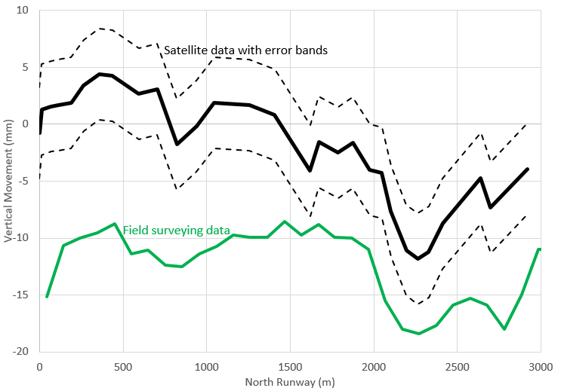
Figure 11. North runway profile change between 21-June-2019 and 8-July-2021: Satellite-based vs. Surveying-based
Potential reasons for the observed discrepancy include: (1) the stability of the surveying monument and errors associated with surveying operations may be at play; however, it is deemed to be unlikely, and (2) the assumption of negligible horizontal movement in the calculation of the vertical component of movement from the measured satellite LOS displacement (with Equation (4)) may be a significant contributing factor [8].

Conclusions
This paper outlines a case study comparing sets of settlement measurements taken over the North runway of the Vancouver International Airport obtained from satellite monitoring techniques and conventional surveying methods conducted by the airport authority. Comparisons demonstrated similar trends. Further investigation is ongoing to explain the discrepancies.

ACKNOWLEDGMENTS
The authors wish to acknowledge the financial contributions of Transport Canada and Infrastructure Canada. The kind support and surveying data from Vancouver Airport Authority is also acknowledged.

References
- FCM (2019): Canadian Infrastructure Report Card 2019, Federation of Canadian Municipalities - Monitoring the State of Canada’s Core Public Infrastructure, Ottawa, Ontario, Canada, 56 p.
- U.S. DOT, FHWA, FTA (2019): Status of the Nation’s Highways, Bridges, and Transit: Conditions & Performance, Report to Congress, 23rd Edition, Washington, November, 486 p.
- NCHRP (2007): Bridge Inspection Practices, Synthesis 375, National Cooperative Highway Research Program Washington DC, Transportation Research Board.
- TRE Altamira (2021): InSAR Analysis of Ground Displacement over Smiths Falls Railway, Technical Report No JO21-1475-CA for NRC, September 30, 35 p.
- Cusson D, Ozkan I, Greene Gondi F, Eppler J (2020a): Chapter 7 - Remote Monitoring of Highway Bridges with RADARSAT-2 Satellite - Validation Case Study on Jacques Cartier and Victoria Bridges in Montreal, Canada, In: Advances in Remote Sensing for Infrastructure Monitoring, Editor: Vern Singhroy, Publisher: Springer, December, 159-182, https://doi.org/10.1007/978-3-030-59109-0_7.
- Cusson D, Rossi C, Ozkan I (2020b): Early Warning System for the Detection of Unexpected Bridge Displacements from Radar Satellite Data, Journal of Civil Structural Health Monitoring, Special Issue on Structural Health Monitoring for Resilience of Infrastructure, Editor: Genda Chen, 19 p.
- 3v Geomatics (2021): Historical InSAR Analysis of the Vancouver Port Authority and YVR Sea Island, Technical Report for NRC, Sept. 23, 22 p.
- Fuhrmann T & Garthwaite M C (2019): Resolving Three-Dimensional Surface Motion with InSAR: Constraints from Multi-Geometry Data Fusion, Remote Sensing, 11(241), doi:10.3390/rs11030241.

