Early Assessment of Pipeline Failure using A Data-Driven CIC Framework
Mohammad H. Alobaidi ¹, Mohamed A. Meguid ¹, Tarek Zayed ²
¹ Department of Civil Engineering, McGill University, 817 Sherbrooke Street West, Montreal, Quebec, Canada, H3A 2K6
² Department of Building and Real Estate (BRE), Hong Kong Polytechnic University, Kowloon, Hong Kong
Email : mohammad.alobaidi@mail.mcgill.ca, mohamed.meguid@mcgill.ca

ABSTRACT: Early assessment of failure events of oil and gas pipelines promotes a faster and more appropriate response plan, which in turn reduces the potential economic and environmental impacts. One of the major challenges in developing a robust failure identification system is the diverse and often incomplete initial failure reports. Different oil and gas pipeline operational entities and service providers may opt to provide incident reports in a shared database. However, they adopt slightly different reporting on a given incident. In addition, the problem is exacerbated when oncoming failure reports are incomplete, which is often the case, and a data-driven model requires a structured feature space to operate. To this extent, this work proposes a scalable semi-supervised Cluster-Impute-Classify (CIC) learning framework which is capable of learning useful clusters of similar incidents as the oncoming report. The matched existing oil and gas pipeline databases are then used to imputer missing information using a tensor decomposition approach. To quantify the magnitude or type of failure, an on-the-fly classifier training is then utilized within a homogeneous ensemble learning environment. The matched and reconstructed descriptors, predetermined from a diverse set, is finally used to classify event types. The proposed CIC framework is shown to effectively reconstruct missing information and identify the failure magnitude when demonstrated on a pipeline failure database from operational entities in the United States.
KEYWORDS: Pipeline failure; Data imputation; Cluster-Impute-Classify; Machine learning.

introduction and background
Pipelines are the backbone of the oil and gas industry, whether they are utilized for onshore or offshore operations [1]. While pipeline networks are the safest means to transport petroleum products, relative to rail and roadways, they are prone to different failures. Such unexpected events may lead to catastrophic environmental consequences owing to oil spilling or gas line explosions as well as substantial economic losses due to production cessation [2]. Pipeline failure is usually caused by mechanical, corrosion, natural hazards, operational, and other third-party sources [3]. As a result, timely and frequent inspections to structural integrity, operational and environmental parameters of pipeline conditions can substantially mitigate unexpected accidents or major failures and their impact [4].
Inspection techniques have been applied to discover pipeline anomalies and flaws without shutting down production. Such approaches can be in the form of safety assessment frameworks for oil and gas pipelines which utilize a probabilistic modeling of a predetermined set of failure causing features [5]. This group of techniques is devised to increase the success of assessing pipeline health while managing to decrease inspection frequency and, hence, all associated costs. Nevertheless, pipeline failure events are prone to occur as the associated uncertainty of the driving factors cannot be fully treated [6]. Possible factors leading to failure of oil and gas pipeline have been attributed to operational overloading, construction faults, poor installation, mechanical damage, and environmental conditions, short- and compounding long-term conditions [3].
As a consequence, gathering historical failure information about pipeline incidents is a valuable mean of analyzing failure behavior and consequences. This also allows for developing different approaches which targets a more direct modeling of the relationship between failure factors and, for instance, magnitude of failure. Such failure information is nowadays available, many of which are made open access for a variety of reasons, such as advancing research in this field. Databases can be designed to comprise operational conditions of one pipeline network. They can also be constructed by simply pooling all failure incidents. The latter is more commonly available as they do not require sophisticated monitoring and frequent inspection to populate such database with time-dependent explanatories [1]. Instead, incident logs are mandatory upon any failure event and their collection is, hence, relatively cheaper and more suasible to both government regulation entities and service providers [5].
Recently, new data-driven techniques, under machine learning, have been successfully applied in health and safety monitoring of pipeline networks using different databases. Supervised machine learning approaches use predefined feature space (i.e. inputs) to estimate a target variable (i.e. output) which can take the form of continuous (for timeseries and regression problems) or discrete (for classification problems) identity. This class of machine learning requires observed instances, comprising a data set, which record the value of input and output variables per observation in order to train the supervised model. Examples of these techniques are Artificial Neural Networks (ANNs), Support Vector Machines (SVMs) as well as Classification and Regression Trees (CARTs) [8].
In [9], ANN is utilized to predict the condition of three offshore oil and gas pipelines based on historical data specific to this network. Available features, used to predict the discrete-type condition of the pipeline at a given time, include age, diameter, metal loss, and operating pressure. In [10], multiple regression and ANN models are developed to predict the failure cause of failure in onshore oil pipelines with a relatively similar predictor set as the former study. The target variable is also discrete and represents failure types such as mechanical, operational, corrosion based. While such models have been reported to predict the target variable with exceptional accuracy, the databases based on which these studies are developed can be expensive and difficult to obtain by the scientific community and develop by service providers, respectively [11].

Incident-based databases and the need for generalized models
A more useful, yet challenging to develop, data-driven approach can be developed to exploit the second type of databases which are publicly available and comprise incident reports for a wide range of pipeline networks. Such modeling framework has the advantage of being scalable to a wide variety of more accessible features and publicly available databases [10,11]. In general, such data sets are based on incident reports which are usually generated at the beginning of the failure event and may include information such as the location of the incident, readily cross-referenced pipeline characteristics, visible damage, signs of flame or explosion, oil spills as well as initial damage signs to nearby property and possible human casualty. As these reports are usually generated via oncoming reports, a response plan can be appropriately put in place to mitigate further consequences. Hence, a failure magnitude prediction model can significantly help improve the response effort if it can provide reliable insights from initial incident reports.
On the other hand, databases of incident reports have several challenges hindering the development of a supervised learning model. The main drawback is the irregularity in recorded information pertaining to the failure event as well as the pipeline or site characteristics and operational conditions. When an oncoming incident report is recorded, it is usually the case that available information does not have to include a predetermined set of failure parameters, but rather information on most obvious conditions of the pipeline section. Enforcing this fixed reporting scheme may also be impractical as reports are usually made by the public or regular operations workers who may not be aware of this strategy.

Motivation behind CIC framework for data-driven pipeline failure assessment
The absence of a fixed feature space is, from our perspective, translated as a database with missing information. Under supervised machine learning, this challenge prompts a lose-lose tradeoff. Moreover, to fix this problem for the latter approaches to be utilized, the database should be filtered such that either a feature space is fixed and few observations, with full information, are selected or a larger set is selected but the considered feature space is limited to what is commonly available in the failure database. Under both scenarios, a disadvantageous preprocessing is carried out, which will affect the generalization ability of the resulting models, beating the purpose of such modeling solution and constituting the major gap in the relevant literature [6].
The question here is related to how we can utilize incomplete incident reports in determining the cause of the failure event for a more data-driven model dedicated to response planning. This solution should be integrated in the machine learning framework to allow on-the-fly extraction of the missing information into the input feed of the detection model.
An appropriate solution to this problem is governed by semi-supervised learning techniques which are capable of contiguous feature imputation stage that allows the utilization of datasets with missing information. In semi-supervised modeling, the learning framework is enhanced by additional data points of unknown (missing) proportion of the feature space or even output labels. Furthermore, in the case of missing input features, clustering methods are developed through mapping groups of instances in the original database into a similar set. Such semi-supervised approaches are commonly referred to as cluster-then-classify (CTC) models [12]. While the broad literature provides CTC examples, there has been no attempt to utilize CTC, or the required cluster-impute-classify (CIC) approaches in this field [10].
This work proposes a CIC framework which is able to accommodate the challenges in the problem of interest, all while producing a stable generalization ability with limited information, be it the size of the database or the missing information in the incident report. The benefits of such framework are made two folds by its ability to adaptively learn over diverse feature sets from different databases and autonomously impute important variables for a specific database application utilized by the relevant industry.

Methodology
The proposed CIC framework comprises three primary phases, clustering, imputation, and classification. The CIC approach is manifested in an ensemble learning environment [13]. Figure 1 depicts the three stages of the proposed CIC framework, applied to the early assessment problem of pipeline failure using information from oncoming incident reports. From a machine learning perspective, the main advantages of the proposed framework are the inherently scalable building blocks of the three stages, generalization ability via models’ independence from the target dataset (input/output) as well as flexibility in stage-specific training requirements, as they are developed for an in-parallel computational routine. The pure literature on semi-supervised learning models is extensive and detailed review can be found in [14]. It is important to note here that the proposed CIC framework falls under inductive semi-supervised learning. The choice to pursue a CIC approach under this branch is motivated by the targeted advantages.

Stage 1: Clustering
In general, an unsupervised machine learning model can be used here to group the available instances from the database into a number of clusters. Depending on the utilized model, the clusters will host subsets of observations which are similar based on the assumed discrimination function.
While this subsection, and those for the second stage and third stages, describes training strategy of stage-1 model in the proposed CIC framework. However, at the deployment level (or in a testing scheme), the same approach is largely followed to match an oncoming incident report with that in the available dataset.
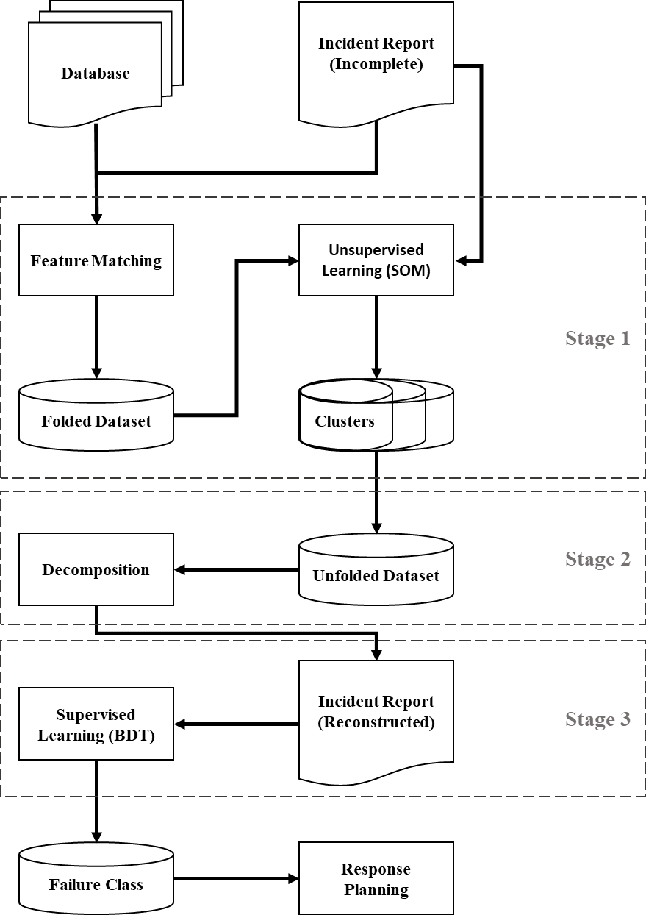
Figure 1: Proposed CIC framework for early assessment of oil and gas pipeline failure.

In this work, Self-Organizing Maps (SOMs) are applied for the clustering stage. SOMs are essentially ANNs which learn a nonlinear projection of the input space to a low-dimensional output space [15]. Only the common features between the resampled subset and the test instance will, obviously, be utilized at this stage. The feature space will be folded to match that which is available by the oncoming incident report.
When a test instance is chosen, the trained SOM will determine its relation to one of the clusters, from which a subset is drawn to create the dataset of Stage-2 model, with the full-feature space unfolded here. The objective of this unsupervised learning stage is to allow a more homogeneous final sample which is used to reconstruct the missing features of the test instance. It is expected that the omission of this stage will severely affect the quality of the imputed information as will be shown in the results.

Stage 2: Imputation
At this point, we have a clustered set of observations coming from the SOM. The homogeneous sample, with respect to the target incident, is then used to construct a feasibility set, with effective size based on which a decomposition model is defined (Figure 2). To optimize the tradeoff between the size of the feasibility set and the computational cost, the considered set may not comprise all of the clustered observations. This approach is determined to control for parameter dilation and strengthen the identity of the estimate [16]. Instead, $S$ reduced feasibility sets are constructed, and the result of their individual decomposition can either be integrated into a final reconstructed dataset or be fed into one of the individual supervised learners comprising the overall ensemble model. The decomposition model is in the form:
$X_{i}≅I_{i}∙\sum_{j=1}^{K_{i}}{V_{j}^{i}∙{W_{j}^{i}}^{T}}$ (1)
where $V_{j}^{i}$ and $W_{j}^{i}$ are the latent vectors partly representing the reduction of the reduced feasibility set $X_{i}$, generalizing over the test instance $(i=1,2,…,S;j=1,2,…,K_{i})$, and a predefined $K_{i}$ is the number of corresponding vector pairs. In order to account for missing information in the feasibility set, the indicator function $I_{i}$ is utilized, where it is set to zero when incident log entries are detected, and one otherwise.
In addition, a scaled version of the feasibility set is used in the factorization problem, as a positive matrix factorization is important for improved estimation $(V_{j}^{i}, W_{j}^{i}≥0)$, and wide-enough margins between the categorical features, if any, further facilitates the convergence.

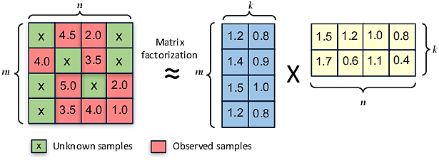
Figure 2: Generic illustration of the decomposition problem in two-dimensional space (matrix factorization).

During training of Stage 2 decomposition models, the hyperparameter $K_{i}$ is optimized by trial and error for each reduced feasibility set. This is expected to have minimal effect on the total computational cost due to the utilized reduction of the feasibility set. The number of latent vector pairs for each dispatch process, and the decomposition model, is found by minimizing the loss function, as follows:
$L_{i}=\frac{1}{2}\sum_{t=1}^{n_{i}}{E_{i}(t)+\frac{1}{2}\sum_{j=1}^{K}{E_{j}}}$ (2)
where,
$E_{i}(t)=\sum_{t=1}^{n_{i}}{{I_{i}(t)∙\left(X_{i}(t)-\sum_{j=1}^{K}{V_{j}^{i}(t)∙{W_{j}^{i}(t)}^{T}}\right)}^{2}}$ (3)
and,
$E_{k}=λ_{i} \left({\left\|V_{j}^{i}\right\|}_{F}^{2}+{\left\|W_{j}^{i}\right\|}_{F}^{2}\right)$ (4)
where || · || represents the Frobenius norm, λ is a regularization parameter, t is the entry from the set ($t = 1, 2, …, n_{i}$), and $n_{i}$ is the size of reduced feasibility set. Once the latent vectors are estimated, the missing information from the target instance, denoted as ${\hat{x}}^{*}$, is then computed as:
${\hat{x}}^{*}=\frac{1}{S}\sum_{i=1}^{S}{\sum_{j=1}^{K_{i}}{{V(t=t^{*})}_{j}^{i}∙{{W(t=t^{*})}_{j}^{i}}^{T}}}$ (5)
The constrained Alternate Least-Squares (ALS) algorithm is used to minimize the loss function [17]. At the end of stage 2, any important missing information in the target instance (i.e. oncoming report) is imputed such that its feature space is now complete for the supervised learning stage.

Stage 3: Classification
The target instance and the unfolded dataset are merged back into a training set comprising incident reports many of which are not related to the feasibility set determined by the SOMs. This further promotes diversity of available information in the training set and is expected to improve the generalization ability of the stage 3 learners. Moreover, a classifier is trained at this stage, which is able to identify pipeline failure types from oncoming incident reports. Given the nature of the problem and characteristics of the associated feature space, ensemble learning models are investigated for better stability results in the final stage of the proposed framework. Ensemble learning is well-defined in the pure and applied literature, and a good review can be found in [13].
In this work, Boosted Decision Tree (BDT) ensemble models are utilized to serve as the final classifier [18]. However, the work also includes performance results of different machine learning models to verify the reason behind choosing BDTs, which is related to the nature of the feature space in this application. As the input variables to the classifier will include both continuous and categorical features, CART individual models are expected to generalize better over mixed features. The RUSBoost Algorithm is utilized to generate and train the boosted tree ensemble model and different ensemble sizes are considered.

Results and Discussion
This work demonstrates the proposed framework using the database of the Pipeline and Hazardous Materials Safety Administration (PHMSA) of the United States Department of Transportation, spanning the years 1970 to 1985. The PHMSA database contains information on various types of pipelines and is divided according to the classification of pipelines. Records of pipeline failure incidents are collected with respect to the incident (location, time, visual traits), Weather (season, temperature), pipeline characteristics (Material, Age, Depth, Thickness), failure magnitude and other standard incident markers. A total of 28 explanatories are considered in this work (Figure 3). Detailed information on the database and previous extensive studies can also be found in [11]. The target of the classification model is considered as the cause of failure, being construction defect (material failure or improper installation), corrosion (both internal and external), and outside force (natural force or manmade).
From validation, SOMs with 2×2 topology have been determined optimal for the considered PHMSA database. When combined with stage 2 of the proposed framework, the imputation shows good reconstruction results of the continuous or categorical features, as shown in Figure 3. In addition, the figure clearly demonstrates that without Stage 1 model, feature reconstruction results deteriorate significantly, as expected.

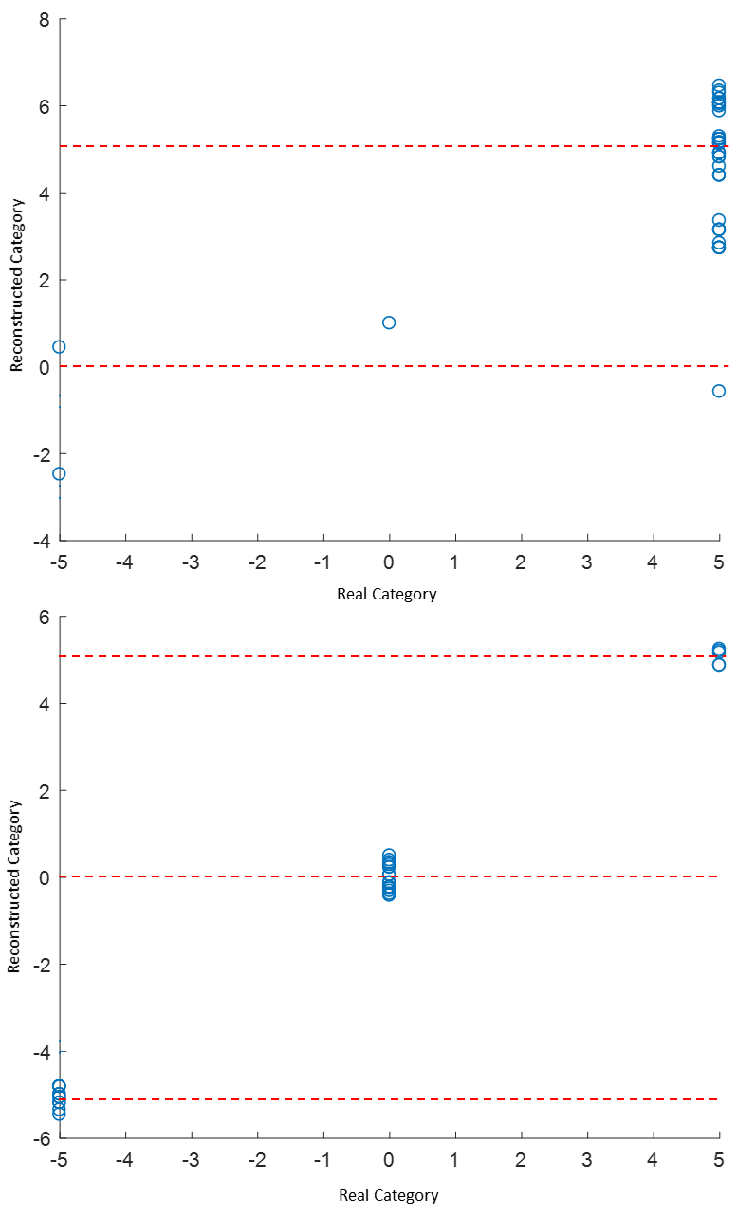
Figure 3: Reconstruction results of a categorical feature without (top) and with (bottom) stage 1 SOM model.

Different supervised learning approaches are investigated to serve as stage 3 models, where a classification of the failure type is the output based on training the models using the 28 considered features. Table 1 shows the performance of five models, namely Naïve Bayes Classifier, SVM, ANN, CART, Random Forest and Boosted Trees, with the last ensemble model being the proposed approach for this application, as discussed in Section 2. It is clear that the ensemble models provide the best classification performance, as they combine the inference from multiple individual models to generate a stable performance. Moreover, Decision Trees are also shown to have the best performance among the individual models. This is in line with the requirements of the available feature space, as CARTS are a good modeling solution for mixed (continuous and categorical) features. It is, however, important to note that the performance of ANN and SVM models will differ based on the utilized training algorithm.
Table 1. Training and testing results (%) of five single and ensemble machine learning models.
Model | Training Accuracy | Testing Accuracy
Naïve Bayes | 80.2 | 67.7
SVM | 100 | 86.5
ANN | 100 | 78.0
Decision Tree | 97.5 | 90.8
Random Forest | 100 | 92.4
Boosted Trees | 100 | 95.0
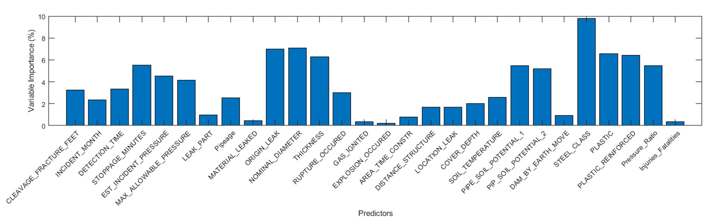
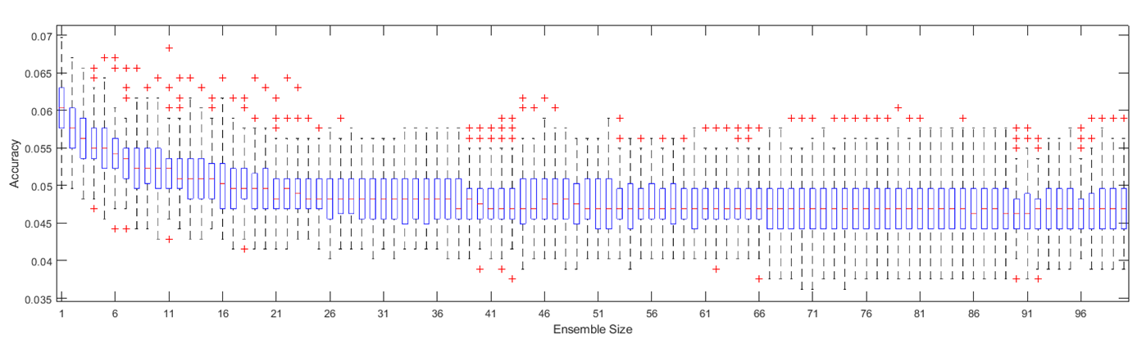
The stability in performance, given by ensemble models, is demonstrated by increasing the ensemble size of the stage 3 model, as shown in Figure 4. As the ensemble size increases, the overall accuracy increases and so does the generalization ability of the model. For the current case study, an ensemble size of 50 can be considered for deployment. Finally, it is important to investigate the considered features in order to allow further improvements to the application of the proposed framework, as it is the case in supervised machine learning. Figure 5 depicts the feature importance results. The figure confirms the significance of different features as imagined during the preprocessing of the database.
Figure 5: Variable importance results using the relative importance of features from CART training/validation studies.

Figure 4: Performance results of Boosted Trees based on the relationship between the classification error and the ensemble size.

Conclusions
This work is aimed to prompt cheap monitoring approach which can substantially reduce the impact of pipeline failure events. The proposed semi-supervised framework is able to detect the failure type of pipelines from raw databases in presence of missing information. Further research should study graph-based imputation techniques for improved results.

References
- Abdoul Nasser, A.H.; Ndalila, P.D.; Mawugbe, E.A.; Emmanuel Kouame, M.; Arthur Paterne, M.; Li, Y. A descriptive study on gas industry. Journal of Marine Science and Engineering 2021.
- Parvizsedghy, L.; Senouci, A.; Zayed, T.; Mirahadi, SF.; El-Abbasy, MS. Condition-based maintenance decision support system for oil and gas pipelines. Structural and Infrastructure Engineering 2015.
- Zakikhani, K.; Nasiri.; F, Zayed, T. A review of failure prediction models for oil and gas pipelines. Pipeline Sys. Eng. and Practice 2020.
- Hu, Z.; Tariq, S.; Zayed, T. A comprehensive review of acoustic based leak localization method in pressurized pipelines. Mechanical Systems and Signal Processing 2021.
- Kabir, G.; Sadiq, R.; Tesfamariam, S. A fuzzy Bayesian belief network for safety assessment of oil and gas pipelines. Struct. Infrast. Eng. 2016.
- Elshaboury, N.; Al-Sakkaf, A.; Alfalah, G.; Abdelkader, E.M. Data-driven models for forecasting failure modes in oil and gas pipes. Processes 2022.
- El-Abbasy, M.S.; Senouci, A.; Zayed, T.; Mirahadi, F.; Parvizsedghy, L. Condition prediction models for oil and gas pipelines using regression analysis. Journal of Construction Engineering and Management 2014.
- Brown, G. Encyclopedia of Machine Learning. Springer 2011.
- El-Abbasy, M.S.; Senouci, A.; Zayed, T.; Mirahadi, F.; Parvizsedghy, L. ANN models for predicting condition of offshore oil and gas pipelines. Automated Construction 2014.
- Senouci, A.; Elabbasy, M.; Elwakil, E.; Abdrabou, B.; Zayed, T. A model for predicting failure of oil pipelines. Struct. Infrast. Eng. 2014.
- Abdrabou, B. Failure prediction model for oil pipelines. Master’s Thesis, Concordia University, Montreal, QC, Canada, 2012.
- Peikari, M.; Salama, S.; Nofech-Mozes, S.; Martel, A. L. A cluster-then-label semi-supervised learning approach for pathology image classification. Scientific Reports 2018.
- Zhang, C.; Ma, Y. Ensemble machine learning: methods and applications. Springer 2012.
- van Engelen, J.E.; Hoos, H.H. A survey on semi-supervised learning. Machine Learning 2020.
- Kohonen, T. The self-organizing map. Neurocomputing 1998.
- Constantinescu, T. Factorization and dilation problems. Springer 1996.
- Surian, D. A shared latent space matrix factorisation method. Journal of Biomedical Informatics 2018.
- Seiffert, C. RUSBoost: A hybrid approach to alleviating class imbalance. IEEE Transactions on Systems, Man, and Cybernetics 2009.

