Investigation of Smoke Movement from Solar Roof Fire by a Modified Froude-Modeling Scaling Method
Xin Zhang¹, Monireh Aram¹, Dahai Qi¹, Liangzhu (Leon) Wang²
¹Department of Civil and Building Engineering, Université de Sherbrooke, Sherbrooke, Québec, Canada, J1K 2R1
²Department of Building, Civil, and Environmental Engineering, Concordia University, Montreal, Quebec, Canada, H3G 1M8
Email : xin.zhang@usherbrooke.ca, monireh.aram@usherbrooke.ca, dahai.qi@usherbrooke.ca, leon.wang@concordia.ca

ABSTRACT: As one of the most important clean technologies, solar roof is increasingly applied. To understand the mechanics of smoke spread from solar roof fire into the building, it is necessary to conduct small-scale experiments, which need an accurate scaling method by considering both wind and buoyancy effects. This study proposes a modified Froude-modeling scaling, where the impacts of wind and buoyancy forces are considered using two modification coefficients, α, and β. A series of sub-scale and full-scale CFD simulations were conducted. By comparing the dimensionless velocity and temperature, it was found that when α=0.25 and β=0.1875, the indoor velocity and temperature can satisfy the similarity, while for the outdoor environment, α=0.035.
KEYWORDS: Froude modeling; solar roof fire; smoke spread; CFD simulations.

Introduction
To reduce carbon emissions and create a clean environment, Quebec aims to reduce greenhouse gas emissions by 27.5% in 2030 compared to the 1990 level [1]. Therefore, solar roof is promoted to reach the goal of greenhouse gas emissions reduction. However, there is a huge concern on the fire safety issue of the solar roof, e.g., seven fire accidents originating from Photovoltaic (PV) panels roof were reported in the US in 2019 [2]. To address the fire safety issues, it is necessary to research the smoke spread from solar roof fire into the building. Small-scale experiments based on traditional Froude modeling are often used in fire safety research. However, the traditional Froude modeling neglects the wind impact; therefore may not work for the PV roof fire-induced smoke spread where there are strong wind effects. This study proposes a modified Froude-modeling scaling by considering both wind and buoyancy force and validating its accuracy.

Methodology

Modified Froude-modeling-based scaling
Based on the Froude number, velocity modification coefficient α is added to represent the other external field, such as buoyancy force as below. Fr is modified Froude number; u is velocity (m/s); g is gravity acceleration (m/s²); l is length (m); T is temperature (K); T* is the dimensionless temperature; subscript s is sub-scale model; subscript f is full-scale model.
$Fr=\frac{u_{s}}{g^{0.5}l_{s}^{0.5+α}}=\frac{u_{f}}{g^{0.5}l_{f}^{0.5+α}}$ (1)
Velocity scaling can be derived as:
$\frac{u_{s}}{u_{f}}={\left(\frac{l_{s}}{l_{f}}\right)}^{0.5+α}$ (2)
Similarly, temperature modification coefficient β is imported in the densimetric Froude number:
$Fr=\frac{u_{s}}{g^{0.5}{T^{*}}^{0.5}l_{s}^{0.5+β}}=\frac{u_{f}}{g^{0.5}{T^{*}}^{0.5}l_{f}^{0.5+β}}$ (3)
$T^{*}=\frac{T_{smoke}-T_{a}}{T_{a}}$ (4)
Therefore,

$T_{s}^{*}{\left(\frac{l_{f}}{l_{s}}\right)}^{2α-2β}=T_{f}^{*}$ (5)

CFD modeling
The CFD software, Fire dynamic simulator (FDS), is applied to simulate the sub-scale (1/15) and full-scale cases of flat roof and 45º sloped roof houses, as shown in Figure 1. In the full-scale model, the opening is 1.2 m × 3.6 m for the flat roof case skylight and the attic vent in the 45º sloped roof case. PV panel is installed on the south of the roof (2 m × 2 m). Two windows (1.2 m × 1.8 m) are installed on both sides of the wall. The wind speed is defined as 20 m/s in the full-scale model and 5.2 m/s in the sub-scale model based on the Froude modeling.
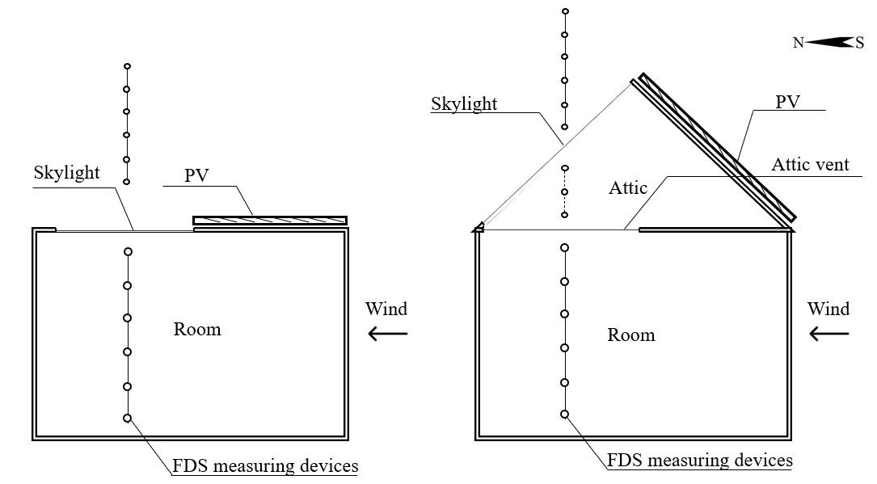
Figure 1. Schematic view of buildings with a flat roof and 45º sloped roofs

REsults and discussion
Figure 2 compares the dimensionless velocity (Equation 2), which indicates a good agreement between full-scale and modified sub-scale results. However, in the 45º sloped roof case, there is a distortion near the dimensionless height, which is defined as the interface flow area, i.e., a transitional region from external to internal flow. The reason may be that the pressure discharge through the skylight and the wind speed is slowed down based on the Froude modeling scaling. It seems that the distortion of interface flow affects the similarity in the original Froude modeling; however, it does not change the characteristics of the airflow. Therefore, the new modification coefficients can be proposed to mitigate this distortion. Meanwhile, an interface flow exists between indoor and outdoor conditions, therefore, indoor and outdoor will have different modification coefficients. Here, velocity modification coefficients α=0.25 (indoor) and α=0.035 (outdoor).

Figure 2. Comparing dimensionless velocity.
Figure 3 compares the dimensionless temperature (Equation 4) between full-scale results and modified sub-scale results. Similarly, at the building height, there is an interface flow area to distort the similarity of dimensionless temperature. Therefore, it is possible to import another temperature modification coefficient β=0.1875 (indoor) and β=0.085 (outdoor). After modification of Froude modeling, the similarity can be maintained between sub-scale results and full-scale results.

Figure 3. Comparing dimensionless temperature.

Conclusion
This research proposed and verified two new coefficients for Froude modeling to solve the problem that the similarity is difficult to be maintained between the indoor and outdoor environments due to the coupled wind and buoyancy effects. The results of dimensionless velocity and dimensionless temperature were obtained by a validated CFD model. α=0.25 and β=0.1875 for the indoor environment/ α=0.035 and β=0.085 for the outdoor environment can be obtained in modified Froude-modeling-based scaling.

ACKNOWLEDGMENTS
This work was supported by the Start-up Fund of the Université de Sherbrooke, Discovery Grants of Natural Sciences and Engineering Research Council of Canada (NSERC), and Fonds de recherche Nature et technologies (FRQNT) – Research support for new academics.

References
[1] M. de lEnvironnement, de la Lutte contre les changements climatiques, and D. générale de la transition climatique, “Tableau détaillé des actions du Plan de mise en œuvre 2021-2026 du Plan pour une économie verte,” 2030.
[2] C. Dolmetsch, “Tesla solar panels caused fires at 7 Walmart stores, retailer alleges - Los Angeles Times,” 2019.

