ABSTRACT: The tunnel inspection task using the digital camera or mobile laser scanning (MLS) has become a popular approach for efficiently assessing the tunnel infrastructure's structural health status. However, these modern techniques are hindered by practical issues for a comprehensive tunnel inspection. The tunnel lining images obtained from the digital cameras only contain RGB information of the surface defects (e.g., crack, leakage, spalling) with high pixel resolution, which cannot provide the spatial location of the defects and the tunnel deformation. The point cloud data acquired by the MLS can quickly provide 3D coordinates of the inspected tunnel and conduct deformation analysis using intensity corrected methods. However, the resolution of point cloud data obtained from the state-of-the-art MLS is limited to 0.5mm, which cannot meet the required accuracy for crack width (0.2mm) in tunnel inspection practice. This study proposed a novel approach by combining laser point cloud and images via the scale-invariant feature transform (SIFT). The cloud points obtained from the MLS are firstly converted to grayscale images. The defect features are segmented using deep learning algorithms, and the key features in both camera acquired images and the point cloud-converted gray images are matched using the SIFT. A 3D reconstruction method based on the processed point cloud data and the matched defect features in the image data is then used to construct a 3D tunnel model to obtain spatial locations of the deformation and the tunnel lining defects. As a result, a comprehensive tunnel inspection is achieved, including quantified tunnel deformation and multi-defect detection with required accuracy and 3D coordination. The capability of the proposed approach is successfully demonstrated via a field inspection experiment inside a highspeed rail tunnel.

Comprehensive tunnel inspection combining laser point cloud and images via the scale-invariant feature transform
Shuyi Liu¹, Mingliang Zhou¹, Hua Shao², Dongming Zhang¹,Hongwei Huang¹
¹ Key Laboratory of Geotechnical and Underground Engineering, Department of Geotechnical Engineering, Tongji University, Siping Road 1239, Shanghai 200092, China
² Shanghai Shentong Metro Co.,Ltd. Pudian Road 489, Shanghai, 200122, China
Email: 1851814@tongji.edu.cn (S.L.), zhoum@tongji.edu.cn (M.Z.), shkypy79@sina.com (H.S.), 09zhang@tongji.edu.cn (D.Z.), huanghw@tongji.edu.cn (H.H.)
KEY WORDS: Tunnel inspection, point cloud data, scale-invariant feature transform detection, 3D reconstruction.

Introduction
As China's economy grows and the urban population increases, urban transportation systems face tremendous pressure, with many tunnels being built and entering operation. Underground tunnels are continuously affected by external loading and environmental changes, which inevitably lead to structural defects (structure deformation, crack, water leakage, spalling, etc.) and are harmful to the safety and durability of the tunnel structure. Besides, Tunnels are often characterized by high construction costs, high concealment, complex ground conditions, irreversibility of construction, and more severe consequences of hazards. Therefore, regular inspection of the structural health of tunnels is necessary. Traditional manual inspection methods (total station detection of deformation, manual naked eye identification of apparent defects, etc.) are subjective and inefficient. In practice, urban subway tunnels have only about 3 hours of midnight for inspection and maintenance (Liao, 2020). Therefore, there is an urgent need to propose an automated method for accurately and efficiently detecting structural defects.
With the fast-developing vision-based inspection technology, there are two popular methods for tunnel defects detection. The photogrammetric technique takes photos of the tunnel lining surface and performs image processing to detect defects. The deep learning method has been applied to recognizing diseases in tunnel lining structures, and it is more advanced in generalization ability and robustness (Zhou et al., 2021b). Among many models, the Mask R-CNN model developed based on Faster R-CNN incorporates semantic segmentation and target detection while quantifying and calculating the detected region and effectively solving the gradient explosion and gradient disappearance problems (Wu et al., 2019, Zhao et al., 2020). Nevertheless, the image-based method cannot provide the spatial location of the defects and the tunnel deformation. The mobile laser scanning (MLS) system has gained popularity lately, which captures high-precision point cloud (x, y, z, I) data by a laser scanning device equipped on a movable cart, where x, y, z are the 3D spatial coordinates of the obtained point cloud data, and I is the laser intensity of each point. Then ellipse fitting method is performed based on the 3D coordinates to detect the structural deformation (Fan et al., 2020, Fitzgibbon et al., 1999, Wu and Huang, 2018). However, the resolution of point cloud data obtained from the state-of-the-art MLS is limited to 0.5mm, which cannot meet the required accuracy for crack width (0.2mm) in tunnel inspection practice. Therefore, data fusion of multiple sensors (digital camera and MLS system), which can obtain comprehensive tunnel defect information, is a promising approach.
The key to images and point cloud data fusion is establishing a mapping correlation between two data sources. One can use the spatial coordinates of two devices to get the mapping correlation (Wang et al., 2021). However, this is not feasible in the field since the MLS and camera system do not have fixed positions during the inspection. A more robust approach widely used in computer vision study is to extract and match the key feature points of two data sources to calculate the mapping matrix. For feature extraction, there are two main methods. One uses a calibration board and gets feature points manually; another uses a feature extraction operator and gets feature points automatedly (Zhang et al.). The scale-invariant feature transform (SIFT) is an algorithm for automatically detecting local features, which performs well in various applications (Karami et al., 2017). SIFT features have scale invariance and can achieve a good detection effect even if the rotation angle and brightness of the image are changed. In addition, the fast library for approximate nearest neighbors (FLANN) algorithm is used for efficient feature matching between different source images (Wang and Zhou, 2018).
This study proposes a comprehensive tunnel defect inspection approach based on digital cameras and MLS systems. It can automatically detect and quantify structural deformation, crack, water leakage, and spalling defects. The ellipse fitting method and Mask R-CNN model calculate structural profile deformation and detect apparent damages through the 3D point cloud and digital images. With the gray images generated via point cloud unfolding and square grid partition method, the comprehensive detection results are obtained via data fusion using SIFT and FLANN algorithms.

Methodology

Structure deformation calculation
This paper calculates structure profile deformation based on the MLS system, which can obtain the spatial location of the tunnel lining surface. The ellipse fitting method is used to perform the structure deformation calculation. The calculation steps are as follows:
(1) Calculate the standard equation of the ellipse:
(1)
Where P = [A, B, C, D, E, 1] refers to the parameter vector of the elliptic equation, which is also the target quantity to be solved for the fitting process. X = [x², xz, z², x, z, 1] is the coordinate vector of a point in the point cloud. x and z are the tunnel cross-section's horizontal and vertical coordinate values.
(2) Solving elliptic parameters using the least-squares principle:
(2)
Eq.(1) is simplified to Eq.(2) by the Direct Least Square method (Fitzgibbon, 1999). XC = [X₁, X₂,…,X_{n}]^{T} is the set of points whose coordinates vectors are X_{i}. By solving the Eq.(2), parameter set P can be calculated and the optimal elliptic curve is fitted based on the coordinates of cloud points. The difference in fit R_{i} = [r₁, r₂,…, r_{n}] can be calculated, and the points with a difference in fit greater than three times the standard deviation can be eliminated. The elliptic fitting and denoising steps are repeated until all points deviate from the mean value by a low amount. After the denoising process, the computed elliptic curve is the final tunnel lining profile.

Lining surface defect detection
The defect in tunnel linings can be detected from the digital images and the gray-scale images converted from the 3D point cloud data. The image conversion process usually consists of two steps (Wu and Huang, 2018). Firstly, projecting the 3D point cloud (x, z) onto a cylinder with a radius of the tunnel design radius (x′, z′), and then unrolling the cylinder along its parent line to obtain a 2D planar point cloud (x″, z″). Secondly, using the average point cloud intensity value as the gray value via the square grid partition method (Huang et al., 2020). The mean filtering method is used for the grid without points to obtain its grayscale value (Figure 1).
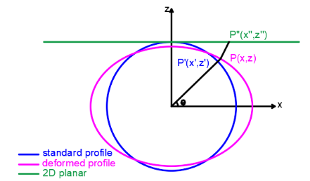
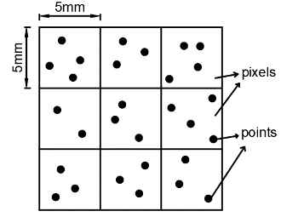

(a) (b)
Figure 1: (a) Projecting and unrolling. (b) Square grid partition method.
In this study, Mask R-CNN (He et al., 2017) algorithm (as shown in Figure 2) is used for apparent defect recognition on images, which can segment tunnel lining defects with high efficiency and accuracy. The composition of Mask R-CNN includes skeleton structure, neck structure, and head structure. The skeleton structure consists of ResNet (He et al., 2016) and FPN (Long et al., 2015), mainly used to output high-quality feature maps. The ResNet algorithm can establish shortcut connections, thus effectively solving the gradient explosion and gradient disappearance problems. The FPN achieves the multi-scale detection problem of the target by connecting the upsampling of high-level features with the bottom-up generated feature maps of the same size horizontally. The neck structure consists of RPN and ROI-Align, which are used to receive the feature map and output the candidate frames and classification results, and ROI-Align, which converts the candidate frames of different scales to the same scale and retains the pixel-level information better because of the bilinear interpolation method. The head structure consists of three parallel branches: object segmentation implemented by FCN, box regression implemented by a fully connected layer, and classification, where the FCN method is the key to achieve prediction (Zhou et al., 2021a).
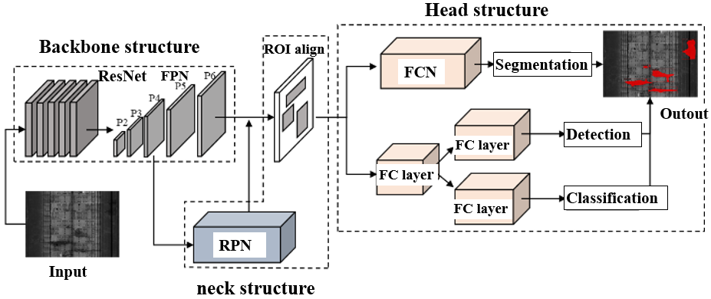
Figure 2: The overall structure of the Mask R-CNN model

Images fusion

SIFT algorithm for feature detection
The SIFT algorithm is adopted to automatically detect image features from MLS and digital camera systems. A multiscale image pyramid (As shown in Figure 3) consists of images I(x,y) that are downsampled to form octaves of images of different sizes. Then the images are smoothed and made to vary continuously in size by Gaussian convolution G(x, y, σ) to form multiple image scales L(x, y, σ) within the octave:
(3)
(4)
There are multiple octaves in a pyramid, and each octave contains multiple scales. The images in the same octave have the same scale but different smoothness. The down-sampling approach removes half the pixel value of the penultimate scale of the previous octave to reduce the size. Gaussian fuzzing is a Gaussian convolution of different scales on each octave using different standard deviation values (σ).
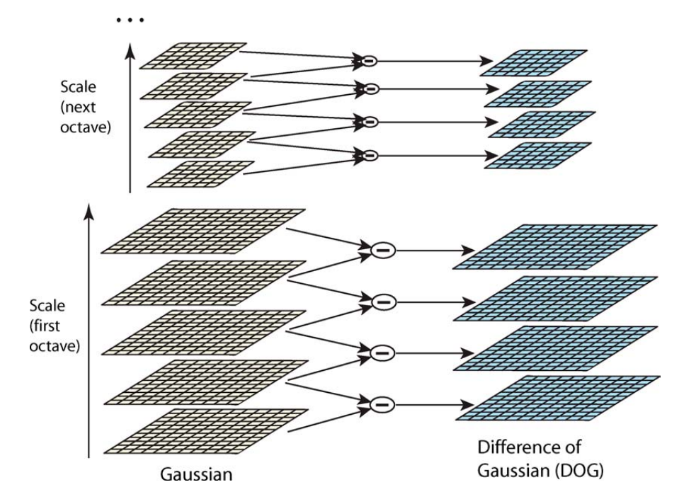

Figure 3: Multiscale image pyramid and DOG operator
Since the convolution kernel and the image scale are consistent, and the feature points are solved based on each scale, the scale invariance is achieved, which means that the feature points can be effectively extracted regardless of the close range or far range. The Difference of Gaussian (DOG) operator (As shown in Figure 3) describes the rate of gray value change by differencing the pixel values of images in two adjacent scales and thus extracts the point with the most significant change (extreme point) as a candidate feature point (As shown in Figure 4). This method greatly improves the computational speed compared with the Laplacian of Gaussian (LOG) operator:
(5)
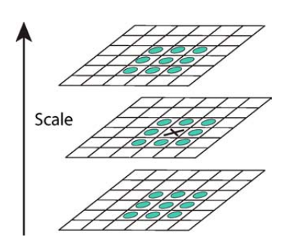

Figure 4: The extraction of extreme points
Moreover, the candidate feature points need further denoise since the DOG operator is sensitive to edges and noises. The Talyor expansion of the function D(x, y, σ) is employed as a fitting function for searching the extreme points in continuous space.
The candidate features points can be obtained by finding the derivative of equation (6) and letting this derivative equal 0. In addition, A 2x2 Hessian matrix in the location and scale of a key point can compute the ratio of the principal curvatures. To select and eliminate the edge response, one can then compare the ratio with the setting value (Lowe, 2004).
The main direction of the feature point is allocated using the distribution of adjacent pixels in the gradient direction θ(x,y) in their neighborhoods (Li et al., 2019), which can maintain rotation invariance for the image. The weights of different gradient direction of pixels depends on their gradient value m(x,y).
Calculating the gradient orientations of the points in a region near the feature point can form an orientation histogram. Take the highest point as the main direction of this feature point. Finally, the feature descriptor is generated via a direction vector, consisting of the adjacent points’ gradient orientation.

FLANN algorithm for feature matching
The FLANN algorithm is mainly implemented based on the KD-TREE operation or K-mean tree. The effective search type and retrieval parameters are given by the known distribution characteristics of the data set and the required space resource consumption. The feature space required by the FLANN algorithm is usually the n-dimensional real vector space R, and searching to find the nearest neighboring point in the neighborhood of the instance point is based on the Euclidean distance dis(x,y) (Xu and Diao, 2020).
(9)

Image fusion
After matching the features of digital images and gray-scale images, the homography matrix, which reflects the mapping relationship between two images, can be calculated through feature point pairs. And then, the pixels on gray-scale images should be replaced by the pixels of the defects on the digital images at the corresponding location.

Experiment and results
To verify the reliability of this integrated approach and the effectiveness of the fusion algorithm, a tunnel section of a highspeed rail tunnel in Yunnan Province, China, was selected for the field inspection experiment. The Z&F9012 MLS system with ten thousand points per second and 360° rotational scanning was used for the point cloud data acquisition. A mobile phone camera took the digital images of the tunnel lining defects. Figure 5(a) and Figure 5(b) are the digital image and gray-scale image generated from point cloud data, respectively. The lining crack defect in Figure 5(a) is one of the cracks in Figure 5(b) at the bottom right. The computed result from the SIFT and FLANN algorithm is shown in Figure 5(c), where green lines are illustrated to connect the feature points pairs. Figure 5(d) shows the final fusion image, which contains the detected cracks in the tunnel lining.
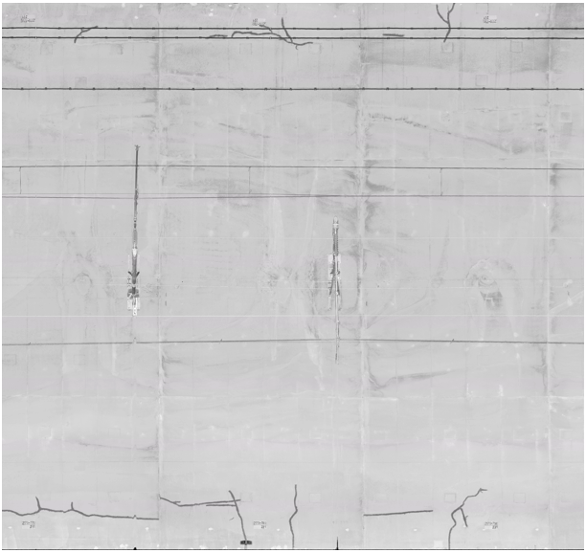
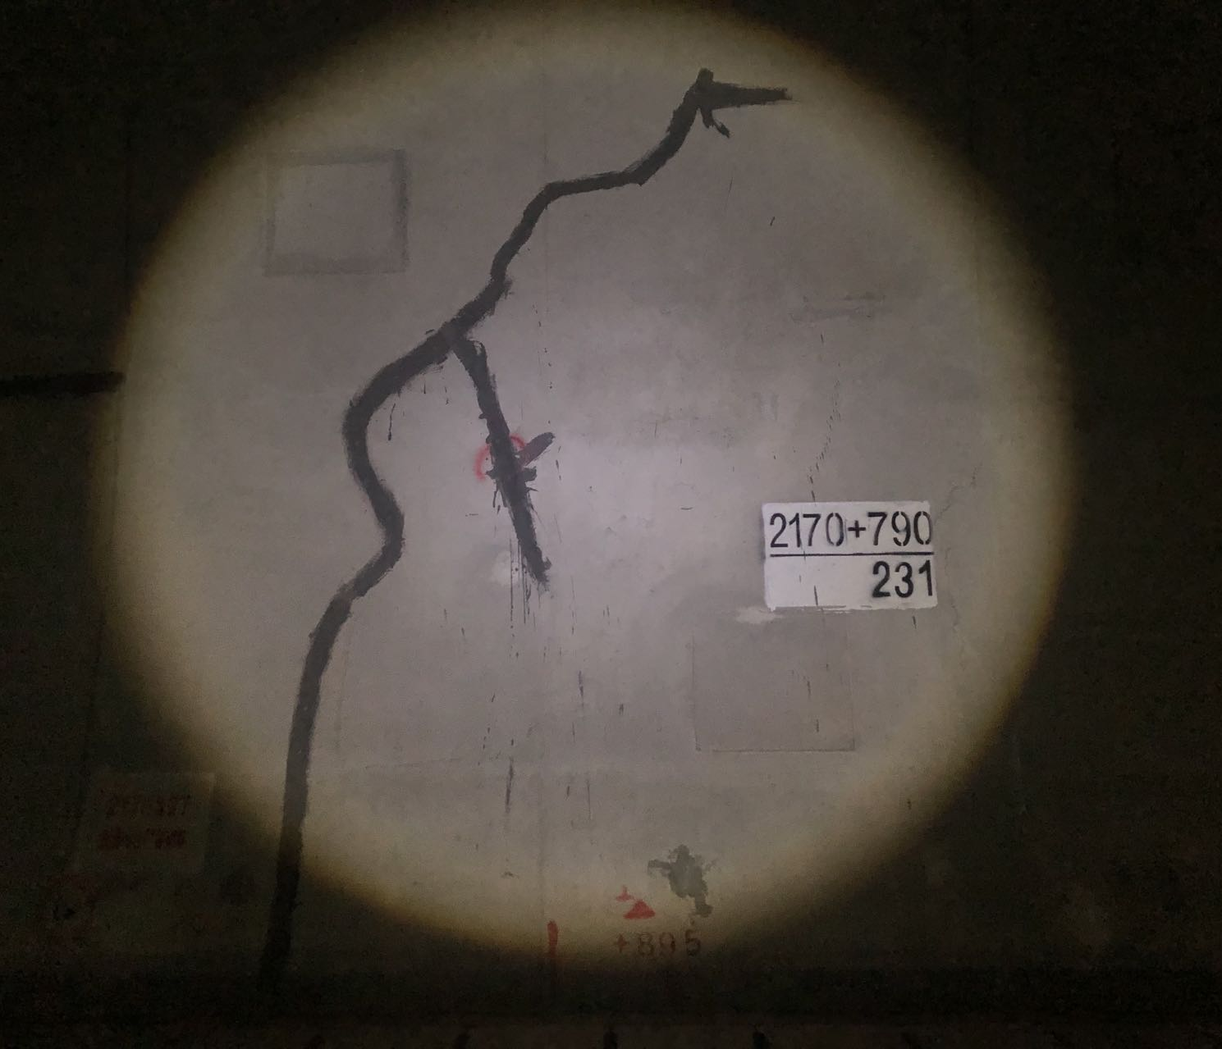

(a) (b)
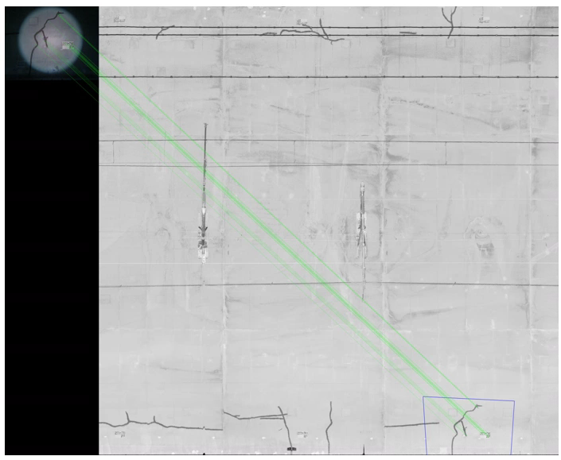

(c)
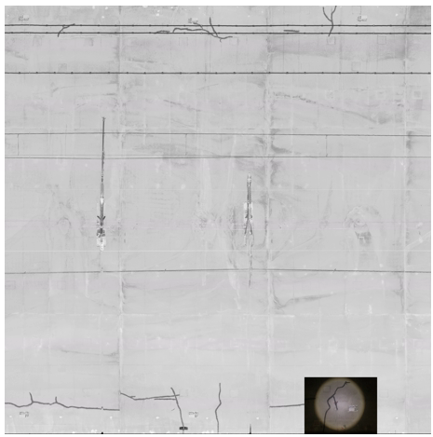

(d)
Figure 5: (a) Digital image. (b) Gray-scale image. (c) Feature matching. (d) Image fusion.
Meanwhile, a tunnel section of Line 13 of the Guangzhou Metro was also selected for example validation. Since the areas of water leakage and spalling are relatively large and do not require high accuracy, the recognition of them is based on point cloud grayscale images using Mask R-CNN model (As shown in Figure(a)). Their relative locations in the tunnel could be visualized by 3D reconstruction model (As shown in Figure 6(b)).

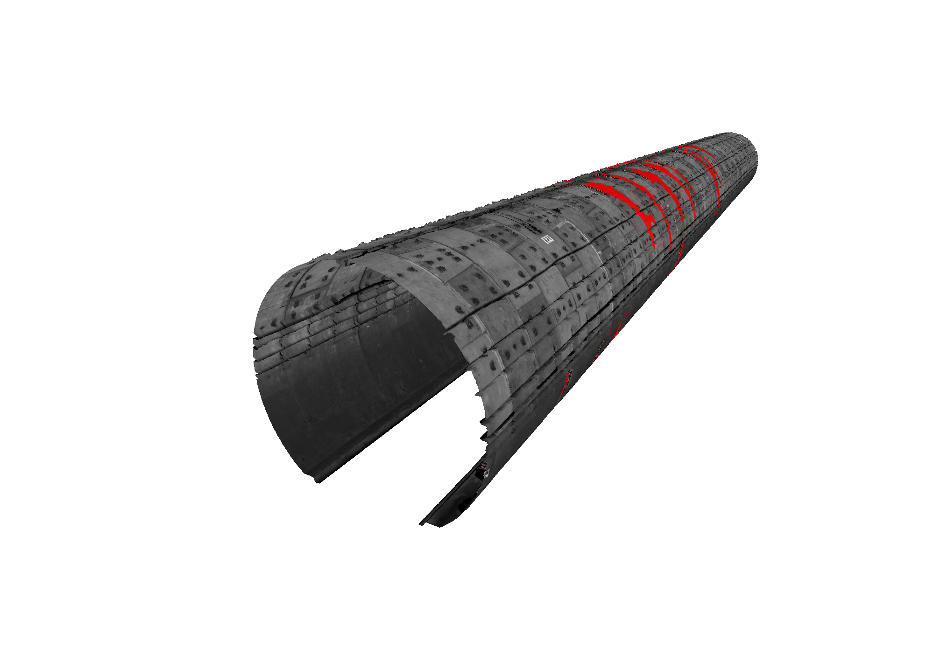

(a) (b)
Figure 6: (a) The water leakage defects. (b) The 3D visualization model

CONCLUSION
This study integrates photogrammetry and MLS systems to detect comprehensive tunnel lining defects via the proposed image fusion algorithm. It could get the deformation of the tunnel lining, detect the apparent damages on the lining, and obtain their spatial location. The feasibility of the method was verified through actual site tunnels. The main conclusions are as follows:
(1) Through the point cloud ellipse fitting method and the Mask R-CNN model, an automatic detection method of tunnel structure deformation and apparent damages is proposed.
(2) Based on the image fusion algorithm, the spatial location of the damages recognized via the Mask R-CNN model on digital images could be obtained from the grayscale images generated by point cloud data.
(3) The proposed approach can perform a comprehensive inspection of the health and safety of a tunnel.
As for the future work, with the development of deep learning technology, which can capture features automatically, it will be more precise to match images through deep learning models. Besides, searching features in local areas by pre-judging the defects could develop the efficiency of feature matching algorithm.

References
FAN, T. L., TANG, C. & WANG, B. Q. 2020. Application of Mobile 3D Laser Scanning Technology in Shield Tunnel Convergence Monitoring (in Chinese). Bulletin of Surveying and Mapping (in Chinese), 50-53.
FITZGIBBON, A., PILU, M. & FISHER, R. B. 1999. Direct least square fitting of ellipses. Ieee Transactions on Pattern Analysis and Machine Intelligence, 21, 476-480.
HE, K. M., GKIOXARI, G., DOLLAR, P. & GIRSHICK, R. 2017. Mask R-CNN. 2017 Ieee International Conference on Computer Vision (Iccv), 2980-2988.
HE, K. M., ZHANG, X. Y., REN, S. Q. & SUN, J. 2016. Deep Residual Learning for Image Recognition. 2016 Ieee Conference on Computer Vision and Pattern Recognition (Cvpr), 770-778.
HUANG, H. W., CHENG, W., ZHOU, M. L., CHEN, J. Y. & ZHAO, S. 2020. Towards Automated 3D Inspection of Water Leakages in Shield Tunnel Linings Using Mobile Laser Scanning Data. Sensors, 20.
KARAMI, E., PRASAD, S. & SHEHATA, M. 2017. Image matching using SIFT, SURF, BRIEF and ORB: performance comparison for distorted images. arXiv preprint arXiv:1710.02726.
LI, X. K., GAO, C., GUO, Y. C., HE, F. L. & SHAO, Y. H. 2019. Cable surface damage detection in cable-stayed bridges using optical techniques and image mosaicking. Optics and Laser Technology, 110, 36-43.
LIAO, J. H. 2020. Research on rapid detection method of tunnel surface disease (in Chinese).PHD, Shenzhen University (in Chinese).
LONG, J., SHELHAMER, E. & DARRELL, T. 2015. Fully Convolutional Networks for Semantic Segmentation. 2015 Ieee Conference on Computer Vision and Pattern Recognition (Cvpr), 3431-3440.
LOWE, D. G. 2004. Distinctive image features from scale-invariant keypoints. International Journal of Computer Vision, 60, 91-110.
WANG, G. Q., MAO, Q. Z., XU, H. X., DU, Y. & XIONG, Y. G. 2021. Tunnel point cloud and high-definition image alignment method based on spatio-temporal synchronization information (in Chinese). Bulletin of Surveying and Mapping (in Chinese)
52-58.
WANG, J. L. & ZHOU, Z. F. 2018. Research on SIFT-based image feature extraction and FLANN matching algorithm (in Chinese). Computer Measurement & Control (in Chinese), 26, 175-178.
WU, C. R. & HUANG, H. W. 2018. Laser Scanning Detection Method and Application of Water Leakage in Metro Tunnel (in Chinese). Journal of Natural Disasters (in Chinese), 27, 59-66.
WU, Y., HU, M., XU, G., ZHOU, X. & LI, Z. Detecting Leakage Water of Shield Tunnel Segments Based on Mask R-CNN. 2019 IEEE International Conference on Architecture, Construction, Environment and Hydraulics (ICACEH), 2019. IEEE, 25-28.
XU, M. & DIAO, Y. 2020. Research on Image Matching Method Based on SURF Operator and FLANN Search (in Chinese). Modern Computer (in Chinese), 49-52+57.
ZHANG, J., TANG, Y., BIAN, Z. Y., SUN, T. Y. & ZHONG, K. J. 3D point cloud and visible light image fusion method and visualization (in Chinese). Laser And Optoelectronics Progress (in Chinese)
1-13.
ZHAO, S., ZHANG, D. M. & HUANG, H. W. 2020. Deep learning-based image instance segmentation for moisture marks of shield tunnel lining. Tunnelling and Underground Space Technology, 95.
ZHOU, M. L., CHENG, W., HUANG, H. W. & CHEN, J. Y. 2021a. A Novel Approach to Automated 3D Spalling Defects Inspection in Railway Tunnel Linings Using Laser Intensity and Depth Information. Sensors, 21.
ZHOU, M. L., CHENG, W., ZHANG, D. M. & HUANG, H. W. 2021b. Automated detection and 3D visualization of structural defects in operational shield tunnels (in Chinese). Journal of Basic Science and Engineering, 29, 1265-1279.

