ABSTRACT: Lime and limestone products are among the oldest materials used in the construction industry for various purposes. Today the general use of the product is to improve the physical and mechanical strength of soft and problematic soils. In this study, industrial raw lime as kiln dust in optimum amounts is mixed with the silty clayey soil to study the deformation and failure behavior. A large number of uniaxial compression and indirect tensile (double punch) tests were performed on lime-treated soil under various loading rates and curing periods. The results show that the deformation pattern is stable and unique for tests with a slow deformation rate. By contrast, the deformation pattern is abrupt and random in samples tested under a higher loading rate. Additionally, the pattern of deformation pattern at failure stages changes with the freeze and thaw cycles.

Evolution of macroscopic deformation in lime stabilized soil
Sohail Akhtar¹, Biao Li¹
¹Building Civil and Environmental Engineering Department, Gina Cody School of Engineering and Computer Science, Concordia University, Montreal, Quebec, Canada, H3G 1M8
Email : sohail.akhtar@concordia.ca, biao.li@concordia.ca

KEY WORDS: Lime-soil mixture, double punch test, freeze and thaw cycles.

Introduction
Lime, having pozzolanic properties, has been known to engineers in the construction industry for centuries (McDowell 1959). The reason for the wide usage of lime in light construction work is its cheap price, readily available, and minimum skill requirements. Nowadays, lime is commonly used as a stabilizing agent for weak soils in shallow foundations, and slope stability for canals and embankments (Wilkenson et al. 2010; Abiodun and Nalbantoglu, 2016).
Lime is added to the expansive and highly plastic soil to reduce the soil expansion in the foundation which leads to reduction in swelling pressure on substructures (Wilkinson et al. 2010) and due to the pozzolanic reaction in the presence of free water, lime behaves as a cementing material leading to increase the physio-mechanical strength of soil (Khattab et al. 2007). It is because of the cation’s exchange in the presence of lime in clay (Bell and Coulthard 1990).
The role of lime has been extensively studied not only for the enhancing the mechanical strength of weak and sensitive soil (Kumar and Monowar 2012; afrin 2017) and also for the ill effects of excessive lime (Halt and Davidson 1960; kumar et al. 2007). It is because lime alone has no friction and cohesion properties, if added more than the required amount it will have adverse effects on soil stabilization. However, the deformation path of lime-soil mixture requires extensive studies to predict the long-term allowable deformations to avoid sudden and unexpected failure in lime-soil mixtures.
Moreover, instrumentation and monitoring of slope soil stabilized with lime is required for over a large period of time to study the long-term deformation performance of stabilized sub-surface soil under loading condition. The monitoring of slope stability is extremely effective and important specially in cold regions considering the negative effects of freeze and thaw cycles to ensure safety, resiliency of structure, postconstruction deformation and to develop effective solutions to the problems related to road design (Yi et al., 2014; Maadani eta al., 2014).
In this study, we conducted a large number of uniaxial compression and double punch tensile tests under three different loading rates. The crack initiation and the limitation of crack propagation under different curing periods, loading rate and freeze and thaw cycles indicate the micro level deformation.

Physical properties and Experimental procedure
The soil collected for this study is silty clayey soil which was dry sieved through US mesh size number 8 (i.e., >2.36 mm). The physical properties of both soil and lime are given in Table 1.
The soil was initially air dried and then mixed with required optimum amount of water and lime content followed by compaction. Then the compacted samples were kept in covered in plastic containers for the tests. In this study, 28 days of curing of lime-soil mixture is assumed to be enough time for the mixture to reach approximately strength. The samples were extracted after 28 days of curing and then covered with aluminum foil followed by vacuumed plastic bags to be used for freezing and thawing.
The setup used for the uniaxial compression tests and double punch tests are given in Figure 1. It is worth noting that in this study only the axial strain was recorded for both type of tests.

Table 1 Physical properties of soil and lime
Property | Value
Natural soil Bulk  density (kg/m3) | 2030
Lime-soil bulk  density1 (kg/m3) | 2146
Sieve size of soil | >2.36 millimeter
Sieve size of lime | 0-1.5 micro-meter
Water content (%) | 14.5
¹Density of soil sample after two hours of mixing with
lime
²water content of specimens at time of preparation

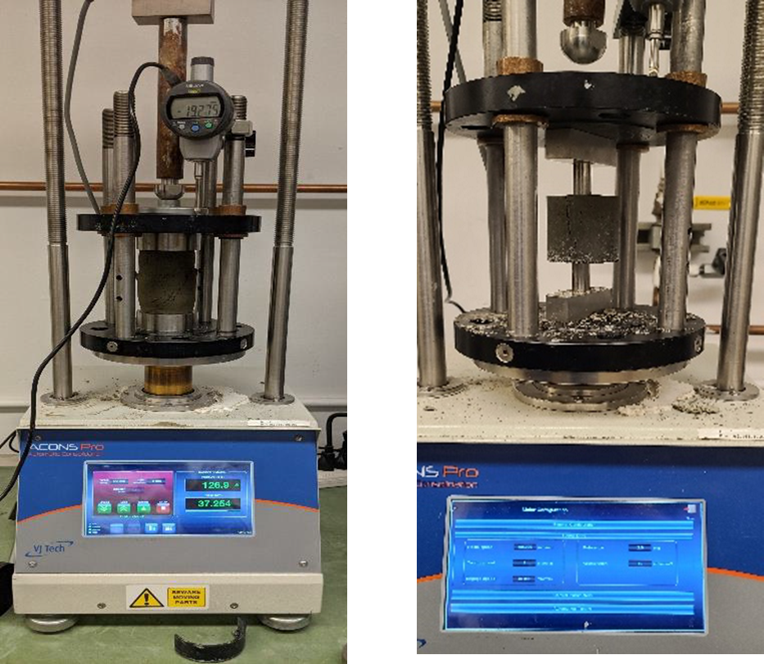
Figure 1. Setup for the Compression test and Double punch test.

Results and Analysis
The post failure deformed samples without freeze and thaw effect under both compression tests and double punch tests are given in Figure 2 and Figure 3, while the deformed samples with freeze and thaw effect under both compression tests and double punch tests are given in Figure 4 and Figure 5.
The results show under compression loading (Figure 2) that at lower deformation rate (1 mm/min.), the deformation is unique passing through section of sample but at higher deformation rate (9 mm/min.), the deformation is limited to top one-quarter area while at 3mm/min. The samples exhibit mix mode deformation. It is because at slow loading, the sample has enough time to pass stress on granular level, however, at higher loading rate the sample has not enough time to distribute the load throughout the section, but the micro cracks join each other in local area leading to wide crack. It is worth noting that this pattern is consistent with curing period. Moreover, the macro-scale deformation pattern is not unique under the double punch tests (Figure 3) except at lower loading rate. It is because, the contact area of puncher of double punch test to the sample is very small causing less visco-plastic deformation due to the loading.
The deformation patter and crack appearance of samples changes under compression tests after freeze and thaw cycles (Figure 4). The change in is more visible at lower loading rate as compared to the higher loading rate. The lower loading rate (1mm/min) tends to yield deformation pattern similar to higher loading rate (9mm/min). It is because, internal changes occur to freezing and thawing. The freezing of available water in sample leads to swelling of sample leading to release the energy stored due to compaction causing a particles rearrangement after a thawing. However, the change in deformation pattern in samples with freeze and thaw cycle are not visible under double punch tests (Figure 5).

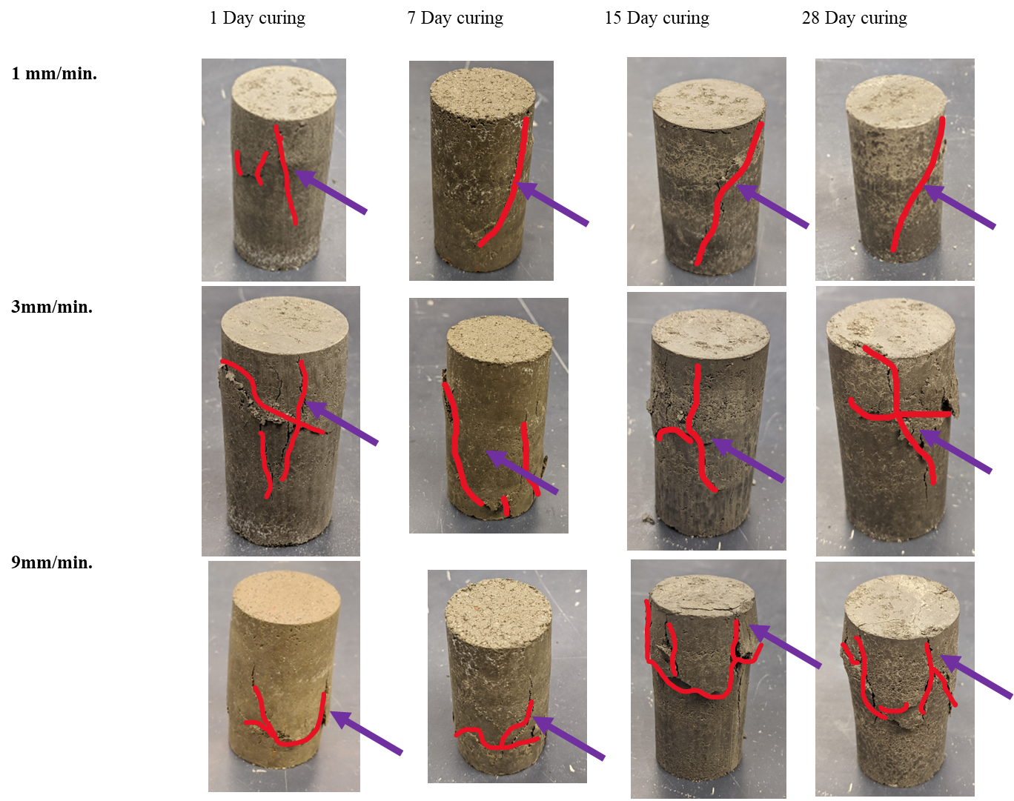
Figure 2. Post-failure photos of UCS test samples at different applied deformation rates and curing periods.

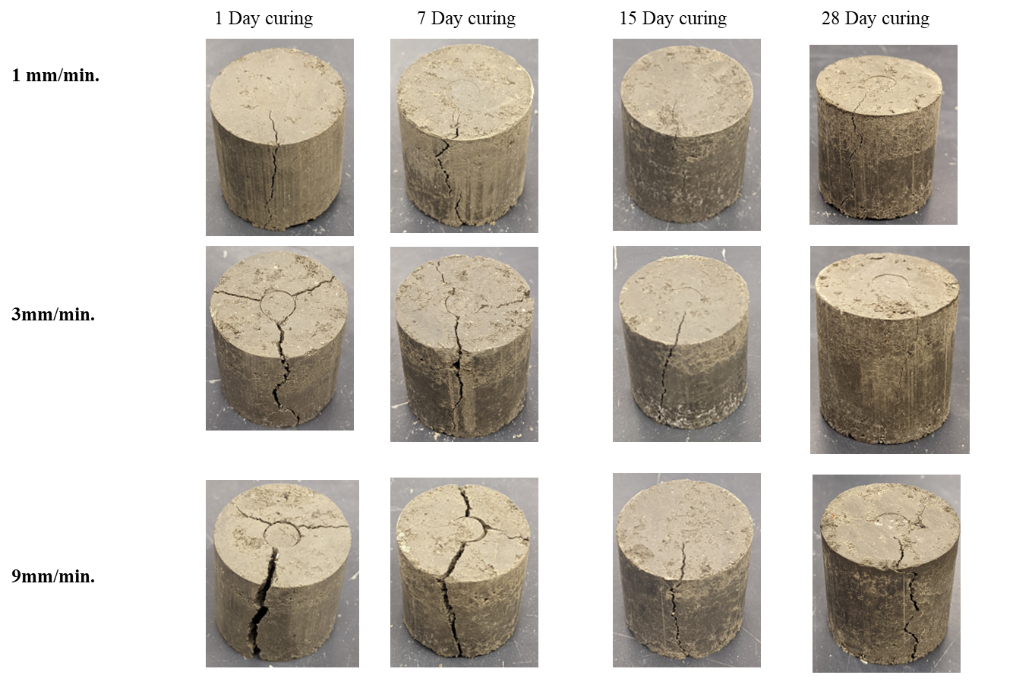
Figure 3. Post-failure photos of Double punch test samples at different applied deformation rates and curing periods.

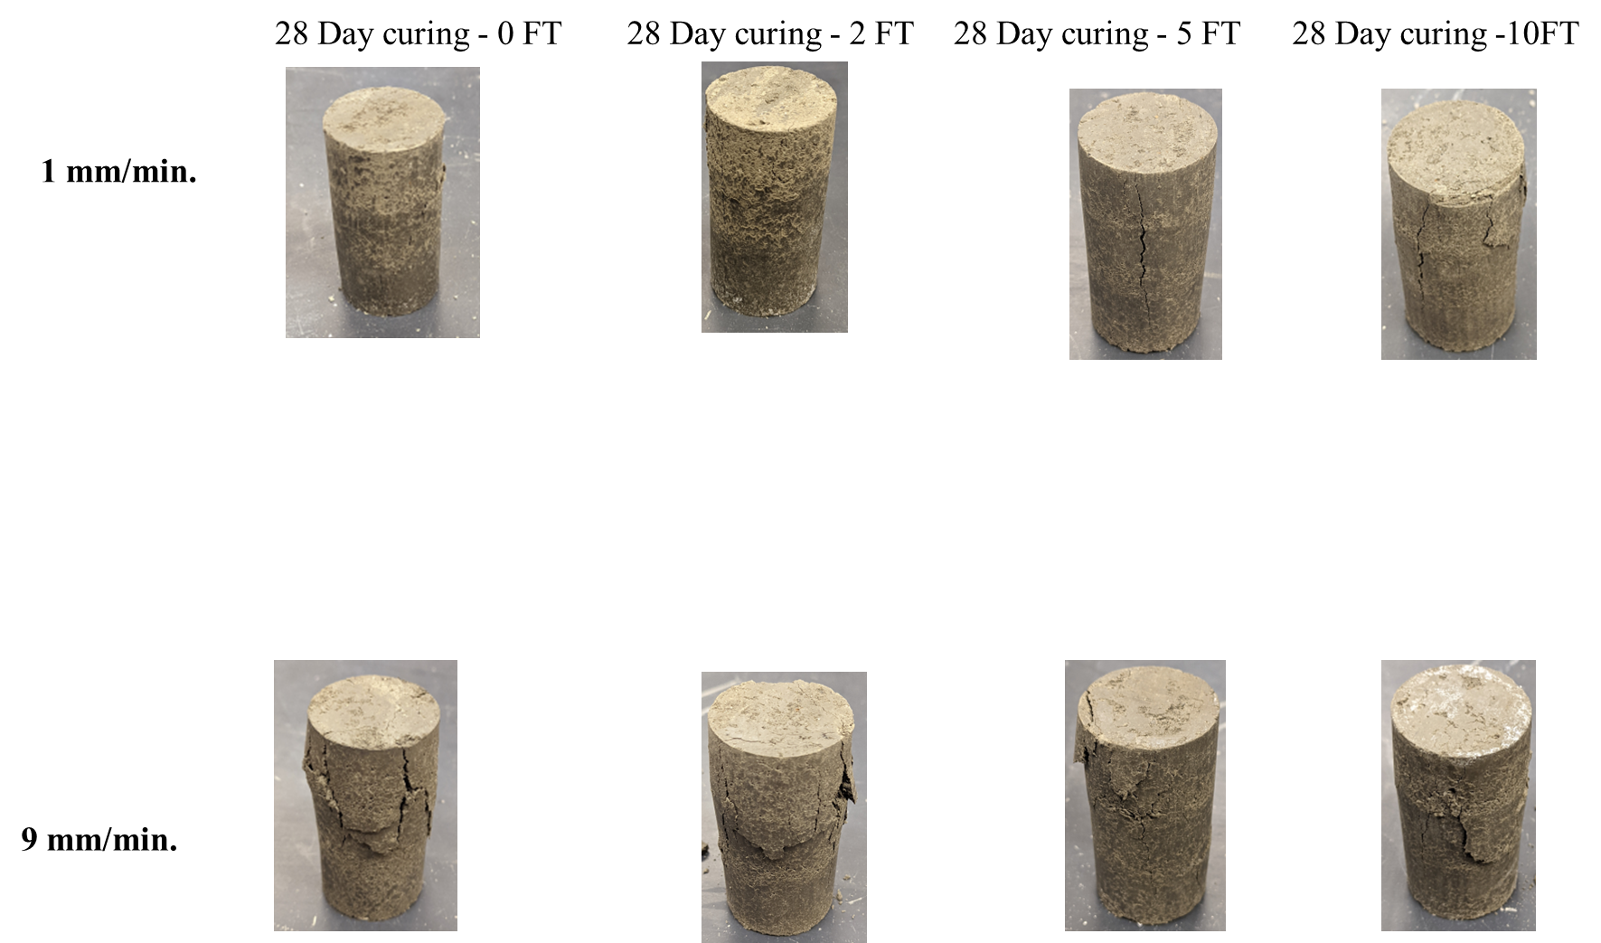
Figure 4. Post Failure photos of lime-soil mixture in freeze/thaw cycles under compression tests.

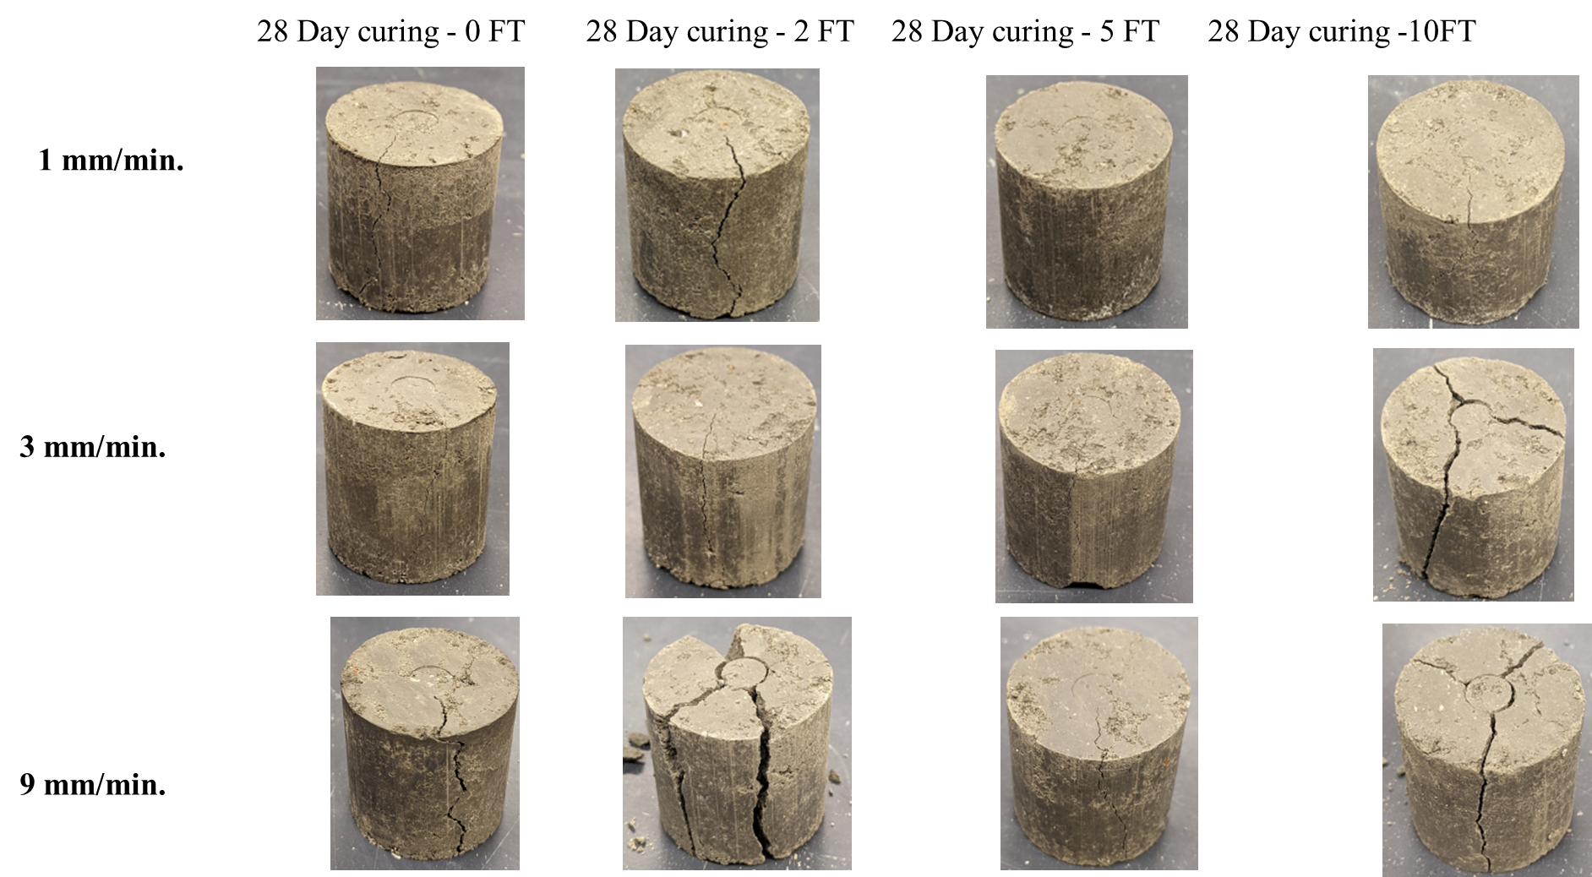
Figure 5. Post Failure photos of lime-soil mixture in freeze/thaw cycles under double punch tests.

Conclusions and summary
The use of lime in soil stabilization and enhancing the physio-mechanical strength shows impressive results. However, the purpose of lime usage is most important, especially in cold regions. If the lime is used to enhance the strength of embankments of highways, the lower bound strength and upper bound strength limitation should be determined and quantified especially at higher loading rates. Moreover, in the case of construction in cold regions, the limitations of lower and upper bound strength should be determined. The change in deformation pattern plays important role in long-term strength if the lime is used as a cementitious material for structures like Dams or piles.
The changing of deformation path and pattern under loading speed and freezing and thawing cycles shows that the instrumental measurements should be used to monitor the time dependent strain or displacement. Slow loading combined with quick freeze and thaw cycles could fail the slope by lowering the bearing capacity. The monitoring through instrumentation will provide not only continuous check for allowable settlement but will also help to determine the process effectiveness. Data provided by sensors will lead to develop an effective solution to the field problems developed due to real world loading combinations. The key parameters to be monitored includes relative settlement between the treated and untreated soil, creep deformation under intense loading conditions, and response of treated soil towards loading along with measurement of soil properties for numerical modeling.

ACKNOWLEDGMENTS
The authors would like to acknowledge the support by
Natural Sciences and Engineering Research Council
(NSERC) Discovery Grant Canada (NO. RGPIN-2017-
05169).

References
- McDoweU, C., 1959. Stabilization of soils with lime, lime-flyash and other lime reactive materials. High. Res. Board, Bull. 231, Washington, DC, 60-66.
- Wilkinson, A., Haque, A., Kodikara, J., Adamson, J., and Christie, D. (2010). Improvement of problematic soils by lime slurry pressure injection: case study.” J. Geotech. Geoenviron. Eng., 136(10),1459–1468.
- Abiodun, A.A. and Nalbantoglu, Z. 2016, Lime pile techniques for the improvement of clay soils, Canadian Geotechnical Journal, p: 1-9.
- Khattab, S. A. A., Al-Mukhtar, M., and Fleureau, J. M. 2007. Long-term stability characteristics of a lime-treated plastic soil. J. Mater. Civ. Eng., 19(4), 358–366
- Bell, F.G. and Coulthard, J.M. 1990. Stabilization of clay soils with lime. Mun. Engr., 7:125 140.
- Kumar, D. S. A. and Monowar, H. 2012. Lime Stabilization of Soils: Reappraisal. J. Mater. Civ. Eng., 24(24), 707–714.
- Afrin, H. 2017. A Review on Different Types Soil Stabilization Techniques, International Journal of Transportation Engineering and Technology, Vol-3, pg:19-24.
- Halt, G. H., and Davidson, D. T. 1960. Lime fixation on clayey soils. Bulletin No. 262, Highway Research Board, Washington, DC, 20–32.
- Yi, J., Dore, G., Bilodeau, J. P., Prophete, F., 2014. Monitoring the structural behavior variation of a flexible pavement structure during freze and thaw, Paper presented at thev2014 Conference of the Transportation Association of Canada.
- Maadani, O., Abd El Halim, A. O., Mostafa, N. 2014. Instrumentation for monitoring pavement performance in cold regions. Journal of Cold Regions Engineering, 29(4), 04014017.

