ABSTRACT: In recent decades, the use of ground-penetrating radar (GPR) in non-destructive evaluation (NDE) of structures has increased significantly due to its ability to detect subsurface defects in a short duration. This paper investigates the signal attenuation of GPR signals using an image processing factor, entropy, and compares it with the widely adopted amplitude value in concrete slabs with subsurface materials including rebars, air gaps, and water gaps as simulated in a controlled laboratory setting. Three small plain concrete slabs with surface dimensions of 25 x 50 cm and depths of 5 cm, 10 cm, and 20 cm were cast for experimentation. The slabs were scanned using a hand-held GPR by placing one on top of the other in different combinations to investigate materials at depths of 5 cm, 10 cm and 15cm. The rebar sizes include 6 mm, 10 mm, 18 mm, and 20 mm and an FRP (Fiber-Reinforced Polymer) bar while air and water gaps were created between the slabs to simulate defects associated with horizontal cracks and delamination. The results indicate that GPR can identify and distinguish various subsurface materials and defects at differing depths using entropy as well. Additionally, entropy factor yielded consistent results for all the three investigated subsurface materials across all depths unlike those obtained using amplitude values.

Entropy evaluation of subsurface materials and defects in Concrete Slabs using GPR
Mohammed Abdul Rahman¹, Dipesh Donda¹, Fawzi Latosh¹, Alexander Tarussov², Ashutosh Bagchi¹
¹Building Civil and Environmental Engineering Department, Gina Cody School of Engineering and Computer Science, Concordia University, Montreal, Quebec, Canada, H3G 1M8
²Radex Detection Inc., 4 Place du Commerce, Suite 101, Verdun, Québec, Canada, H3E 1J4
Email: mohammed@outlook.in, d_donda@encs.concordia.ca, fawzi.latosh@concordia.ca, alex@radarexpert.ca, ashutosh.bagchi@concordia.ca

KEY WORDS: Ground Penetrating Radar (GPR); Non-Destructive Evaluation (NDE); Subsurface Detection; Entropy.

INTRODUCTION
Reinforced concrete (RC) is a prevailing construction material because of its exceptional durability and load-bearing capacity. While visual inspection is widely used for condition assessment of RC elements such as detection of cracks, it is often unreliable unless subsurface defects are identified and accounted for during investigation [1]. The internal subsurface defects include voids, rebar corrosion, and delamination; and the most common methods for their detection are core drilling and other Non-Destructive Evaluation (NDE) techniques. NDE methods are preferred for Structural Health Monitoring (SHM) as they do not compromise structural integrity. GPR has been utilized in this study as it has been rated as one of the most effective methods among various NDEs due to its ability to recognize major subsurface defects (corrosion, voids, vertical cracks, and concrete degradation) in a relatively shorter time [2]. However, transportation authorities have often expressed concern about depending exclusively on GPR as a comprehensive condition evaluation system [3]. Therefore, an elaborate study is being conducted in a controlled laboratory environment at Concordia University, Montreal, with a broader perspective of investigating GPR scans to improve the reliability of GPR for practical applications. The specific goals of this paper are to evaluate an image processing factor, entropy, for GPR scans of concrete slabs with varying interfacing materials and differing depths and subsequently, compare this factor with the commonly adopted amplitude value.

GPR AND ENTROPY EVALUATION
GPR is a NDE technique that records the reflected signals generated from sending electromagnetic (radio) waves into a concrete element [2]. The first step in GPR assessment of a concrete element is to scan it using GPR equipment, which can be done manually or with the use of a portable acquisition system. Energy in the form of electromagnetic waves is transmitted down through the material by a transmitting antenna, and the signal reflected by the receiving antenna is registered. An A-Scan can be plotted at a specific location which is a graph of the amplitude vs. time of the recorded signal. When such A-scans are stacked across the whole length of the element, the resulting greyscale image obtained is called a B-scan [4].
The next step, GPR data analysis, is an active field of investigation among researchers aimed at improving reliability. The amplitude-based analysis of signal attenuation has been commonly adopted and improved over the years as delineated by Abdul Rahman et al., (2022) [5]. However, this analysis does not always provide accurate and reliable results as it does not consider various structural or surface anomalies besides other limitations [6]. A method based on visual image-based analysis (IBA) wherein an analyst processing the GPR data manually marks deterioration zones while considering anomalies and other factors have proven to generate fairly accurate deterioration maps [7]. This visual-IBA method was automated by: a) adopting Viola-Jones algorithm for hyperbola detections; b) evaluating a textural factor, entropy, for detected regions; and c) classifying regions based on K-means for generating deterioration maps [5]. In this paper, this entropy factor was also evaluated for GPR B-scans of concrete slabs with varying materials and differing depths and compared with respective amplitude values as part of laboratory experiments conducted by Donda et al. (2021) [3]. Entropy is a numerical value with no units and can be evaluated for an image region as follows [8]:
$$Entropy = -\sum_{i = 0}^{L-1}{P(z_{i}) \log_{z}{P\left(z_{i}\right) (1) }}$$
- z – random variable representing intensity
- P(z_{i}) – respective histogram; i= 0,1,2…., L-1
- L- number of distinct intensity levels
To illustrate the evaluation of amplitude and entropy, Figure 1 shows a sample GPR scan of a 20 mm rebar placed at 5 cm depth placed between two plain concrete slabs [3]. The rebar reflections form a characteristic hyperbola with the peak representing its position; the amplitude value is measured at this peak (red dot) as shown in Figure 1(a) while the entropy value is for the image region bounded in red box as shown in Figure 1(b).

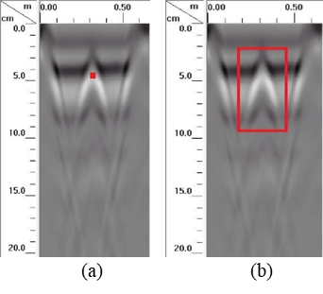
Figure 1 . (a) Measuring amplitude at peak (red dot); and (b) Measuring Entropy for bounded region (red box)

EXPERIMENTAL SETUP
The lab experimental setup for this study is described briefly here and further details can be found in Donda et al. (2021) [3]. The GSSI model used for scanning is 51600S with a hand-held cart and SIR-4000 control unit having the following input parameters: a) antenna frequency - 1.6 GHz; b) pulse duration - 0.7 ns; c) Samples/ scan: 256; d) Bits/sample – 16; d) dielectric constant – 6.0 (concrete); and e) depth range- 35 cm. Three plain cement concrete slabs with in-plan dimensions of 25 x 50 cm and depths of 5 cm (Slab 1), 10 cm (Slab 2), and 20 cm (Slab 3), respectively were cast with a high early strength commercial grade concrete mix named Quikrete 5000. To obtain GPR data, these three slabs were arranged in numerous positions and experiment was repeated for each interfacing material (rebar, air, and water). In the first configuration, Slab 1 was stacked on top of Slab 3, with the interfacing material sandwiched in-between. It was used to evaluate GPR results at a 5 cm depth of concrete. Slab 2 was stacked above Slab 3 in the second arrangement to analyze profiles at a depth of 10 cm. The third configuration used all three slabs, with a combination of Slab 1 and Slab 2 stacked together and the material put underneath it to test at a total depth of 15 cm, while Slab 3 was at the bottom.
To investigate reflections from the rebars, this study utilized four rebars with diameters of 6 mm, 10 mm, 18 mm, and 20 mm, as well as an FRP bar with a diameter of 21.8 mm. Due to relatively smaller slab dimensions, a single bar was placed for scanning during each test to obtain a complete hyperbolic reflection and avoid overlaps. To simulate air gaps and investigate their effect on signal attenuation, pairs of metal strips of varying sizes were edge-positioned for each case in between the slabs along the length of the scan (to prevent GPR signal interference). The metal strips sizes were 3 mm, 4 mm, 4.8 mm, 5.8 mm, and 8.8 mm to simulate air gaps of respective thickness. The experiment was conducted for all three slab arrangements for analyzing attenuation at varying depths (5 cm, 10 cm & 15 cm) due to differing gap widths. To simulate water gaps, similar arrangement was used as air gaps but to prevent water leakage (not applicable for air gaps), a multipurpose waterproofing membrane along with an all-purpose silicone was additionally applied at membrane joints to ensure water tightness. Figure 2 shows a schematic diagram of the unique setup to simulate water gap for the third arrangement (15 cm depth).

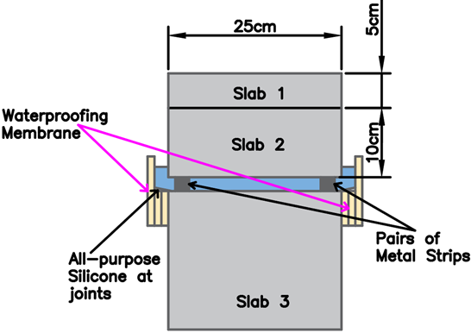
Figure 2 Schematic diagram to simulate water gap at 15 cm depth.

RESULTS AND DISCUSSION

Comparative analysis for rebars
To ensure lab test conformity in obtaining consistent results, three GPR scans were performed for each case i.e., the slab was scanned thrice for each rebar size (6 mm to 21.8 mm) at all depths (5 cm, 10 cm, and 15 cm). The amplitude values were taken at hyperbolic peaks and averaged over the three similar scans for each case; unless an anomaly was detected and ignored. Similarly, the entropy values were obtained for a rectangular area surrounding the hyperbolic reflection.
Figure 4 shows the amplitude of reflection vs depth graph while Figure 5 shows the entropy values vs. depth graph for all rebar sizes i.e., 6 mm, 10 mm, 18 mm, and 20 mm rebar along with a 21.8 mm FRP bar. It was observed that as the diameter of the rebar increases, so does the value of both factors across all depths. The amplitude value increased from 4.6 x 10⁶ mV for 6 mm rebar to 5.1 x 10⁶ mV for 20 mm rebar at a depth of 5 cm (10.9% increase). Similarly, for the same depth, the entropy value showed good correlation as it increased from a value of 6.45 for 6 mm to 7.15 for a 20 mm rebar (10.9% increase). The outlier in the results was 21.8 mm FRP bar due to its different dielectric properties. With an increase in depth, the signal attenuation values obtained were lower as greater penetration causes more loss of signal. An average value was taken for all rebars (6 mm to 20 mm, ignoring FPR bar) at each depth to draw inferences. The amplitude values for each rebar significantly dropped from a depth of 5 cm to 10 cm; the averaged value dropped by 76% from a value of 4.9 x 10⁶ mV to 1.2 x 10⁶ mV. Furthermore, there is a noticeable decrease of 20% (1.2 x 10⁶ - 0.96 x 10⁶ mV) in averaged amplitude values from a depth of 10 cm to 15 cm. Similarly, the averaged entropy value dropped by 24.5% (6.8 - 5.1) from 5 cm to 10 cm depth while it dropped by 6.4% (5.1 - 4.7) from a depth of 10 cm to 15 cm. Since the range of entropy values is smaller than amplitude values, the overall drop percentage was lower but comparable. Two inferences can be drawn from the obtained values of amplitude and entropy for rebars: a) a significant decrease in both factors is observed with depths across all rebar sizes; but b) an increase in rebar size has relatively less impact on the increase in both factors, making it difficult to distinguish rebar sizes in a real case [3].

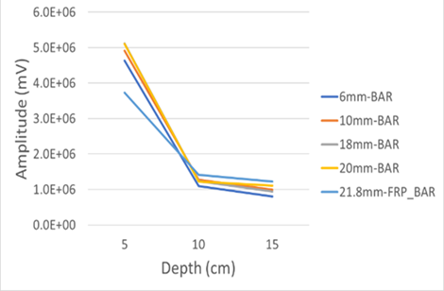
Figure 3 Amplitudes for rebars of varying sizes [3]
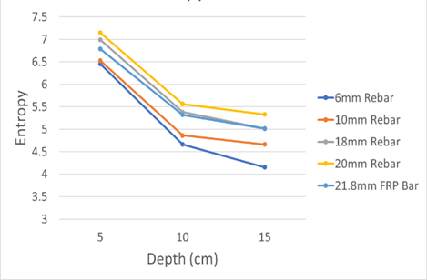
Figure 4 Entropies for rebars of varying sizes

Comparative analysis for air gaps
The tests were repeated thrice for each case of air gaps to ensure lab conformity. Figure 5 shows amplitude values vs. depth values for all gap sizes while Figure 6 shows respective entropy values. Across all depths for air gaps, there was an increase in values of both factors with an in-crease in gap size. For example, at 5 cm depth, the amplitude value increased by 38% from 3 mm gap (1.6 x 10⁶ mV) to 8.8 mm gap (2.2 x 10⁶ mV) while the entropy value increased by 17% (5.09 - 5.95). A significant decrease in both factors was observed for all sizes of air gaps from a depth of 5 cm to 10 cm. For example, there was a 75% decrease of amplitude value (1.8 x 10⁶ mV - 0.44 x 10⁶ mV) while a 29% decrease (5.39 - 3.80) was observed in entropy values when averaged for all gaps from 5 cm to 10 cm depth. However, there was an inconsistent average rise in amplitude of 14% (4.44 x 10⁵ mV - 5.06 x 10⁵ mV) for depth from 10 cm to 15 cm while the entropy values were consistent with an averaged decrease of 11% (3.8 - 3.4). The explanation for these skewed values in amplitude is due to very weak reflections observed at greater depths but utilizing an image processing factor, entropy, overcomes this limitation.

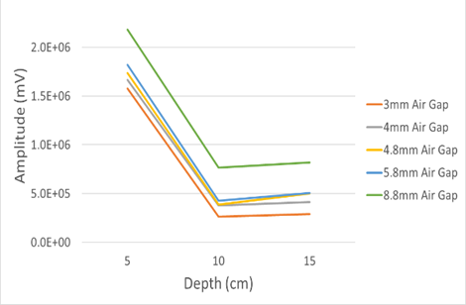
Figure 5 Amplitudes for varying thicknesses of air [3]
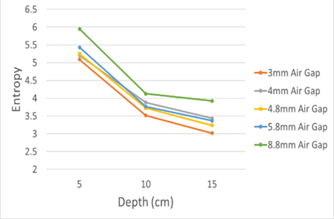
Figure 6 Entropies for varying thicknesses of air gaps

Comparative analysis for water gaps
The water gap analysis yielded results that were substantially different from those of other materials. It was observed that the amplitude and entropy values remained similar for all depths for gaps ranging from 3 mm to 5.8 mm. However, an average decrease of 18% (1.22 x 10⁷ mV - 1.01 x 10⁷ mV) in amplitude value was observed for all depths from a gap of 5.8 mm to 8.8 mm while an averaged decrease of 7% (18.3 - 17.11) in entropy value was observed. There was an anomaly in entropy value at 8.8 mm gap for 5 cm depth as it was closer to 5.5 mm gap. Water and/or the effect of moisture has a substantial influence on the GPR signal, which explains the inconsistency. The attenuation was less for small water gaps (3 mm to 5.8 mm) as indicated by higher amplitude values. However, as the water gap becomes wider, the reflections become weaker, as seen by lower values of 8.8 mm gaps. This indicates that the water gaps must be significant to show variance in evaluated factors. Nevertheless, across all water gaps, a consistent substantial average decrease in both the factors was observed with an increase in depth. An average decrease of 69% (8.02 x 10⁶ mV - 2.48 x 10⁶ mV) in amplitude values was observed, while an averaged decrease of 20% (7.23 - 5.8) in entropy values was observed for depths of 5 cm to 10 cm. Similarly, for depths of 10 cm to 15 cm, a consistent yet slight decrease in averaged amplitude values of 25% (2.48 x 10⁶ mV - 1.87 x 10⁶ mV) was observed while a similar decrease of 10% (5.8 - 5.24) in averaged entropy values was observed across all water gaps.

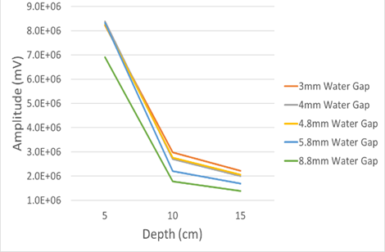
Figure 7 Amplitudes for varying thicknesses of water gaps [3]
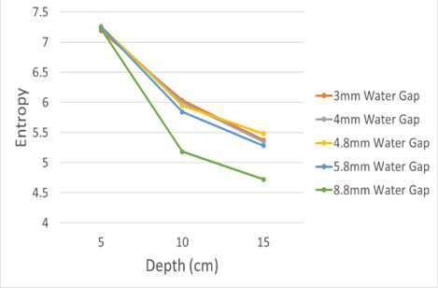
Figure 8 Entropies for varying thicknesses of water gaps

Comparative analysis for different materials
A comparative analysis of signal attenuation for different materials (rebars, air, and water) could be deduced from amplitude and entropy values. Since rebars and gaps were of different sizes, an average value (of amplitude or entropy) was taken at each depth for every material for reliable comparison. For instance, to obtain a resulting amplitude value for varying rebar sizes at 5 cm depth, the amplitude values evaluated for all rebars sizes (6 mm to 20 mm) were averaged and obtained as 4.94 x 10⁶ mV. The FRP rebar values were ignored since it is an outlier. Table 1 shows averaged amplitude values for all materials while Table 2 shows respective entropy values.
Since increasing depths cause lower reflected signals, the trend should be similar for all materials. The amplitude values show consistent results for rebars and water gaps as the values are decreasing with depth. However, the amplitude values did not yield consistent results for air gaps. The entropy values obtained were reliable for all materials at all depths. The results also indicate that at a given depth, reflections are strongest from water gaps, followed by rebars and lastly, airgaps. The range of these values could be utilized to differentiate various subsurface materials using GPR. Moreover, the loss in signal reflection is higher from a depth of 5 cm to 10 cm across all materials when compared to loss at a depth range from 10 cm to 15 cm. This indicates that much of the energy of the attenuated signals is lost closer to the surface.
Table 1. Comparison of Amplitudes for different materials [3]
Amplitude (mV)
Depth↓ | Rebars | Air Gaps | Water Gaps
5 cm | 4.94 x 10⁶ | 1.80 x 10⁶ | 8.02 x 10⁶
10 cm | 1.21 x 10⁶ | 4.44 x 10⁵ | 2.48 x 10⁶
15 cm | 7.12 x 10⁵ | 5.06 x 10⁵ | 1.87 x 10⁶

Table 2 Comparison of Entropies for different materials
Entropy Values
Depth↓ | Rebars | Air Gaps | Water Gaps
5 cm | 6.78 | 5.39 | 7.23
10 cm | 5.12 | 3.80 | 5.80
15 cm | 4.79 | 3.40 | 5.24

CONCLUSIONS
This paper evaluated entropies and compared respective amplitude values for a GPR study conducted in a controlled laboratory setting of concrete slabs with varying materials and differing depths. If the interfacing material is rebar, an increase in both the evaluating factors is observed with an increase in rebar size at any depth. Additionally, with increasing depth, there is a decrease in amplitude and entropy values. If the interfacing materials are air and water gaps, an increase in both the evaluating factors is observed with an increase in gap size at any depth. Moreover, with increasing depth, there is a consistent decrease only in entropy values. Conclusively, GPR can be used to detect and distinguish various subsurface materials and defects at differing depths based on evaluated factors, and entropy evaluation gives more reliable results. The analysis has some drawbacks, such as short dimensions of slab, lack of embedded rebars, and the fact that real cracks/gaps of in-situ concrete contain other impurities such as salts and corrosion products. These limitations are being addressed as part of ongoing lab work by investigating GPR signals in reinforced concrete induced with varying degrees of corrosion.

References
[1] M. A. Rahman and T. Zayed, “Developing Corrosion Maps of RC bridge elements based on automated visual image analysis,” in Session of the 2016 Conference of the Transportation Association of Canada, Toronto, ON, 2016.
[2] N. Gucunski and National Research Council, “Nondestructive Testing to Identify Concrete Bridge Deck Deterioration,” 2013.
[3] D. Donda, F. Latosh, M. A. Rahman, and A. Bagchi, “Detection of subsurface defects in concrete slabs using ground penetrating radar,” in Proc.SPIE, Mar. 2021, vol. 11592, doi: 10.1117/12.2582807.
[4] K. Dinh, T. Zayed, F. Romero, and A. Tarussov, “Method for Analyzing Time-Series GPR Data of Concrete Bridge Decks,” J. Bridg. Eng., vol. 20, no. 6, p. 4014086, Aug. 2014, doi: 10.1061/(ASCE)BE.1943-5592.0000679.
[5] M. Abdul Rahman, T. Zayed, and A. Bagchi, “Deterioration Mapping of RC Bridge Elements Based on Automated Analysis of GPR Images,” Remote Sensing, vol. 14, no. 5. 2022, doi: 10.3390/rs14051131.
[6] R. Parrillo, R. Roberts, and A. Haggan, “Bridge deck condition assessment using ground penetrating radar,” Proc. ECNDT, Berlin, 2006.
[7] A. Tarussov, M. Vandry, and A. De La Haza, “Condition assessment of concrete structures using a new analysis method: Ground-penetrating radar computer-assisted visual interpretation,” Constr. Build. Mater., vol. 38, pp. 1246–1254, Jan. 2013, doi: 10.1016/j.conbuildmat.2012.05.026.
[8] R. Gonzalez, R. Woods, and S. Eddins., Digital Image Processing Using MATLAB®. Tata McGraw Hill Education, 2010.

