Biography

Colonel (Ret.) Lee Hammond, CD, MSM and Bar
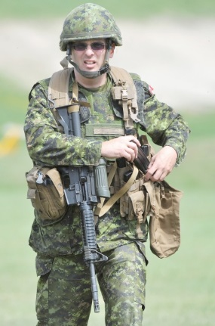
Lee Hammond is the Director of Operations for Western Canada Marine Response Corporation, joining the company in that capacity in November of 2015.

Coming from a military background, Lee served in the Canadian Army for thirty years; first as a reservist artillery gunner in Vancouver, and thereafter as an artillery officer with the Regular Force. During his time with the Canadian Forces, Lee served in numerous locations across Canada, from British Columbia to New Brunswick, in both mechanized and airborne units.
Lee completed two tours of duty in Afghanistan, first as the Chief of Operational Plans for Task Force Afghanistan, in Kandahar, and second, as the Deputy Commander of the Canadian Contribution to the NATO Training Mission in Kabul. He was awarded the Meritorious Service Medal by the Governor General following both tours. Before Afghanistan, Lee served as a Missile Inspector with the United Nations in Iraq, following Gulf War 1.
Lee graduated from numerous courses in the Canadian Armed Forces, including the Land Staff College, the Joint Command and Staff Program, the U.S. Army Ranger Course, and numerous long and arduous artillery courses.
Lee retired from the Canadian Forces as a Colonel in November 2015, with his last assignment being with the Strategic Joint Staff, in Ottawa. He continues to stay in close touch with national security and defence issues through his extensive network of contacts.
Since joining WCMRC, Lee has overseen over 100 marine oil spills of all sizes. He has also begun his education in the Spill Response field by attending numerous spill response and Incident Command courses, including the Northwest Oil Spill Control Course, in Washington State, the Canadian Coast Guard’s Marine Spill Response Operations Course, and Unified Command training. Additionally, Lee has participated in numerous tabletop and on-water certification exercises.
Lee is a graduate of the University of Manitoba, with a degree in Political Studies. He also possesses a MA degree from American Military University in Joint Warfare, and a second MA degree in Military Studies from the Royal Military College of Canada, in Kingston, Ontario.
Lee is married to Corey, a Nurse Practitioner, and has two adult daughters; Katia, a third-year student in International Studies at Simon Fraser University (currently working in Ottawa for Global Affairs on an internship), and Daria, who is a third year Psychology student at UBC.
In his free time, Lee likes to hike in B.C.’s great outdoors and is an avid movie fan.

