https://www.cimalpes.properties/en/properties/676
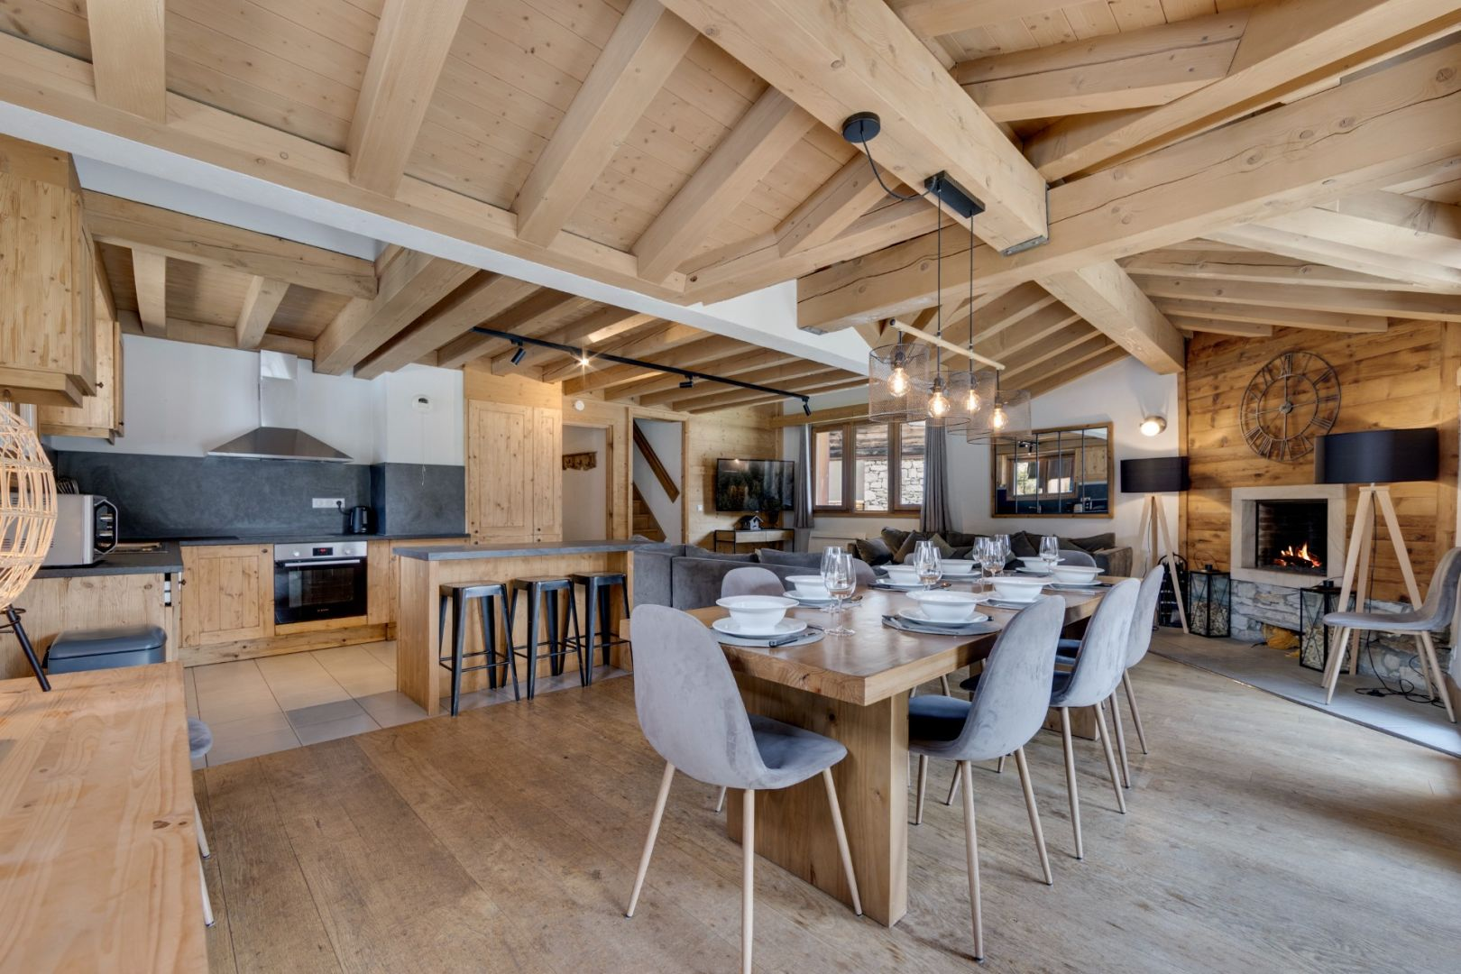
GPS: 45.449848, 6.976710

Detached chalet - Close to the slopes
€15,000,000
VAL D'ISERE 73150
Ref : 6690

Features
Area : 403 m²
Rooms : 16
Bathroom : 7
Exposure : south
Sale without lease

Services
Balcony
Basement
Fireplace
Terrace

Description
A rare find, this renovated, detached chalet offers 500sqm of living space spread over four levels and enjoys a prime location, just steps from the slopes and the center of Val d'Isère. Two single-level apartments and a duplex, each with five to six en-suite bedrooms, offer spacious, light-filled rooms thanks to their south-facing aspect and breathtaking views of the Avallon peaks. This property presents significant rental potential, accommodating up to 32 people and boasting a premium location right next to the ski slopes.

