https://www.cimalpes.properties/en/properties/355
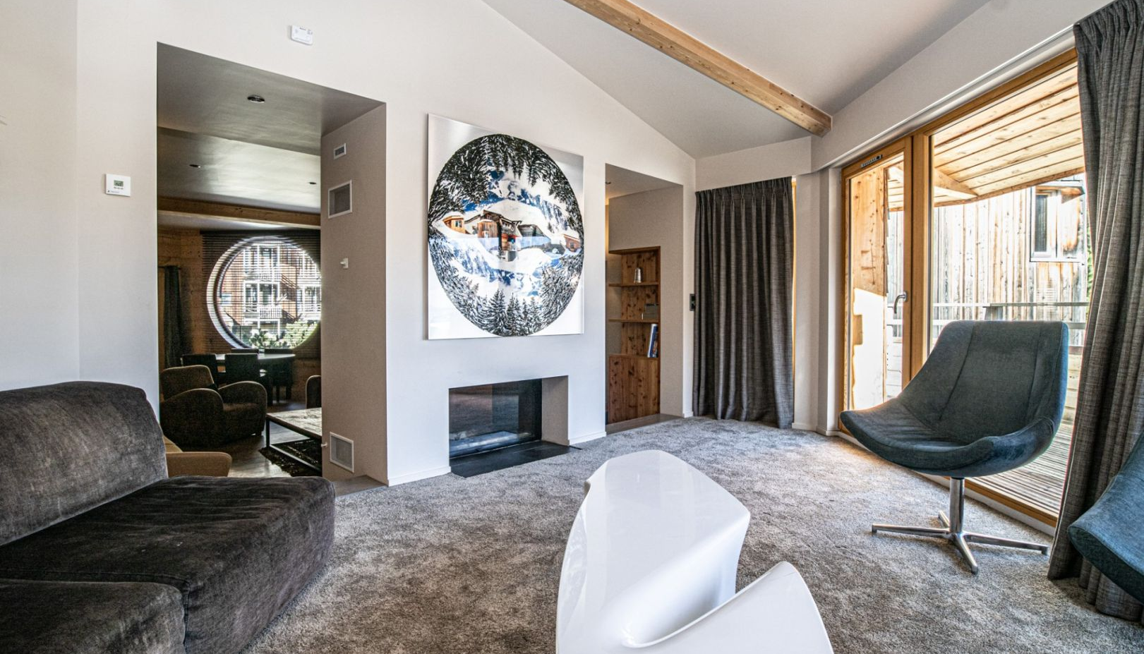
GPS: 46.189248, 6.778377

1-room chalet - resort centre - Avoriaz
€5,200,000
MORZINE 74110
Ref : 6684

Features
Area : 295 m²
Rooms : 8
Bathroom : 2
Exposure : south
Sale without lease

Services
Sauna
Fireplace
Terrace

Description
Located in the center of the pedestrianized resort of Avoriaz, in the Ruches district, this exceptional 338 m² chalet sleeps up to 16 people. It includes 11 rooms spread over three half levels to the east and two levels to the west. It has 8 bedrooms, 5 shower rooms and 4 WCs. The chalet has two separate entrances, one of which has a vestibule with a shoe dryer and dressing room. The double aspect living room, with its central fireplace and two terraces, offers a warm and comfortable living space. The modern, fully-equipped kitchen opens onto a dining room with a large dining table.

