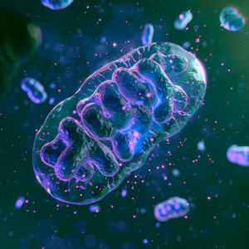
Skeptic Check: Health Fads
The tiny bean-shaped structures in your cells – mitochondria – are little powerhouses. Recent research suggests they may unlock overall good health, or, when they fail, cause diseases such as diabetes and Alzheimer’s. How strong is the science for these claims and what, if anything, should we be doing to improve our mitochondrial health? Should we take a cue from influencers who suggest drinking an industrial dye called methylene blue? Meanwhile, there have been beefed up calls for adding protein to our diets by eating high protein ice cream, energy bars and huge slabs of meat. Protein builds muscles, but is the muscle of science behind these claims? This week, we consider recent health trends on Skeptic Check.
Guests:
Martin Picard – Professor of behavioral medicine and mitochondrial psychobiology at Columbia University, where he runs the Mitochondrial Psychobiology Group.
Howard LeWine – General internal medicine physician at Brigham and Women's Hospital in Boston, Chief Medical Editor at Harvard Health Publishing, and editor in chief of Harvard Men’s Health Watch.
Featuring music by Dewey Dellay and Jun Miyake
You can get early access to ad-free versions of every episode by joining us on Patreon. Thanks for your support!
Big Picture Science is part of the Airwave Media podcast network. Please contact advertising@airwavemedia.com to inquire about advertising on Big Picture Science.

