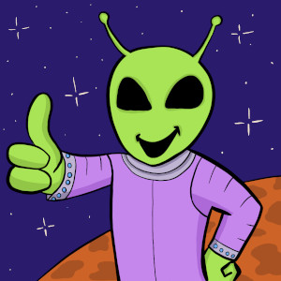
Aliens Now
We are closer than ever to finding aliens according to astrophysicist Adam Frank. He isn’t alone in his optimism. Over the last two decades, the tools used to search for extraterrestrials have been advancing mightily. Where we were once only monitoring with radio telescopes, we are now actively looking for bio and technosignatures on exoplanets. Find out why scientists think new technology may be a game changer in the hunt for life off Earth.
Guest:
Adam Frank – Astrophysicist and author of a new book “The Little Book of Aliens”
Featuring music by Dewey Dellay and Jun Miyake
Originally aired July 1, 2024
You can get early access to ad-free versions of every episode by joining us on Patreon. Thanks for your support!
Big Picture Science is part of the Airwave Media podcast network. Please contact advertising@airwavemedia.com to inquire about advertising on Big Picture Science.

