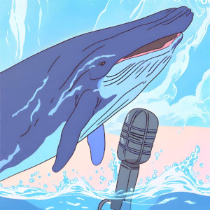
Alien Says What?
Whales are aliens on Earth; intelligent beings who have skills for complex problem-solving and their own language. Now in what’s being called a breakthrough, scientists have carried on an extended conversation with a humpback whale. They share the story of this remarkable encounter, their evidence that the creature understood them, and how the experiment informs our Search for Extraterrestrial Intelligence. After all, what good is it to make contact with ET if we can’t communicate?
Guests:
Brenda McCowan – Research behaviorist at the University of California Davis in the School of Veterinary Medicine who studies the ecological aspects of animal behavior and communication.
Fred Sharpe – whale biologist and behavioral ecologist at Simon Fraser University and member of the Templeton WhaleSETI Team.
Laurance Doyle – astrophysicist and information theory researcher at the SETI Institute.
Featuring music by Dewey Dellay and Jun Miyake
Originally aired February 2, 2024
You can get early access to ad-free versions of every episode by joining us on Patreon. Thanks for your support!
Big Picture Science is part of the Airwave Media podcast network. Please contact advertising@airwavemedia.com to inquire about advertising on Big Picture Science.

