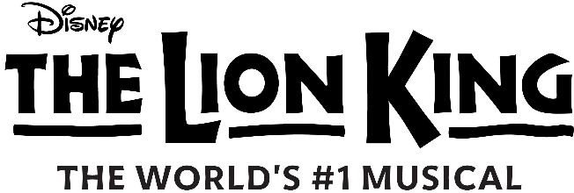

ABOUT THE LION KING
Approaching 30 landmark years on Broadway, The Lion King continues ascendant as one of the most popular stage musicals of all time. Since its premiere on November 13, 1997, 30 global productions have been seen by over 127 million people. Produced by Disney Theatrical Group, under the direction of Andrew Flatt and Anne Quart, The Lion King has made theatrical history with two productions worldwide running 20 or more years and three others running 25 or more years.

Performed over its lifetime in nine different languages (English, Japanese, German, Korean, French, Dutch, Spanish, Mandarin and Portuguese), there are currently eight productions of The Lion King around the world: Broadway, London, Paris, Hamburg, Madrid, Tokyo, Mexico City and on tour across North America. The Lion King has played over 100 cities in 24 countries on every continent except Antarctica; its worldwide gross exceeds that of any film, Broadway show or other entertainment title in box office history.

The Lion King won six 1998 Tony Awards®: Best Musical, Best Scenic Design (Richard Hudson), Best Costume Design (Julie Taymor), Best Lighting Design (Donald Holder), Best Choreography (Garth Fagan) and Best Direction of a Musical (Julie Taymor). The Lion King has also earned more than 70 major arts awards including the 1998 NY Drama Critics Circle Award for Best Musical, the 1999 Grammy® for Best Musical Show Album, the 1999 Evening Standard Award for Theatrical Event of the Year and the 1999 Laurence Olivier Awards for Best Choreography and Best Costume Design.

Julie Taymor, who conceived and directed the production and is its costume designer and mask co-designer, was the first woman to win a Tony Award for Best Direction of a Musical. She remains actively involved in the show, launching new productions and maintaining the flagship Broadway production.

The Broadway score features Elton John and Tim Rice’s songs from the Lion King animated film along with three new songs by John and Rice; additional musical material by South African Lebo M, Mark Mancina, Jay Rifkin, Julie Taymor and Hans Zimmer; and music from "Rhythm of the Pride Lands," an album inspired by the original music in the film, written by Lebo M, Mark Mancina and Hans Zimmer. The resulting sound of The Lion King is a fusion of Western popular music and the distinctive sounds and rhythms of Africa, ranging from the Academy Award®-winning song “Can You Feel the Love Tonight” to Lebo M’s rich choral numbers.

Elton John, Lebo M and Hans Zimmer all collaborated on the 2019 version of the film, executive produced by Julie Taymor and Thomas Schumacher, which has gone onto extraordinary worldwide success.

The book has been adapted by Roger Allers, who co-directed the animated The Lion King feature, and Irene Mecchi, who co-wrote the film’s screenplay. The stage production was originally produced by Peter Schneider and Thomas Schumacher. Other members of the creative team include: Michael Curry, who designed the masks and puppets with Taymor, Steve Canyon Kennedy (sound design), Michael Ward (hair and makeup design), David Kreppel and Sean Mayes (music supervisors), Anthony Lyn (associate director), Marey Griffith (associate choreographer), Lisa Dawn Cave (production supervisor), Thomas Schlenk (general manager), Robert Elhai (associate music producer), Michael Keller (music coordinator), Robert Elhai and David Metzger (orchestrators), Rick Sordelet (fight director) and ARC/Mark Brandon, CSA (casting).

For more information worldwide, visit LionKing.com, www.facebook.com/thelionkingusa and www.instagram.com/thelionking.

