

Press contacts:
Dennis Crowley dennis.m.crowley@disney.com
Michael Strassheim michael.strassheim@disney.com

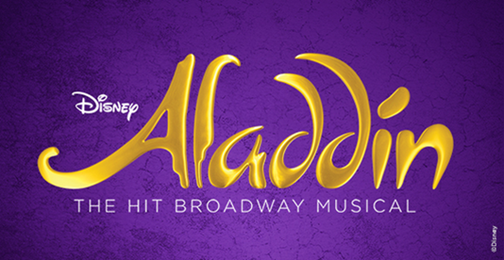

ALADDIN CELEBRATES 12th ANNIVERSARY
ON BROADWAY MARCH 20th, 2026

Aladdin, one of the biggest hits in Broadway history, celebrates its 12th anniversary at the New Amsterdam Theatre today, March 20th, 2026. As it plays performance 4,349 tonight, Aladdin has welcomed more than 7.2M guests to the New Amsterdam Theatre and ranks #14 on the list of all-time Broadway long runs. Aladdin has joined the megahits The Lion King, Wicked and Hamilton as the highest-grossing Broadway shows of the last dozen years.

Each performance of Aladdin is a vast, custom-made experience. It takes more than 200 people – onstage, backstage, in the pit and in the front of house – to bring each performance to life. 59 of them have been with the show for five years or more, and 33 since the very beginning in 2014. Over its life, 119 performers have appeared in the show, 28 of them in their Broadway debuts.

As of Aladdin’s milestone 12th anniversary, Broadway audiences have been treated to a staggering number of special effects:
- Aladdin and Jasmine have flown over 140 miles on the magic carpet while singing the Oscar-winning “A Whole New World”
- The Genie has set off nearly 165,000 pyrotechnics in the showstopping “Friend Like Me”
- In the Act Two opener “Prince Ali,” the cast and wardrobe team have made over a quarter million lightning-fast costume quick changes
- Over 1,000 pounds – half a ton – of custom-mixed glitter have been used to create the Genie’s signature sparkle

Globally, Aladdin has achieved a reach and enduring popularity rare among Broadway musicals. There have been 11 productions on four continents welcoming over 22 million guests.

For Aladdin production photography and b-roll, visit press.aladdinthemusical.com.

ABOUT ALADDIN
Aladdin, the hit musical based on the Academy Award®-winning animated film, opened on Broadway at the New Amsterdam Theatre to critical acclaim on March 20, 2014 and quickly established itself as one of the biggest hits in Broadway history.

Hailed by The New York Times as “fabulous and extravagant,” the Broadway production has set 17 New Amsterdam Theatre house records and spawned 11 productions on four continents. Worldwide it has welcomed over 22 million people and can be seen currently on Broadway and in Tokyo, Japan.

Produced by Disney Theatrical Group, under the direction of Andrew Flatt and Anne Quart, Aladdin features music by Tony Award and eight-time Oscar® winner Alan Menken (Beauty and the Beast, Newsies, Sister Act), lyrics by two-time Oscar winner Howard Ashman (Beauty and the Beast, The Little Mermaid), three-time Tony Award and three-time Oscar winner Tim Rice (Evita, Aida) and six-time Tony Award nominee Chad Beguelin (The Wedding Singer), with a book by Beguelin, and is directed and choreographed by two-time Tony Award winner Casey Nicholaw (Hercules, The Book of Mormon).

Aladdin, adapted from the animated Disney film and centuries-old folktales including “One Thousand and One Nights,” is brought to fresh theatrical life in this bold new musical. Aladdin’s journey sweeps audiences into an exciting world of daring adventure, classic comedy and timeless romance. This new production features a full score, including the five cherished songs from the Academy Award-winning soundtrack and more written especially for the stage.

The animated film Aladdin was released by Disney in 1992 and was a critical and box office smash, becoming the highest-grossing film of the year and winning two Academy Awards for Best Original Score and Best Original Song for the indelible hit “A Whole New World.”

Aladdin is designed by seven-time Tony-winning scenic designer Bob Crowley, eight-time Tony-winning lighting designer Natasha Katz, three-time Tony-winning costume designer Gregg Barnes and sound designer Ken Travis.

The production was originally produced by Thomas Schumacher. The creative team also includes illusion designer Jim Steinmeyer, hair designer Josh Marquette and makeup designer Milagros Medina-Cerdeira. The music team is headed by music supervisor and music director Michael Kosarin, who also created the vocal and incidental music arrangements, joined by orchestrator Danny Troob and dance music arranger Glen Kelly. John MacInnis is the associate choreographer, Jason Trubitt is the production supervisor and Myriah Bash is the general manager.

For more information, visit AladdinTheMusical.com.

