Press contacts:
Dennis Crowley dennis.m.crowley@disney.com
Michael Strassheim michael.strassheim@disney.com

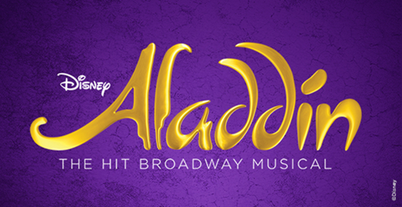

NOW PLAYING ON BROADWAY
AT THE NEW AMSTERDAM THEATRE

Aladdin, the hit musical based on the Academy Award®-winning animated film, opened on Broadway at the New Amsterdam Theatre to critical acclaim on March 20, 2014 and quickly established itself as one of the biggest hits in Broadway history.

Hailed by The New York Times as “fabulous and extravagant,” the Broadway production has set 17 New Amsterdam Theatre house records and spawned 11 productions on four continents. Worldwide it has welcomed over 22 million people and can be seen currently on Broadway and in Tokyo, Japan and Busan, South Korea.

Produced by Disney Theatrical Group, under the direction of Andrew Flatt and Anne Quart, Aladdin features music by Tony Award and eight-time Oscar® winner Alan Menken (Beauty and the Beast, Newsies, Sister Act), lyrics by two-time Oscar winner Howard Ashman (Beauty and the Beast, The Little Mermaid), three-time Tony Award and three-time Oscar winner Tim Rice (Evita, Aida) and six-time Tony Award nominee Chad Beguelin (The Wedding Singer), with a book by Beguelin, and is directed and choreographed by two-time Tony Award winner Casey Nicholaw (Hercules, The Book of Mormon).

Aladdin, adapted from the animated Disney film and centuries-old folktales including “One Thousand and One Nights,” is brought to fresh theatrical life in this bold new musical. Aladdin’s journey sweeps audiences into an exciting world of daring adventure, classic comedy and timeless romance. This new production features a full score, including the five cherished songs from the Academy Award-winning soundtrack and more written especially for the stage.

The animated film Aladdin was released by Disney in 1992 and was a critical and box office smash, becoming the highest-grossing film of the year and winning two Academy Awards for Best Original Score and Best Original Song for the indelible hit “A Whole New World.”

Aladdin is designed by seven-time Tony-winning scenic designer Bob Crowley, eight-time Tony-winning lighting designer Natasha Katz, three-time Tony-winning costume designer Gregg Barnes and sound designer Ken Travis.

The production was originally produced by Thomas Schumacher. The creative team also includes illusion designer Jim Steinmeyer, hair designer Josh Marquette and makeup designer Milagros Medina-Cerdeira. The music team is headed by music supervisor and music director Michael Kosarin, who also created the vocal and incidental music arrangements, joined by orchestrator Danny Troob and dance music arranger Glen Kelly. John MacInnis is the associate choreographer, Jason Trubitt is the production supervisor and Myriah Bash is the general manager.

For more information, visit AladdinTheMusical.com.

