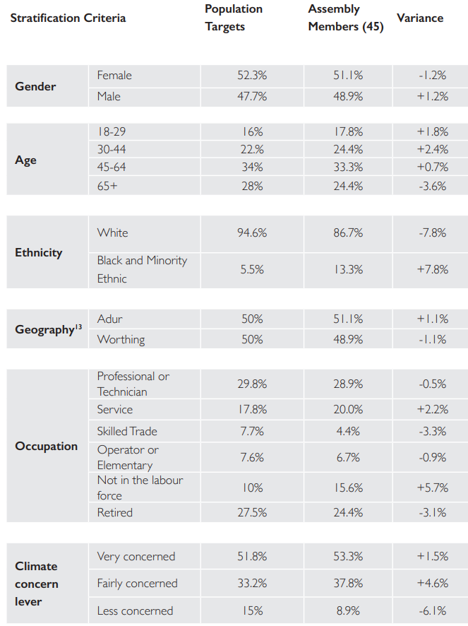
Table 1- Stratification of Participants

