CONSENT FORM

Study title: PAIR3038 Reinventing Democracy: Innovation, Participation and Power

Name of Researchers: Mikaela Kostadinova
Please add your initial in each box:

- I confirm that I have read the information sheet dated 25/04/2026 for the above study. I have had the opportunity to consider the information, ask questions and have had these answered satisfactorily.
MR

- I understand that my participation is voluntary and that I am free to withdraw up to 1/05/2026 by emailing Paolo Spada at mk9g23@soton.ac.uk. After such date the video interview transcript will be publicly available in the Participedia platform.
MR
MR
- I understand that due to my role in organising the democratic innovation I will be interviewed about it is not possible to keep the interview anonymous.

- I understand that the transcript of the video interview will be uploaded to the Participedia.net website as a reference for the case study and will be governed by the Participedia.net website terms of use described in the participant information sheet and in the webpage https://participedia.net/legal.
MR
MR
- I agree to take part in the above study and to be contacted by the researchers for the purposes of taking part in the video interview.

Data Protection.
I understand that my contact information will not be shared in the Participedia platform.

Matt Ryan 16/04/2026 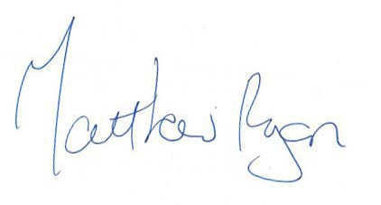
Name of Participant Date Signature

Mikaela Kostadinova
16/04/2026 mikaela
Name of Person Date Signature
taking consent

