NO TO CHILD MARRIAGE; YES TO EDUCATION

**www.foundationforyouthempowerment.org**

FOUNDATION FOR YOUTH EMPOWERMENT. P.O Box 928, Lilongwe, Malawi, Southern Africa Email: sann.99@yahoo.com / fye68@yahoo.com. Cell: 265 99566 2079 / 888 5512 12. Web: www.fye.org

www.foundationforyouthempowerment.org

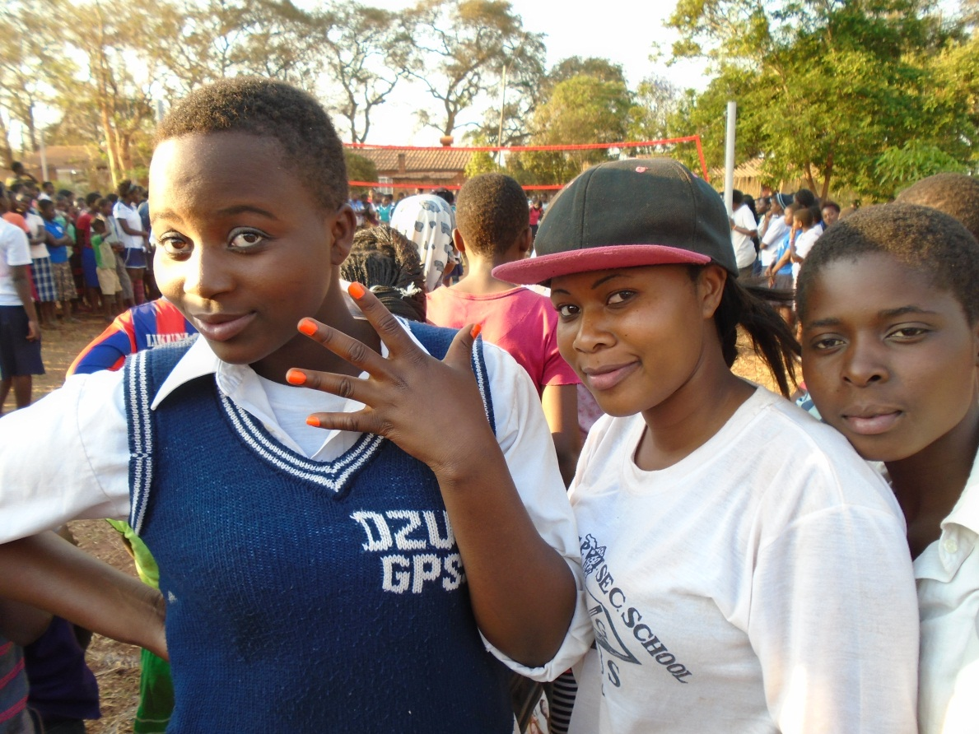



NO TO CHILD MARRIAGE!!!!

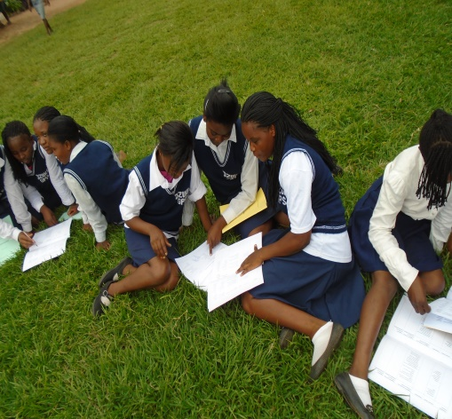YES TO EDUCATION FOR GIRLS!!!!

With education, a girl gets skills, knowledge and opportunities……

To lift her out of poverty is why Foundation for Youth Empowerment exists.

In fact the way out of poverty is knowledge acquired through education

whether formal or informal.

And gains the knowledge and confidence to choose the future she wants.

But millions of girls are expected to marry not to study.

An estimated 15 million girls a year are married before they are 18.

Child marriage often means the end of girl child education.

Married girls who would like to continue schooling may be both practically and legally excluded from doing so.

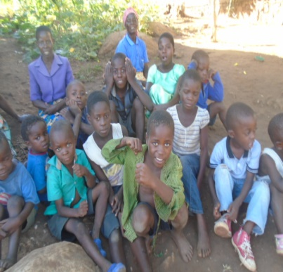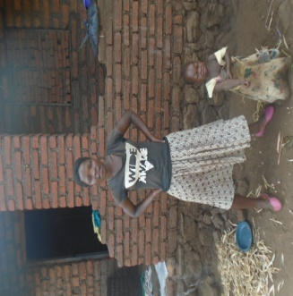

Many girls aren’t in school because their families are too poor to afford school fees perhaps because of the traditional roles girls are expected to play or parents do not see the value of sending girls to school.

Education is critical to help girls to stay in school and out of marriage hence breaking the chain of poverty.

The longer a girl stays in school, the less likely she is to be married before the age 18 and have children during her teenage years.

**Rabecca,gavebirth to a child mercy at the age of 13.**

**SO WHAT CAN WE DO?**

*Ensure that education is available to girls and address practices and factors that impinge the confidence and ability of families to keep them in schools.*

**Secondary education**

School dropout rates for girls tend to escalate during adolescence. We must increase provision of secondary education for girls.

**Guiding Principles**

It is our belief that children, youth and women must have equal access to a quality education. They should be provided with opportunity to develop their knowledge, talents and skills;

We believe that we must empower children, youth and women through the development of educational and social projects which goal it to create better learning opportunities;

We are committed to work with governmental institutions, charity foundations and other national and international organizations in order to have a bigger impact and achieve our goals.

**Our mission**

Our mission is to encourage accessible education for children and youth by ensuring safe and relaxing learning environment; to motivate children and youth to develop and expand their knowledge and skills through the creation of educational facilities; to improve the quality of learning and education using modern innovative teaching technologies and approaches.

The aim of Foundation for Youth Empowerment is to empower children and youth to learn about today’s world and economy in the era of globalization by facilitating their education in becoming successful citizens of the world.

**Our vision**

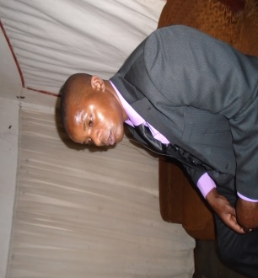Imagine the world where all children have the chance to fulfill their potential and talents, to develop their knowledge and skills, to be prepared for becoming global citizens. A world where children have the opportunity to acquire real-life skills in finance, investments and innovations which will allow them to become self-reliant individuals thereby breaking the chains of poverty.

**Our story**

In 2010 we founded the Foundation for Youth Empowerment to support children`s right to education and self-improvement and to give further opportunities to learn and develop.

Foundation for Youth Empowerment is legally registered with the Malawi government under trustees incorporation Act 1962 as a non-profit local non-governmental organization.

**How Can I Help**

If you have youth mentoring skills or a passion to help, come to Malawi and join as a volunteer.

Collect and send basic items such as clothes, shoes, development games, school and sports equipment or gifts.

Send a financial donation to help us to fund the foundation`s programs. Contact us for details.

If you have questions or would like detailed information about Foundation for Youth Empowerment, please contact us.

**The Word from the Executive Director**

**Dear friend and colleague**

Thank you for your generous support of the FYE. Your contribution to Foundation for Youth empowerment is making a difference and changing lives of less privileged children and teens in Malawi.

It is very difficult for vulnerable children to survive on their own especially within the very vulnerable ages 5 to 18, having few skills to provide for themselves. Facing life all alone, their lives become helpless.

Take a step today and invest in vulnerable children. Pass this message on to your friends and family. You never know how one small action can make a difference in the life of a vulnerable child.

With best regards

Sann Jali

Founder, Executive Director