# Partnerships in Improving Primary Education Performance: Community Score Card in Kyarusozi Model Primary School in Kyenjojo District, Uganda

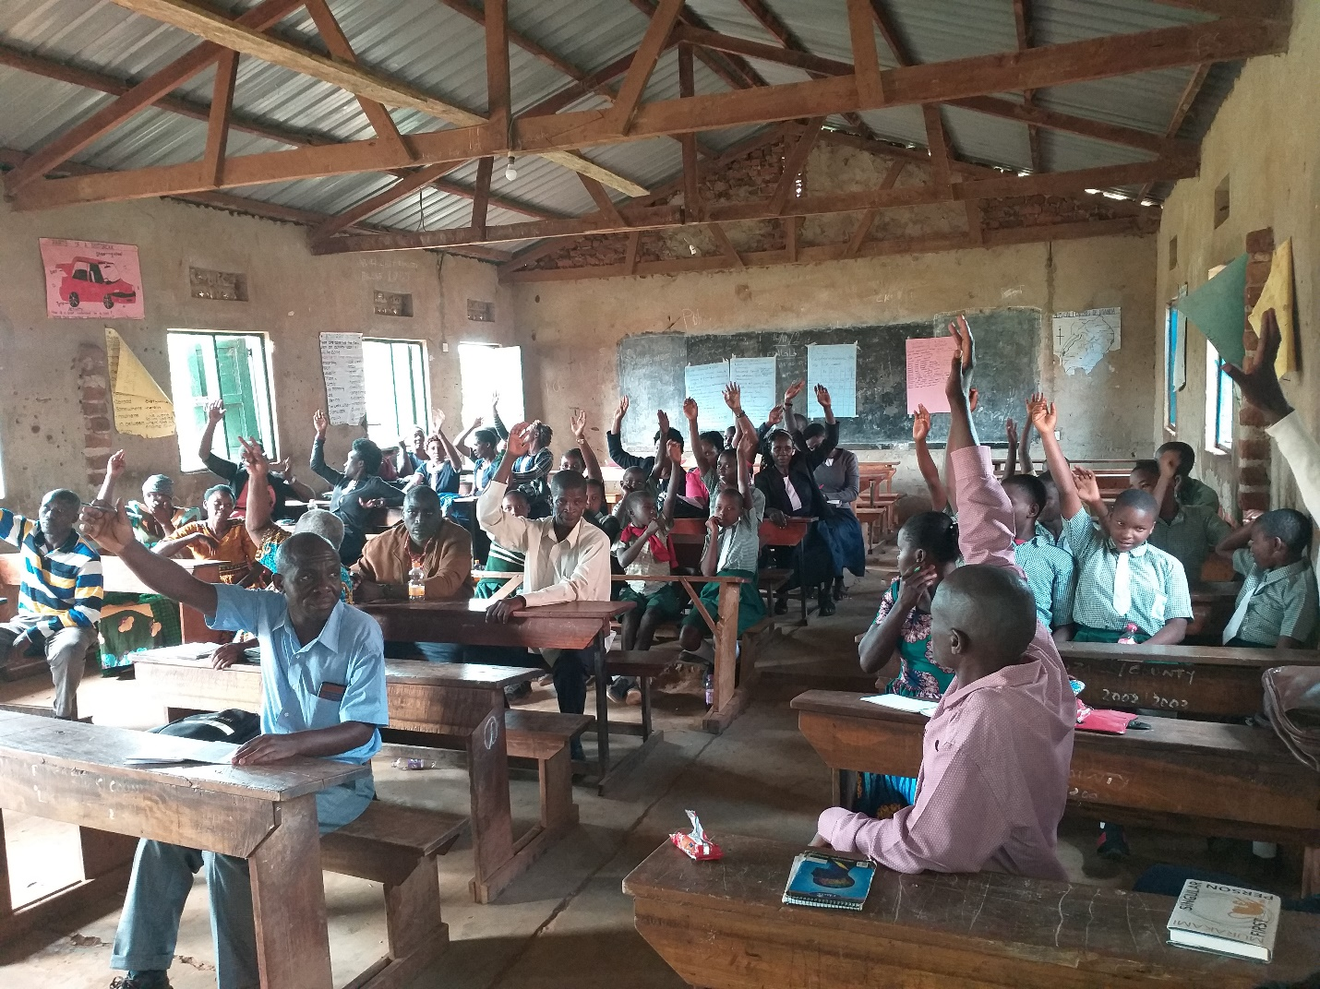

## **Wiki Contributor History**

## Improving quality of education, student performance and community engagement through collaboration by key actors (parents, teachers, pupils, local leaders and national authority of education) in Kyarusozi Primary School in rural Uganda.

## **Problems and Purpose**

In Uganda, the primary level education is the first level of formal education that forms the basic foundation which is expected to take seven years. In 1997, Uganda like other countries on the continent, launched the Universal primary education which allowed families to enroll their children in primary schools without being expected to pay. While this increased enrollment at the beginning of the program, rates continued to drop. The primary education sector faces many challenges including inadequate funding from government that limits classroom space and instructional materials thus affecting the facilities available for children to learn. On the other hand, despite registering positive results, the Uganda Universal Primary Education program faces significant unresolved challenges instigated by widespread corruption in the school system, ghost teachers, and ghost schools, the lack of schooling incentives such as pens, pencils, books, large classes, and lack of collaboration among the school partners Musika (2019).

Universal Primary Education increased enrollment, which overwhelmed the available teachers later affecting the quality of learning and performance. Girls continue to be adversely affected by the lack of sanitary facilities to enable them stay in school during their periods. All these factors increase school dropouts and performance. According to the Uganda National Examinations Board (UNEB); a body mandated to manage examinations in Uganda, Kyarusozi Primary school had experienced poor student performance. For instance, few first grades were recorded in the Primary Leaving examinations (PLE), some students recorded third and fourth grades; and others especially girls failed their exams. Although they were exposed to the same sessions, girls’ attention span is affected by the preference of the boy child, religious practices, household chores, child betrothal, child fosterage and polygyny as factors impeding girls' education The lack of equity in participation and time for academic work leaves many girls behind. Vermeulen (2013).

The primary level of education has seven grades/classes with the majority joining at the age of 6 and expected to complete this level of education at 12 years. (Education statistical abstract,).

The Ministry of Education and sports reported in 2017 that out of 8,840,589 pupils enrolled in all primary schools, 11.8% are orphans. Majority of the orphans 866,127 (83.1%) are found in Government schools which the Balinda Childrens foundation collaborates with. These children struggle to survive due to lack of resources to provide food and medical supplies and other core needs. Children who are Analysis by grade indicates that most orphans are in P1and these decrease with ascendance to higher classes. Orphans are more likely to drop out of school or repeat classes due to various reasons than the other children.

Inadequate access to reading resources affects performance and in Uganda, the pupil book ratio is high in lower classes and better in upper primary classes. The lack of reference materials was cited as a key challenge affecting children’s performance in schools (p43) and even where resources are available, the need to build the reading culture is critically important.

Participation was critical given the multidimensional nature of the problem and the need for different stakeholders to share their views but also take part in addressing the problem. The multiple issues identified above, could not be solved without strong partnerships with communities, schools, religious institutions, parents, and the teachers.

## **Background History and Context**

Kyarusozi Primary school located in the rural district of Kyenjojo in Western Uganda (<https://mapcarta.com/35335164/Map>). Uganda’s education system includes public and private schools. Since 1997, Uganda adopted the Universal Primary Education (UPE) with a goal to increase access to primary education (children enroll and complete) with the Government funding education cost. The main purpose was to reduce the systemic inequalities and ultimately address issues of poverty- due to the economic divide. While the policy was able to improve access to schools and increase enrollment, gender inequality was visible evident in the inability of girls to access and complete their education. Likewise, student performance in UPE schools compared to private schools remained poor. Kyarusozi Primary School just like other rural schools, continued to record poor performance in Primary leaving examinations (PLE[[1]](#footnote-1)). The factors ranged from ill equipped schools, in terms of reading and reference resources, inadequate teachers, lack of basic amenities to boost students’ concentration, cultural biases that kept girls out of school and affected performance. The results for the years preceding the participation of key actors are indicated in the table below.

|  |  |  |  |  |  |  |
| --- | --- | --- | --- | --- | --- | --- |
| **Year** | **Division 1** | **Division 2** | **Division 3** | **Division 4** | **Division U** | **Division x** |
| 2015 | 01 | 40 | 3 | - | 6 | 1 |
| 2016 | 03 | 60 | 10 | 4 | 3 | 2 |
| 2017 | 4 | 50 | 20 | 3 | 10 |  |

\* Source: *Kyarusozi Primary School office of the headmaster*

\**Division U is considered a ‘Fail’ as students cannot progress with that result to the secondary level, while Division X are students who register but do not sit for exams.*

While these issues were continuously being discussed in Parents Teachers Association (PTA[[2]](#footnote-2)) meetings, solutions were not implemented and there was no accountability. The role of a participatory approach was critical in bringing more than these two parties together. This created an opportunity for the pupils/students to share their views and incorporated an advocacy angle that engaged leaders in the process. The Balinda Children’s Foundation had held discussions with the children, parents, and teachers separately, but the convening of all stakeholders through a community scorecard was the first introduced in 2018. The community score card approach provided an opportunity for the parents, children, and teachers to have a one voice but also present issues during the political campaigns in 2020, leading to an election in 2021. The discussions held in separate groups helped to avoid the impact of the power imbalances among students, teachers, parents, and community leaders.

**Organizing, Supporting, and Funding Entities**

The community scorecard was organized by the Balinda Children’s Foundation in 2018 in collaboration with the Head teacher of Kyarusozi Primary school. The team worked closely with the Parents Teacher Association leaders and the student leaders. Balinda Children’s Foundation being a long-term support of the school had an interest in improving the performance of the school. The head teacher, (Gilbert Mubangizi) who was new at the time, was interested and highly motivated in enforcing positive change. Similarly, parents wanted better education and lives for their children.

Although, the community leaders had political goals to win elections, there were sentimental considerations. For instance, Kyarusozi Primary school was attended by the political leaders and some of their children. From the onset, the foundation team explained the purpose to the various stakeholders to manage expectations. The major costs were refreshments and stationery which were borne by the foundation. The school provided venue for the different meetings. Leaders were selected based on their role but also perceived interest in the performance of the school.

## **Participant Recruitment and Selection**

## The participants included parents, teachers, students, and community leaders. The team did not invite an education expert since the standards for the school performance were available and the school leadership was aware of the measures. Facilitators from BCFU has the education standards available for reference in the introductory session and in the discussions.

The sessions were not open to all, but the selection focused on ensuring participation at different levels – teachers were from each class and level, parents were selected to ensure each class had parents included and the children/students included all levels- upper, middle, and lower primary. The parents also included those that had been in the school during the identified period – from 2015 till present. A total of 40 (23 were female and 17 were male) community members which included parents, pupils, teachers, religious leaders, members of PTA, and security personnel were assessed in two rounds. All the CSC sessions were facilitated by staff/volunteers of BCF.

## The Parents and teachers’ association (PTA) leaders took on the responsibility of informing/inviting the parents, in addition to letters shared by the children. Visits to the local leaders and some of the school management committees were held to explain the purpose of the participation activity and their roles which helped clarify any logistical expectations. The participants were not facilitated with monetary benefits, but refreshment was provided. The organizers explained to the parents ‘leaders and some of the participants that this was voluntary participation and therefore nothing else was provided.

## **Methods and Tools Used**

## The community scorecard was the approach used to facilitate this process with the various stakeholders. The method was selected because it engages different stakeholders at different times and allows for objective discussions. Four key steps were used to engage the different stakeholders.

**Step 1: Preparation and Orientation**

Initial discussions with the head teacher and local leaders played a key role in bring key stakeholders on board. This facilitated new members and leaders to appreciate the purpose and support mobilization and engagement of other stakeholders. Meetings played a key role in bringing the headteacher, some teachers and leaders to plan for the scorecard exercise.

**Step 2: Sharing standards and assessment by students, parents, and teachers**

This step was critical to have the national standards from the Education Standards Agency on pupil classroom, ratio, pupil teacher ratio, pupil book ratio, Study hours, infrastructure, latrines, physical environment. This facilitated discussions with the participants in assessing the performance of the school against these and their own developed standards. Small group discussions for the different categories of the stakeholders were organized separately to allow independent and objective discussions.

**Step 3: Interface with leaders**

Leaders’ involvement at this stage was critical to enable the different groups present their own assessment of the school and chat a way forward together. The leaders included the Mayor of Kyarusozi Town Council, school management committee and Parents Teacher Association.

**Step 4: Follow up implementation**

From the discussion and action planning, the participants selected a committee to support the implementation of key actions and monitor progress.

## **What Went On: Deliberation, Decisions, and Public Interaction**

## Participation by students, teachers, parents, and local leaders involved face to face sessions. The groups started together with an introduction to the methodology, except for the leaders who only participated in the last session where results were presented. The facilitators introduced the methodology and how it would be implemented. They requested for members to set the rules that included active participation, respect of others’ opinions and time management. The Head teacher at the school and the Chair of the school management committee, shared the national standards for primary schools that were discussed to ensure everyone had a shared understanding.

The participants had a discussion on their performance indicators for the school which were used in separate groups of parents, students, and teachers to assess the school’s performance. The results of the previous three years were displayed before the participants split in their different groups to show the level of performance then as per the national examinations.

Each category of participants had their discussions and were able to rate their school’s performance in the different areas and standards discussed in the first session, that is, students and parents. Teachers also decided to form a group to assess themselves instead of waiting for feedback from the other groups. However, each group preferred to identify what was most critical.

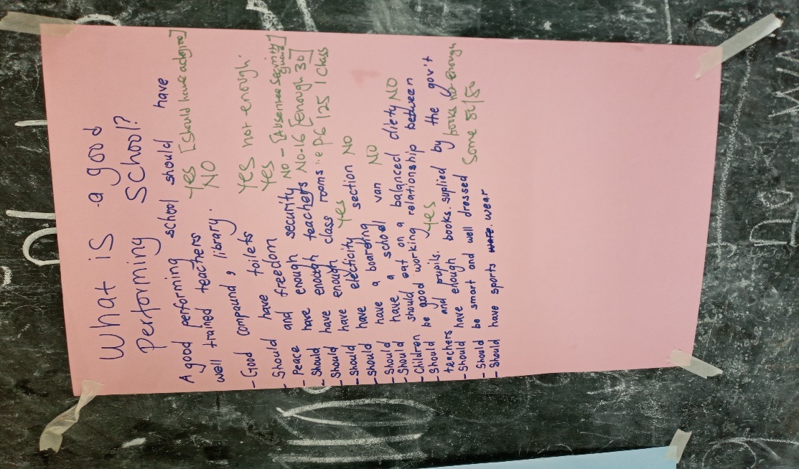i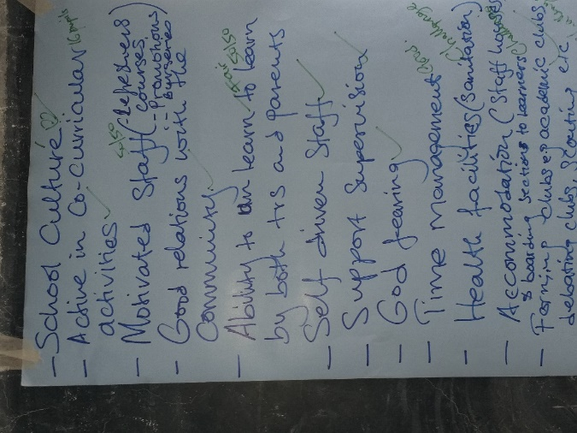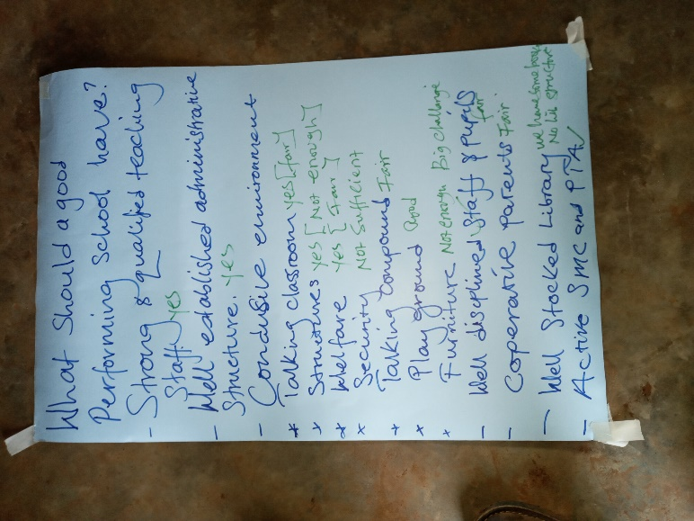

Figure 1 A good performing school according to students (L), parents (M) and teachers (R)

This process led to prioritization of the indicators of a good performing school which was the basis of rating by the different groups of participants and identification of the factors that affect performance in Kyarusozi Model Primary School. Each of the groups had a facilitator and a note taker; and the team from BCFU was available to provide any clarification. After the discussion on indicators, each of the teams assessed the school according to the indicators agreed and identified the factors affecting performance at the Kyarusozi Model Primary School. Consequently, open voting was held where the facilitators asked the participants if each of the issues raised was valid and the participants raised their hands to affirm the validity of each issue. These were pinned and participants were able to vote against each of the issues.

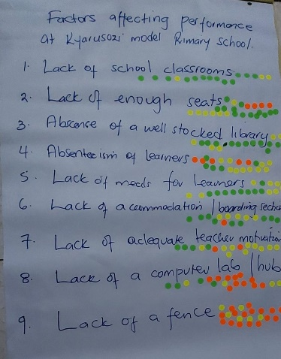The voting at this stage was not done in the open to allow for confidentiality especially for the students. The picture below shows the voting where each participant was given three sticky dots of different colors; green for what they thought was the first and greatest factor, yellow signified second and red signified third.

On the second day, the local leaders which included local council 1 chairperson, the women councilor at the district, and the Mayor of Kyarusozi Town Council were present at the meeting, where the priority issues were presented to the leaders with justification regarding the importance of each issue and the extent to which it affected the performance of the school. The leaders responded to the issues, appreciated the facilitators and participants; and made commitments to address some of the actions as evidenced in the action plan below.

## **Influence, Outcomes, and Effects**

The community score card exercise had immense outcomes for the school but also for each of the groups that participated. This was the first community scorecard implemented in this community and at the school. This provided an opportunity to apply a new approach to resolving school academic performance which was a big concern to the students, parents, teachers, and the leaders. The opportunity to have these different categories of people together to discuss issues of performance was applauded by the parents, teachers, and leaders. The fact that BCFU did not provide cash reimbursements as was expected by some of the participants changed the community attitude towards more focus on their contributions rather than financial benefits. The Chair of the school management committee committed to have these sessions hold at least once a year. A committee was selected to closely monitor the implementation of the action plan.

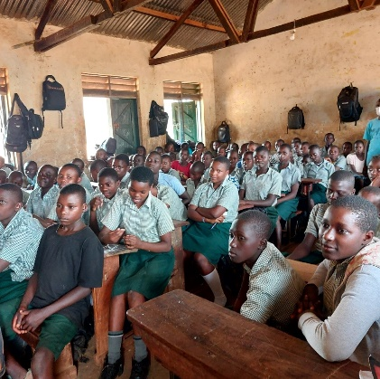The Head teacher with support from the school management committee made a provision for a boarding section for the candidates to enable them concentrate and have them closely monitored. This has greatly improved the performance of the school in the National examinations as seen in the results in the table below. The improved performance has led to increased demand for the school which has become a school of choice for parents. At the recent handover of library to the school the head teacher expressed his worry to the leaders.

*“We have a challenge with over enrollment because parents want their children to enroll in the school, yet we don’t have adequate facilities like classrooms. The classes are congested, and parents cannot appreciate these conditions we are working with. Hon Mayor, if you hear the parents complaining it’s because of that issue’ said Mr. Gilbert Mubangizi. (Kindly cite your source)*

Due to this great performance, the founding body/catholic church has offered some of the structures at the nearby technical /vocational school as dormitories for the school to have more students accommodated close to the school.

|  |  |  |  |  |  |  |
| --- | --- | --- | --- | --- | --- | --- |
| **Year** | **Division 1** | **Division 2** | **Division 3** | **Division 4** | **Division U** | **Division x** |
| 2018 | 03 | 50 | 5 | - |  |  |
| 2019 | 13 | 50 |  |  |  |  |
| 2020 | 13 | 79 | 01 |  |  |  |

\* Source: *Kyarusozi Primary School Office of the Headmaster*

Being the political season, some of the issues were integrated into the leaders’ plans. For example, the mayor agreed to contact the different authorities to ensure the school gets fenced. Although this was not part of the top priorities, the mayor felt it was necessary. The mayor also reached out to the BCFU to mobilize reading resources for the school. BCFU initiated contact with the National Library of Uganda who linked the foundation to Book Aid International for a book donation of 1000 books which were officially handed over to the school in February 2023.

The head teacher also mobilized the alumni group to support the school and commitment was made to support the candidate class with sanitary pads for the girls, school requirements like mathematical sets, books, pens; and motivate them with special meals for the candidate class since they have a boarding section. Similarly, the alumni group has committed to provide mentorship and career guidance to the candidates. This was an unintended benefit from this process.

## **Analysis and Lesson Learned**

## The analysis in this section is drawn from the lessons picked by the facilitators/organizers and some shared by the stakeholders. The community score card was an effective approach in bringing key stakeholders together to discuss the school’s performance. The following steps proved effective in achieving the intended results.

Mobilization of the stakeholders and leaders was an effective strategy. The mix method of using the school management committee, reaching out to parents on the phone (those who had) and sending letters through their children ensured that the invited participants were present at meetings. The meetings with the leaders to explain the purpose and request for their participation brought key leaders to the meetings and made commitments to address the factors identified. Collaboration and support from the school head teacher contributed to great strategies for mobilization.

The facilitation of the process was well done and ensured each of the stakeholders invited had a role. This started with the orientation on the process that allowed participants to ask questions and select their group leaders. The approach for presentations and voting was not only interesting but provided an opportunity for participants to participate and have their views heard. The separation of students from the adults was a great strategy to allow them to contribute without fear of retaliation.

The action planning was critical to ensure that issues were not left in the meetings but implemented. This was enhanced with the selection of a committee to oversee and follow-up implementation. All the actions were followed up and there is clear progress as indicated on the major issues raised.

The key lessons learnt was the untapped potential in the community to address their own issues but also the knowledge of their issues is critical. From the children to adults, each knew their challenges clearly but needed such a process to harness each other’s potential to address the issues.

## **References**

Atuhurra, J. F. (2016). Does community involvement affect teacher effort? Assessing learning impacts of Free Primary Education in Kenya. International Journal of Educational Development, 49, 234- 246.

Byamugisha, A., & Ssenabulya, F. (2005). The SACMEQ II Project in Uganda: A Study of the Conditions of Schooling and the Quality of Education. Harare: SACMEQ.

Harlen., W (2015) Assessment, Standards and Quality of Learning in Primary Education. A report for the Cambridge Primary Review Trust.

# Kigenyi., E. Kakuru., D.M & Ziwa G (2017). School environment and performance of public primary schools in Uganda. International Journal of Technology and management, Volume 1. Issue ii pp1-14)

Lamas, H. (2015). School Performance. Propósitos y Representaciones, 3(1), 313-386.

Ministry of Education and Sports; April 2009; Basic Requirements and minimum standards indicators for Education Institutions; <https://www.education.go.ug/utsep/wp-content/uploads/2020/03/Final-Copy-BRMS.pdf>

Ministry of Education and Sports 2017; the education and sports sector annual performance report Financial Year 2016/17; retrieved from

<https://www.education.go.ug/wp-content/uploads/2019/08/ESSAPR-2016-17.pdf>

Ministry of Education and sports; Statistical abstract (2017); [\*Abstract-2017.pdf (education.go.ug)](https://www.education.go.ug/wp-content/uploads/2019/08/Abstract-2017.pdf);pg. 34, 38)

Ministry of Education and sports; 2022, UPE-USE Data; **UPE AND USE/UPOLET AND RELEASES FOR FY 2021/22** [UPE-BY-LG.pdf (education.go.ug)](https://www.education.go.ug/wp-content/uploads/2020/01/UPE-BY-LG.pdf)

Ministry of Education and sports; [PRIMARY-ENLORMENT.pdf (education.go.ug)](https://www.education.go.ug/wp-content/uploads/2020/01/PRIMARY-ENLORMENT.pdf)

Musika., R.w (2019) Universal Primary Education and the Uganda’s Economy Report.

The Organization for Economic Cooperation & Development (OECD) report of the Program for International Student Assessment (PISA) 2012.

Polikoff., M.(2021). Beyond Standards: The Fragmentation of Education Volume 15, Issue 4 MA, Harvard Education Press.

Polikoff.,M, Silver., D.Garland.,M.S, Rosefsky., A.R and Amie., F.M (2021).The Impact of a Messaging Intervention on Parents’ School Hesitancy During Covid-19 (October 14, 2021). CESR-Schaeffer Working Paper No. 002, Available at SSRN: <https://ssrn.com/abstract=3942872>

Scwartz., S. (2023). What is the purpose for standards in education? An Explainer Education Week: July 31, 2023.

The World Bank; Education statistics; [Education Statistics | Country - Country at a Glance - Uganda (worldbank.org)](https://datatopics.worldbank.org/education/country/uganda) ;

Uganda Bureau of Statistics; 2021; statistical abstract.

Vermeulen., R(2013) Master’s Thesis: The quality of public primary education in rural Uganda: An assessment using a Capability Approach

## **External Links (Optional)**

## <https://childrensfoundationug.org/>

## Location of Kyarusozi Primary School: [https://www.mindat.org/feature- 11494743.html](https://www.mindat.org/feature-%2011494743.html)

## **Notes**

|  |  |
| --- | --- |
| C:\Users\LENOVO\Documents\from Georginahs computer\Sarah\sarah\All other personal\coady\FInal paper COADY\Alumni mentorship.jpg | C:\Users\LENOVO\Documents\from Georginahs computer\Sarah\sarah\All other personal\coady\FInal paper COADY\Students\Discussions children .jpg |
| Photo 1 by: Racheal Kyomuhendo BCFU Volunteer Kyarusozi Alumni facilitates a mentorship session for Primary Seven Candidates in 2019 | Photo 2 by: Polly Tom  Children in their separate group discussing factors affecting performance |
| C:\Users\LENOVO\Documents\from Georginahs computer\Sarah\sarah\All other personal\coady\FInal paper COADY\Alumni Girls support .jpg | C:\Users\LENOVO\Downloads\IMG-20221017-WA0021 (1).jpg |
| Photo 3: Picture by Herbert Musinguzi  Primary Seven girls with the head teacher receive sanitary pads from the Alumni group before their final examinations November2022 | Photo 4: Alumni group distributes items to Primary Seven class November 2022 |
| C:\Users\LENOVO\Documents\from Georginahs computer\Sarah\sarah\All other personal\coady\SCORE CARD\20221123_113816.jpg | C:\Users\LENOVO\Documents\from Georginahs computer\Sarah\sarah\All other personal\coady\SCORE CARD\20221122_145907.jpg |
| Parents and School management leaders discusssing the indicators and factors | Selected students attending the score card exercise |
| C:\Users\LENOVO\AppData\Local\Temp\Temp1_CSC Pics.zip\CSC Pics\20221123_154958.jpg | C:\Users\LENOVO\Downloads\IMG-20230228-WA0099.jpg |
| The students who participate with some of the school management committee leader and the head teacher | Mayor (Kyarusozi Town Council and the head teacher Kyarusozi school |
|  | C:\Users\LENOVO\Downloads\IMG-20230228-WA0024.jpg |
| Mr. Mubangizi Gilbert- Head Teacher, Kyarusozi Model PS | Handover of the library to the School Management Committee and the Mayor (February 2022) |
| C:\Users\LENOVO\Downloads\IMG-20230227-WA0096.jpg | C:\Users\LENOVO\Documents\from Georginahs computer\Sarah\sarah\All other personal\coady\SCORE CARD\CSC Pics\20221123_142640.jpg |
| Children using the library | The mayor addressing the participants at the community score card meeting |

1. The Primary Leaving Examination is done at the completion of primary level of education to progress to Secondary level [↑](#footnote-ref-1)
2. PTA is a forum that brings both parents and teachers together periodically to discuss the affairs of the school including performance, roles of parents and contributions [↑](#footnote-ref-2)