Introduction to Economics
This course will equip students with fundamental economic knowledge as they transition to college or the workforce. By developing an understanding of the history of economics as well as an introduction to the basics of microeconomics (economic behaviors of individuals) and macroeconomics (national or global economics), students will gain a broader perspective on the role of economics in shaping society. Through discussions and practical activities, students will gain confidence in navigating economic challenges and opportunities that they may encounter in their lives.
Key Facts – 2025 Economics Seminar

7 Sessions
May 22st 11:30-1, May 27th 12-1:30
May 30th 12-1:30, June 3rd 12-1:30
June 5th 12-1:30, June 11th 12-1:30
June 13th 12-1:30

Instructors
Mr. Bursig and Mr. C. O’Brien

For further information: Mrcobrien@Kellenberg.org

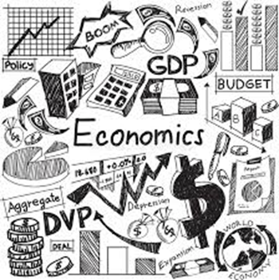

Testimonials
“If you want to get a good start and gain basic but important knowledge on economics before college, this seminar will greatly help you.”
“If you’re planning on majoring in business, I would recommend this seminar in order to gain some basic knowledge of economics going into college.”

This seminar benefits any student interested in the following areas of study:
**Business**
**Marketing**
**Finance**
**History**
**Economics**

