Explainable AI and Ontologies
Co-chairs: Ram D. Sriram and Ravi Sharma

Evolution of AI. Since the 1950s, when the term Artificial Intelligence (AI )was coined, there has been considerable progress in this area. The 1980s was dominated with the rise of knowledge-based systems, which is also called “the first wave.” Advancements in computer hardware facilitated multilayered neural networks, which led to significant improvements in machine learning for certain classes of problems in 2000s. This was the “second wave.” Now, we are witnessing the “third wave,” which will include a combination of neural networks and knowledge structures; DARPA views the third wave as contextual adaption where “systems construct contextual explanatory models for classes of real world problems.” There are other perspective of various AI waves (e.g., Kai-Fu Lee).

Explainable AI (XAI) – The DARPA Initiative (https://www.darpa.mil/program/explainable-artificial-intelligence
)
The first wave of AI produced several reasoning techniques, such as decision trees, inference networks, Bayesian networks, statistical learning techniques, and the beginnings of neural networks. As the second wave took place, multilayered neural networks (deep learning) with more than one hidden layer produced impressive results in a wide variety of classification problems. There was a trade off between performance and explainability (as shown in Figure 1). For example, a major problem with neural networks is the lack of transparency. It was more like a blackbox approach, where the following questions could not be adequately answered: why did you do that? Why not something else? When do you succeed? When do you fail? When can I trust you? How do I correct an error? The DARPA XAI program was started with the goal to address above questions by enhancing AI programs to deal with above questions. Figure 2 provides an overview of three major tracks in the DARPA program – Deep explanation; Interpretable Models; and Model Induction.

Explainable AI (Derek Doran)
Derek first gave an introduction to explainable AI, including categorizing AI into symbolic and sub-symbolic areas. He further noted that sub-symbolic AI can be grouped into white (liner regression), grey (support vector machines),and black (neural networks) boxes. Deep Neural Networks were able to learn and extract latent features, which are difficult to do by hand, and map these features into appropriate classes. XAI in the context of DNNs what input features are being learned by system and relate these input features to input (e.g., what pixels in an image).

Derek put forward the following four theses about explainable AI:
- Explainable AI defines a field of research, not define a particular “type" of AI.
- There exist unique notions of `explanations', making problem or context-independent explainable AI work inappropriate.
- “Strong” and “Ultrastrong'”AI systems (by Michie's definition) demands the integration of symbolic systems and reasoning to provide operationally effective communications of the internal state and operation of an AI.
- Meaningful ontologies and knowledge bases, and Symbolic AI methods are a fundamental (but right now, mostly ignored) to the most important XAI use-case: when in practice, within some context, a layman must understand, trust, and be responsible for the conclusions an AI draws.

Derek contemplates that there is hierarchy of explanation types for an AI system, with Reasonable (conceptualizing how inputs are mapped to outputs) at the bottom, Explainable (explaining how inputs are mapped to outputs) in the middle, and Interpretable (identifying why an input goes to an output). For Reasoning to happen one needs ontologies. He provided an example of his work which involved extracting features and reasoning about these features to explain “why” and “how” through use of ontologies and symbolic reasoning. Derek ended his talk by connecting Confidence, Trust, Safety, Ethics, and Fairness to XAI.

John Sowa: An explanation is the ability to answer how or why question and to answer a follow up question to clarify in a particular context. Neural networks are good at correlation and not causation.

Explanation AI Past, Present, and Future: A Scientific Modeling Approach (William J. Clancey) William (Bill) Clancey gave a historical perspective of the evolution of the Stanford’s MYCIN knowledge-based expert system (KBES) and its role in XAI. MYCIN (1970s) was initially developed as a diagnostic tool for infectious diseases, and a module was incorporated to provide explanations – both why certain questions were asked and also why certain decision paths were not taken. Thus MYCIN and its derivatives can be viewed as forerunners to XAI. A domain-general version of MYCIN – called EMYCIN – was developed and this provided a framework for the development of KBES in several domains (e.g., SACON in structural engineering). EMYCIN retained the explanation module incorporated in the original MYCIN framework. Later projects, such as SRI’s Prospector and its domain-general version KAS were influenced by early MYCIN’s research. MYCIN and its early successors did not use ontologies, but one sees implicit use of ontologies. For example, the disease knowledge was represented in a taxonomy of processes in an implicit manner (though this was explicit in Clancey’s NEOMYCIN reformulation). A domain-general framework — called HERACLES — which could model system process dysfunctions explicitly, knowledge evolved was developed from NEOMYCIN, and this was used to develop a KBES in a manufacturing mechanical engineering domain (CASTER). William Clancey’s work is well documented in the chapter entitled “Methods for Generating Explanations” in the book “Rule-based Expert Systems,” edited by Bruce Buchanan and Edward Shortliffe, and can be found at http://www.shortliffe.net/. In terms of the present,William Clancey pointed out the lack of explanations in systems such as Google Maps and Netflix. For example, he had no clue why the show “Comedians of the World” was suggested to him in Netlfix, based on the fact he watched “AlphaGo.” For the future,William Clancey suggested that we need to take a more systems approach to building XAI systems, including development of ontological patterns – both domain general and domain dependent. Further resources regarding William Clancey’s thoughts can be found at https://billclancey.name/index.html.

DARE: Deep Attentional Representations for Explanations (Giedrius T. Buračas)
DARE focuses on an efficient way of doing VQA (Visual Question Answering). A VQA system will take an image from a list as input and provides a natural language answer as the output for a given natural language question. Generally, VQA systems use Deep Learning Techniques, along with natural language processing, and ontologies in the form of knowledge networks. Giedruis provided an overview of their VQA system -- DARE, as shown in Figure 3. In the Figure, an image from a list is selected and a question is asked about “what is shown in the picture.” DARE comes up with two answers with likelihood associated with these answers. In the first answer, DARE suggests that there are people in a row boat. When asked why does the system think it a row boat, an explanation that row boats are propelled by oars is provided. DARE figures out the objects in the photo by using attention maps – which they innovated -- and a concept ontology. Giedruis and his colleagues demonstrated DARE in action. For a good overview of VQA system see https://tryolabs.com/blog/2018/03/01/introduction-to-visual-question-answering/, Currently there are several datasets available for VQA and a survey of these can be found at https://arxiv.org/abs/1610.01465. A couple demos of thesystem are available online: 1) Prediction task: https://xaidevel.nautilus.optiputer.net/pred; 2) GuessWhich game: https://gwapp.nautilus.optiputer.net/.

Explanation Artificial Intelligence: A Probabilistic Approach (Speaker Sargur Srihari)
Sargur Srihari, whose handwritten recognition system is widely used by the U.S. postal service, views the third AI wave as knowledge being represented using probabilistic graphical models such as Bayesian networks, Markov networks, Restricted Boltzmann machines, etc. He asserts that the third wave is more suited for explainability , as inference in PGMs has methods for most probably explanation (MPE). Srihari described several examples in forensics – footwear impressions, latent fingerprints, and handwriting samples – where patterns are compared and explanations are needed to be presented to a lay jury. He illustrated this with an example from handwriting comparison using two different “and” words. A forensic document examiner provided the following explanation, noting both similarities and dissimilarities: “Similarities include the pointed first arch of the letter “n”, the counterclockwise motion of the formation of the front portion of the “d” and the way the stroke connects from the “n” into the middle of the “d”, and the relative height of the staff of the “d” compared to the other letters. A dissimilarity is noted in the connecting stroke from the “a” to the “n”. Is it below the baseline and has a sharp angle in the questioned “and”, and at or above the baseline and rounded in the known “and”.” Srihari then provided a detailed explanation on how probabilistic models can provide such explanations. He also discussed the role of expert knowledge (e.g., ontologies) for aiding in generating explanations, with an example from the handwritten recognition domain. Srihari mentioned Daphne Koller’s book on Probabilistic Graphical Models as a good reference source.

Explainability
Learning Techniques (today)
Explainability (notional)
Neural Nets
Statistical Models
Ensemble Methods
Decision Trees
Deep Learning
SVMs
AOGs
Markov Models
MLNs
Bayesian Belief Nets
SRL
CRFs HBNs
Random Forests
Graphical Models
Learning Performance

Figure 1: Explainability vs Performance of Many AI Systems

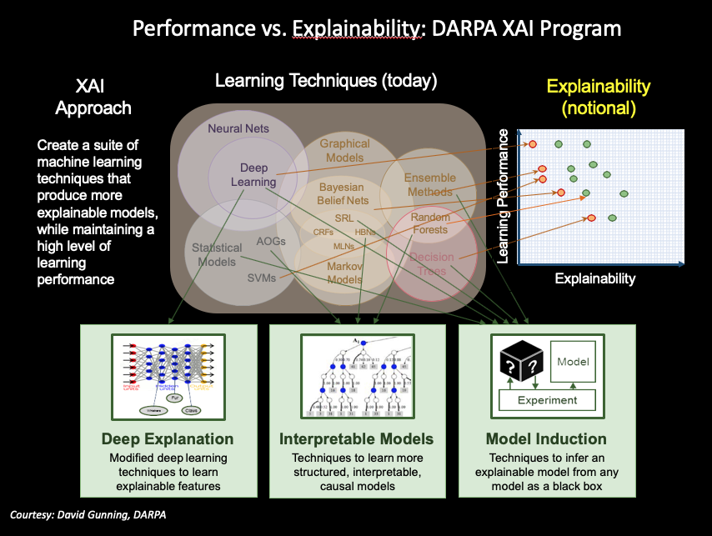Figure 2: Three Tracks for DARPA XAI Program

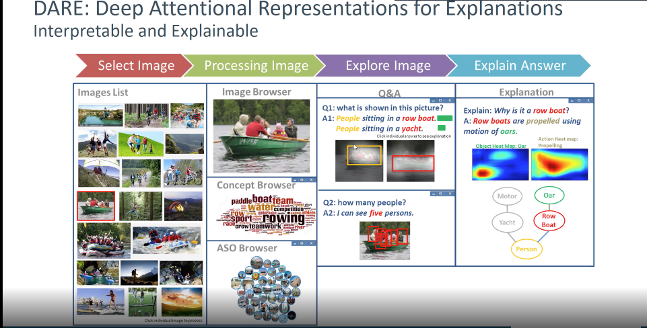

Figure 3: DARE: Deep Attentional Representations for Explanations – SRI Approach

