Ontology Summit 2019 – Explanations XAI Track Synthesis
Co-Champions: Dr. Ram Sriram (NIST) and Dr. Ravi Sharma (EA)
May 1, 2019

Table of Contents
Ontology Summit 2019 – Explanations XAI Track Synthesis 1
explainable - Dictionary Definition: Vocabulary.com 1
XAI Track Synthesis Session 1, Feb 27, 2019 1
Overview and Summary 1
Comments 3
Future Directions 3
XAI Track Synthesis Session 2 - May 1, 2019 3
Overview and Summary 3
March April- Speakers, Summary and domains covered 3
Overlap with Summit Tracks, e.g. Medical 4
Literature search on (explainable AI and Ontology) 4
Synthesis Summary 5
Future Directions 5
Communique comments 5
Publication Paper Approach 5

explainable - Dictionary Definition: Vocabulary.com
adj capable of being understood. “explainable phenomena” Synonyms: interpretable explicable. capable of being explicated or accounted for.

Sanskrit - Vyakhya or Bhashya – implies ability to understand through explanations and / or treatise on a topic

XAI Track Synthesis Session 1, Feb 27, 2019
Co-Champions: Dr. Ram Sriram (NIST) and Dr. Ravi Sharma (EA)

Overview and Summary
While HOW can be often helped by science etc., WHY requires more than quantifiable aspects such as from Social, psychological, SMEs, etc. DARPA XAI inspired this new approach for HCI or Computer-to-Computer understanding a concept or topic etc.
Nov 14, 2018: John Sowa introduced the Summit Theme - Explainability and not only related to Why but also to “Follow-up Questions” and introduced again relevance of Contexts, Enterprise Frameworks etc.
Nov 28, 2018: Ram and Ravi provided a brief overview and introduced Speaker Derek Doran, who related to not only Training Data, ML but also explanable models and Explanations interfaces. He also emphasized need of role of ontologies and Knowledge-bases as being fundamental to describe Why and How. Examples of Decision rules, statistical assistant, etc. were provided. Also described Interpretable and comprehendible, reasonable aspects of Why and Understanding.
January 16, 2019: Summit Introductory Session – Chaired by Ken Baclawski. Ravi Summarized XAI activities (Due to the US Government Shutdown, Ram - not able to attend.), including above track related preparatory work/sessions.
- Explainability is itself not uniquely definable
- XAI has many dimensions: domains, techniques, interdependencies and statistical aspects
- Expertise, Agreements, User consensus, Social aspects important
Potential Speakers with expertise and affiliations were presented.
Review examples of XAI studies were provided, ontology related applications and
domains in 2018-2019 were listed in a Table. Techniques of studies: DL, ML, Pattern theory, Causal and Cognitive modeling, Probabilistic Logic etc. Domains where studies are being done included: Human Agents, Experts, Virtual Assts, Robot-human interfaces, Complex Biosystems, Healthcare, Medical, Defense, e-Learning, e-Commerce, Media etc. Lively interaction and Qs followed that included works at Cyc, Deep Semantics, SemWeb, IKL, XRL -Reinforcement Learning.

Feb 20, 2019: Explainable AI Session 1 – Ravi Introduced Speaker William Clancy (Computer, NASA space program and AI experience) who spoke on "Explainable AI Past, Present, and Future—A Scientific Modeling Approach”. He described MYCIN project of 70’s at Stanford. It included rules, inferences, consultations and Agents such as Bacteria, TB, Fungus, Virus. The sequence of studies such as MYCIN => EMYCIN=> SACON =>Neomycin =>HERACLES => Caster were described. Knowledge from Sand Casting Domain was used, and therapy and logic of why and why-not were used in MYCIN. He said Common AI Models of 70-80’s were using explanations, while some newer AI examples he showed such as GPS navigation systems can still not provide answers interactively and answer Why etc.
• Explanation involves discourse, follow-up and mutual learning;
requires a “user model” of interests & knowledge.
• “Explanation” is not a module – rather it drives the design process;
needs are empirically discovered in prototype experiments.
Shift to Systems Thinking would help; Explanation Might Address Shortcomings of Symbolic AI.
Lively extended discussions and QA followed. David Whitten: (Co-Champion of Medical track with this XAI track’s co-champion Ram) Commented: For example, Gathering, analyzing and review phases of work; People during 1975-1985 recognized how to model data (knowledge representation) and the teaching knowledge of the rules and data. Bill Clancey was always thinking about how to lift the MYCIN and QA system's core into a general tool. This was e-Mycin. Chandrasakaran (KADS Patterns) stated that there were ontological commitments about processes that allowed general models. Breaking down an ontology requires attention to categories used for teaching. David Gunning wants to reconfigure the learning process for machine learning/Neural Nets to be explainable. Note: does not guarantee it will be an Understandable model. No learner-model. No user-model. Gunning wants to focus on other aspects. Work System Design Methodology (from 1992) method to find out requirements, do participatory design, fast turnaround on tools creation, recognize experimental nature of WSDM. Other participants touched on KE, LarKC, FMEA, LINDA, Fluid flow models, etc.

Comments
Preliminary:
Thus XAI has been discussed extensively for some domains. There is need to bridge gaps in implementations, user participation, design patterns and in deeper knowledge through ontologies and contexts, etc.
To Be Added

Future Directions
To Be Added

XAI Track Synthesis Session 2 - May 1, 2019
Co-Champions: Dr. Ram Sriram (NIST) and Dr. Ravi Sharma (EA)

Overview and Summary
To Be Done

March April- Speakers, Summary and domains covered
April 4, 2019 – Giedrius Buračas, Sr. Computer Scientist at SRI, PI of DARPA XAI and Algorithm Lead of AFRL MEADE has experience on AI, ML, neuroscience. Topic: Deep Attentional Representations for Explanations – DARE . XAI adds Explainable Model and interface to AI process steps. Applications include DoD and Transport, Medical, security etc. Explained AI methods for recognizing objects and details as well as concepts based on visual images and deep learning techniques. Visual QA approach Visual Attention and Semantic spatial attention. Attention and Intelligence are correlated. Prediction of VQA accuracy. Human Machine Collaboration demonstrated VQA based recognition and explanations helped in the selection of relevant images from lists. The demo demonstrated how QA criteria were used to progressively analyzed and improve correctness. Future work includes Active probing of image encoding and progressive module networks.
April 10 - Sargur Srihari, SUNY Distinguished Professor in the Department of Computer Science and Engineering at the University at Buffalo, Topic: "Explainable Artificial Intelligence: The Probabilistic Approach". Introduced ML, DL and XAI Probabilistic as 3 waves of AI. Construct Distributions to be Queried, representation and inference used Bayesian, Markov, Monte-Carlo, variational aspects. Using Probabilistic Graphical models, applied techniques to forensic science and example of handwriting analysis. Used 15 features computed most probabilistic explanations, related to intelligence using these and Student Distribution, also computed Least Likelihood ratios, thus using Probabilistic Graphical Models extensively as in Forensic Handwriting Example.
Figure is from Presentation by Giedrius:
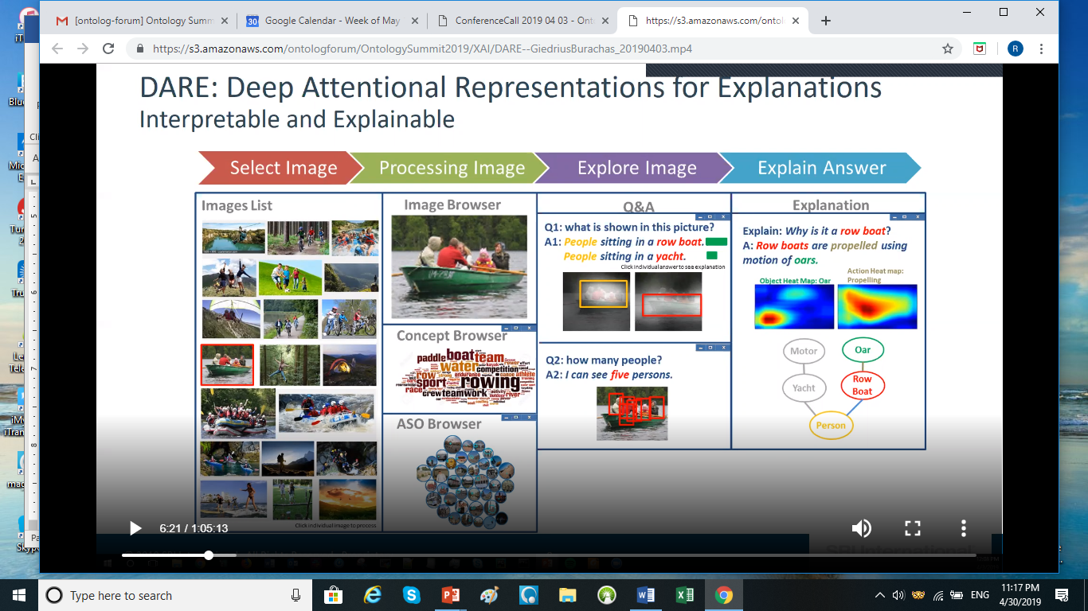

Overlap with Summit Tracks, e.g. Medical
To Be Done

Literature search on (explainable AI and Ontology)
Examples
- [PDF] Bounded Rationality and Heuristics in Humans and in Artificial Cognitive Systems
A Lieto https://philpapers.org/archive/LIEBRA.pdf
- [PDF] Enhancing Domain-Specific Supervised Natural Language Intent Classification with a Top-Down Selective Ensemble Model GB Jenset, B McGillivray - Machine Learning and Knowledge Extraction, 2019 https://www.mdpi.com/journal/make
- Explainable Machine Learning for Chatbots B Galitsky, S Goldberg - Developing Enterprise Chatbots, 2019 https://doi.org/10.1007/978-3-030-04299-8_3
- [PDF] Trusted AI and the Contribution of Trust Modeling in Multiagent Systems BSI Track, R Cohen, M Schaekermann, S Liu… https://cs.uwaterloo.ca/~mschaeke/publications/cohen_trusted_ai_2019.pdf
- Fostering a Healthy AI Ecosystem for Radiology: Conclusions of the 2018 RSNA Summit on AI in Radiology FH Chokshi, AE Flanders, LM Prevedello, CP Langlotz - Radiology: Artificial …, 2019 https://pubs.rsna.org/doi/abs/10.1148/ryai.2019190021
- Deep neural network for hierarchical extreme multi-label text classification F Gargiulo, S Silvestri, M Ciampi, G De Pietro - Applied Soft Computing, 2019 https://doi.org/10.1016/j.asoc.2019.03.041
- [PDF] ARTIFICIAL INTELLIGENCE FOR REGULATORY COMPLIANCE: ARE WE THERE YET? T Butler, L O'Brien https://www.gr3c.com/wp-content/uploads/2019/02/Artificial-Intelligence-and-Regulatory-Compliance-Working-Paper.pdf
- [PDF] Natural Language Interaction with Explainable AI Models AR Akula, S Todorovic, JY Chai, SC Zhu - 2019 https://arxiv.org/pdf/1903.05720.pdf
- [PDF] Algorithmic Transparency of Conversational Agents S Hepenstal, N Kodagoda, L Zhang, P Paudyal… - 2019 http://ceur-ws.org/Vol-2327/IUI19WS-IUIATEC-1.pdf
- [PDF] Artificial Intelligence in Intelligent Tutoring Robots: A Systematic Review and Design Guidelines J Yang, B Zhang - https://arxiv.org/ftp/arxiv/papers/1903/1903.03414.pdf
- [PDF] Knowledge-Driven Stock Trend Prediction and Explanation via Temporal Convolutional Network S Deng, N Zhang, W Zhang, J Chen, JZ Pan, H Chen – 2019 https://www.researchgate.net/profile/Shumin_Deng/publication/331545500_Knowledge-Driven_Stock_Trend_Prediction_and_Explanation_via_Temporal_Convolutional_Network/links/5c7f613f92851c695058d166/Knowledge-Driven-Stock-Trend-Prediction-and-Explanation-via-Temporal-Convolutional-Network.pdf
- [PDF] Explanation in Human-AI Systems: A Literature Meta-Review, Synopsis of Key Ideas and Publications, and Bibliography for Explainable AI ST Mueller, RR Hoffman, W Clancey, A Emrey, G Klein 2019 https://arxiv.org/ftp/arxiv/papers/1902/1902.01876.pdf
- [PDF] Designing Theory-Driven User-Centric Explainable AI D Wang, Q Yang, A Abdul, BY Lim - 2019 http://www.brianlim.net/wordpress/wp-content/uploads/2019/01/chi2019-reasoned-xai-framework.pdf
- [PDF] How to Cooperate with Intelligent Machines: Lessons for Defence Operations TL Tessensohn, B van der Vecht, AR Eikelboom – 2018 https://static1.squarespace.com/static/53bad224e4b013a11d687e40/t/5bf593c90e2e722368c14a4c/1542820809397/23rd_ICCRTS_Revised_paper_24.pdf
- Etc…

Synthesis Summary
To Be Added

Future Directions
To Be Added

Communique comments
To Be Added

Publication Paper Approach
To be Commonly agreed during Communique development.

