
2012: Fighting for the Beginning of the End of the AIDS
We are at a critical moment in the fight against HIV/AIDS. The world has made incredible progress in its efforts to understand, prevent and treat this disease over the last three decades, and progress has been particularly rapid during the last ten years. AIDS used to be a ready death sentence, but by the end of 2010 more than 6.6 million people were on life-saving antiretroviral treatment, up from just 100,000 in 2002. Technology now makes it possible to prevent the transmission of HIV from mother-to-child in as many as 98% of cases. New research has shown that the rate of new HIV infections can be drastically reduced with a combination of existing and new technologies. Leaders from across the aisle and from around the world have demonstrated political and financial will to fight this disease.
Yet there is much work to be done. There are still nearly 8 million HIV-positive people in need of treatment in low- and middle-income countries . More than 390,000 infants and children are infected with HIV each year. New HIV infections still outpace the number of people added on to treatment annually. Funding for AIDS has largely leveled off. Now more than ever, we must recommit ourselves to the fight against HIV and to achieving specific, measurable goals that will help us bend the curve of this pandemic.
Renewing Momentum in the fight against HIV/AIDS
ONE has always been an ardent supporter of the fight against AIDS, advocating for the creation of innovative delivery mechanisms such as the President’s Emergency Fund for AIDS Relief (PEPFAR) and The Global Fund for AIDS, Tuberculosis, and Malaria. ONE continues to advocate for a world in which HIV transmission is halted and there is universal access to treatment for those in need. While the achievement of those goals remains some years off, the achievement of specific interim goals by 2015 can drive momentum. These goals include:
1. Virtually eliminate mother-to-child transmission: an AIDS Free Generation by 2015
2. Accelerate access to treatment: 15 million people on ARVs by 2015 (15x15)
3. Implement innovative prevention strategies to stop new infections
Though these goals are ambitious, they are all measurable and achievable. Critically, to bend the curve of the AIDS pandemic, they cannot be achieved in isolation from one another or by only a handful of donors. Only when achieved in parallel—through the broad support of donors, African governments, organizations, and the private sector—will the beginning of the end of AIDS as a pandemic be real.
1. Virtually eliminate mother-to-child transmission: an AIDS Free Generation by 2015

What’s the situation?
HIV can be transmitted from HIV-positive mothers to their children during pregnancy, labor, delivery or breastfeeding. Without intervention or services provided, there is a 20-45% chance that an infant born to an HIV-infected mother will become infected. For those that are infected with HIV, about half will die before their second birthday without timely treatment. Although the world has made dramatic progress on the prevention of mother-to-child transmission of HIV (PMTCT) and such prevention is now possible in as many as 98% of cases, more than 390,000 infants and children were newly infected with HIV in 2010. 90% of these cases occurred in 22 high-burden countries; 35% of these cases occurred in South Africa and Nigeria alone.
What’s needed?
In June 2011 at the UN High Level Meeting on AIDS, leaders took an important first step by launching the “Global Plan Towards the Elimination of New HIV Infections Among Children by 2015 and Keeping their Mothers Alive”. The Plan identifies a four-prong framework for achieving these goals: preventing HIV among women of reproductive age through services related to reproductive health; providing appropriate counseling and support to women living with HIV; ensuring HIV testing, counseling and access to treatment for pregnant women living with HIV; and HIV care, treatment and support for women and children living with HIV and their families. While we applaud the effort to create this strategy, much work remains to turn strategy into progress. Moving forward, to ensure no child is born with HIV by 2015, the following must be done:
- Design and begin execution of national PMTCT plans for the 22 priority countries by July of 2012. In partnership with the international community (including, but not limited to, the US Office of the Global AIDS Coordinator, UNAIDS, and the Global Fund), health leadership from the 22 priority countries should focus immediate attention on developing plans that outline specific goals, strategies, and associated costs for eliminating MTCT by 2015. These costed plans should then be the basis for mobilizing resources at the country level and for investment by all partners. As outlined in the Global Plan, leaders at the regional level should also utilize existing regional bodies to promote collaboration and to share best practices.
- Strong donor and recipient country commitments to help fill an estimated $2.5 billion gap between now and 2015. Overall, the cost of the interventions to eliminate new HIV infections among children and keep their mothers alive in the 22 priority countries is estimated to be approximately US$ 1 billion per year between 2011 and 2015—and some of this has already been funded. Northern donors can and should continue to demonstrate leadership in funding these efforts, but recipient countries must contribute a growing percentage of the financing for their health challenges. As agreed upon in 2001 in Abuja, recipient countries should continue efforts to increase spending for health to 15% of their national budgets—and as a part of this growth, domestic financing for PMTCT accepted as a goal and resourced appropriately.
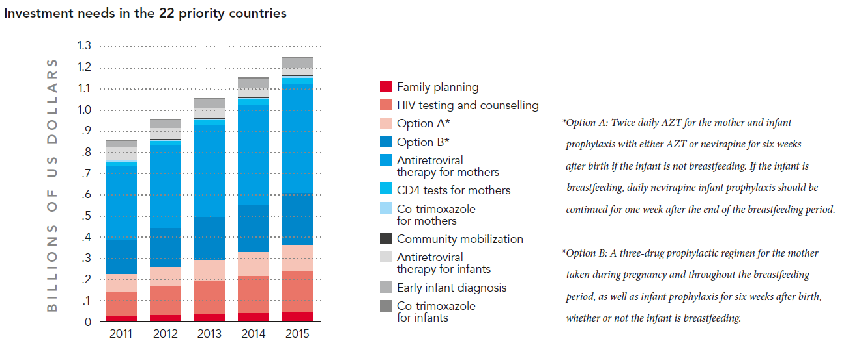
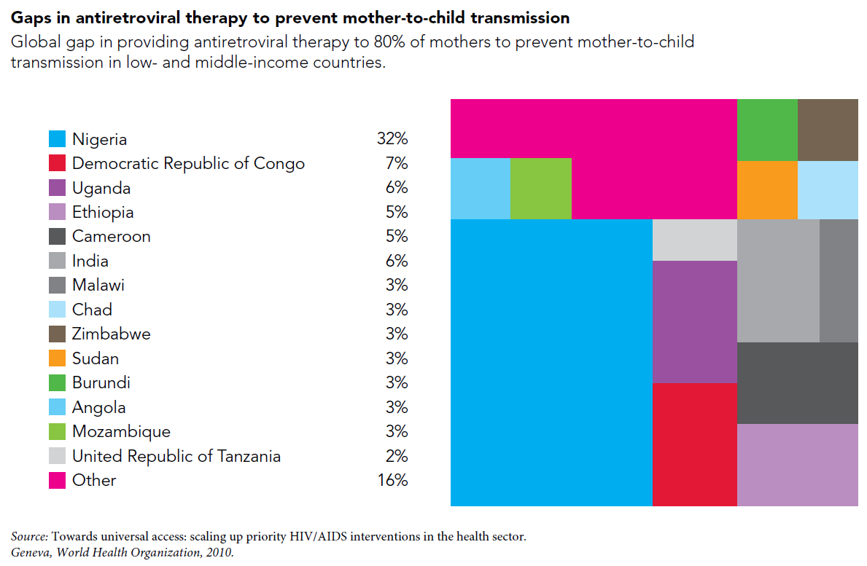
2. Accelerate access to treatment: 15 million people on ARVs by 2015 (15x15)
What’s the situation?
In 2011, more than 6.6 million people were on antiretroviral treatment for AIDS—an impressive feat considering that only 100,000 were on treatment ten years ago. Of those 6.6 million people, more than 5 million are in sub-Saharan Africa, the region most burdened by the pandemic. Still, an estimated 34 million people are HIV-positive in low- and middle-income countries. Of those, nearly half (roughly 14-15 million people) are eligible for treatment based on current WHO guidelines, meaning that millions of people currently in need of treatment are not yet receiving it.
What’s needed?
At the UN High Level Meeting on AIDS in June 2011, donors committed to ensuring 15 million people in low- and middle-income countries are receiving treatment by 2015. Doing so requires:
- Scaling up the pace of treatment initiation. Between 2009 and 2010, the global number on treatment grew from 5.2 million to 6.6 million—adding 1.4 million people in just one year. But even if we sustain this impressive pace, we will only achieve 13.6 million on treatment by 2015. In order to reach 15 million, we need to continue accelerating our pace, adding roughly 100,000 more people per year onto treatment in addition to current rates of scale up (see graph below).
- Scaling up the resources for AIDS treatment. Though the cost of AIDS treatment has fallen dramatically and is likely to continue falling through increased pharmaceutical patent pooling, financing a scale up in AIDS treatment requires substantive growth in international AIDS spending by current donors, new donors, the private sector, and recipient countries.
Over the last decade, sustained increases in international funding for AIDS—particularly through PEPFAR and the Global Fund—have driven impressive gains in the treatment and prevention of AIDS. Research by the Kaiser Family Foundation and UNAIDS shows a six-fold increase in disbursements between 2002 and 2008. Since then, however, global funding increases for AIDS have leveled off (see their chart below):
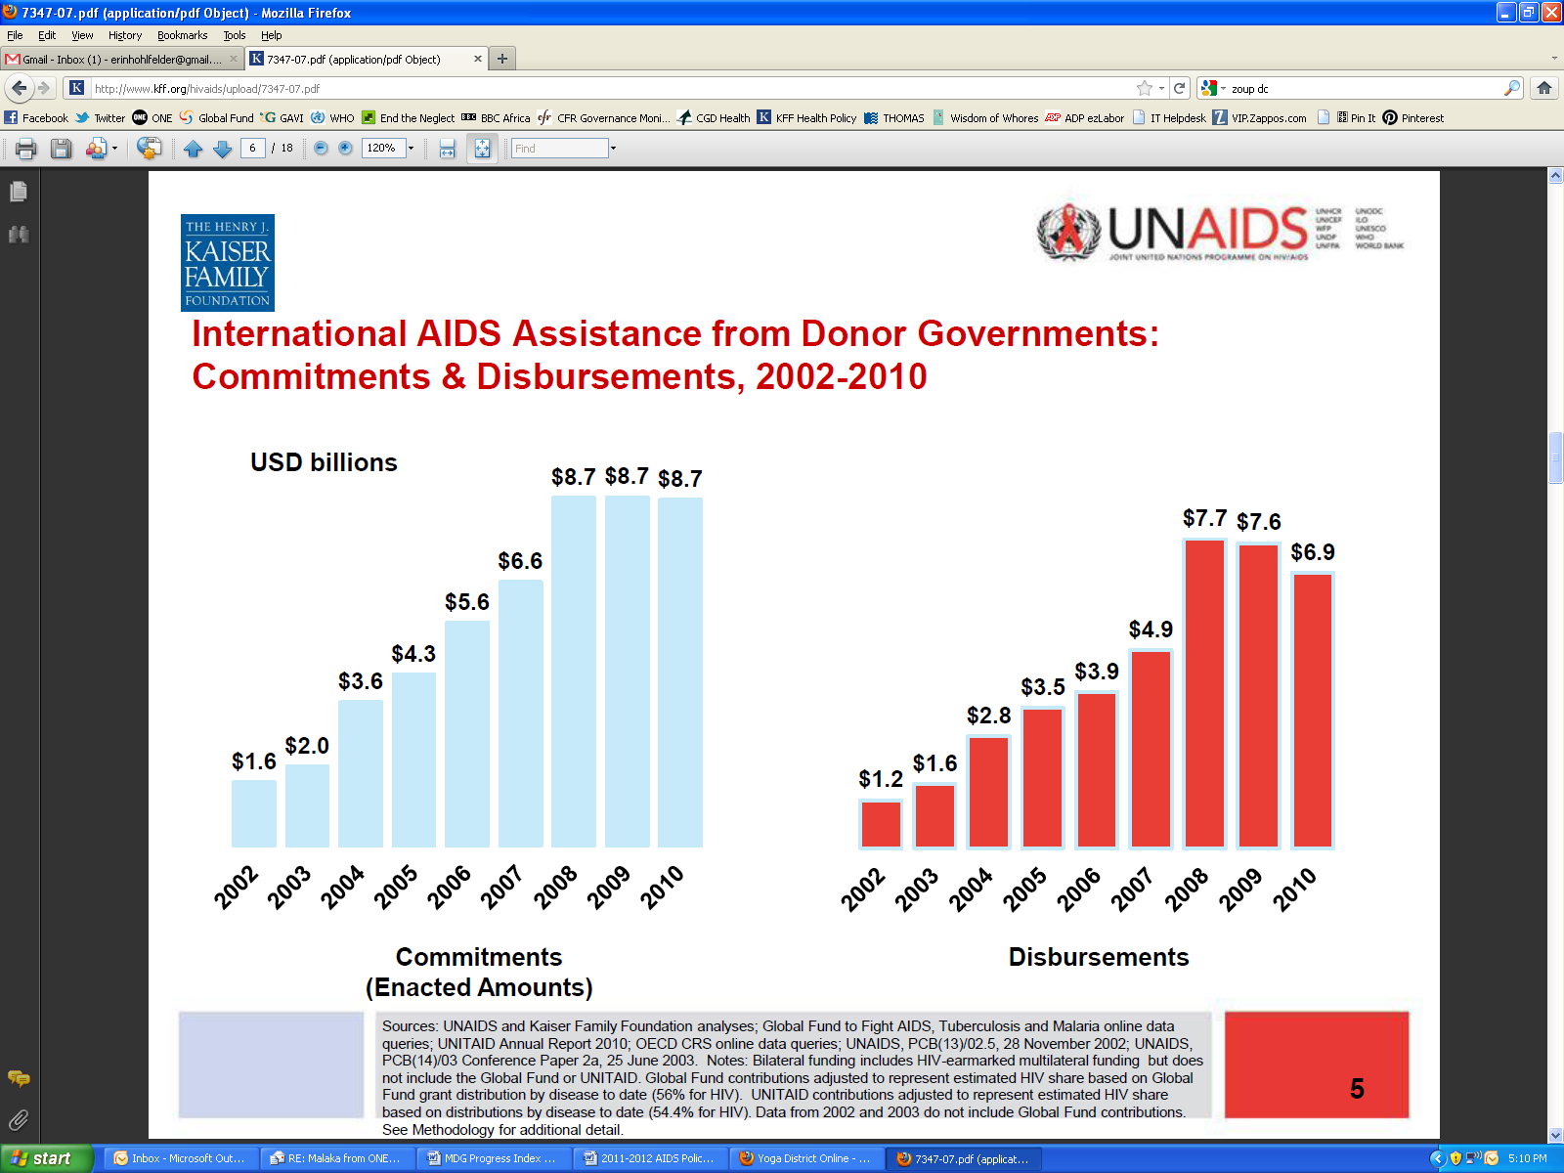
Disbursements in billions, USD

In October 2010, donors made pledges for the Global Fund for 2011-2013. The $11.7 billion pledged represented an increase over the previous replenishment period, but it fell far short of the $13-20 billion need estimated by the Global Fund. The funding situation became more tenuous over the next year; in November 2011, the Global Fund Board decided to cancel Round 11 of grants, establish a Transitional Funding Mechanism for funding of essential services, and delay funding for new programs until 2014. This decision was based on insufficient resources (estimated to be down nearly $2 billion from original projections), in part due to a more cautious methodology for estimating future resource from donors and in part due to many donors delaying or withholding payments.
On World AIDS Day 2011, President Obama made a series of bold new commitments framed around the United States’ contribution toward the beginning of the end of AIDS. These commitments included support for 6 million people on treatment by 2013 and for the expansion of PMTCT and voluntary male circumcision programs. Still, in 2012, PEPFAR—the largest bilateral funding channel for AIDS—is also facing major cuts in the Fiscal Year 2013 budget process.
In light of existing or potential cuts to these two mechanisms, 2012 represents a critical moment in financing for the global AIDS response. Even as programmatic and commodity-related cost-efficiencies are found, donors simply cannot cut or flat line their AIDS spending if they hope to contribute meaningfully toward the beginning of the end of AIDS. Efforts to bolster PEPFAR and the Global Fund this year will generate critical new momentum for bending the curve of this pandemic.
Still, Western donors cannot finance treatment scale-up alone. As recipient countries strive to meet their Abuja commitment on health, their overall spending on AIDS treatment should also increase. A few countries, such as South Africa, now finance as much as 80% of AIDS treatment for their citizens, supplemented by smaller amounts of donor aid for technical support, commodity purchase and health systems strengthening. Other countries, including Rwanda and Botswana, have met or surpassed their Abuja commitment. They should be the models for other countries—particularly for emerging economies that are increasingly equipped with the financial resources to address their own health challenges. Beyond direct financing for treatment, UNAIDS has recently offered up a number of other potential African-led initiatives that are worthy of further discussion, as well.

3. Implement innovative prevention techniques to stop new infections
What’s the situation?
Though we know how to prevent the transmission of HIV/AIDS, there were 2.7 million new HIV infections in 2010—nearly 7,400 each day. Significant progress has been made on this front; between 2000 and 2008, the rate of new HIV infections in 15 to 24 year-olds declined by more than 25% in 15 of the most heavily affected countries in sub-Saharan Africa. New research shows that treatment not only keeps individuals alive but also lowers their likelihood of transmitting HIV to others by as much as 96%. Still, new HIV infections outpace the number of individuals newly placed on treatment each year, at an estimated ratio of nearly 2:1—a main driver of the epidemic.
What’s needed?
Global increases in funding for treatment must not come at the expense of funding for prevention services. If we hope to bend the curve of the HIV epidemic, we cannot do it through treatment alone. There is no magic bullet for prevention, but there are many existing, cost-effective strategies and technologies that should be implemented in combination. Additionally, there are a number of new or pipeline technologies that merit continued research and funding for future implementation. Specifically, the following is needed:
- Support for biomedical prevention strategies. In addition to existing behavioral prevention strategies that have been utilized over the past decade (including male and female condoms, abstinence education, and delayed sexual debut), there are now a number of biomedical prevention strategies that offer great promise in further reducing the number of new HIV infections each year.
  - Scale up implementation of existing strategies including but not limited to PMTCT services for HIV-positive pregnant women, male circumcision, pre-exposure prophylaxis (PrEP), and earlier initiation of treatment (CD4 counts of 350 or higher) where appropriate and feasible
  - Prepare countries for uptake of future new technologies and strategies as they become available including but not limited to microbicides and an AIDS vaccine
- Strengthened planning for tailored implementation strategies. Prevention efforts have previously been less effective because they have not taken into account the unique nature of the HIV epidemic in local and national populations. Greater effort must be made to understand the epidemiology and demographics of HIV infections in a target population, and prevention strategies must be tailored accordingly. AIDS funders must plan for how and where new technologies will be rolled out, and also ensure that appropriate technologies and systems are in place to support prevention efforts (such as cold chain for vaccines or cost-effective applicators for microbicides).

UNAIDS estimates there are more than 14 million HIV-positive people in low- and middle-income countries who have a CD4 count of 350 or lower, qualifying them for antiretroviral treatment; of these people in need of treatment, 6.6 million are currently receiving it.
Angola, Botswana, Burundi, Cameroon, Chad, Côte d’Ivoire, Democratic Republic of the Congo, Ethiopia, Ghana, India, Kenya, Lesotho, Malawi, Mozambique, Namibia, Nigeria, South Africa, Uganda, Tanzania, Swaziland, Zambia and Zimbabwe.
This figure is likely a conservative estimate, as it does not account for needed spending in broader maternal and child health services that the Global Strategy identifies as critical to MTCT elimination

