SUBJECT: This is an “Information Sheet” about the “prepper’s cookout” in Goochland County, Virginia from Wednesday June 23 to Friday June 25.
Dates of the event at Groundhog Flats (20 miles West of Richmond Va.)
The actual day of the event is Thursday June 24. Any attendee can arrive and can depart on that day, June 24th. But the place will be open and overnight accommodations provided on Wed. night June 23 and Thurs night June 24th. Friday the 25th will also be available to continue any of the activities before departing by end of the day Friday June 25. (Some attendees might be heading up next to the Polyface Farm event near Staunton Va., which is about 1.5 hours away going West on Route 64 towards Charlottesville).
So the main day is Thursday but you can make your plans any way you want, whatever is convenient for you, to enjoy the sights and camp-out from Wednesday June 23 through Friday June 24 and any times in-between. For example, to arrive on Wednesday and not depart until Friday. Or arrive and depart on Thursday. Or arrive Wednesday afternoon and depart Thursday evening. You get the idea. The schedule at the Virginia site is flexible for you and the site will be open Wednesday through Friday.
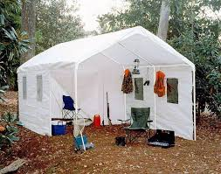
Location:
The location is about 20 miles West of Richmond, Va., just across the Goochland County line in an area known as Manakin-Sabot (“Manakin”). Manakin is mostly rural and farmland, although in the past 10-20 years metro Richmond has been moving Westward and developments are springing up almost every month it seems. Still at the location of this Prepper’s site, the neighbors are a few recently built houses with a large expanse of farmland, usually corn and other crops rotated during the season. In the other direction is a large pasture of cows, who at times remind you at night that they still have grazing rights with their “mooing”.
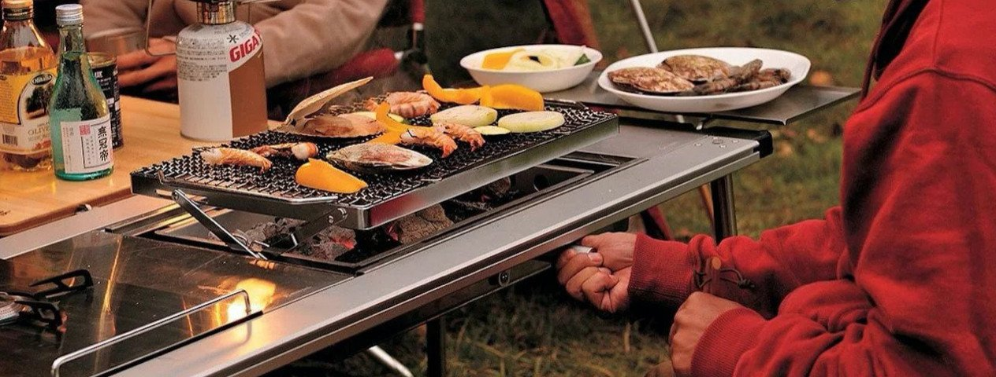

The location, called “Groundhog Flats”, is part of what used to be a large pig and dairy farm started at the turn of the century and into the 1900s. The property consists of the main farmhouse on 3 cleared acres, with 14 shed type outbuildings, two rows of what used to be chicken and pig stalls, a pump house building (no longer used) and a smokehouse where the pigs were hung. The farmhouse was built in 1896 and its heating system is still 3 fireplaces. A property manager does live on-site, but no one is currently living in the farmhouse while it is undergoing a (slow) restoration.
Legend has it (as told by a longtime family living in the area for ages), that a large oak tree…. still standing near the house …. was the site of a Confederate camp during the Civil War. This was one outpost of sites defending the City of Richmond, 20 miles away. If true, one of the campfires at this June’s event can be celebrated as the renewal of a Confederate campfire some 150 years ago.
In short, Groundhog Flats is 3 acres of open space with a decent amount of isolation, and with a commardarie to be enjoyed whether under the sun or under the stars, or both. The lectures on prepper crafts, the “hands on” demos, and the mingling and engaging in a variety of activities, will be enjoyed in a mostly rural farmland environment.

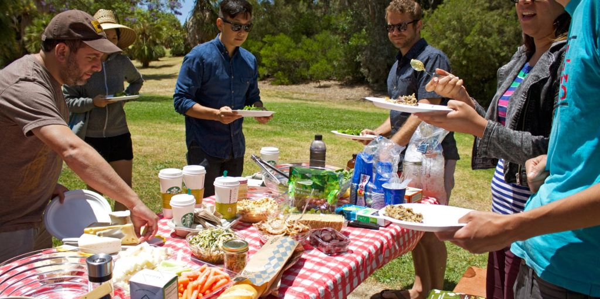

The location is ideal for our group because it is “out of the way”, many woods and farm fields, and you can do pretty much whatever you want without being disturbed.
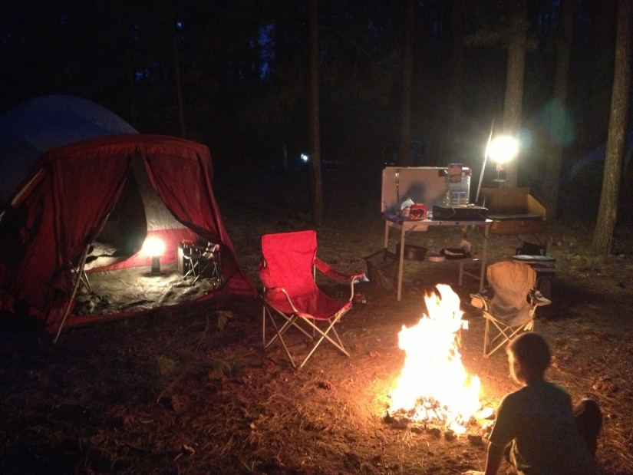
What to expect……
Some canopies and tents will have been put up. Cots, sleeping bags, makeshift beds, maybe on the ground, and whatever else we come up with to make sure you have a comfortable sleep. But this will be rustic. No Hilton Inn here. Although yes, a modern day bathroom, and shower, will be available. At least one campfire, with marshmallows and hot dogs for those who want to relive their boy scout/girl scout days, and a small fish pond where about 15 good size outdoor gold fish call home. With some lanterns and string lights strung around, we will not be in total darkness.
Educational subject matter
To mention just four examples: There will be at least 4 good size solar panels around for experimentation and making connections, with examples of powering survivalist equipment (making coffee; powering makeshift communication systems; lighting). Ham radio will be taught and demos given. An M.D. and R.N. team will present the best for first aide care in the wild. An expert will demo a solar powered hot water heater for the home. And a farmer will showoff his food right-from-the-farm as we all enjoy it while learning of prepper food basics. A brief description of some topics and subject matter to be covered in presentations will be sent out at a time in June closer to the dates of the event.
Input from attendees is invited and welcomed on any subject you would like to (1) make a presentation on, or (2) hear someone else give information on it. With such a mixture of backgrounds in a group like this, …even though joined together by the common ground of a “prepper spirit”,… we would like input in advance of anyone’s favorite subject, your curious technology or hearing of experiences of interest to be discussed or demonstrated. This way it might be possible to bring in someone with specific expertise in that area, or a prepper attendee can be added to the training agenda, and this is why we’d like to get any input of this type in advance.

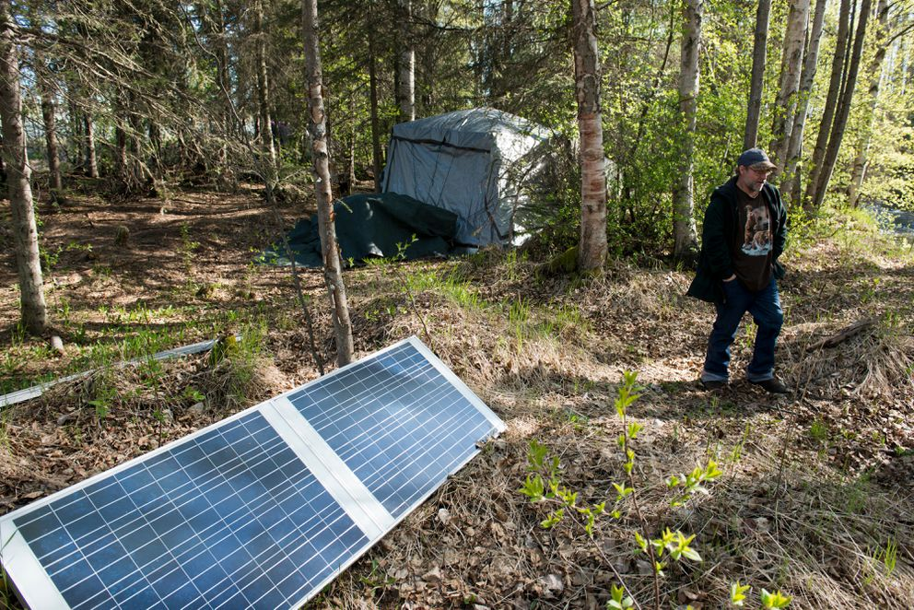
Otherwise, in addition to the educational aspects, this will be a great gathering place of like-minded people enjoying casual time outdoors. The discussions in such a relaxed and casual environment often lead to things that we can pursue and exchange thoughts on well after this is over and we are back in our home territory.
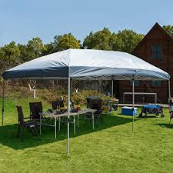
Grills, Drinks and Food
Of course, there will be multiple grills fired up; Virginia Bar-B-Q, hamburgers and all the dressings; and coolers packed with ice and your favorite beer and wine refreshments. We ask that you bring your own as much as possible as this is not a money making event (notice that there is no admission fee). The property owner is not able to offer an unlimited amount of free refreshments and meals. Nonetheless, we will try to accommodate as much as possible. Plus there is a grocery store (and a Dollar General and other friendly stores) just 2 miles away, so you do not have to lug food and drinks during your drive or other travel in getting here. You can pick up whatever you want from the local stores when you get here and as your appetites click in.
In other words, plan on buying nearby what you need when you get here, and then be surprised when you are able to get more freebies at the event itself.
Contact information
As property owner and welcoming host, I live in Richmond and my name and cell phone are: Michael Morrissey: 804-502-4468. Email is: patentfirst@comcast.net You can contact me about any concerns, questions, new thoughts (always want that) and anything else. The address in Manakin-Sabot, Va. 23103 will be given to each attendee at the time he/she registers.
Adding to the attraction of the event is the broad backgrounds of people who will be attending. So far registered are people coming from Japan, Colorado, Tennessee and Massachusetts, as well as from within Virginia. Short bios of presenters and attendees will be available to the extent they are available from particicpants. This will enhance the probability of finding “similar interests” among the group to explore…. to know a little about the people we will be camping with. On this point I add this brief personal information.
I developed an interest in the prepper technologies from my close friend Marvin Motsenbocker, who will be a presenter at the event coming here from Japan. We both met from common work in the patent law field in Wash DC. My past work has been in electrical engineering (B.S.) and law (J.D.). I was an Examiner at the US Patent & Trademark Office, and did Defense Dept work for government agencies in Wash DC. I now live in my hometown of Richmond and my work is in patents and in applying new technologies to come up with useful devices/products/systems.
Major drive routes nearby
Route 95 brings you into Richmond from the North or South, and Route 64 goes West out to Groundhog Flats and beyond…. about 50 miles more to Charlottesville, Va.
RSVP REQUIRED
This is necessary in order to keep track of things and of people. No one will be admitted who has not registered in advance. In other words, no strangers will be allowed on the property. A stranger is anyone who is not on the list of registered attendees.
Registration here consists simple of you emailing me that you plan to attend and receiving from me a reply email that welcomes you to attend. If you can give the dates of your arrival and departure that will help in planning for your overnight accommodations. Last minute adjustments to the actual dates are no problem. We just want to have an extra pillow for you at night instead of a log for your head.
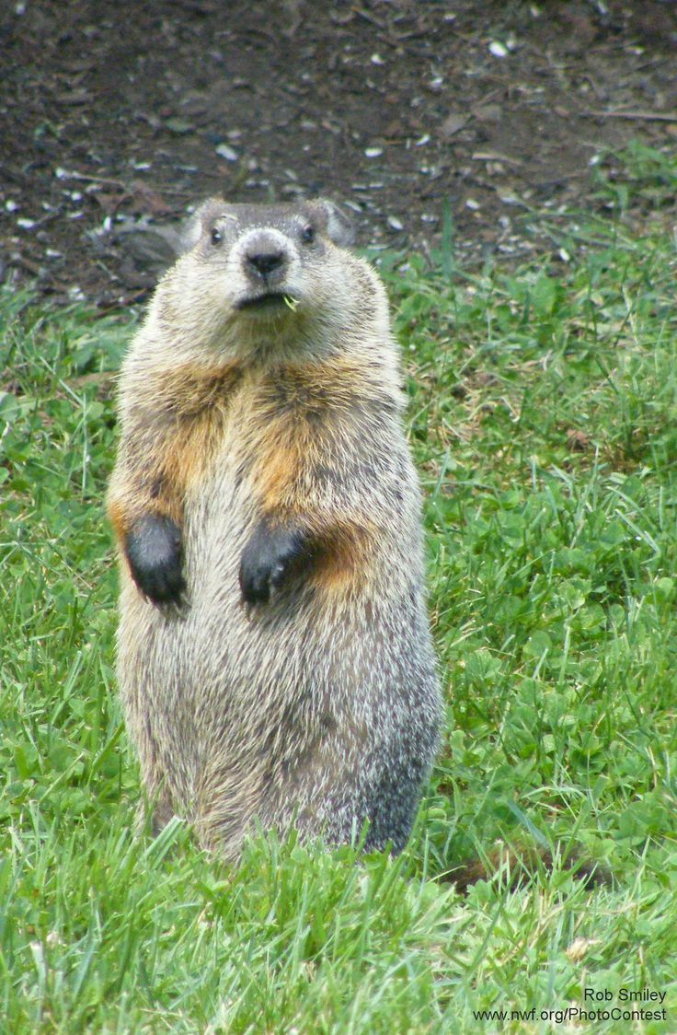
“Groundhog Flats here we come!”

