
FOR IMMEDIATE RELEASE
March 27, 2020
Charleston, WV – The West Virginia Nurses Association is in daily communication with the American Nurses Association (ANA) and chief nursing officers from around the state, as well as other nursing organizations in West Virginia. We are joining forces to help health care workers on the front lines of this pandemic get the personal protective equipment (PPE) and staffing that they need.
If you are someone that would have access to PPE that you would like to donate, please contact your local hospital, nursing home, clinic, home health organization or local Hospice. Most of them are accepting donated equipment now and it is greatly appreciated.
The WVNA urges folks to go only out when absolutely necessary and to follow all of the proper guidelines, such as social distancing, no gatherings in groups of more than ten people — and then only when absolutely necessary — wash hands often, and wipe down all hard surfaces in your home at least daily with the appropriate disinfectant.
If you do become ill with fever, shortness of breath, or other flu-like symptoms, call your primary care provider for further instructions.
Be smart, be safe, and stay healthy. West Virginians are strong and hardy. We always take care of each other. Together we will get through this.
Sending Love and Light,
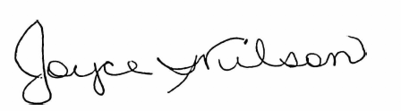
Joyce Wilson, RN, President
West Virginia Nurses Association / centraloffice@wvnurses.org / (866) 986-8773

