SAVE THE DATE
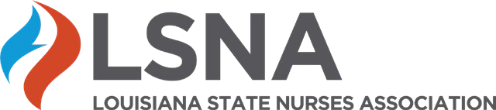

2026 Virtual Fall Symposium
Power of Nurses
Strengthen • Innovate • Inspire
📅 September 17, 2026
🕣 8:30 AM – 12:00 PM

❤️ Strengthen – Nurse Wellness & Resilience
Focus: Nurse well-being, resilience & burnout prevention
🤖 Innovate – AI in Healthcare
Focus: AI in clinical practice, ethics & nursing leadership
⭐ Inspire – Transition to Practice
Focus: Transition to practice, role socialization & professional identity
💙 Special Panel – H.E.R.O. Fund
Focus: Discuss recipient benefits for educators, students and the community

Registration Opens Soon!

Continuing Nursing Education Credit Available

