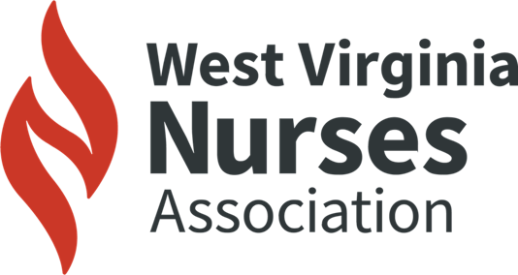

Mission: Leading quality health care in West Virginia
Vision: Empowering all nurses in West Virginia to leverage the transformation of health care by advocacy, quality, and collaboration

2025 LEGISLATIVE WRAP UP

HB 2776 / SB 460 (Multiple): Relating to Childhood Immunizations: Keep WV Childhood Immunization Standards Strong

DEFEATED TWICE in one 60-day legislative session. Governor Morrisey still has executive orders in place, we are watching to see what will happen.

- West Virginia’s school immunization policies are effective and have been in place for over a decade. These policies have proven remarkably successful in protecting our students and allows all West Virginians the freedom to live in communities that are protected from vaccine-preventable diseases.

SB 810/HB 3261: Clarifying Requirements of Administration of Anesthesia and Chronic Pain Practice by Certain Licensed Nurses

COMPLETED LEGISLATION – Waiting for Governor Morrisey to sign.

Sponsors: Rucker (Jefferson), Fuller (Wayne), Taylor (Taylor), Bartlett (Kanawha), Rose (Monongalia), Roberts (Raleigh), Maynard (Wayne), Hard (Mingo), Helton (Fayette)
- Certified registered nurse anesthetists (CRNAs) to practice in cooperation with physicians
- CRNAs are working in almost every hospital in WV that provides anesthesia services
- Removal of supervision for CRNAs has passed overwhelmingly in the House for the past 3 years
- CRNAs administered anesthesia through Governor Justice’s Executive Orders throughout the pandemic
- CRNAs have proven themselves safe and effective team players by proving their ability to practice safely while providing health care for West Virginians

HB 2544/SB 660: Remove Restrictions for Supervising Physicians for Nurse Practitioners or Physician Assistants in West Virginia

HOLDING – Delegate Worrell promised to run it in 2026 (wanted SB 810 to complete legislative process).

Sponsors: White (Berkeley), Anders (Berkeley), Ridenour (Jefferson), McGeehan (Hancock), Crouse (Putnam), Kump (Berkeley), Hite (Berkeley), Hornby (Berkeley), Parsons (Jackson), Dillon (Wayne)
- HB 2544 removes unnecessary government restrictions on nurse practitioners (NPs), certified nurse- midwives (CNMs), certified registered nurse anesthetists (CRNAs), clinical nurse specialists (CNSs), and physician assistants (PAs)
- Increases access to care, especially in rural areas
- Cuts red tape and aligns WV with 24 states, the VA, and the U.S. military
- This is a pro-patient autonomy, anti-regulation, and anti-bureaucracy bill

SB 482: Certified Professional Midwife Licensing and Regulation
HELD UP - in the House on second reading.

Sponsors: Woodrum (Summers), Rucker (Jefferson), Hamilton (Monongalia)
- To House Government Organization 03/04/2025; passed in Senate 03/03/2025
- A bill to create licensure for the state’s certified professional midwives (CPMs)
- Certified professional midwives are licensed in 37 states and DC and serve patients in home birth and birthing center settings
- CPMs are part of the solution to the state’s maternity care provider shortage
- The CPM credential is certified by the same organization that certifies the CNM (certified nurse-midwife) credential, a mark of its high standards
- This bill will allow CPMs to order medical testing, order medical devices, and use medications necessary for providing midwife care

HB 3023: Requiring Each County School Board to Employ at Least One Full Time School Nurse
HELD UP - in the House Education Committee.

Sponsors: Hott (Grant), Kelly (Tyler), Fehrenbacher (Wood), Jeffries (Kanawha), Dittman (Braxton), Mazzocchi (Logan), Hall (Kanawha), Cooper (Summers)
- To House Education 02/27/2025
- Each county school board should employ at least one full-time school nurse in each school
- Specialized health procedures that require a licensed health professional’s skill, knowledge, and judgement may be performed only by school nurses
- In collaboration with the student’s provider, a school nurse may delegate health care procedures to a trained school employee monitored or supervised by the school nurse. Note: “specialized health procedures” means, but is not limited to, catheterization, suctioning of tracheostomy, nasogastric tube feeding, or gastrostomy tube feeding

Established in 1933, the West Virginia Nurses Association (WVNA) is the only full-service professional association that represents the state’s entire nursing population.

