A Memorable First AORN Conference Experience
By Elizabeth Sasser, BSN, RN
When my coworker friend and I decided to attend the AORN Conference in New Orleans this year, I was extremely excited to plan the trip with her. She had another former coworker friend who has since transferred to a different position join us on the trip. All three of us were first-time attendees and had never been to New Orleans before. It also helped that we all love to try good food and New Orleans was a great place for that!
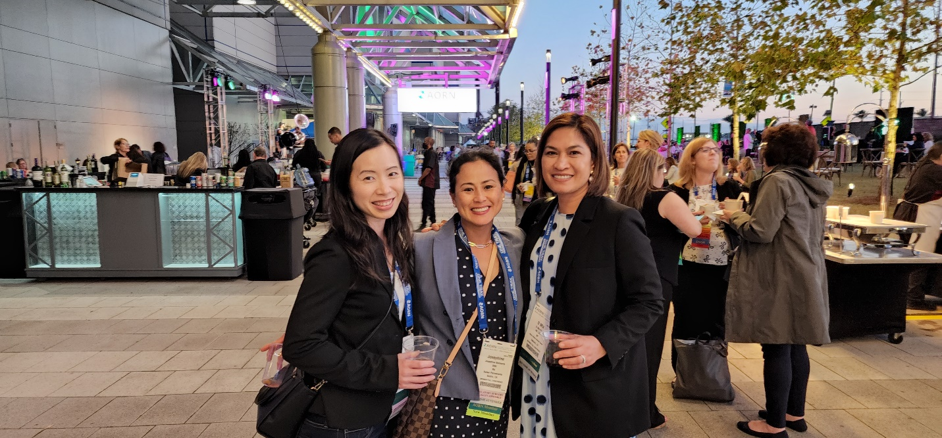
On the first day of the conference, we were in awe at how enormous the New Orleans Convention Center was. Throughout the week, we woke up at 6-6:30 am every day and went from lecture to lecture. There were so many options and topics to pick from that we were disappointed we could not see everything we wanted in real-time. Fortunately, the lecture recordings would become available later. Every speaker had a myriad of credentials behind his/her name with tons of experience. Their research summaries and findings were highly informative and educational. One of the topics that stood out to me was listening to the impact of the pandemic on OR nurse redeployment. It was amazing to learn that a majority of nurses in the study did not receive proper orientation to the unit they were floating to help. Most did not even voluntarily float to the med-surg/telemetry unit or ICU. One of my favorite speakers was Pamela Hunt whose session was titled “Nursing: The Right Choice!” She detailed moments in her life that inspired her to become a nurse from being the patient since she was a child to when she became an adult. It was a motivating lecture that made us reexamine our own reasons for why we became a nurse, especially in the last two years with the trying times of the pandemic.
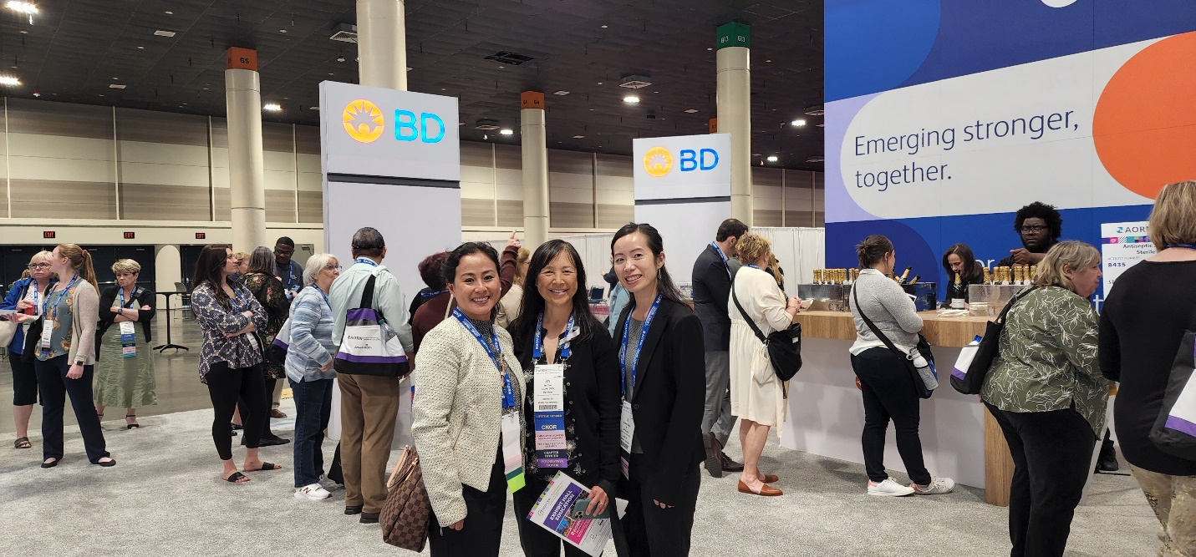
The Expo Hall was more than what I imagined it would be. We had so many booths to pick from with so many current and new products to see and play with. Lazurite had the most memorable product that truly impressed me—the first wireless surgical camera system for minimally invasive surgeries, ArthroFree. I do not know how many times we have all said how wonderful it would be to have a cordless OR. ArthroFree is definitely one of the most innovative ideas out there. We also saw companies that we normally work with which helped us further network and discuss future opportunities for newer products in our facility. I was able to take a video demonstration of the new wheelchairs that my facility was thinking of purchasing to help with patient and staff safety. Not only was I able to view products from these companies, but I was also able to attend multiple booth educational sessions for more CEUs. There were so many interesting sessions to pick from that I could not attend everything I wanted.
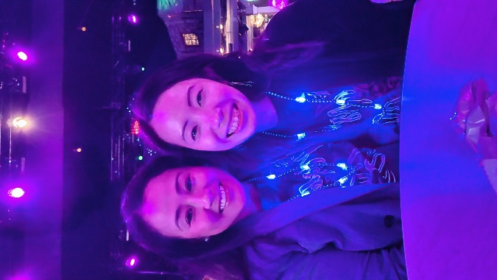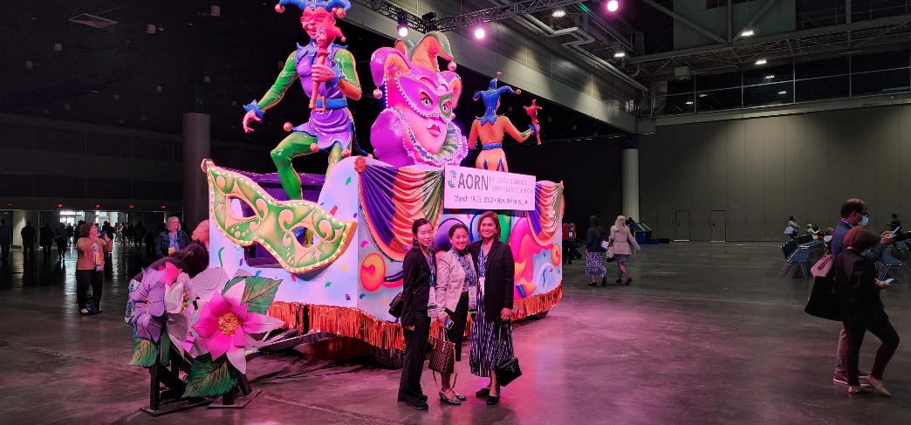
While the conference had a lot to offer us, the city of New Orleans was amazing as well. My friends and I were able to attend the local annual Louisiana Crawfish Festival where we tasted crawfish bread for the first time. We also had our fill of trying five distinct types of oyster preparations, crawfish etouffee, jambalaya, gumbo, and our favorite dessert—bread pudding! The AORN Kick-off Party on Saturday night had one of the best party appetizers we had. It was so fun dancing at the Foundation Night of Stars at the Generations Hall. Even the storm that came on Tuesday night was exciting when we learned New Orleans had the tornado warning! On the last day, we walked to the French Quarter and had the famous café au lait and beignets at Café Du Monde. We were also able to tour the Sazerac House where we learned about the family that started the Sazerac cocktail of New Orleans.
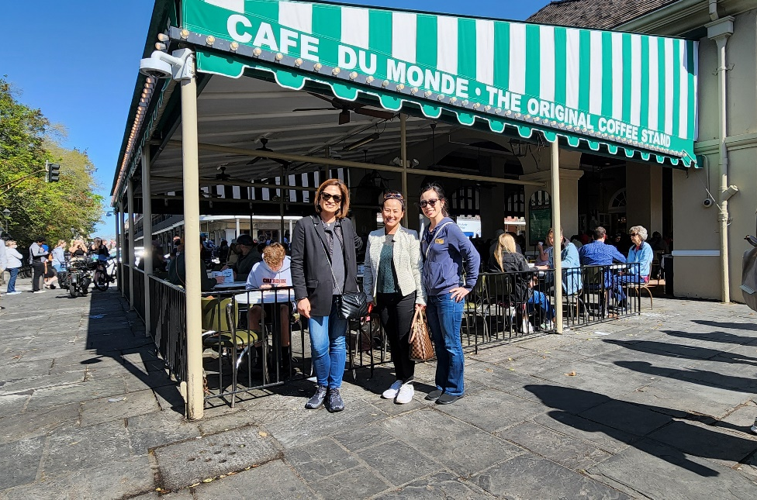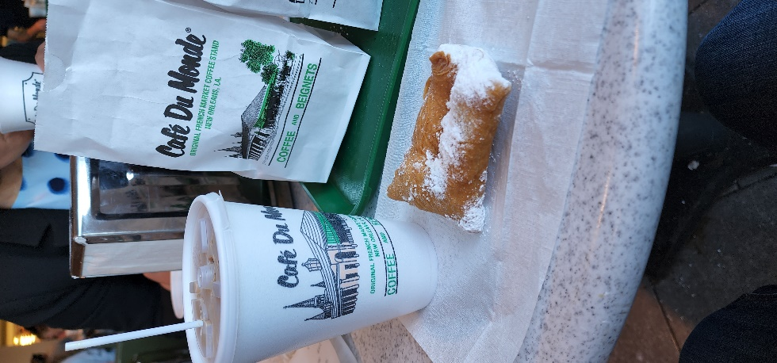
The AORN Conference was a wonderful experience that I would recommend to anyone interested in increasing their knowledge working in the OR. My friends and I made incredible memories on this trip and would love to go to another AORN Conference together again!

