**President**

Kimberly J. Cotter BSN, CNOR, RNFA

[kcotter@cheshire-med.com](mailto:kcotter@cheshire-med.com)

**Treasurer:**

Lisa B. Ryder RN, BSN, MSN

Lisa.Ryder@va.gov

**Secretary**

Diane D. Kelly, RN, CNOR

Diane.D.Kelly@hitchcock.org

**Board of Directors**

Christa Weaver RNFA, CNOR

[cweaver@cheshire-med.com](mailto:cweaver@cheshire-med.com)

Matthew J. Sheehan RN

msheehan@cmc-nh.org

**Nominating Committee**

Marcella A. Shea, RN

rosariom59@yahoo.co

Michelle A. Baril Andrejak MBA-HCA, BSN, CNOR

[mab0615@gmail.com](mailto:mab0615@gmail.com)

**New Hampshire AORN 3001 Chapter Website**

<https://www.nursingnetwork.com/>.

**Facebook Page: AORN NH Chapter 3001**

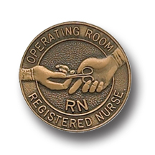

PRESIDENT’S MESSAGE

Dear Chapter 3001 members,

**AORN Global Conference and Exposition**

The AORN Exposition in Boston was a fantastic event! I commend all who planned, organized and volunteered and made this such a great event. The opening ceremony was exceptional. Jeff Keane, Massachusetts Chapter 1, gave a fabulous welcome speech at the opening ceremony, with appropriate Boston humor and ‘slang’, the invocation was delightful and the speaker, Brad Montgomery was funny! I heard from several that “this was the best conference in a long time”. I must admit, I personally loved the simulation sessions held in the exhibit hall, and I learned so much from the poster presentations and the many educational sessions I was able to attend.

Our chapter, funded registrations for seven delegates, including myself as the chair, to attend this event. In return, they attended the four business meetings of the board, two forums, and two House of Delegates meetings. I have provided the following business as just an example of what we voted on at congress. We hope to continue to send chapter members to this event. We did attempt fund raising at this exposition, to replenish the chapter funds, but unfortunately we were not as successful as we had hoped. We will provide this budget information in our next newsletter.

**2017 Proposed Bylaws Changes at AORN global conference**

This year, the AORN Bylaws Committee is recommended two bylaws amendments, both stemming from charges received from the board of directors after the 2016 Congress business sessions.

The proposed bylaws changes were related to:

1. the individual qualifications to serve in an elected position with AORN
   * It was recommended that CNOR be required
   * There was an attempt to amend this to say CNOR or other professional certifications (to include CNM, CPAN, CAPA, etc)
   * All of this was “put back on the table” for the bylaws committee to discuss, review and return at next year’s conference as there was much discussion and dissent.
   * **Food for thought** **If certification is required, and possibly the addition of BSN, or a bachelors degree of some sort, how would this effect our local chapter?
     + **I ask you to give us your feedback. This may be important information for us to get to National AORN before next year’s meeting.**
2. changing the responsibilities of the Nominating and Leadership Development Committee (NLDC) to reflect a more traditional nominating committee.

**The by law to change the name of the nominating and leadership development committee (NLDC) was passed. It is now the Nominating committee.**

To view more regarding this, <http://www.aorn.org/aorn-org/about-aorn/governance/bylaws/2017-proposed-bylaws-changes>.

**How does AORN affect YOU?**

Do you rely on the professional expertise of AORN for your recommended practice standards? Do you function in your own silo? If AORN did not exist, how would you collaborate with other facilities to attain the same standards, establish policies, procedures and guidelines? Do you have the resources to conduct studies, and research criteria regarding best practices without the assistance of our professional organization? Who would you rely on for the evidence based information that guides us and recommends our practices?

**Chapter 3001 Election time**

We need new VOLUNTEERS on our board. It is time to get new creative, collaborative and effective leaders to our chapter leadership. Please consider yourself or someone else who you think would be a great resource to this committee. Willingness to serve forms are out and need to be completed and returned ASAP, and before the May deadline.

Happy spring!

Sincerely,

Your Chapter 3001 President

Kim Cotter

*“If you don't like something, change it. If you can't change it, change your attitude.* Maya Angelou,

**Upcoming conferences and events:**

**CNOR Exam Prep and Review class**

**Zander Perioperative Education**

**May 20-21, 2017**

Exeter Hospital

5 Alumni Drive

Exeter NH

Register on line at [www.periop-ed.com](http://www.periop-ed.com)

OR

Mail the attached form to:

Zander Perioperative Education

162 S. Oak Pointe Drive

Seneca SC 29672

Early registration fee $245 if received by April 20, 2017

Regular fee $270 if received April 21-May 13, 2017

June date to be determine

Conference at Cheshire Hospital Keene NH

The BOD is interested in knowing what educational experiences you are interested in. Please email any of the members with your ideas and thoughts.

.

**Wanted**

Wanted chapter members to run for chapter president, president- elect, secretary, nominating committee and Board of directors. Please fill out the Willingness to Serve letter and return to Marcia or Michelle by May 6, 2017

**Meeting Time options**

What days and time would work best for you? Please do the Monkey survey if you haven’t already done it

<https://www.surveymonkey.com/r/D7FKBMD>

[](https://www.google.com/imgres?imgurl=http://www.de-soutter.com/gallery/NewsAndEvents/Boston-Convention-and-Exhibition-Center.png&imgrefurl=http://www.de-soutter.com/News--Events&docid=ozUzUFa4IJ_nQM&tbnid=iM1sIEuOU2L9AM:&vet=10ahUKEwik_oTE56vTAhXLx4MKHVd2CEk4yAEQMwhDKEEwQQ..i&w=566&h=301&bih=849&biw=1513&q=aorn%202017%20boston&ved=0ahUKEwik_oTE56vTAhXLx4MKHVd2CEk4yAEQMwhDKEEwQQ&iact=mrc&uact=8)

## Boston by night, Boston by day



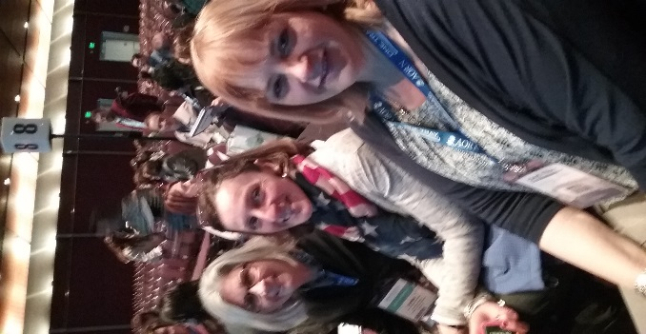

**Delegates Cynthia and Barbara with Kim, President**



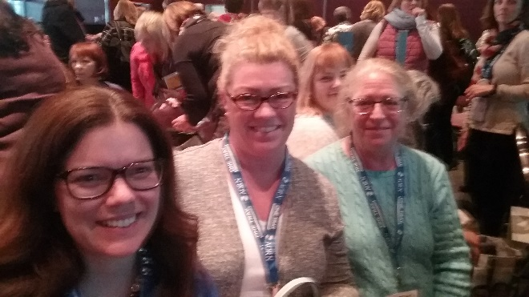

**Delegates Carrie, Dawn and Diane**

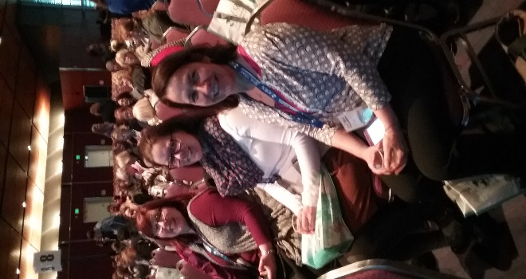

**Delegates Marcie and Carrie with Laurie Heels**