|  |  |
| --- | --- |
|  | AORN Greater Houston #4407 Meeting Minutes  April 11, 2017 |

# Attendees

Members: 30  
Students: 32  
Visitors: 9  
Teleconference: 3

Total: 74!

# Welcome – Nakeisha Archer - 1645

Recap from Expo!  
- Networking  
- Leadership  
- Fun music/dancing/parties/awards  
- Mentorship  
- So much more!

# AORN Global Surgical Conference & Expo 2017 – 1645-1700

## #4407 AORN of Greater Houston Awards

* GOLD CHAPTER OF EXCELLENCE
* CHAPTER OF THE YEAR

**Member Awards & Recognition in Boston**

* Major Ty Houston recognized (New Member)
* Nikki Washington, BSN, MBA, CNORelected by her peers to fulfill the position as a member of the AORN National Nominating Committee 2017-2018.
* Joanne Oliver, BSN, RN, CNORawarded AORN National Outstanding Nurse Philanthropist for 2017.
* Daphny Peneza, MSN, RN, CNOR: AORN National Appointments, Global Relations Committee 2017-18, Professional Practice & Issues Chair Educator’s Specialty Assembly 2017-18
* Ebony Mitchell, MSN, RN, Awarded , AORN National Forty under Forty

**Linda Groah CEO: Executive Directors Report**

•Highlighted AORN’s value as leaders in evidence-based practice, confirmed by the more than 40 government and other organizations that have requested AORN representation on their boards, task forces, and committees.

•In response to the member needs assessment survey, AORN now provides Periop101 students with a membership for one year and is exploring content for a Periop202 that would be based on surgical specialties such as MIS, orthopedics, cardiac and neuro.

•6,100 new members and 7,400 lapsed members who have recently rejoined.

•Members with less than 2 years experience will receive membership at rate of $99 (rather than $160)

**National Treasures Report**

AORN Foundation, reported on the Foundation’s accomplishments in the past year:

The Foundation awarded:

•$160,000 in academic scholarships,

•180 professional development grants,

•All to support educational programs and regional seminars focused on current topics affecting the industry.

•New in 2016, the Foundation helped launch the AORN Go Clear Surgical Smoke Free Recognition program

•87% of all Foundation revenue went directly to support resources touching the lives of real nurses.

•The Foundation raised over $240,000 in the past week in Boston.

**Congress Bylaw Changes**

1.Change the name for NLDC: Members nearly unanimously approved an amendment to the bylaws that restores the Nominating and Leadership Development Committee to a more traditional nominating committee by eliminating the committee’s leadership development responsibilities, allowing the committee to focus more exclusively on candidate selection and the election processes.

2.Members considered a bylaw amendment that would have required all candidates for AORN board of directors, officers, and the newly renamed Nominating Committee, to hold current CNOR certification.

3.Both proposals were ultimately laid on the table by a strong majority, meaning that AORN will be creating a bylaws committee in the coming year to consider both options regarding certification. The issue of whether a BSN should be required to serve in elected office with AORN will also be considered in the coming year by the same committee.

# 

# Business Meeting - 1700-1735

* 2017-2018 Ballot Candidates Speak
* **Open Positions Candidates for 2017-2018**
* •President Elect (1 to be elected):
  + Ebony Mitchell
* •Secretary (1 to be elected):
  + Falynn Chapman
* •Board of Directors (2 to be elected):
  + Fred Perry
  + Suzanne Bailin
* •Nominating Committee (2 to be elected):
  + Latoya Hamilton
* *If you are interested in being on AORN of Greater Houston’s ballot for 2017-2018 please contact any member of our present NLDC.
* Treasurer’s report – next month will have updated items from symposium and expo
  + Financial Report AORNGH - March
  + • Balance Checking: 7228.57
    - Meeting room at Expo -50.00
    - Chapter dues for March 831.50
    - Interest Earned .06
    - Ending Balance for March 8010.13
  + • Balance Savings: 32689.66
    - Interest .56
    - Ending Balance for March 32690.22
* LEGISLATIVE REPORT – JOANNE OLIVER – 1728-1735
  + We are very excited to have Ebony Mitchell, Deshon Essia, and Ida Calago to represent AORN of GREATER HOUSTON at “Nurses Day at the Capitol”
  + They were able to tour the capitol and meet with many colleagues regarding current legislative issues. They received a wonderful orientation to the legislative process at our state capitol. THANK YOU!
  + NLAC, representing over 22 various nursing organizations across Texas, is continuing to monitor the progress of many of the healthcare bills. Our chapter has been an integral part of contributing to this through weekly conference calls. My continuing thanks to several of you who have helped with this responsibility.
  + Go to <https://tcorn.nursingnetwork.com/nursing-news/70261-latest-legislative-update-from-nlac>
  + Keep listening carefully as we may need your help with speaking to your legislator in your own district.
  + To find out who represents you: <http://gis1.tlc.state.tx.us/mobile/fyi>

# Education Session – “SKIN SUBSTITUTE” by Reagen Green & Austin w/ Integra - 1740-1815

* **Tissue Technologies**
  + Providing world class portfolio in wound & tissue repair products
  + Technology is about 25 years old
  + Bioengineered Collagen Matrix & Native Acellular Dermal Matrix
* **“Bottom Up” vs “Top Down” approached**
  + Collagen matrix or sponge so cells could infiltrate and not contract.
  + Improve life
  + Bottom up – pure collagen coming from cow
    - Start with tendon and pull all collagen out
    - Purify collagen
    - Sterilization period
    - Add silicone layer on top of that – highly conformable
  + Top down – from cow fetal bovine dermis
    - Take fetus and pull skin off of it and acellularize it
    - Sterilization
    - Native acellular dermal matrix
  + Key differences – tactile, top down is more robust, moisture loss
* When you’re in a flap case, these products are a back up if it fails
* Designed for burns
* Dressing & wound care

**CE CREDIT: Medline University** [**https://www.medlineuniversity.com/lms/course/1010000075/**](https://www.medlineuniversity.com/lms/course/1010000075/)

**Collagen Dressings in Chronic Wounds**

# Announcements & Events

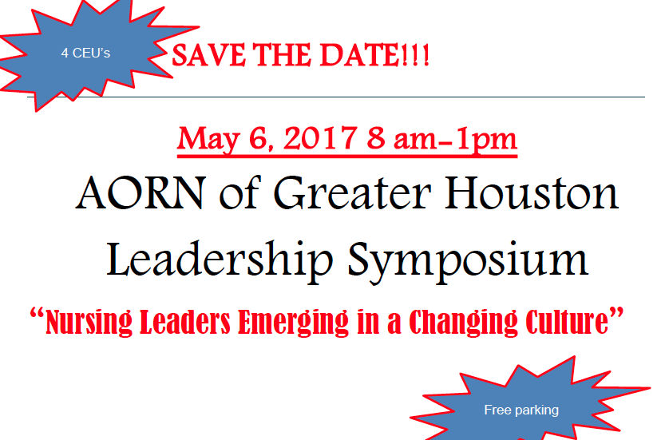

# VISIT OUR FACEBOOK & WEBSITE!

# Next meeting

May 9, 2017 | 4pm | Texas Children’s Hospital Pavilion for Women 4th floor conference rooms D & E