|  |  |
| --- | --- |
|  | AORN Greater Houston #4407 Meeting Minutes  March 14, 2017 |

# Attendees

Members: 32  
Students: 50  
Visitors: 6  
Teleconference: 0

# Welcome – Nakeisha Archer

Happy certified nurses day!

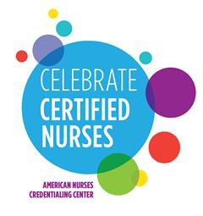

# JeoPARODY with Suzy Bailin – 4:30-4:55

## Safety First, ID before med, Infection control, Fire safety, Sentinel events, Anything goes

## This should be done prior to a blood transfusion, giving medications, and when conducting a timeout – What is identifying the patient using at least two ways? (name, DOB, MRN, or per your facility’s policy)

1. Always done prior to surgery to verify correct patient, site, and procedure – what is universal timeout?
2. This must be done in order for alarm parameters to be disabled – what is a physician’s order?
3. When receiving critical test results verbally, these two things should be done before communication with the physician – what is “write it down, read it back”
4. During handoff report, these are the words that that acronym “SBAR” stand for – what is situation, background, assessment, recommendations
5. Two ways in which the RN circulator and the scrubbed personnel verify labels when meds are dispensed – both verbally and visually
6. Name, strength, expiration date, expiration time, diluent name and volume, amount of med if not apparent from container – what are the 6 things that should be included on the label of a medication placed on the back table?
7. Medication labels should be reviewed by the circulator and scrub person at which two times? – when first dispensed and with change of personnel
8. Multi-dose medications are intended for this route of administration – what is parenteral route? (subq, intramuscular, intravenous)
9. The number of days an opened multi-use vial may be used before the “beyond date” expiration – 28 days
10. Following isolation precautions, using appropriate PPE, and hand hygiene – What are ways to prevent healthcare associated infections (HAI’s)
11. Clipping not shaving, CHG prep, & appropriate timing of antibiotics - What are preoperative ways (EBP) to prevent SSIs
12. bundle elements, hand hygiene, scrub the hub, maximum sterile barriers for insertions - What are some EBPs to prevent CLABSIs?
13. Limiting use to absolute necessity, aseptic technique during placement, securing catheter, and replacing the collection system when required – what are evidence based practices to prevent CAUTI’s
14. Before & after patient contact, before & after glove use, before preparing or administering meds or food, after touching likely contaminated sources, before & after eating, after using the restroom – what are the six times that hand hygiene should be performed
15. The first actions you should take in the event of a fire – RACE (rescue, activate, confine, extinguish)
16. Three factors that compromise the fire triangle – what are an oxidizer, an ignition source, and a fuel source
17. The sites/areas on a patient that are most at risk for a surgical fire – what are the head and neck? (xiphoid process, oropharynx)
18. These 2 things should be verified in the room/on back table as immediately available before starting a laser case – saline/water and appropriate type of fire extinguisher
19. Areas separated by smoke doors with magnets that automatically release when a fire alarm is activated – what is a smoke compartment
20. Death, injury, or risk – what is the three unexpected occurrences that cause a sentinel event
21. What are three OR related sentinel events? – surgery on the wrong site, wrong procedure, wrong patient
22. The acronym RSI stands for these words – what is a retained surgical item
23. What is used by a multidisciplinary team to identify system factors that led to a sentinel event? – A Root Cause Analysis (RCA)
24. A guard who stands watch and signals the need for an immediate investigation and response – who does the word Sentinel Describe?
25. The two areas other than exit doors and stairwell doors that equipment, carts, beds are not allowed to block – what are fire extinguishers and medical gas zone valves?
26. The tape on a wrapped instrument turns from red to what color when STERRAD sterilization has occurred – yellow
27. Per AORN guidelines, an unused OR suite should be cleaned within this frame – when is every 24 hours
28. ANSI ST79 – what is the name of the association for the advancement of medical instrumentation’s (AAMI) recommended practices for hospital steam sterilization guideline?
29. The procedure for a tissue test – stand outside the door, hold a tissue to the edge of the door, if the tissue blows towards you, the room is positive pressure

# Business Meeting – 4:55 – 5:24

* **2017 Chapter Excellence Award Recipients**
  + **Small Chapter Category (0-50 members)**
    - **Gold:4601 Northern Vermont**
  + **Medium Chapter Category (51-150 members)**
    - **Bronze:**0402 Central Arkansas
    - **Silver:**4406 Fort Worth Chapter of AORN
    - **Gold:**4410 North Harris Montgomery County
  + **Intermediate Chapter Category (151-300 members)**
    - **Bronze:**2601 Greater Kansas City
    - **Silver:**0511 AORN of San Diego County
    - **Gold:**5001 AORN of Southeast Wisconsin
  + **Large Chapter Category (301+ members)**
    - **Bronze**: #0310 Grand Canyon
    - **Silver**: #2101 AORN of Baltimore
    - **Gold**: #4407 AORN of Greater Houston
  + But who will be chapter of the year!?
  + April the 3rd will be announced
* Expo delegate count 2017 – 23 allotted
  + 1.Nakeisha Archer
  + 2.GeorgeanneGreen
  + 3.FalynnChapman
  + 4.DeshonBurton-Essia
  + 5.Darlene Murdock
  + 6.Nancy Allen
  + 7.Joanne Oliver
  + 8.Joan Persaud
  + 9.Holly Mishoe
  + 10.Carrie Claffey
  + 11.Patricia Rodriguez
  + 12.LaSandraBrown
  + 13.Naomi Brown
  + 14.Nikki Washington
  + 15.Daphne Grace Peneza
  + 16.Ebony Mitchell
* Bylaws changes
  + “hereinafter referred to as the ‘association’
  + Updated section numbers
  + Clarifying “national”
  + Regarding dues – if we needed to raise dues we would bring it to the membership with majority vote
  + Officers of the chapter – responsibilities outlined. To be in line with what national has in their bylaws.
  + Inserted teleconference meetings to allow for technology
  + NLDC at the national level may be changed to Nominating Committee.
  + Take out president appointing a member of NLDC.
  + Elections are consistent with national
  + Adding a new task force
  + The numbers for delegates are given to us by National
  + Fiscal year of the association
* The Chapter Bylaws for 2017 have been approved! @ 5:10
* Legislative update @ 5:13-5:23 – Joanne Oliver
  + Deshon talked about her experience in Austin with Joanne.
  + No more bills can be filed right now.
  + 6,485 is the final bill count for this legislative session. In process of going through committees.
  + TNA is tracking over 700 bills to make sure that nursing is fully covered and represented
  + HB 281 by Rep. Howard – grant program to prevent workplace violence
  + HB 62 by Rep Cradick – Texting and driving ban
  + SB 790 by Sen. Miles/HB 279 by Rep. Howard – continuation of the women’s health advisory committee (funds for facility reimbursement program – small cig tax could be add to give us almost 9 million?
  + NLAC BILLS OF INTEREST
    - BON sunset legislation – hearing pending
    - Advanced Practice registered nurses – remove unnecessary barriers to practice for APRN’s
    - Mental health – prohibit weapons in mental health facilities, statewide reporting system for injuries, fund more inpatient care for patients and community based health services
    - Nurse education – provide incentive funding to institutions that increase nursing graduates
    - School nurses – require parental notification if no nurse is on school campus
    - Workplace advocacy – consider innovative grants for workplace violence prevention programs
    - Child safety – require children under 2 to be in rear facing car seats
    - Texas Women’s Health coalition – support strength of women’s health programs, improving access to contraceptives, and minimizing barriers to preventive care
    - Public health – raising minimum age of tobacco sales from 18 – 21
    - Key to watch:
      * Dental hygienist
      * Disclosing identity to nurses reporting physicians to TMB
      * Physician assistants prescribing schedule 2 drugs
      * Anesthesia assistants

Open Positions for 2017-2018 (WTS form at end of meeting minutes)

* President elect – 1 to be elected
* Secretary – 1 to be elected
* Board of Directors – 2 to be elected
* Nominating Committee – 1 to be elected

# Education Session – 3M – Reducing Bacteria in the Nares (preoperative protocol) by Anna Cypert, BSN, RN | Clinical consultant 3M infection prevention division – 5:30-6:20

* Surgical site infections
  + Surgical procedures are becoming increasingly more complicated
  + Population of surgical patients has more underlying conditions
  + These factors increase the risk for developing surgical site infections
* SSI epidemiology – 2014 updates on strategies to prevent SSI
  + SSI occur in 2-5% of patients undergoing inpatient surgery
  + Approx. 160,000-300,000 SSI occur each year in US
  + Outcomes: up to 60% may be preventable, each SSI increases LOS by approx. 7-11 days, SSI is associated with 2-11 times higher risk of mortality compared with operative patients without SSI
    - 77% of mortality in patients with SSI is directly attributable to that SSI
    - Attributable costs of SSI depend on the type of operative procedure and the infecting pathogen
    - Believed to account for 3.5-10 billion dollars annually in health care expenditures
* (Dose of bacteria [**contamination])** x (virulence [**resistance])** / resistance of host = risk
* Patient variability: resistance of the host
  + Age, compromised immune system, diabetes, remove site infection not treated prior to sx, nutritional status, nicotine use, prolonged prop stay, obesity, steroid use, duration of surgery
* Process variability
  + Hand hygiene, appropriate antimicrobial prophylaxis, preop bathing, nasal decontam, oral decontam, hair removal, skin prep, surgical hand antisepsis, appropriate surgical attire and drapes, operating room characteristics (ventilation, traffic environmental surfaces, sterilization), patient mgmt. (normothermia, glucose control, oxygenation), surgical technique (hemostasis, failure to obliterate dead space, tissue trauma).
* Staph aureus is the leading cause of surgical site infections
  + Approx. 30% of pop has s. aureus in nasal
  + 80% of the s. aureus infections are caused by the patient’s own clonal nasal flora
* Nasal carriage of staph a as a major risk factor for wound infections after cardiac surgery, following orthopedic prosthetic joint surgery
* There is a common unfortunate trend with nasal carriage ending up in the wound
* In 2007 started treating nasal carriages with abx – becomes resistant!
* 2014 – shoulder screen surgical patients for S. Aureus and DECOLONIZE prop for high risk procedures including ortho and cardiac procedures – do not give mupriocin if you have no screened
* REDUCING S. A. IN NARES PRIOR TO SURGERY
  + Bactroban Nasal (mupirocin calcium ointment 2%) – indicated for institutional outbreaks of MRSA
  + Greater than 90% of subjects’ patient in clinical trials had eradication of nasal colonialization 2-4 days after therapy was completed
  + Challenges to using this: patient compliance and resistance
* Antiseptic prep – 5% povidone iodine
  + Applied 1 hour before incision
  + Provides 99.5% reduction of s. a. in the nares at 1 hour
  + Maintains this log reduction for at lest 12 hours
  + Patented formula designed specifically for those nose – presents unique challenges compared to prepping skin
  + Advantages
    - Resistance has not been shown
    - Broad spectrum
    - Easy to implement in pre-op
    - No need to change current protocols (screening)
    - Directly observed application ensures compliance
    - Demonstrated in reducing SSI risk
  + Disadvantages
    - A small number of patients may be sensitive to povidone iodine containing products
    - Reduces bacteria, does not eradicate
* CONCLUSION
  + Of that particular study:
  + 5% of nasal PI may be considered as an alternative to mupirocin in a multifaceted approach to reduce SSI
* CONCLUSION – THERE WERE SIGNIFICANT COST SAVINGS WITH NO DIFFERENCE IN INFECTION RATES; THEREFORE, THE 5% P-I NASAL ANTISEPTIC IS FINANCIALLY AND CLINICALLY SUCCESSFUL & RESULTED IN DECREASE IN POSTOP INFECTIONS – best to apply P-I before surgery
* SUMMARY
  + NASAL CARRIAGE OF S. AUREUS INCREASE RISK OF SSI AND IS INCREASED FOCUS FOR HIGH RISK SURGICAL PROCEDURES
  + IF S. AUREUS SSI IS HIGHER THAN BENCHMARK DESPITE EFFECTIVE BASIC SSI RISK REDUCTION STRATEGIES THEN IMPLEMENTATION OF S. AUREUS DECOLONIZATION PROGRAM IS RECOMMENDED
  + INTRANASAL MUPIROCIN HAS BEEN USED HISTORICALLY TO DECOLONIZE THE NARES AND IS ASSOCIATED W COMPLIANCE BURDENS
  + 5% PI FORMULATED SPECIFICALLY FOR INTRANASAL APPLICATION IS AN OPTION THAT PROVIDES DIRECTLY OBSERVED, JUST IN TIME APPLICATION WITH DEMONSTRATED EFFICACY IN REDUCING THE RISK OF SSI

# Announcements & Events – 5:24-5:30

May 6, 2017 8 am-1pm

AORN of Greater Houston

Leadership Symposium

* “N_u_r_s_i_n_g_ _L_e_a_d_e_r_s_ _E_m_e_r_g_i_n_g_ _i_n_ _a_ _C_h_a_n_g_i_n_g_ _C_u_l_t_u_r_e_”
* Memorial Hermann the Woodlands Perianesthesia Seminiar

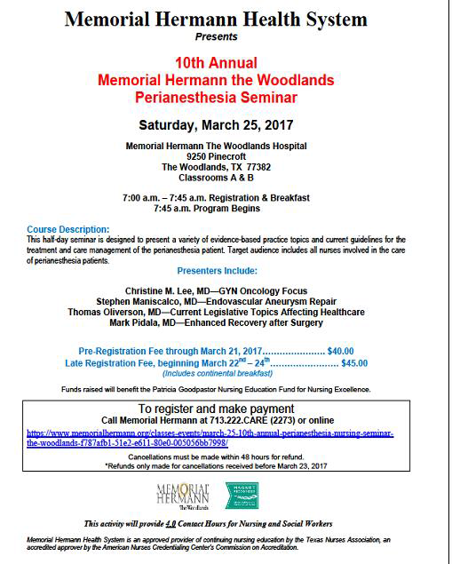

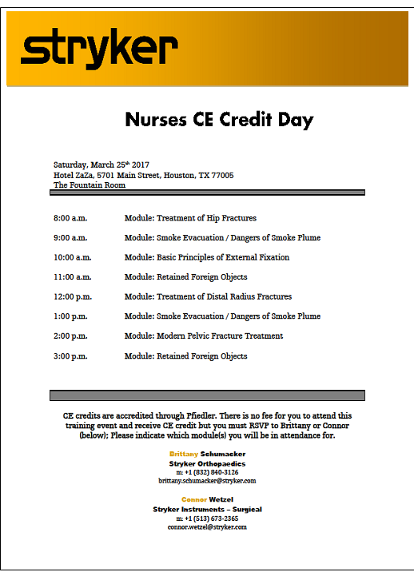

* Check out the newsletter for all kinds of information!
* Facebook page!
* Website!

# Next meeting

April 11, 2017 | 4PM | Texas Children’s Hospital Pavilion for Women fourth floor rooms D&E

