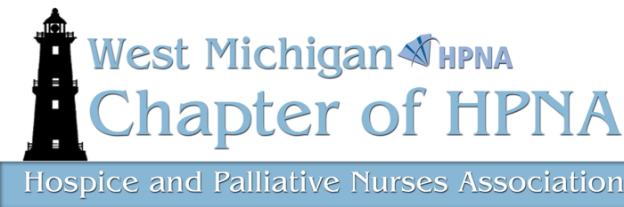

Presents:

Strategies to Obtain Palliative Care in the LTC Setting: One Family’s Story

Family Member: Bryant D.
Nurse Practitioner: Amy Zuidemna, MSN, NP-C
State of Michigan Dept. of Licensing & Regulatory Affairs:
Rick Brummette, RN, BSN & Cheryl Howlett, RN, BSN
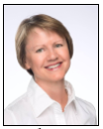

Moderator:
Carol Robinson, DNP, MS, BSN, RN, CHPN
Panel discussion will address barriers & myths and will describe the role of family members and advanced practice palliative care nurse
March 20, 2017

Faith Hospice
Trillium Woods Chapel
8214 Pfeiffer Farms Dr. SW
Byron Center, MI 49315

Please park on lower level.

6:00 pm Membership meeting
with refreshments
6:30 pm CE Presentation

CEU: 1.0 Nursing CEU
Cost: $10 cash/check
($5 members)
Pay at the door
(No credit or debit cards can be accepted)

****************
Reservations Required:
RSVP to Theresa Lynn at
tlynn@wingsofhopehospice.com

Please Note: You do not need to be a current HPNA member to attend

