New Year, New Beginnings
Newsletter
Winter 2017 | Edition 2

Join AACN-Chicago West Suburban Chapter
• • •
Collaborate with other nurse colleagues to review up-to-date evidence based practices to use in your area. Share important information and ideas pertinent to our organization and the critical care nursing profession.
Go to https://cwsaacn.nursingnetwork.com and click on “Become a member”.
Chapter Membership- $20
Student Membership- $15
Retired Membership- $10
We are looking for new board members to lead us through the next year! If you are interested, please contact Becky Pedersen at Rebecca.pedersen@amitahealth.org
  - Becky Pedersen MSN, RN, PCCN

AACN News
AACN Updates Cardiac Monitoring Practice Alerts
Published Jan. 24, 2017
Summary of recommendations for nursing practice for monitoring dysrhythmia and ST segments:
- Two leads should be displayed whenever available to aid in accurate rhythm interpretation.
- Electrodes should be changed daily.
- Electrode placement is integral for accurate results. When an electrode is misplaced by as little as one intercostal space, QRS morphology may change and contribute to misdiagnosis.
- Both the onset and termination of the dysrhythmia should be documented.
- A short PR interval on a resting ECG may be associated with the presence of an accessory pathway.
- The QTc interval should be measured once per shift in patients who meet the criteria for QT-interval monitoring. More frequent assessment may be indicated on the basis of additional ECG and clinical risk factors.
Upcoming Educational Offerings
AACN Chicago West Suburban Chapter Meeting and Journal Club
May 16th, 2017 5pm AMITA Lagrange Dixon A

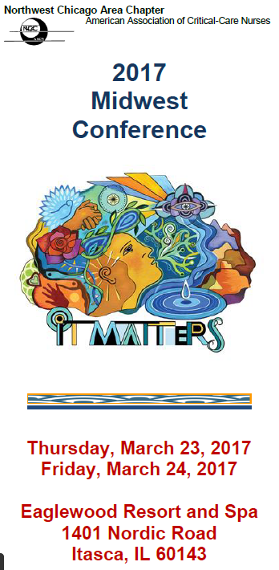

November’s Journal Club and AACN Chapter Meeting
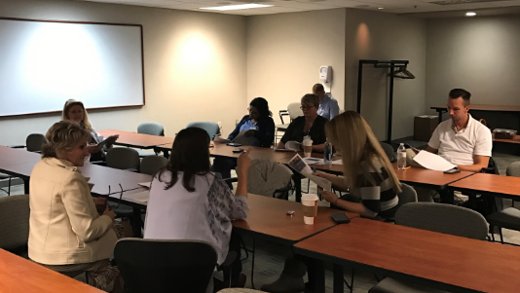
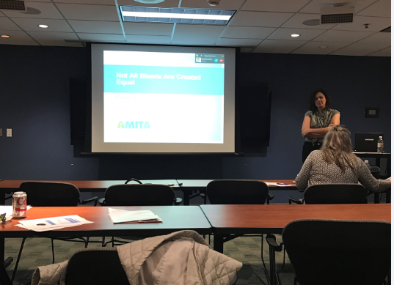
AACN- West Suburban Chapter Meetings and Journal Club
Quarterly Meetings
February 21st; May 16th; August 15th; November 21st
5pm Journal Club and 6pm Meeting

