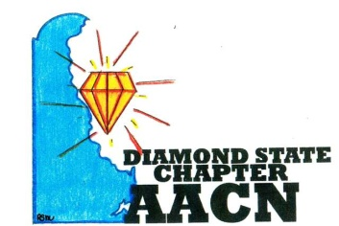Est.2006
“Shine Bright Like A Diamond”
Agenda-February 14, 2017 6pm
- Welcome and recognition
- Introductions of any new members
- Recognition of newly certified or any other professional accomplishments of chapter members
- Reports
- Review of January minutes
- Treasury report
- Old Business
- It Matters member recognition January
- Polos
- Fundraising ideas
- Education Event for 2017- email Ludy by 2/17/17
- Chapter Excellence Award applications-submitted!
- Mentoring Sessions April
- New Business
- Certification Recognition March 14
- NTI scholarship 2017
- Roundtable

Next meeting March 14th 6pm

