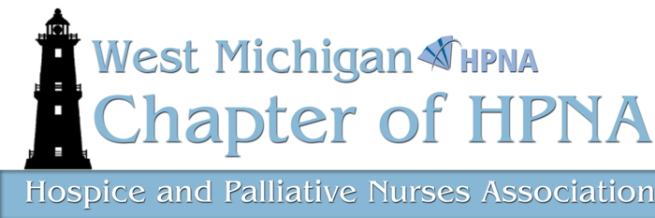

Presents:

CDC Guidelines for
Chronic Pain Management:
How does this Impact Hospice and
Palliative Clinical Practice?

With

Rachel Cardosa, DNP, NP


Review CDC recommendations in 2016 Chronic Pain Management Guidelines. Review rationale for recommendations for change in opioid prescribing and management related epidemic. Discuss recommendations for application and integration to current and future management of pain and symptoms within life limiting illness.

February 27, 2017

Faith Hospice
Trillium Woods Chapel
8214 Pfeiffer Farms Dr. SW
Byron Center, MI 49315

Please park on lower level.

6:00 pm Membership meeting
with refreshments
6:30 pm CE Presentation

CEU: 1.0 Nursing CEU
Cost: $10 cash/check
($5 members)

Pay at the door
(No credit or debit cards
Can be accepted)

Reservations Required:
RSVP to Theresa Lynn at
tlynn@wingsofhopehospice.com

Please Note: You do not need to be a current HPNA member to attend

