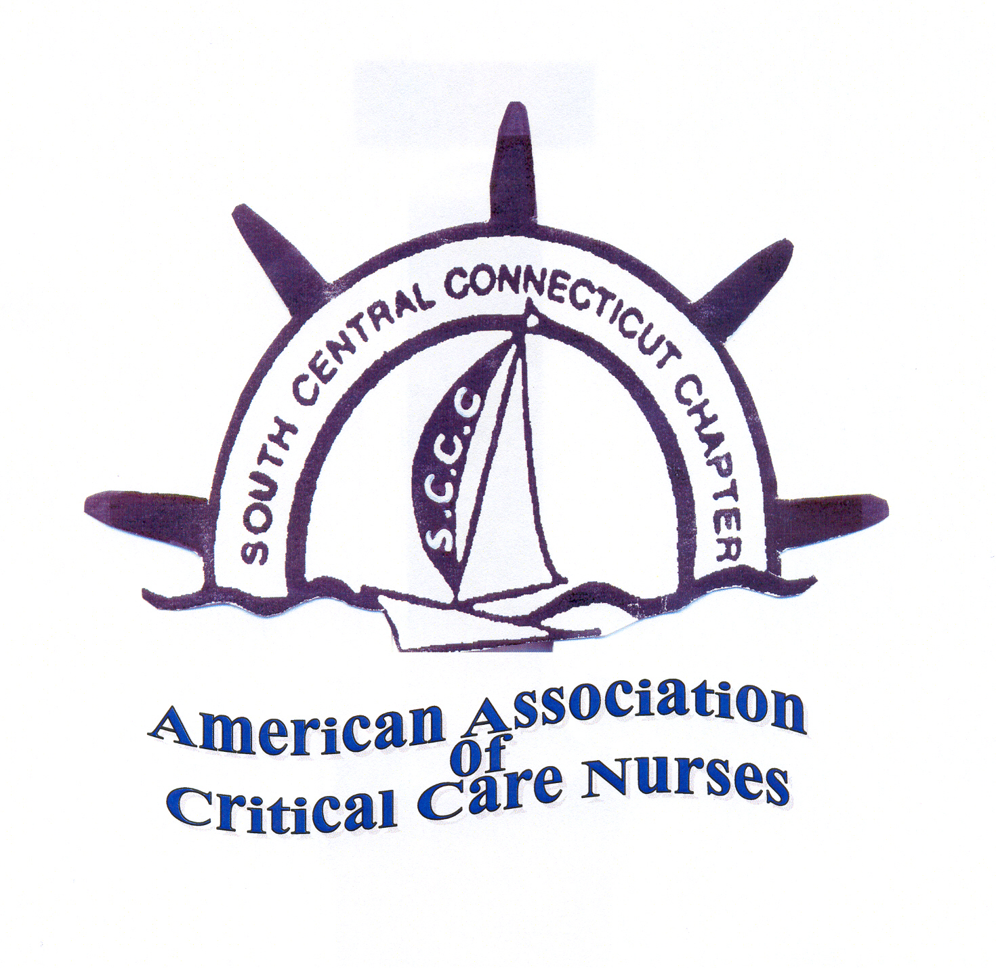

Nomination Form for SCCC Board of Directors term July 2017- July 2018

Board members must be able to participate in monthly board meetings

Program-elect _______________________________
A 2 year term, the first year, you will be mentored by the Program Chair. The second year, as Program Chair, you will supervises the organization and planning of the educational programs provided by the chapter (on average 3-4 annually). This includes website responsibilities for program advertising, working closely with the Treasurer to assure the accurate tracking of program expenses, mentoring the program-elect and other duties as described by the SCCC Board of Directors.

Treasurer-elect ______________________________
A 2 year term, the first year, you will be mentored by the Treasurer. The second year, as Treasurer, you will prepare an annual budget, supervises the maintenance of all funds and securities of the chapter and perform other financial duties related to the website, complete AACN financial reports & mentor the treasurer-elect, & other duties as prescribed by the SCCC Board of Directors.

Special Project Chair_______________________
A 2 year term that includes leadership of the volunteer chapter ambassadors, planning & organization of chapter community outreach activities and communicating with vendors for program support, and other duties as described by the SCCC Board of Directors.

Please return form by mail to:
Carla Hannon, Nominating Chair
217 Mountain Rd
Cheshire, CT 06410
Or send an Email to:channon3@cox.net

Nominations must be received no later than March 31, 2017

